[UNIVERSITY NAME]
[Faculty / Department]
Relay: A Source-Cited Question-Answering Assistant for Dental Radiographs, Documents, Videos and a Knowledge Base
Graduation Project Report (Phase 1)
Prepared by
[Student Name], [Student ID]
[Student Name], [Student ID]
Advisor
[Advisor Title and Name]
October 2026

Abstract
General chatbots can answer questions about a dental X-ray, a PDF or a lecture video, but they seldom show where an answer came from and often answer when the material does not support it. This project presents Relay, a Flask web application where a user loads a dental radiograph, a document, a YouTube video or a built-in knowledge base and asks questions by text or voice. Each answer ends with the locations it relied on: a page, a paragraph, a video timestamp, a knowledge base entry or the findings of a dental detection model. For radiographs, a pretrained YOLO detector runs locally before any language model is called. It was chosen, without any training, by benchmarking eleven public dental models on 194 held-out panoramic X-rays from the Kaggle Dental Radiography dataset. The selected model reached an image-level F1 of 0.93 for fillings, 0.56 for cavities, 0.50 for impacted teeth and 0.39 for implants. Answers that hedge are caught by a pattern filter and passed on through a fixed chain of sources (detector, GPT vision, web search, general model), and the last two steps are labelled in the interface. The detector can be trusted for fillings and is only a hint for the other classes. We also discuss privacy, licensing and the missing evaluation of answer quality.
Keywords: dental radiography, object detection, YOLO, retrieval-augmented generation, source citation, large language models

Table of Contents
Abstract
Table of Contents
1. Introduction
1.1 Background
1.2 Problem definition
1.3 Motivation
1.4 Objectives
1.5 Organisation of the report
2. Literature Review
2.1 Deep learning for dental radiographs
2.2 Object detection architectures
2.3 Retrieval-augmented generation and citation
2.4 Language and vision models in medicine
2.5 Hallucination and abstention
2.6 Open challenges
3. Methodology
3.1 System overview
3.2 Data sources
3.3 Dental model selection
3.4 Image handling and the X-ray check
3.5 Location-tagged chunking and retrieval
3.6 Answer generation and the fallback chain
3.7 Experimental design and testing
4. Comparative Analysis of Previous Related Work
4.1 Comparison of pretrained dental detectors
4.2 Comparison with published dental AI studies
4.3 Comparison with question-answering and RAG systems
4.4 Summary of the comparison
5. Discussion and Limitations
5.1 Strengths
5.2 Weaknesses and limitations
5.3 Insights
6. Conclusion and Future Work
6.1 Conclusion
6.2 Future work
References

Right-click the table and choose Update Field if page numbers are missing.

1. Introduction

1.1 Background
Dental radiographs are among the most frequently taken medical images. A single panoramic image (an orthopantomogram) shows both jaws, all erupted and unerupted teeth, existing restorations and the surrounding bone, and dentists use it to plan treatment and to spot problems that a clinical examination can miss. Reading one well takes training. Patients who receive a copy of their X-ray usually cannot tell a filling from a cavity, and dental students spend a long time learning to separate normal anatomy from findings that need attention. Over the last decade, convolutional neural networks have been applied to these images with good results for tasks such as tooth detection and numbering, caries detection and the measurement of periodontal bone loss (Schwendicke et al., 2019; Khanagar et al., 2021). Reviews of the field agree that the technology is promising but that most models are trained on small, single-centre datasets and are rarely tested outside the conditions in which they were built (Schwendicke et al., 2020).
In parallel, large language models (LLMs) such as GPT-4 have become general-purpose question-answering tools (OpenAI, 2023). They can explain a medical term, summarise a document or describe an image. Their main weakness for this kind of use is well documented: they produce fluent text that is not grounded in the input and sometimes not true, a behaviour usually called hallucination (Ji et al., 2023). Retrieval-augmented generation (RAG) reduces the problem by first retrieving passages from a trusted source and then asking the model to answer from them (Lewis et al., 2020; Shuster et al., 2021). Even with retrieval, models often fail to cite the passages that support their claims (Gao, Yen, et al., 2023), so a user still has to trust the answer or check the whole source by hand.

1.2 Problem definition
The problem this project addresses is how to let a non-expert ask natural-language questions about a specific piece of material (a dental X-ray, a document, a video or a fixed body of facts) and receive answers that are traceable to that material. Three requirements follow from this. First, when a specialised model exists for the material, as it does for dental radiographs, its output should be used before a general model is asked to guess. Second, every answer must state where it came from at a level the user can check: a page number, a paragraph, a timestamp, an entry in the knowledge base or a list of model findings. Third, the system should avoid two opposite failures: confidently answering from nothing, and refusing to answer when a reasonable answer is available from another source.
The second failure is easy to overlook. When an LLM is told to answer strictly from supplied excerpts, it often replies "the document doesn't mention that" or "I can't tell from this image" even when a later source could have answered. During early testing of this project, these evasive replies were a frequent complaint. A useful system therefore needs a way to recognise a non-answer and move the question to the next source, while making it clear to the user which source finally answered.

1.3 Motivation
Several observations motivated the work. Patients increasingly receive digital copies of their radiographs and look for explanations online, where the information is generic and unrelated to their own image. Tools that put automated findings on the image itself, with their positions and confidence values, give the patient something specific to discuss with a dentist. At the same time, the system has to be honest about accuracy. A detector that is reliable for fillings but weak for cavities should not present both with the same authority, and the report of its findings should say that they are automated and not a diagnosis.
A second motivation is cost and reproducibility for student projects. Training a dental detector requires annotated data, GPU time and expertise that a small team may not have. Many groups have already released trained dental detection weights on public model hubs such as Hugging Face, but these models come with little documentation of how well they work on data they have not seen. A practical alternative to training is to collect such models, test them on a common held-out set and use the best one as it is. This also keeps the project honest about where its accuracy comes from.
A third motivation is that the same interaction, "ask about this thing and show me where the answer is", applies well beyond dentistry. Students ask questions about lecture slides, recorded lectures and university regulations. Building one interface that handles X-rays, documents, videos and a knowledge base with the same citation rule lets us compare how grounding works across very different kinds of source.

1.4 Objectives
The objectives of the project were the following:
- Build a web application in which a user can load an image, a document, a YouTube video or use a built-in knowledge base, and ask questions by text or voice.
- Select a pretrained dental detection model by benchmarking public candidates on held-out panoramic X-rays, without training, and run it locally on every uploaded image.
- Attach a checkable source location to every answer and label answers that come from outside the user's material.
- Reduce evasive "I don't know" answers by detecting them and falling back through an ordered chain of sources.
- Report the detector's per-class accuracy openly, both in the documentation and in how findings are worded to the user.

1.5 Organisation of the report
Section 2 reviews earlier work on deep learning for dental radiographs, object detection, retrieval-augmented generation and abstention. Section 3 describes the data, the model selection experiment and the design of the application. Section 4 compares the results with previously published systems. Section 5 discusses strengths, weaknesses and lessons learned, and Section 6 concludes with directions for future work.

2. Literature Review

2.1 Deep learning for dental radiographs
Early surveys of deep learning in dentistry found that most studies used convolutional neural networks (CNNs) on periapical, bitewing or panoramic radiographs, and that classification and detection were the most common tasks (Hwang et al., 2019). A scoping review by Schwendicke et al. (2019) counted dozens of CNN studies on dental images and noted that sample sizes were small, reference standards varied and very few studies tested their models on external data. A later systematic review by Khanagar et al. (2021) reached similar conclusions across a wider range of applications, reporting high accuracy figures in many papers but warning that they were difficult to compare.
Some individual studies are widely cited. Lee et al. (2018) trained a CNN on 3,000 periapical radiographs to detect dental caries and reported an accuracy of 89% for premolars, 88% for molars and 82% for both together. Tuzoff et al. (2019) used a two-stage detector on panoramic radiographs for tooth detection and numbering and reported a sensitivity of 0.994 and a precision of 0.995 for detection, close to expert performance. Krois et al. (2019) applied a CNN to panoramic images to detect periodontal bone loss and found an accuracy of 0.81, comparable to that of the six dentists in the study. Mohammad-Rahimi et al. (2022) later reviewed deep learning for caries detection and found that reported accuracy varied widely with image type and study design.
Public benchmarks have helped. Wang et al. (2016) organised a challenge on cephalometric landmark detection and bitewing caries segmentation with shared data and metrics. More recently, the DENTEX challenge released annotated panoramic X-rays with a hierarchical labelling of quadrant, tooth number and diagnosis (caries, deep caries, periapical lesion and impacted tooth) to make detection methods comparable (Hamamci et al., 2023). The Kaggle Dental Radiography dataset used in this project (imtkaggleteam, n.d.) is smaller and less carefully curated, but it labels the four classes Relay focuses on: fillings, implants, cavities and impacted teeth.

2.2 Object detection architectures
Most dental detectors build on general object detection research. The YOLO family introduced single-stage detection, which predicts boxes and classes in one pass over the image and runs in real time (Redmon et al., 2016). Later versions, maintained in the Ultralytics library (Jocher et al., 2023), added better backbones, anchor-free heads and simple training pipelines, which explains why most community-trained dental models on Hugging Face are YOLO checkpoints. Transformer detectors take a different approach. DETR treats detection as a set prediction problem and removes hand-designed steps such as non-maximum suppression (Carion et al., 2020), and RT-DETR makes this approach fast enough to compete with YOLO models in real-time settings (Zhao et al., 2024). Both families are usually pretrained on general datasets such as COCO (Lin et al., 2014) and then fine-tuned on the target domain. The two strongest candidates in our benchmark used these two architectures, which gave a small, direct comparison between them.

2.3 Retrieval-augmented generation and citation
Lewis et al. (2020) introduced RAG as a combination of a dense retriever and a sequence-to-sequence generator, and showed that grounding a generator in retrieved Wikipedia passages improved open-domain question answering. Dense passage retrieval, which encodes questions and passages into the same vector space and ranks passages by similarity, became the standard first stage (Karpukhin et al., 2020). Shuster et al. (2021) showed that retrieval also reduces hallucinated facts in open-ended dialogue. A survey by Gao, Xiong, et al. (2023) groups later work into naive, advanced and modular RAG and lists the remaining problems: retrieval of irrelevant passages, poor use of long contexts and the difficulty of evaluating the output. On the last two, Liu et al. (2024) found that models use information at the beginning and end of a long context much better than information in the middle, which argues for passing only a few relevant passages instead of whole documents.
Showing sources is a separate problem from retrieving them. WebGPT trained a model to browse the web and collect references to support its answers (Nakano et al., 2021). The ALCE benchmark measured how well LLMs cite the passages they use and found that even the best models lacked complete citation support for a large share of their statements (Gao, Yen, et al., 2023). Evaluation frameworks such as RAGAS try to score faithfulness and relevance automatically (Es et al., 2024). Relay borrows the simplest practical form of these ideas: passages are numbered, the model must list the numbers it used, and the interface shows the locations of those passages.

2.4 Language and vision models in medicine
General-purpose models have shown surprising medical knowledge. Singhal et al. (2023) reported that a large language model tuned for medicine reached a passing score on questions in the style of the US medical licensing exam, while clinicians still preferred human answers on several safety-related measures. Moor et al. (2023) argued for "generalist" medical models that combine images, text and other data, and Topol (2019) described the general move toward AI support in clinical work along with its risks. Vision-language models such as LLaVA (Liu et al., 2023) and GPT-4V can describe images in free text. An early case study of GPT-4V on medical images found that it could recognise imaging modalities and anatomy reasonably well but was unreliable for diagnosis and sometimes produced confident but wrong findings (Wu et al., 2023). This matches what we saw in testing: the vision model described panoramic X-rays fluently but missed an abscess on an image labelled as showing one.

2.5 Hallucination and abstention
Ji et al. (2023) define hallucination as generated content that is nonsensical or unfaithful to the source and review methods to measure and reduce it. One response is to let the model abstain. Kamath et al. (2020) studied selective question answering, where a system answers only when it is confident enough, and showed that calibrators trained for this purpose transfer poorly when the data distribution changes. Abstention has a cost: a system that refuses too often is unhelpful. Most work treats abstention as the end of the interaction. Relay instead treats an abstention from one source as a signal to ask the next source, and labels the answer according to the source that finally produced it.

2.6 Open challenges
Several gaps in the literature are relevant to this project. Dental AI models are usually evaluated only on the test split of the dataset they were trained on, so there is little evidence on how publicly shared weights perform on other data (Schwendicke et al., 2020). Studies report accuracy for the model alone and say little about how findings should be shown to patients, or how a weak class should be presented differently from a strong one. RAG research mostly uses text sources and seldom handles images, timed transcripts and documents in the same system with a common citation format. Finally, there is no agreed way to decide when an LLM's answer is a real answer and when it is an evasion, which matters for any system with a fallback chain. Relay does not solve these problems, but it makes practical choices on each and reports what they cost.

3. Methodology

3.1 System overview
Relay is a Python 3.12 Flask application with three modules: app.py holds the HTTP routes, the per-session source store and rate limiting; main.py turns each kind of source into location-tagged text chunks and answers questions from them; dental.py wraps the dental detection model. The front end is a single HTML page with plain JavaScript. It has four tabs (X-ray or photo, Document, Video and Knowledge), and each tab keeps its own loaded source, so a user can switch between an X-ray and a PDF without reloading either. Voice input and spoken answers use the browser's Web Speech API, so no audio is sent to the server for questions. Loaded sources live in process memory, keyed by session and tab, and per-IP rate limits and upload size limits (20 MB for images, 50 MB for documents) protect the server. Figure 1 shows the order in which sources are tried for each tab.
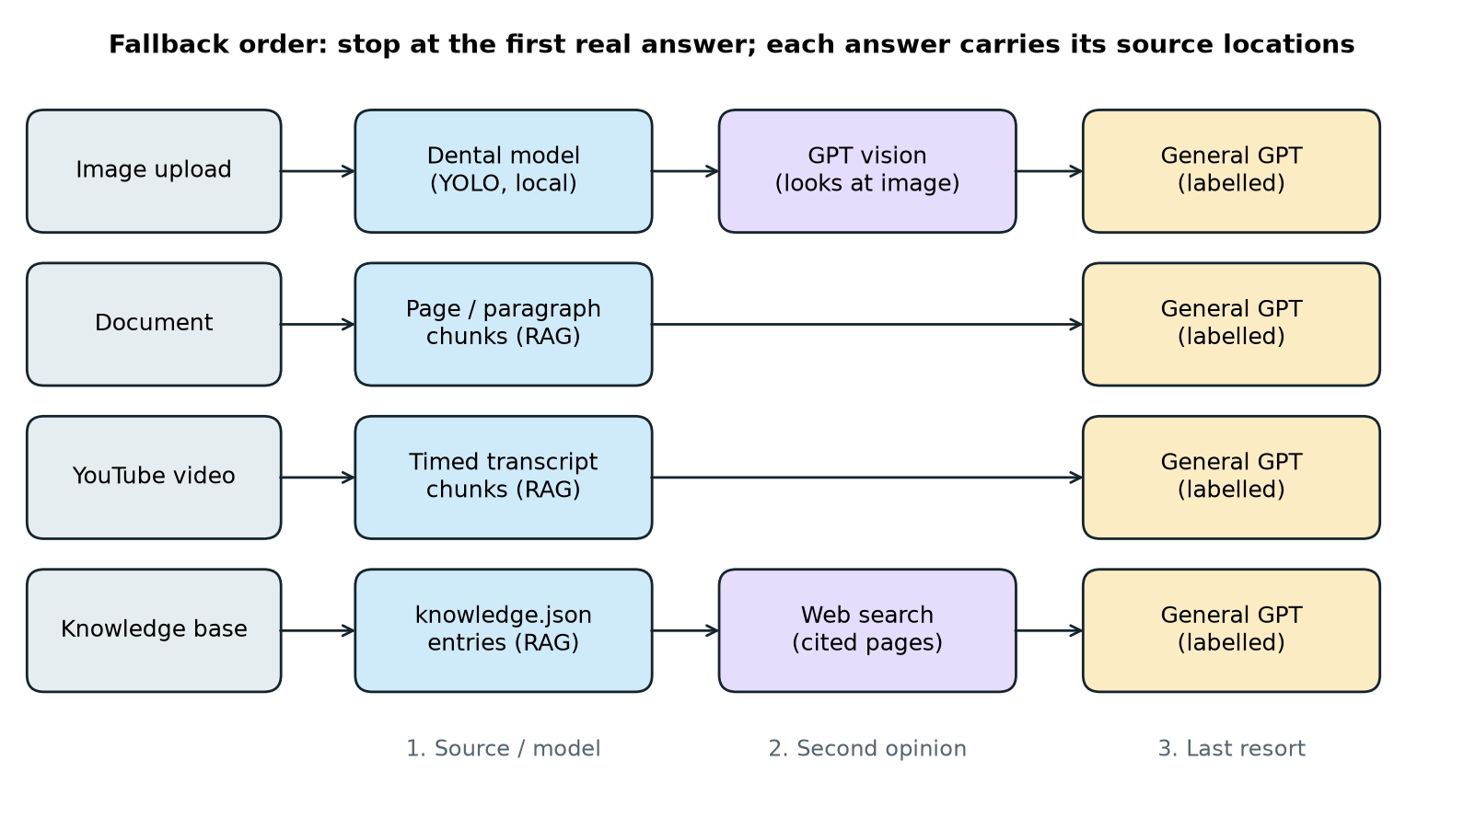
Figure 1. Fallback order for each tab. The chain stops at the first real answer, and each answer carries its source locations.

3.2 Data sources
The main dataset is the Kaggle Dental Radiography dataset (imtkaggleteam, n.d.), released under CC BY-SA 4.0. It contains 1,269 panoramic X-rays split into 1,075 training, 121 validation and 73 test images, with bounding-box annotations for four classes. Across all splits there are 6,097 filling boxes, 2,047 implant boxes, 641 cavity boxes and 498 impacted-tooth boxes, so the classes are strongly imbalanced. Because no training was done, the training split was not used. The 194 validation and test images served as the evaluation set for model selection, and all 1,269 images were used to measure colour saturation for the X-ray check described in Section 3.4.
Three sample radiographs are bundled with the application for demonstration: two images from Wikimedia Commons (one showing impacted third molars and one showing fillings with bone loss) and one image from the Kaggle set showing fillings, an implant and an impacted tooth. A sepia-tinted scan of historic implants from Wikimedia Commons and several ordinary photographs were used to test the X-ray check. The knowledge base is a JSON file with five entries of facts about Near East University; each entry can carry a source URL that is shown with the citation. Documents and videos are supplied by the user at run time, so they are not part of a fixed dataset.

3.3 Dental model selection
We did not train or fine-tune any model. Instead, eleven pretrained dental detection checkpoints were downloaded from Hugging Face. Each model's class list was mapped onto the four target classes; seven models detected at least one of them and were scored, and the other four (for example, models that only detect teeth) were excluded. Each model was run on the 194 evaluation images at a confidence threshold of 0.4 and an input size of 640 pixels.
The metric was image-level F1 per class. For each image and class, a prediction counts as positive if the model reports at least one box of that class, and the ground truth is positive if the annotation contains at least one box of that class. Precision, recall and F1 are then computed over images. We chose this metric over box-level mean average precision because the application's first question to the model is "is there a filling, cavity, implant or impacted tooth in this X-ray?", which is answered at the image level. To rank models, we averaged F1 over the four classes and gave a score of zero for any class a model cannot detect, so that partial models were not favoured. The winner was lukasiktar11/dental-radiography-yolo26 (lukasiktar11, n.d.), a YOLO checkpoint released under AGPL-3.0. Its results are reported in Section 4.1.

3.4 Image handling and the X-ray check
Every uploaded image is first passed to the dental model. During testing we found that the model alone also "finds" implants in colourful abstract pictures, so its output cannot be the only test of whether an image is an X-ray. We measured the mean HSV saturation of images: all 1,269 Kaggle X-rays have a mean saturation of 0, the sepia scan measured 28, and ordinary photos measured between 42 and 245. An image is therefore treated as an X-ray straight away only if the model detects something and the mean saturation is at most 35. Otherwise GPT vision describes the image and is asked to flag it if it is a dental radiograph. A flagged image, such as a phone photo of an X-ray on a screen, still goes back to the detector's findings, which are then reported even if they are "none found".
For X-rays, the findings are turned into a short text listing each of the four classes with its count, approximate position and confidence range. Position is derived from the box centre: the upper or lower half of the image gives the jaw, and the left, middle or right third gives the patient's right, front or left (the patient's right appears on the image's left). Other classes the model knows, such as crowns, root canal treatment and bone loss, are listed as "other" findings. The findings are drawn on the image in colour, with labels and confidence values, as in Figure 2.
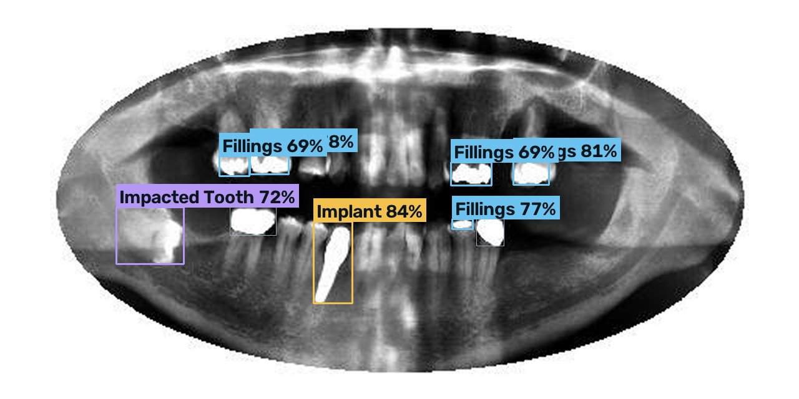
Figure 2. Detector output on a Kaggle test image: fillings, one implant and one impacted tooth, each with its confidence.

3.5 Location-tagged chunking and retrieval
Each source is converted to a list of chunks, and every chunk records where it came from. PDF text is extracted page by page with pypdfium2, DOCX files paragraph by paragraph with python-docx, and text files line by line. Small units are merged into chunks of about 1,500 characters, and units longer than that are split with a 200-character overlap. A chunk's label is the range it covers, for example "Page 4" or "Pages 4-5". For videos, the system tries YouTube's own transcript first, then downloadable subtitle files through yt-dlp, and finally downloads the audio and transcribes it with Whisper (Radford et al., 2023). Timed captions are packed into chunks of about 1,000 characters labelled with a time range and linked to that moment of the video. Videos longer than one hour are rejected. Knowledge base entries become one chunk each.
Chunks are embedded once at load time with OpenAI's text-embedding-3-small model. At question time the question is embedded and the four chunks with the highest cosine similarity are selected, in the manner of dense passage retrieval (Karpukhin et al., 2020). Sources with four or fewer chunks skip embedding altogether, since all of their chunks fit in the prompt.

3.6 Answer generation and the fallback chain
The selected chunks are numbered and sent to the chat model at temperature 0 with instructions to answer only from them and to end with a line of the form "SOURCES: 1, 3". If the excerpts do not contain the answer, the model must reply with the token NOT_FOUND. A parser removes the SOURCES line and maps the numbers back to chunk locations, which become the "From" line under the answer. For X-rays, the instructions add that the detector only reports a few classes, so the model should not infer a tooth count or general health from its counts.
In practice the model still sometimes replies with an evasion such as "the document doesn't mention that" instead of NOT_FOUND. A regular expression catches common hedges ("I can't tell", "it doesn't show", and similar forms), and another catches outright refusals. A hedged source answer is discarded and the next source is tried. For images, the next source is GPT vision, which sees the image and the detector's findings and is told to give its best direct answer with a stated level of confidence and to describe the visible signs for questions that need a dentist's judgement. Hedging about certainty is allowed at this step, but a flat refusal still falls through. For the knowledge tab, the next source is OpenAI's web search tool, given the two closest knowledge entries as context so that a vague question such as "who is the current rector?" is read as being about the right university; the pages it cites are shown as links. The final step is the general model, whose answer is always labelled "General knowledge from GPT, not from your [source]". Figure 3 shows the workspace with answers from two different steps.
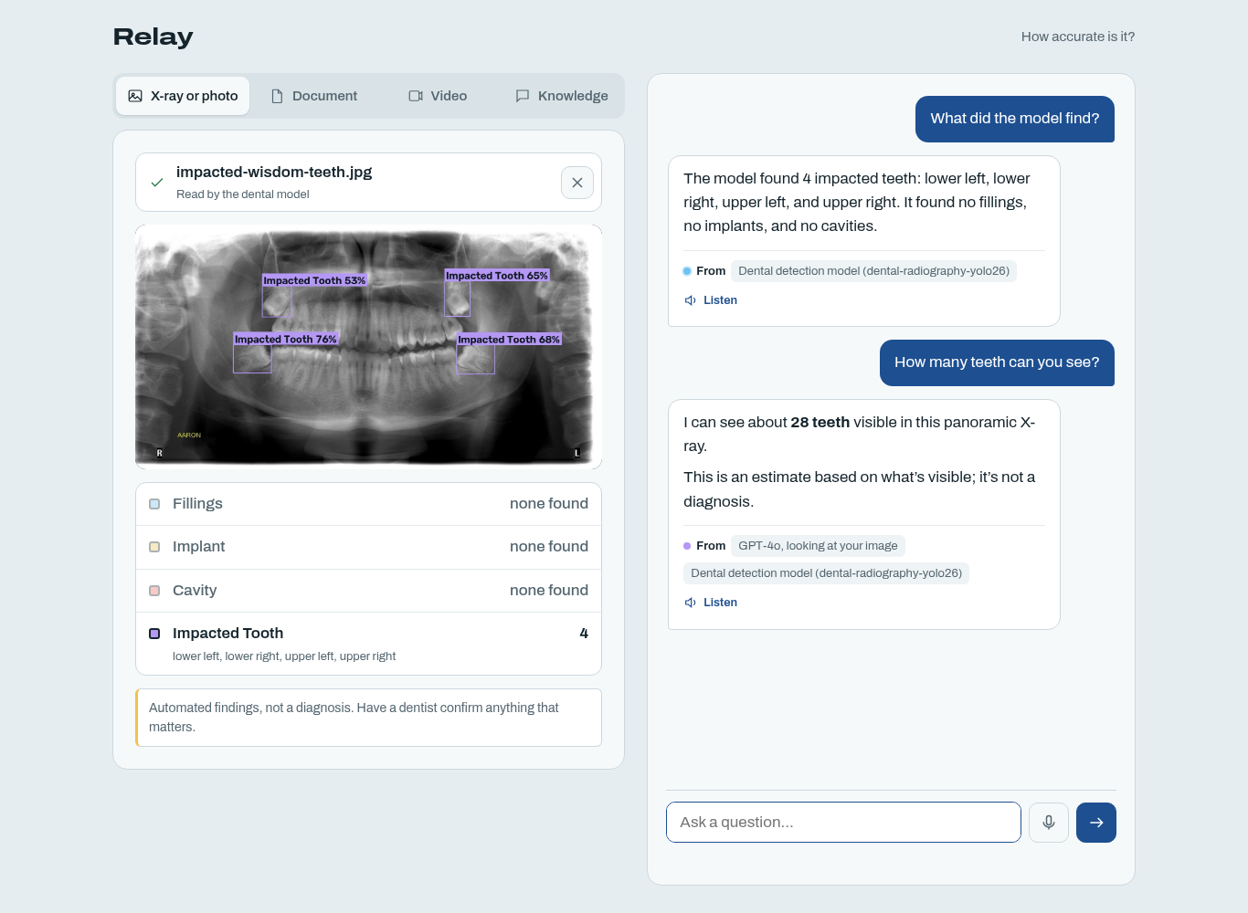
Figure 3. The Relay workspace. The first answer comes from the detector; the second, a tooth count the detector cannot give, comes from GPT vision.

3.7 Experimental design and testing
The evaluation had two parts. The first was the quantitative model selection experiment described in Section 3.3. The second was functional testing of the application. A test script drives the Flask app end to end with the OpenAI calls replaced by stubs, so it costs nothing to run; it checks routing between tabs, the citation format, the hedge filter and every step of the fallback chain, and it can also run the real detector on a sample X-ray. Both main.py and dental.py also carry self-checks for chunk labels, citation parsing, the hedge patterns, the findings text and position labels. Manual tests were run with the three bundled samples, the sepia scan, ordinary photos, PDFs, Word files and YouTube videos with and without captions. We did not run a formal user study or a scored evaluation of answer quality; Section 5 returns to this.

4. Comparative Analysis of Previous Related Work

4.1 Comparison of pretrained dental detectors
Figure 4 compares the mean image-level F1 of the leading candidates. The selected YOLO model scored 0.60 and an RT-DETR model from the same family of releases scored 0.59, so the two architectures performed almost identically here, consistent with the claim that RT-DETR is competitive with YOLO at similar speed (Zhao et al., 2024). The YOLO model was chosen because it scored marginally higher. A third general-purpose dental YOLO model scored 0.45. The remaining models could detect only two or three of the four classes, and because a missing class counts as zero, their averages fell to between 0.21 and 0.26. One of these, a YOLO11x model whose name points to the DENTEX labels, illustrates a general problem: dental datasets use different class definitions, so a model can be strong on its own benchmark and still not cover the questions a particular application needs answered.
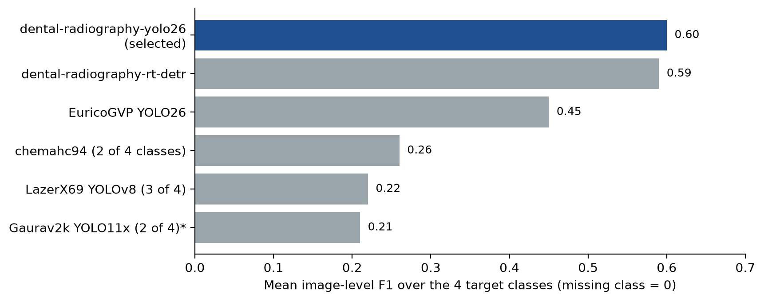
Figure 4. Mean image-level F1 over the four target classes on 194 held-out panoramic X-rays (a missing class counts as 0).
Figure 5 shows the per-class F1 of the selected model. Fillings, which are bright, high-contrast and by far the most common class in the data, reached 0.93. Cavities (0.56), impacted teeth (0.50) and implants (0.39) were much weaker. The low implant score is surprising, since implants are also very bright on X-rays, and we did not investigate its cause in this phase. Based on these results, the application describes fillings as dependable and the other three classes as "a second look, not a verdict".
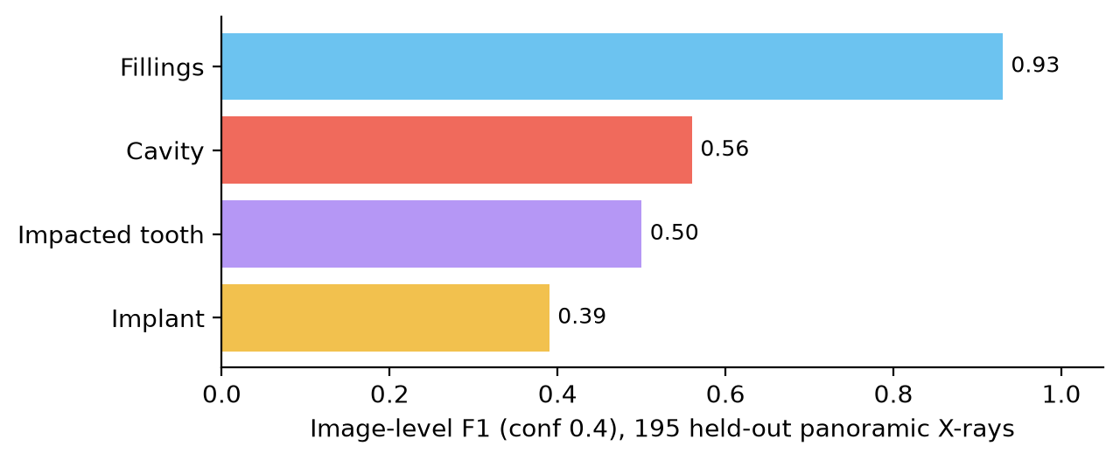
Figure 5. Per-class image-level F1 of the selected model at confidence 0.4.

4.2 Comparison with published dental AI studies
Table 1 places the detector next to frequently cited dental studies. The numbers are not directly comparable: the studies use different image types, tasks, metrics and test sets, and most report results on a test split from the same source as their training data. What the comparison does show is the gap between what a purpose-built, carefully trained model can achieve on one task and what a publicly shared model achieves when evaluated by a third party. Lee et al. (2018) and Krois et al. (2019) each focused on a single finding and reached accuracy around 0.8 to 0.9, and Tuzoff et al. (2019) reached near-expert accuracy on tooth detection, a task with clear visual boundaries. Relay's detector matches that level only for fillings. For caries, its image-level F1 of 0.56 is well below most results summarised by Mohammad-Rahimi et al. (2022), which is expected for a model that was neither designed nor tuned for this test set.
Table 1. Relay's detector compared with published dental radiograph studies.
Study | Image type | Task | Model | Reported result
Lee et al. (2018) | Periapical | Caries detection | CNN (GoogLeNet Inception v3) | Accuracy 82-89%
Tuzoff et al. (2019) | Panoramic | Tooth detection and numbering | Faster R-CNN based | Detection sensitivity 0.994, precision 0.995
Krois et al. (2019) | Panoramic | Periodontal bone loss | CNN | Accuracy 0.81, similar to dentists
Hamamci et al. (2023) | Panoramic | Abnormal tooth detection (DENTEX) | Benchmark of several detectors | Shared benchmark, hierarchical labels
Relay (this work) | Panoramic | Fillings, cavity, implant, impacted tooth | Pretrained YOLO, no training | Image-level F1 0.39-0.93 on 194 held-out images

Relay differs from these studies in purpose. They aim to show that a model can reach clinical-level accuracy; Relay takes an existing model, measures it honestly and builds a system around its known strengths and weaknesses. This is closer to the deployment concerns raised by Schwendicke et al. (2020), who argued that dental AI needs external validation and transparent reporting before it is used in practice.

4.3 Comparison with question-answering and RAG systems
Table 2 compares Relay with representative grounded question-answering approaches. Classic RAG (Lewis et al., 2020) retrieves passages for text questions but does not, by itself, show the user which passages were used. WebGPT (Nakano et al., 2021) and systems evaluated on ALCE (Gao, Yen, et al., 2023) add citations, but work on web pages or text corpora only. General chat assistants based on GPT-4 (OpenAI, 2023) and GPT-4V (Wu et al., 2023) accept images and documents, yet give answers without page-level locations and, for medical images, without a specialised model behind them.
Table 2. Features of Relay compared with related question-answering approaches.
Approach | Inputs | Shows source location | Specialist model first | Handles evasive answers
RAG (Lewis et al., 2020) | Text corpus | No (retrieved passages internal) | No | No
WebGPT (Nakano et al., 2021) | Web pages | Yes, references | No | No
ALCE-style citation (Gao, Yen, et al., 2023) | Text corpus | Yes, passage citations | No | No
GPT-4V chat (Wu et al., 2023) | Images, text | No | No | No
Relay (this work) | X-rays, photos, PDF/DOCX/TXT, YouTube, knowledge base | Yes: page, paragraph, timestamp, entry, model findings | Yes, local dental detector | Yes, hedge filter and fallback chain

Relay's contribution is in combining these elements, not in improving any single one. Its retriever is a standard embedding search, and its citation method is a simple numbered-excerpt prompt, far less sophisticated than trained citation models. What it adds is a uniform location format across very different source types, a rule that a domain model answers before a general one, and an explicit treatment of evasive answers. Selective question answering (Kamath et al., 2020) stops when confidence is low; Relay continues to the next source and tells the user which one answered. The cost of that choice is that a weaker source can end up answering, which is why the general-knowledge step is always labelled.

4.4 Summary of the comparison
Compared with published dental studies, Relay's detector is weaker on every class except fillings, but its scores come from an independent held-out evaluation rather than from the authors of the model. Compared with RAG and citation research, Relay is simpler technically but covers more input types and makes every answer's origin visible. The two comparisons point to the same design principle: use the most specific source available, measure it, and tell the user both what it found and how far to trust it.

5. Discussion and Limitations

5.1 Strengths
The main strength of Relay is traceability. Every answer names the page, paragraph, timestamp, knowledge entry, web page or model output it came from, and answers from outside the user's material are marked as general knowledge. A user can check a claim in seconds instead of reading the whole source.
The second strength is that model accuracy is measured and reported, not assumed. Selecting the detector from eleven candidates on 194 images it had not seen gives a defensible basis for the claim that it is reliable for fillings, and the per-class scores directly shaped how the findings are worded. Using pretrained weights also kept the project cheap: no GPU was needed, and the detector runs on a CPU inside the web server, so radiographs are processed locally before anything is sent to an external API.
Third, the fallback chain reduced the number of evasive answers that reached the user. Questions the detector cannot answer, such as how many teeth are visible, are answered by the vision model with a stated estimate, and questions about recent facts not in the knowledge base are answered from cited web pages. The saturation check also prevented the detector's false "implants" on colourful images from being shown as dental findings. Finally, the code base is small (about 1,300 lines of Python and JavaScript), has self-checks and an end-to-end test that runs without API costs, and uses configuration instead of hard-coded thresholds.

5.2 Weaknesses and limitations
Diagnostic accuracy is the largest limitation. Only fillings reach a level that could be called dependable. Cavities, impacted teeth and implants are detected with F1 between 0.39 and 0.56, so roughly half of the positive or negative calls for these classes may be wrong. Relay is therefore a tool for discussion and learning, not for diagnosis, and the interface says so. The vision model is no substitute: in our tests it missed an abscess on a radiograph labelled as showing one, in line with earlier reports on GPT-4V (Wu et al., 2023). Position estimates are coarse (upper or lower jaw and left, front or right third) and do not use tooth numbering.
The evaluation itself has limits. The 194 images come from a single public dataset whose annotation quality and acquisition conditions are not fully documented, and image-level F1 ignores whether the boxes are in the right place. Several candidate models may have been trained on parts of this same dataset, which would favour them; we could not verify the training data of every checkpoint. The answer quality of the chat pipeline was not measured with a scored benchmark or with users, so claims about fewer evasive answers rest on functional tests and manual checks. A faithfulness metric such as those in RAGAS (Es et al., 2024) or a citation-support score as in ALCE (Gao, Yen, et al., 2023) would be needed to make that claim quantitative.
The hedge filter is a regular expression. It catches common English phrasings but will miss unusual wording and other languages, and it may occasionally discard a correct answer that happens to contain a phrase like "doesn't mention". Retrieval uses only the top four chunks, which can miss answers spread over many pages. Scanned PDFs contain no text and cannot be read, and videos must be public and shorter than an hour.
There are also practical limits. Uploaded documents, images and questions are sent to OpenAI for embedding and answering; only the dental detector runs locally. This raises privacy concerns for real patient data, which would need consent and an appropriate data-processing agreement. Sources are kept in the memory of a single process, so they are lost on restart and the application cannot run several workers without a shared store. There are no user accounts. The detector is licensed under AGPL-3.0, which may require publishing the application's source if it is offered as a public service.

5.3 Insights
Three lessons stand out. First, publicly available pretrained models vary a great deal, and their model cards are not a reliable guide; a small independent benchmark on held-out data was the only reliable way to rank them and to see which classes to trust. Second, a detector's raw output is not enough to decide what an image is. A simple, measurable rule (grayscale or not) fixed a failure that the model could not fix on its own, and was easier to justify than a learned classifier. Third, the most common failure from the user's point of view was not a wrong answer but an evasive one. Treating "I can't tell" as a signal to try the next source, while labelling that source, made the system more useful without hiding where answers came from. This suggests that grounded assistants should be judged by how often they give a correct, cited answer, not only by how rarely they give an incorrect one.

6. Conclusion and Future Work

6.1 Conclusion
This project built Relay, a web application that lets users ask questions about dental X-rays, documents, YouTube videos and a knowledge base, and that attaches a checkable source location to every answer. For radiographs, a pretrained YOLO detector selected from eleven public candidates runs locally before any language model is consulted. On 194 held-out panoramic X-rays, it reached an image-level F1 of 0.93 for fillings, 0.56 for cavities, 0.50 for impacted teeth and 0.39 for implants, and the application presents its findings with that difference in reliability made clear. A fixed chain of sources, combined with a filter for evasive answers, reduced unhelpful "I don't know" replies while keeping each answer's origin visible.
The work shows that a useful, grounded assistant can be built without training any model, provided that the pretrained components are measured independently and their limits are passed on to the user. It also shows the limits of that approach: the quality of the dental findings is set by the best available public model, and for three of the four classes that quality is not yet good enough for clinical use.

6.2 Future work
The most direct improvement would be a better detector for cavities, implants and impacted teeth. Within the constraint of using pretrained models, this means repeating the benchmark as new checkpoints are released and testing ensembles of the two strongest candidates. If training becomes possible later, fine-tuning on the DENTEX data (Hamamci et al., 2023) and on locally collected, consented radiographs would be the natural next step, followed by evaluation on images from a different clinic. Tooth numbering, as in Tuzoff et al. (2019), would replace the coarse position labels with standard dental notation.
The question-answering side needs a formal evaluation. A test set of questions with reference answers for each source type would allow citation precision, faithfulness and the rate of evasive answers to be measured before and after changes, using metrics from ALCE and RAGAS. A small user study with dental students and patients would show whether the citations and accuracy labels are understood. The hedge filter could be replaced by a lightweight classifier and extended to other languages, starting with Turkish for the university's users.
On the engineering side, sources and rate limits should move to a shared store such as Redis so that the application can run several workers and survive restarts. A local or self-hosted language model would remove the need to send patient images and documents to an external service. Optical character recognition would allow scanned PDFs to be read, and the knowledge base could be extended from five entries to the university's full set of regulations and course information, each linked to its official source.

References
Carion, N., Massa, F., Synnaeve, G., Usunier, N., Kirillov, A., & Zagoruyko, S. (2020). End-to-end object detection with transformers. In European Conference on Computer Vision (ECCV) (pp. 213-229). Springer.
Es, S., James, J., Espinosa-Anke, L., & Schockaert, S. (2024). RAGAS: Automated evaluation of retrieval augmented generation. In Proceedings of the 18th Conference of the European Chapter of the Association for Computational Linguistics: System Demonstrations (pp. 150-158).
Gao, T., Yen, H., Yu, J., & Chen, D. (2023). Enabling large language models to generate text with citations. In Proceedings of the 2023 Conference on Empirical Methods in Natural Language Processing (pp. 6465-6488).
Gao, Y., Xiong, Y., Gao, X., Jia, K., Pan, J., Bi, Y., Dai, Y., Sun, J., Wang, M., & Wang, H. (2023). Retrieval-augmented generation for large language models: A survey. arXiv preprint arXiv:2312.10997.
Hamamci, I. E., Er, S., Simsar, E., Yuksel, A. E., Gultekin, S., Ozdemir, S. D., Yang, K., Li, H. B., Pati, S., Stadlinger, B., Mehl, A., Gundogar, M., & Menze, B. (2023). DENTEX: An abnormal tooth detection with dental enumeration and diagnosis benchmark for panoramic X-rays. arXiv preprint arXiv:2305.19112.
Hwang, J.-J., Jung, Y.-H., Cho, B.-H., & Heo, M.-S. (2019). An overview of deep learning in the field of dentistry. Imaging Science in Dentistry, 49(1), 1-7.
imtkaggleteam. (n.d.). Dental radiography [Data set]. Kaggle. https://www.kaggle.com/datasets/imtkaggleteam/dental-radiography
Ji, Z., Lee, N., Frieske, R., Yu, T., Su, D., Xu, Y., Ishii, E., Bang, Y. J., Madotto, A., & Fung, P. (2023). Survey of hallucination in natural language generation. ACM Computing Surveys, 55(12), 1-38.
Jocher, G., Qiu, J., & Chaurasia, A. (2023). Ultralytics YOLO [Computer software]. https://github.com/ultralytics/ultralytics
Kamath, A., Jia, R., & Liang, P. (2020). Selective question answering under domain shift. In Proceedings of the 58th Annual Meeting of the Association for Computational Linguistics (pp. 5684-5696).
Karpukhin, V., Oguz, B., Min, S., Lewis, P., Wu, L., Edunov, S., Chen, D., & Yih, W. (2020). Dense passage retrieval for open-domain question answering. In Proceedings of the 2020 Conference on Empirical Methods in Natural Language Processing (pp. 6769-6781).
Khanagar, S. B., Al-Ehaideb, A., Maganur, P. C., Vishwanathaiah, S., Patil, S., Baeshen, H. A., Sarode, S. C., & Bhandi, S. (2021). Developments, application, and performance of artificial intelligence in dentistry: A systematic review. Journal of Dental Sciences, 16(1), 508-522.
Krois, J., Ekert, T., Meinhold, L., Golla, T., Kharbot, B., Wittemeier, A., Dörfer, C., & Schwendicke, F. (2019). Deep learning for the radiographic detection of periodontal bone loss. Scientific Reports, 9, 8495.
Lee, J.-H., Kim, D.-H., Jeong, S.-N., & Choi, S.-H. (2018). Detection and diagnosis of dental caries using a deep learning-based convolutional neural network algorithm. Journal of Dentistry, 77, 106-111.
Lewis, P., Perez, E., Piktus, A., Petroni, F., Karpukhin, V., Goyal, N., Küttler, H., Lewis, M., Yih, W., Rocktäschel, T., Riedel, S., & Kiela, D. (2020). Retrieval-augmented generation for knowledge-intensive NLP tasks. Advances in Neural Information Processing Systems, 33, 9459-9474.
Lin, T.-Y., Maire, M., Belongie, S., Hays, J., Perona, P., Ramanan, D., Dollár, P., & Zitnick, C. L. (2014). Microsoft COCO: Common objects in context. In European Conference on Computer Vision (ECCV) (pp. 740-755). Springer.
Liu, H., Li, C., Wu, Q., & Lee, Y. J. (2023). Visual instruction tuning. Advances in Neural Information Processing Systems, 36.
Liu, N. F., Lin, K., Hewitt, J., Paranjape, A., Bevilacqua, M., Petroni, F., & Liang, P. (2024). Lost in the middle: How language models use long contexts. Transactions of the Association for Computational Linguistics, 12, 157-173.
lukasiktar11. (n.d.). dental-radiography-yolo26 [Pretrained model]. Hugging Face. https://huggingface.co/lukasiktar11/dental-radiography-yolo26
Mohammad-Rahimi, H., Motamedian, S. R., Rohban, M. H., Krois, J., Uribe, S. E., Mahmoudinia, E., Rokhshad, R., Nadimi, M., & Schwendicke, F. (2022). Deep learning for caries detection: A systematic review. Journal of Dentistry, 122, 104115.
Moor, M., Banerjee, O., Abad, Z. S. H., Krumholz, H. M., Leskovec, J., Topol, E. J., & Rajpurkar, P. (2023). Foundation models for generalist medical artificial intelligence. Nature, 616, 259-265.
Nakano, R., Hilton, J., Balaji, S., Wu, J., Ouyang, L., Kim, C., Hesse, C., Jain, S., Kosaraju, V., Saunders, W., Jiang, X., Cobbe, K., Eloundou, T., Krueger, G., Button, K., Knight, M., Chess, B., & Schulman, J. (2021). WebGPT: Browser-assisted question-answering with human feedback. arXiv preprint arXiv:2112.09332.
OpenAI. (2023). GPT-4 technical report. arXiv preprint arXiv:2303.08774.
Radford, A., Kim, J. W., Xu, T., Brockman, G., McLeavey, C., & Sutskever, I. (2023). Robust speech recognition via large-scale weak supervision. In Proceedings of the 40th International Conference on Machine Learning (pp. 28492-28518). PMLR.
Redmon, J., Divvala, S., Girshick, R., & Farhadi, A. (2016). You only look once: Unified, real-time object detection. In Proceedings of the IEEE Conference on Computer Vision and Pattern Recognition (pp. 779-788).
Schwendicke, F., Golla, T., Dreher, M., & Krois, J. (2019). Convolutional neural networks for dental image diagnostics: A scoping review. Journal of Dentistry, 91, 103226.
Schwendicke, F., Samek, W., & Krois, J. (2020). Artificial intelligence in dentistry: Chances and challenges. Journal of Dental Research, 99(7), 769-774.
Shuster, K., Poff, S., Chen, M., Kiela, D., & Weston, J. (2021). Retrieval augmentation reduces hallucination in conversation. In Findings of the Association for Computational Linguistics: EMNLP 2021 (pp. 3784-3803).
Singhal, K., Azizi, S., Tu, T., Mahdavi, S. S., Wei, J., Chung, H. W., et al. (2023). Large language models encode clinical knowledge. Nature, 620, 172-180.
Topol, E. J. (2019). High-performance medicine: The convergence of human and artificial intelligence. Nature Medicine, 25(1), 44-56.
Tuzoff, D. V., Tuzova, L. N., Bornstein, M. M., Krasnov, A. S., Kharchenko, M. A., Nikolenko, S. I., Sveshnikov, M. M., & Bednenko, G. B. (2019). Tooth detection and numbering in panoramic radiographs using convolutional neural networks. Dentomaxillofacial Radiology, 48(4), 20180051.
Wang, C.-W., Huang, C.-T., Lee, J.-H., Li, C.-H., Chang, S.-W., Siao, M.-J., et al. (2016). A benchmark for comparison of dental radiography analysis algorithms. Medical Image Analysis, 31, 63-76.
Wu, C., Lei, J., Zheng, Q., Zhao, W., Lin, W., Zhang, X., Zhou, X., Zhao, Z., Zhang, Y., Wang, Y., & Xie, W. (2023). Can GPT-4V(ision) serve medical applications? Case studies on GPT-4V for multimodal medical diagnosis. arXiv preprint arXiv:2310.09909.
Zhao, Y., Lv, W., Xu, S., Wei, J., Wang, G., Dang, Q., Liu, Y., & Chen, J. (2024). DETRs beat YOLOs on real-time object detection. In Proceedings of the IEEE/CVF Conference on Computer Vision and Pattern Recognition (pp. 16965-16974).

