TÜBİTAK Progress Report
  - English version

ABSTRACT
Geochemical simulators such as PHREEQC describe how water, gas, rock minerals and microorganisms react over time, but each simulation is slow when many thousands are needed. This project develops a neural network “surrogate”: a fast model that learns to reproduce PHREEQC results from examples. This report covers the work from November 2025 to September 2026 in four stages. In stage 1, a recurrent neural network (LSTM) was trained on solutions of a reaction model based on ordinary differential equations and showed that using a window of past values reduced the error of step by step prediction in these experiments. In stage 2, the same approach was applied to 1,000 PHREEQC runs; the error of a single step was small, but errors grew when the model fed its own predictions back. In stage 3, the model was redesigned to take the experimental conditions as input and produce the whole trajectory of 301 time steps at once; on four rock types the typical normalised error per test run was about 0.02 standard deviations. In stage 4, the dataset was extended to eight rock types (55,122 runs) and the model was tested on rocks it had never seen, using leave one rock out validation. Without regularisation, the error on an unseen rock was 6 to 63 times larger than on a seen rock. A mild L2 penalty (λ = 1e-4) reduced the median error on unseen rocks from 1.21 to 0.30 and improved all eight rocks, at a small cost on seen rocks. In the remaining period, the focus will shift from improving generalisation to using the trained surrogate to search for initial conditions that give desired outputs (input condition optimisation). The model weights will be kept fixed, the inputs will be changed with a gradient method, and the conditions found will be checked with PHREEQC.

1. INTRODUCTION
Water–rock–gas systems in the subsurface change over months to years: minerals dissolve and precipitate, gases such as H₂, CO₂ and CH₄ exchange between phases, and microorganisms consume and produce chemical species. Geochemical codes such as PHREEQC (Parkhurst and Appelo, 2013) compute these changes from thermodynamic and kinetic rules. They are reliable but slow when thousands of scenarios must be explored, for example for uncertainty studies or inside larger transport models.
A surrogate model is an approximation trained on examples produced by a simulator, with the aim of reducing prediction time. A fair speed comparison with PHREEQC remains to be carried out in this project. Neural networks are a common choice for such surrogates because they can learn nonlinear relations from large example sets (Karniadakis et al., 2021; Brunton and Kutz, 2024).
The aim of this project is to build a neural network surrogate that, given the conditions of a PHREEQC batch experiment (temperature, gas pressures, dissolved ions and minerals), predicts the time evolution of 26 chemical and physical outputs over 180 days. A second aim is to find out how well such a model works for a rock type that was not in its training data. In the remaining period, the trained model will be used to search for input conditions that give desired outputs. Section 2 summarises the neural network literature, Section 3 describes the data and method, Section 4 presents the results of the four stages, Section 5 discusses limitations and Section 6 gives the conclusions and the plan for the remaining period.

2. LITERATURE SUMMARY
Recurrent networks for time series. A recurrent neural network reads a sequence one step at a time and keeps an internal memory. The Long Short-Term Memory (LSTM) network adds “gates” that decide what to keep and what to forget, which makes long sequences learnable (Hochreiter and Schmidhuber, 1997; Gers et al., 2000). The gated recurrent unit is a simpler variant (Cho et al., 2014). A large comparison of LSTM variants found that the learning rate and the network size are the most important settings (Greff et al., 2017), which motivated our learning rate sweeps. Training of recurrent networks can be unstable when gradients become very large; limiting their size (“gradient clipping”) is a standard remedy (Pascanu et al., 2013).
Neural surrogates for simulators. Physics-informed neural networks (Raissi et al., 2019; Karniadakis et al., 2021) and neural operators (Li et al., 2021; Lu et al., 2021; Azizzadenesheli et al., 2024) are the main recent families of simulation surrogates. Reported gains are often overstated because the comparison baselines are weak (McGreivy and Hakim, 2024), so a surrogate must be compared fairly with its parent simulator.
Error accumulation in long predictions. When a model predicts step by step and feeds its own outputs back, small errors add up. This mismatch between training (true history) and use (predicted history) is known as exposure bias (Bengio et al., 2015), and recent work on neural PDE solvers targets the resulting error growth (Brandstetter et al., 2022; Lippe et al., 2023).
Honest testing of generalisation. Random train/test splits overestimate performance when data come in groups (Roberts et al., 2017), and information leakage between training and test data is a common cause of overly optimistic results (Kapoor and Narayanan, 2023). Models also lose accuracy when the test data come from a different distribution (Koh et al., 2021). For this reason we hold out entire rock types for testing.

3. MATERIALS AND METHODS

3.1 Workflow
Figure 3.1 shows the workflow used in stage 4 step by step. (1) The PHREEQC simulations produced by the chemistry team are collected. (2) Every simulation is brought into the same format: units are converted to mol/kgw, and each simulation is stored as 57 initial conditions (inputs) and 26 outputs at 301 time points. The rock name is not given to the model as an input. (3) A logarithm is applied to 19 of the outputs, and all values are scaled to a mean of 0 and a standard deviation of 1. This scaling is computed from the training data only. (4) The simulations are split into training, validation and test sets. All time points of a simulation stay in the same set, so the model never sees any part of a test simulation during training. (5) The network is trained on Google Colab. (6) For new conditions, the trained network predicts the whole time series of 301 steps. (7) The error is measured separately for each output and each rock. (8) The settings and results of every experiment are saved in a database. All settings (model size, learning rate, regularisation, batch size, number of epochs, random seed and data paths) are read from configuration files. In this way, an experiment can be repeated with the same settings without changing code.
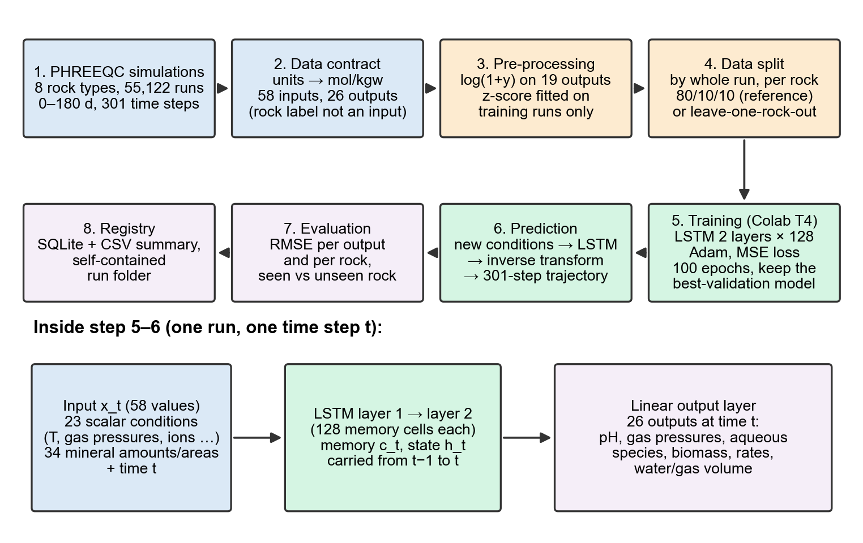
Figure 3.1. Workflow of the surrogate pipeline (stage 4). The lower row shows what happens inside the network at one time step.

3.2 Training data
The training data are PHREEQC batch simulations prepared by the project’s chemistry team. In each run, initial conditions such as temperature, porosity, water and gas volume, gas partial pressures (CO₂, H₂S, N₂, CH₄), alkalinity and dissolved ions are drawn at random within ranges set by the chemistry team, and PHREEQC computes the reaction path over 180 days in 300 steps of 0.6 days, giving 301 time points per run. The database is the standard phreeqc.dat, extended with acetate and formate species and with rate laws for sulphate reducing and iron reducing bacteria. About 10,000 runs were attempted per rock; runs that PHREEQC could not complete were excluded (Table 3.1).
Table 3.1. PHREEQC datasets used in stage 4. All runs cover 0–180 days with 301 time points.
Rock type | Successful runs | Input units in the files
Calcite | 9,875 | mol/kgw
Dolomite | 9,882 | mol/kgw
Halite | 9,425 | mol/kgw
Trona | 9,899 | mol/kgw
Sandstone | 3,677 | mol/kgw
Quartzite schist | 8,069 | mg/L
Mica schist | 1,346 | mg/L
Mica carbonate schist | 2,949 | mg/L
Total | 55,122
Why these data. Eight rock types with different mineral assemblages make it possible to ask whether a single model can cover many rocks and, more importantly, whether it can predict a rock it has not seen. For the three schists the ion concentrations were given in mg/L; they were converted to mol/kgw by dividing by 1000 and by the gram formula weight of each species in phreeqc.dat (for silicon, SiO₂ = 60.08 g/mol, as confirmed by the chemistry team).
Inputs and outputs. Each run is described by 57 fixed conditions: 23 scalar values (temperature, porosity, volumes, gas pressures, ions) and 34 mineral values (amount and surface area for a vocabulary of 17 minerals; a mineral absent from a rock is set to zero). These 57 values plus the time give 58 inputs per time step. The model predicts 26 outputs per time step: pH, total and partial gas pressures, gas amounts, dissolved species (SO₄, formate, acetate, Ca, Fe, HS⁻), bacterial biomass, Fe(OH)₃, six microbial reaction rates, and water and gas volume. The rock name is never given to the model; it is used only to split the data and to report results per rock.

3.3 How the neural network works
An LSTM reads the input of one time step, combines it with a memory carried over from the previous step, and updates that memory. Three gates (numbers between 0 and 1) control how much new information enters the memory ($i_{t}$), how much old memory is kept ($f_{t}$) and how much is passed on as output ($o_{t}$). For layer input $x_{t}$ and previous state $h_{t-1}$ (PyTorch formulation):
$$i_{t}=σ(W_{ii}x_{t}+b_{ii}+W_{hi}h_{t-1}+b_{hi}) (3.1)$$
$$f_{t}=σ(W_{if}x_{t}+b_{if}+W_{hf}h_{t-1}+b_{hf}) (3.2)$$
$$g_{t}=tanh(W_{ig}x_{t}+b_{ig}+W_{hg}h_{t-1}+b_{hg}) (3.3)$$
$$o_{t}=σ(W_{io}x_{t}+b_{io}+W_{ho}h_{t-1}+b_{ho}) (3.4)$$
$$c_{t}=f_{t}⊙c_{t-1}+i_{t}⊙g_{t}, h_{t}=o_{t}⊙tanh(c_{t}) (3.5)$$
Here $σ$ is the logistic function, $⊙$ is element wise multiplication, the $W$ and $b$ are learned weights, and $h_{0}=c_{0}=0$. Two LSTM layers of 128 memory cells are stacked; the second layer reads the $h_{t}$ of the first. A linear output layer converts the final state into the 26 predictions at every time step:
$${\hat{z}}_{t}=W_{out} h_{t}^{(2)}+b_{out}, W_{out}∈R^{26×128} (3.6)$$
The model has 231,706 trainable parameters. Because the conditions are repeated at every time step and the model never receives its own earlier predictions as input, the whole trajectory of 301 time steps is produced in one pass.

3.4 Data preparation and prediction equations
Many outputs (gas amounts, organic acids, biomass, rates) span several orders of magnitude, so 19 of the 26 outputs are first transformed with a logarithm. All outputs are then standardised, using a mean $μ$ and standard deviation $σ$ computed on the training runs only, so that no information from the test runs leaks into training:
$$y^{'}=log\left(1+max(y,0)\right) \text{(19 outputs with logarithm only)} (3.7)$$
$$z=\frac{y^{'}-μ_{train}}{σ_{train}} (3.8)$$
The 57 conditions are standardised in the same way (without the logarithm), and time is scaled as $\tilde{t}=(t-90)/52.134$ (days). A prediction in physical units is obtained by reversing these steps:
$$\hat{y}=exp\left(σ_{train} \hat{z}+μ_{train}\right)-1 \text{(outputs with logarithm)},$$
$$\hat{y}=σ_{train} \hat{z}+μ_{train} \text{(others)} (3.9)$$

3.5 Training
Training means adjusting the weights so that the predictions approach the PHREEQC values. The error measure (“loss”) is the mean squared error (MSE) over a batch of $B$ runs, $T=301$ time steps and $F=26$ outputs, in standardised units:
L=1B T Fb,t,f​zbtf-zbtf2 (3.10)
The model is trained with Adam (Kingma and Ba, 2015), a constant learning rate η = 0.001, batches of 64 runs and 100 epochs. For each batch, the MSE gradient is computed and its total norm is limited to 1.0 by gradient clipping. In stage 4, Adam then adds the L2 contribution to this gradient before calculating the weight update. This is controlled by the weight_decay setting and discourages large parameter values. The update is:
$$g_{k}={clip}_{1}\left(∇_{θ}L\right)+λ θ_{k-1}, θ_{k}=θ_{k-1}-η \frac{{\hat{m}}_{k}}{\sqrt{{\hat{v}}_{k}}+ϵ} (3.11)$$
where ${\hat{m}}_{k}$ and ${\hat{v}}_{k}$ are the bias corrected exponential moving averages that Adam keeps for $g_{k}$ and $g_{k}^{2}$ (running averages of the gradient and of its square). The penalty values tested were $λ∈\{0,{10}^{-4},{10}^{-3}\}$. The operator clip₁ limits the total size (norm) of the MSE gradient to 1.0. The term λθ is the contribution of the L2 penalty to the gradient; Adam processes it together with the MSE gradient. The recorded training and validation losses contain only MSE; the penalty is not added to the loss and is applied only when the weights are updated. Dropout (randomly switching off neurons during training) was not used in stage 4, and the learning rate was kept constant. After each epoch, the validation MSE is measured without updating the weights, and the model with the lowest validation MSE is kept for evaluation. The random seed is fixed at 42.

3.6 Evaluation
Error measure. The main measure is the root mean square error (RMSE) in standardised units. For output $f$ over $N$ test runs:
RMSEf=1N Tn,t​zntf-zntf2, RMSE=1Ff​RMSEf (3.12)
A value of 1.0 corresponds to an error of one training standard deviation in the transformed space. Standardisation puts outputs with different units (pH, atm, mol, L) on a common scale. The error is summarised in two ways in this report. The aggregate score in Equation (3.12) uses all test runs together: for each output, one RMSE is calculated over all runs and time steps, and these values are then averaged. The result is a single number for the whole model. Box plots instead treat each run separately: for every run, one RMSE is calculated by pooling all of its time steps and outputs, RMSEn=1TFt,f​(zntf-zntf)2. Each run thus appears as one point in the box plot. Because the two scores summarise different things, their values can differ: the aggregate score is affected by a few runs with large errors, while the median in the box plot shows the error of a typical run.
Data splits. Whole runs are assigned to one set, so time steps of the same run never appear in both training and test data. In the reference model, the runs of each rock are split 80/10/10 into training, validation and test (44,096 / 5,513 / 5,513 runs). In leave one rock out (LORO) validation, eight models are trained; each time, one rock is removed completely and used only for testing (“unseen rock”), and the other seven are split 80/10/10 (“seen rocks”). Scalers are refitted for each fold.

3.7 Setup of the four stages
The data, models and evaluation methods of the four stages are summarised in Table 3.2.
Table 3.2. Data, model and evaluation in the four stages.
Stage (period) | Data | Model | Split and evaluation
1 (Nov 2025 – Feb 2026) | ODE reaction model (MATLAB), basalt at 25 °C: one trajectory, 500 points over 19 days, 14 variables | Autoregressive LSTM (predicts the next step from past steps) | Error of the free run on the same trajectory (in sample)
2 (Mar – May 2026) | 1,000 PHREEQC pilot runs × 101 time points (0–96 days) × 12 outputs | Autoregressive LSTM without condition inputs; window 3–20 steps, 64–256 cells | 900 training / 100 test runs; no validation set
3 (Jun – Aug 2026) | 2 rocks (19,757 runs), then 4 rocks (39,081 runs); 301 time points; 20 inputs, 32 outputs | Conditional LSTM, 2 × 128 cells | 80/10/10 split for each rock with validation set
4 (Sep 2026) | 8 rocks (55,122 runs); 58 inputs, 26 outputs | Conditional LSTM, 2 × 128 cells, L2 penalty λ ∈ {0, 1e-4, 1e-3} | Reference split and leave one rock out

3.8 Software
All software used is free of charge (Table 3.3). Models were trained on Google Colab with an NVIDIA T4 GPU; one LORO fold of 100 epochs took about 22 minutes (estimated from time stamps of the run folders). Each experiment writes a self contained folder (configuration, training history, metrics, checkpoints, plots and fitted scalers), and a summary is stored in an SQLite database mirrored to a CSV file.
Table 3.3. Software, versions and licences.
Software | Version | Purpose | Licence / cost
Python | 3.12 | Programming language | PSF licence, free
PyTorch (Paszke et al., 2019) | 2.14.0 (Colab), 2.12.0 (local) | Neural network and training | BSD-3-Clause, free
NumPy / pandas | 2.4.6 / 3.0.1 | Numerical arrays, tables | BSD-3-Clause, free
scikit-learn | 1.8.0 | Standardisation | BSD-3-Clause, free
Matplotlib | 3.10.9 | Figures | PSF based, free
PyYAML | 6.0.3 | Configuration files | MIT, free
SQLite (Python sqlite3) |  | Experiment registry | Public domain, free
Google Colab |  | GPU computing (NVIDIA T4) | Free tier
Versions other than PyTorch were recorded in the local environment; on Colab the same minimum versions were installed from requirements.txt.

4. RESULTS

4.1 Overview
Table 4.1 lists the main steps. Each stage answered one question and exposed the weakness that motivated the next stage.
Table 4.1. Chronology of the work.
Date | Step | Main outcome
Nov 2025 – Feb 2026 | Stage 1: LSTM on ODE solution (basalt, 25 °C) | Past values reduced error; lowest error at 30 steps
13 Mar 2026 | First 1,000 PHREEQC pilot runs received
28 Mar 2026 | Stage 2: sweep of 12 window/size settings | Best error of the free run: 0.2173 (window 5, 128 cells, 500 epochs)
Apr – May 2026 | Evaluation aligned with Qiao et al. (2025) | Error grows along the rollout
29 Jun 2026 | Stage 3: conditional LSTM; learning rate sweep (2 rocks) | Cosine schedule gave the lowest validation loss
13 Jul 2026 | Conditional LSTM on 4 rocks | Normalised error 0.029–0.050 per rock
20 Aug – 3 Sep 2026 | Dataset of 8 rocks, unit conversion, input schema v2 | 55,122 runs, 58 inputs, 26 outputs
3 Sep 2026 | Stage 4: reference model and LORO without penalty | Error on unseen rock 6–63 × error on seen rock
17 – 27 Sep 2026 | LORO with L2 penalty 1e-4 and 1e-3 | λ = 1e-4 improved all 8 unseen rocks

4.2 Stage 1: learning a reaction trajectory
The first question was whether an LSTM can imitate a geochemical time series at all. PHREEQC data were not yet available, so the solution of the advisor’s MATLAB reaction model (ordinary differential equations, two phase version) for basalt at 25 °C was used. The model predicts the next time step from previous steps and then continues from its own predictions instead of the true values (“free run”, also called rollout).
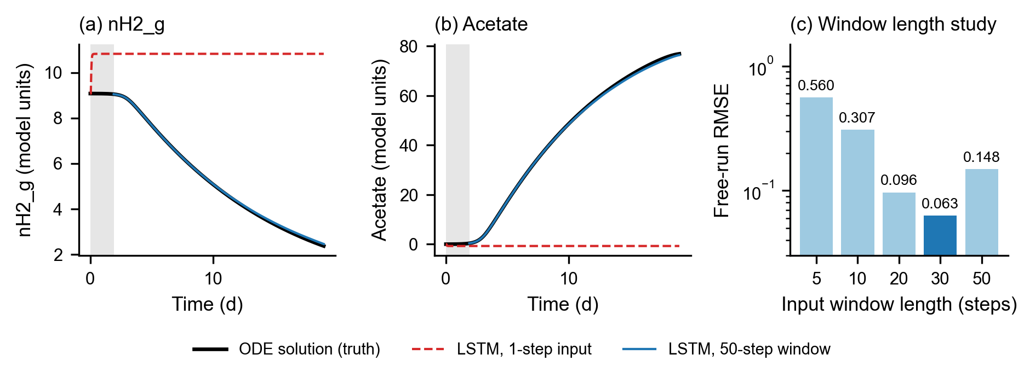
Figure 4.1. Stage 1, ODE reaction model (basalt, 25 °C). (a)–(b) Free run of two state variables by an LSTM with an input window of 1 step and of 50 steps, compared with the ODE solution. (c) RMSE of the free run for different window lengths, in the original units of the ODE model (not normalised) and pooled over all 14 variables. These values cannot be compared with the normalised errors of stages 2–4.
Quantitative. The model was trained on standardised data, and its predictions were converted back to the original units before the error was calculated. With an input window of 1 step, the pooled RMSE of the free run was 17.459 (original units of the ODE model, not normalised); with a window of 50 steps it was 0.1485. In the study of window length (Figure 4.1c) the error fell from 0.5596 (5 steps) to 0.0628 (30 steps) and rose again to 0.1485 at 50 steps.
Qualitative. The model with a window of 1 step quickly settles to a nearly constant value (Figure 4.1a–b), whereas the window model follows the curves closely. Using a finer time grid did not help, and runs on two different machines gave different results.
Lesson. In these experiments, using a window of past values substantially reduced the free run error. However, the error was measured on the same trajectory that was used for training, so generalisation was not tested, and the data did not come from PHREEQC.

4.3 Stage 2: first PHREEQC data
The same step by step approach was applied to 1,000 PHREEQC pilot runs (101 time points, 0–96 days, 12 outputs). The pilot runs represent a single rock setting with low variety between runs. The model saw only the previous outputs and not the experimental conditions. The data were split into 900 training and 100 test runs. No validation set was used, so the best setting was chosen on test results (a weakness of this stage). A logarithm was applied to seven skewed outputs and all outputs were standardised on the training runs. The evaluation followed Qiao et al. (2025).
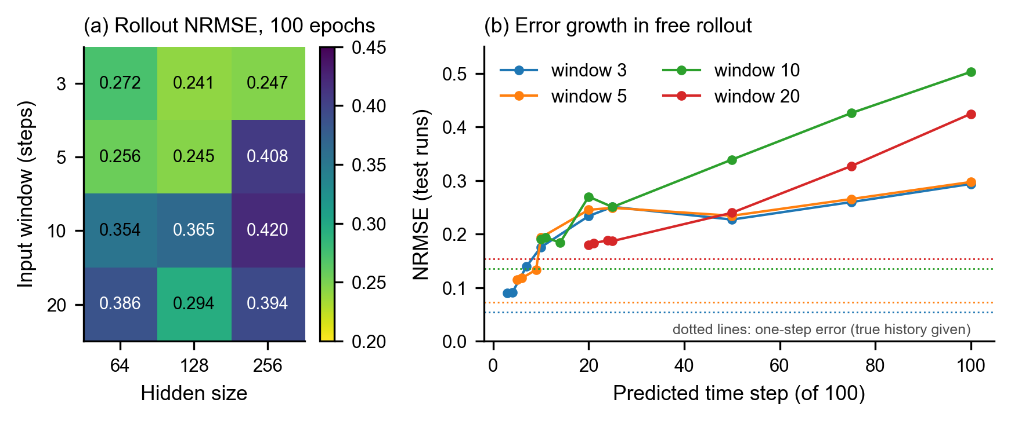
Figure 4.2. Stage 2, PHREEQC pilot data, autoregressive LSTM without condition inputs. (a) Normalised RMSE of the free rollout on test runs for 12 combinations of window length and hidden size (100 epochs). (b) Growth of the error along the rollout for 128 cells; each dotted horizontal line shows the overall test NRMSE for one step ahead predictions using true histories, pooled over test runs, prediction times and outputs. It is a fixed reference score, not the error at an individual time step.
Quantitative. NRMSE is the RMSE computed on standardised data, pooling all test runs, predicted time steps and the 12 outputs. After 100 epochs the rollout error ranged from 0.2411 (window 3, 128 cells) to 0.4200 (window 10, 256 cells); longer windows (10 and 20 steps) were generally worse (Figure 4.2a). Two configurations with input windows of 3 and 5 steps and 128 hidden cells were trained for 500 epochs. The model with a window of 5 steps achieved the lowest rollout NRMSE, 0.2173. For window 3 (100 epochs), the error grew from 0.090 at step 3 to 0.294 at step 100, while the error of a single step with the true history was only 0.0543; for windows 10 and 20 the error at step 100 was 0.503 and 0.425 (Figure 4.2b). In the parity analysis for window 3 (100 epochs), R² was 0.963 for pH, 0.953 for total pressure, 0.953 for pCO₂, 0.856 for Ca and 0.522 for SO₄.
Qualitative. Predictions of a single step are accurate, but every step reuses previous predictions, so errors accumulate (exposure bias; Bengio et al., 2015). A longer window did not help either for single steps or in the free run.
Lesson. The main missing piece is that the model does not know the experimental conditions. It can only extrapolate the curve it has seen so far.

4.4 Stage 3: conditional LSTM
The intended application requires predictions from initial conditions alone, without a measured history of chemical outputs. The model was therefore redesigned (Section 3.3): initial conditions and time are supplied at every time step, and the full trajectory of 301 time steps is predicted in one pass. Previous chemical outputs are not needed as inputs; PHREEQC outputs are used as training targets. This removes the feedback of predicted outputs that caused error accumulation in stage 2. A proper validation set was introduced (80/10/10 per rock). A learning rate sweep was run on Calcite and Dolomite (19,757 runs), and then a model was trained on four rocks (Calcite, Dolomite, Halite, Trona; 39,081 runs; 20 inputs, 32 outputs).
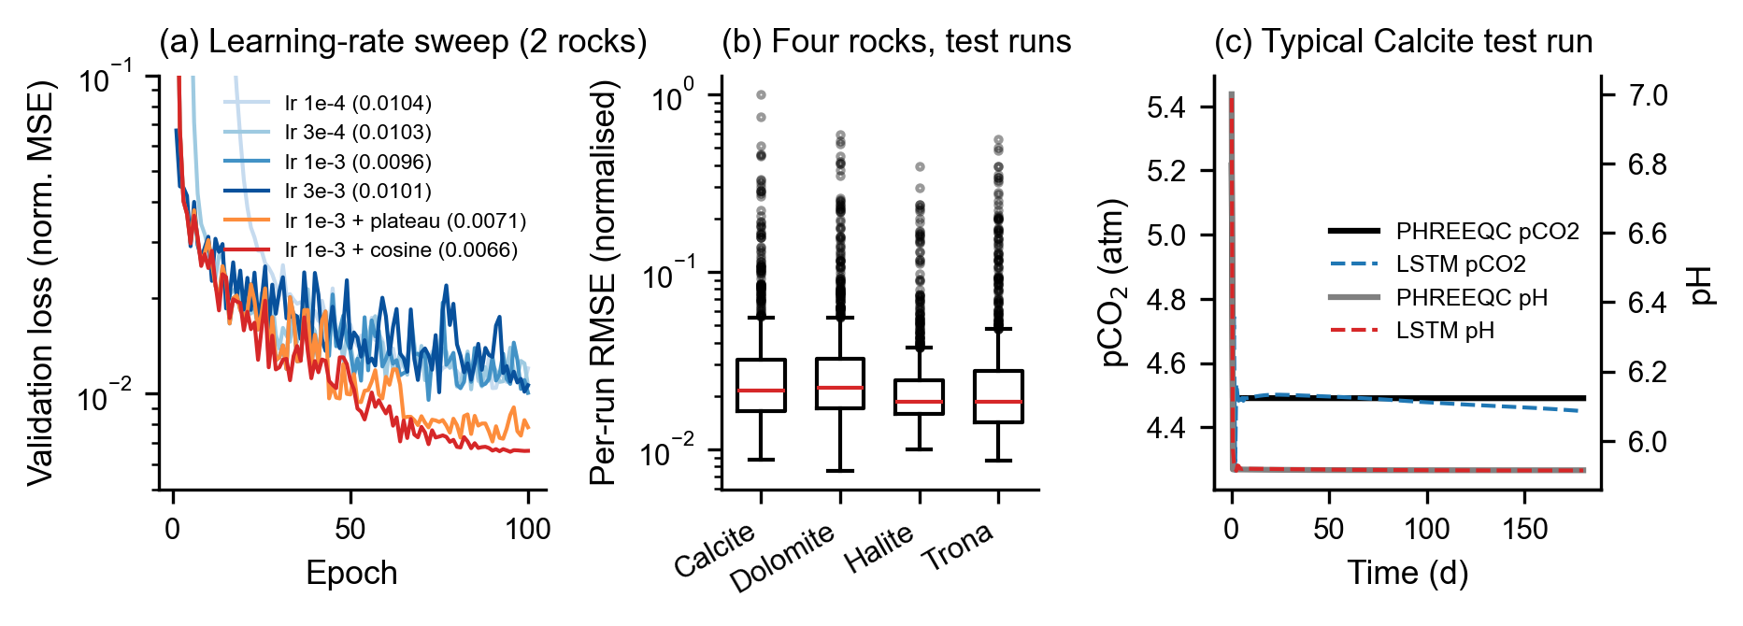
Figure 4.3. Stage 3, conditional LSTM. (a) Validation loss during training for four constant learning rates and for learning rate 1e-3 with two schedules (best value in the legend). (b) Normalised RMSE of each test run for the model trained on four rocks. (c) The Calcite test run closest to the median error (RMSE 0.0214): pCO₂ and pH from PHREEQC and from the LSTM.
Quantitative. With constant learning rates the best validation loss was 0.0096–0.0104; reducing the rate on a plateau gave 0.0071 and a cosine schedule gave the lowest value, 0.0066 (Figure 4.3a). For the model trained on four rocks (best validation loss 0.0104), the median of the per run normalised RMSE values was 0.0214 (Calcite), 0.0222 (Dolomite), 0.0185 (Halite) and 0.0185 (Trona), from 942–990 test runs per rock (Figure 4.3b). The arithmetic mean of the per output normalised RMSE values, calculated across test runs and time steps, was 0.0496, 0.0466, 0.0291 and 0.0408 for the same rocks, respectively. These aggregate scores differ from the run medians because the errors are grouped and summarised differently. A few runs had large errors in pH₂ (above 1.0).
Qualitative. In a typical run (Figure 4.3c) the model reproduces the initial jump in pH and pCO₂; after about day 100 the predicted pCO₂ drifts slightly below PHREEQC (≈4.45 instead of ≈4.49 atm).
Lesson. One conditional model learns four rocks together with low error. However, all test runs came from rocks the model had already seen during training; whether it can predict a new rock was still open. The cosine schedule was not carried forward to later runs (the reason was not recorded; see Section 6).

4.5 Stage 4: eight rocks and testing on unseen rocks
Four further rocks (Sandstone and three schists) were added. Because the schist inputs used different units and minerals, the input schema was rebuilt (58 inputs, 26 shared outputs). A reference model was trained on all eight rocks, and leave one rock out (LORO) validation was run three times: without penalty and with L2 penalties λ = 1e-4 and 1e-3. The success criteria for the penalty runs were written down before these runs were started.
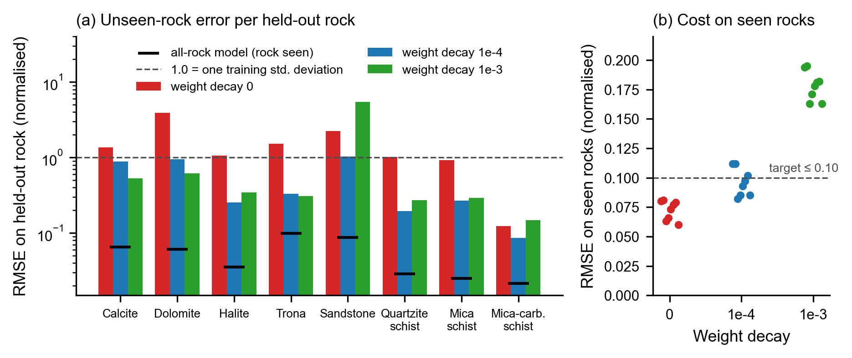
Figure 4.4. Stage 4, leave one rock out validation. (a) Normalised RMSE on each held out (unseen) rock for three L2 penalty levels; black marks show the reference model, which saw that rock during training; the dashed line marks one training standard deviation. (b) Normalised RMSE on the seen rocks, one point per fold; the dashed line is the predefined target (≤ 0.10). Logarithmic vertical axis in (a). “Weight decay” in the figure is the L2 penalty λ.
Table 4.2. Normalised RMSE on each rock: reference model (rock seen) and LORO models (rock unseen) at three L2 penalty levels.
Rock | Reference (seen) | Unseen, λ = 0 | Unseen, λ = 1e-4 | Unseen, λ = 1e-3
Calcite | 0.0656 | 1.362 | 0.886 | 0.535
Dolomite | 0.0614 | 3.896 | 0.957 | 0.618
Halite | 0.0353 | 1.063 | 0.253 | 0.344
Trona | 0.0990 | 1.535 | 0.331 | 0.311
Sandstone | 0.0872 | 2.246 | 1.040 | 5.456
Quartzite schist | 0.0290 | 1.024 | 0.197 | 0.273
Mica schist | 0.0251 | 0.923 | 0.270 | 0.291
Mica carbonate schist | 0.0216 | 0.123 | 0.086 | 0.149
Median (unseen) |  | 1.213 | 0.300 | 0.328
Rocks below 1.0 |  | 2 / 8 | 7 / 8 | 7 / 8
Seen rocks, range |  | 0.060–0.081 | 0.082–0.112 | 0.163–0.195
Quantitative. Without penalty, the error on an unseen rock was 6 to 63 times the error of the reference model on the same rock, and only 2 of 8 rocks stayed below 1.0 (Table 4.2). With λ = 1e-4 the median error on unseen rocks fell from 1.213 to 0.300, all eight rocks improved and seven stayed below 1.0 (Figure 4.4a), while the error on seen rocks rose from 0.060–0.081 to 0.082–0.112 (Figure 4.4b). With λ = 1e-3 six rocks improved compared with no penalty, but the error on seen rocks rose to 0.163–0.195 and Sandstone became much worse (5.456). The predefined target for seen rocks (≤ 0.10) was not met at either penalty level.
Qualitative. Without penalty the largest errors were in acetate and bacterial biomass (for example 10.41 and 7.68 when Calcite was held out). The Sandstone failure at λ = 1e-3 comes from a group of outputs: total pressure (12.38), pH₂ (10.40), pCH₄ (11.48), and Fe(OH)₃ together with the six microbial rates (12.42 each). The other outputs stay between about 0.2 and 3.4. The training and validation losses at λ = 1e-3 (about 0.040–0.046 and 0.039–0.061 at the end) suggest that this strong penalty prevented the model from fitting the data well.
Lesson. A mild penalty makes the model much more transferable to an unseen rock at a small cost on seen rocks; a strong penalty is too restrictive. Errors on unseen rocks remain several times larger than on seen rocks, so the model is not yet ready to replace PHREEQC for a new rock type.

5. DISCUSSION
The four stages show a clear progression: from in sample tests on a single trajectory (stage 1), through step by step prediction that accumulates error (stage 2), to a conditional model that is accurate on seen rocks (stage 3) and is now tested on unseen rocks (stage 4). The following limitations must be kept in mind when reading the numbers:
- Comparability across folds. Each LORO fold uses its own scalers fitted on its training rocks, so standardised errors from different folds are only approximately comparable.
- Missing reference with penalty. The reference model trained on all rocks was trained only without penalty; how much the penalty itself raises the error on seen rocks of a full model is not known.
- Possible duplicated outputs. Fe(OH)₃ and the six microbial rates show identical errors within every fold. This suggests (not yet confirmed) that these outputs may be nearly constant or scaled copies of each other in the data.
- Stages 1 and 2 were preliminary: stage 1 was evaluated in sample and stage 2 had no validation set. Their results are reported for completeness and as motivation, not as evidence of accuracy.
- Speed. The speed of the surrogate has not yet been compared with PHREEQC under fair conditions (McGreivy and Hakim, 2024).

6. CONCLUSIONS AND RECOMMENDATIONS

6.1 Work completed
A reproducible pipeline, controlled by configuration files, was built that turns PHREEQC simulations of eight rock types (55,122 runs) into training data, trains a conditional LSTM surrogate and records every experiment. The surrogate predicts 26 outputs over 180 days in one pass without the rock name as input. For the reference model trained on all eight rocks, the normalised error is 0.02–0.10. On rocks not seen in training, a mild L2 penalty reduced the median error from 1.21 to 0.30 standard deviations. The generalisation experiments also show where the surrogate can be trusted: for the LORO models trained with λ = 1e-4, the error is 0.08–0.11 on seen rocks and has a median of 0.30 standard deviations on unseen rocks. The optimisation in the next stage will therefore be limited to the range of conditions covered by the training data.

6.2 Plan for the remaining period
The main goal of the remaining period is input condition optimisation; the other items support the reliable use of the surrogate for this purpose.
- Input condition optimisation: with the model weights fixed, the input conditions will be changed step by step with a gradient method to find conditions that give desired outputs. The target quantity, the inputs that may change and the choice of starting points will be decided with the advisor.
- Input coverage test: compare the condition ranges of each held out rock with those of the training rocks.
- Verification with PHREEQC: the conditions found by the optimisation will be rerun in PHREEQC and compared with the surrogate prediction.
- Check duplicated outputs: test whether Fe(OH)₃ and the six rate outputs carry independent information, and remove or merge them if not.
- Training settings: test the cosine learning rate schedule (best in stage 3) and intermediate penalty values on the data of eight rocks.
- Evaluation per output: report errors per output in physical units and add R² for the main outputs.
- Speed comparison: measure run time of the surrogate against PHREEQC on the same hardware and number of scenarios.
- Alternative model architectures: compare different neural network architectures with the current conditional LSTM to assess whether they improve generalisation to unseen rock types, using the same leave one rock out splits and evaluation metrics.

REFERENCES
Azizzadenesheli, K., Kovachki, N., Li, Z., Liu-Schiaffini, M., Kossaifi, J., Anandkumar, A. 2024. “Neural operators for accelerating scientific simulations and design”, Nature Reviews Physics, 6 (5), 320-328.
Bengio, S., Vinyals, O., Jaitly, N., Shazeer, N. 2015. “Scheduled sampling for sequence prediction with recurrent neural networks”, Advances in Neural Information Processing Systems, 28.
Brandstetter, J., Worrall, D., Welling, M. 2022. “Message passing neural PDE solvers”, International Conference on Learning Representations (ICLR 2022).
Brunton, S. L., Kutz, J. N. 2024. “Promising directions of machine learning for partial differential equations”, Nature Computational Science, 4 (7), 483-494.
Cho, K., van Merriënboer, B., Gulcehre, C., Bahdanau, D., Bougares, F., Schwenk, H., Bengio, Y. 2014. “Learning phrase representations using RNN encoder–decoder for statistical machine translation”, Proceedings of the 2014 Conference on Empirical Methods in Natural Language Processing (EMNLP), 1724-1734.
Gers, F. A., Schmidhuber, J., Cummins, F. 2000. “Learning to forget: Continual prediction with LSTM”, Neural Computation, 12 (10), 2451-2471.
Greff, K., Srivastava, R. K., Koutník, J., Steunebrink, B. R., Schmidhuber, J. 2017. “LSTM: A search space odyssey”, IEEE Transactions on Neural Networks and Learning Systems, 28 (10), 2222-2232.
Hochreiter, S., Schmidhuber, J. 1997. “Long short-term memory”, Neural Computation, 9 (8), 1735-1780.
Kapoor, S., Narayanan, A. 2023. “Leakage and the reproducibility crisis in machine-learning-based science”, Patterns, 4 (9), 100804.
Karniadakis, G. E., Kevrekidis, I. G., Lu, L., Perdikaris, P., Wang, S., Yang, L. 2021. “Physics-informed machine learning”, Nature Reviews Physics, 3 (6), 422-440.
Kingma, D. P., Ba, J. 2015. “Adam: A method for stochastic optimization”, 3rd International Conference on Learning Representations (ICLR 2015), San Diego.
Koh, P. W., Sagawa, S., Marklund, H., Xie, S. M., Zhang, M., Balsubramani, A., Hu, W., Yasunaga, M., Phillips, R. L., Gao, I., Lee, T., David, E., Stavness, I., Guo, W., Earnshaw, B., Haque, I., Beery, S. M., Leskovec, J., Kundaje, A., Pierson, E., Levine, S., Finn, C., Liang, P. 2021. “WILDS: A benchmark of in-the-wild distribution shifts”, Proceedings of the 38th International Conference on Machine Learning, PMLR 139, 5637-5664.
Li, Z., Kovachki, N., Azizzadenesheli, K., Liu, B., Bhattacharya, K., Stuart, A., Anandkumar, A. 2021. “Fourier neural operator for parametric partial differential equations”, International Conference on Learning Representations (ICLR 2021).
Lippe, P., Veeling, B. S., Perdikaris, P., Turner, R. E., Brandstetter, J. 2023. “PDE-Refiner: Achieving accurate long rollouts with neural PDE solvers”, Advances in Neural Information Processing Systems, 36, 67398-67433.
Lu, L., Jin, P., Pang, G., Zhang, Z., Karniadakis, G. E. 2021. “Learning nonlinear operators via DeepONet based on the universal approximation theorem of operators”, Nature Machine Intelligence, 3 (3), 218-229.
McGreivy, N., Hakim, A. 2024. “Weak baselines and reporting biases lead to overoptimism in machine learning for fluid-related partial differential equations”, Nature Machine Intelligence, 6 (10), 1256-1269.
Parkhurst, D. L., Appelo, C. A. J. 2013. “Description of input and examples for PHREEQC version 3: A computer program for speciation, batch-reaction, one-dimensional transport, and inverse geochemical calculations”, U.S. Geological Survey Techniques and Methods, book 6, chapter A43.
Pascanu, R., Mikolov, T., Bengio, Y. 2013. “On the difficulty of training recurrent neural networks”, Proceedings of the 30th International Conference on Machine Learning, PMLR 28 (3), 1310-1318.
Paszke, A., Gross, S., Massa, F., Lerer, A., Bradbury, J., Chanan, G., Killeen, T., Lin, Z., Gimelshein, N., Antiga, L., Desmaison, A., Köpf, A., Yang, E., DeVito, Z., Raison, M., Tejani, A., Chilamkurthy, S., Steiner, B., Fang, L., Bai, J., Chintala, S. 2019. “PyTorch: An imperative style, high-performance deep learning library”, Advances in Neural Information Processing Systems, 32.
Qiao, H., Jooshaki, M., Rolle, M., Lähivaara, T., Vauhkonen, M., Kauppila, T., Muniruzzaman, M. 2025. “Hidden reactive transport neural network: A physics- and chemistry-informed surrogate modeling approach and application to pyrite oxidation”, Water Resources Research, 61 (12), e2024WR039487.
Raissi, M., Perdikaris, P., Karniadakis, G. E. 2019. “Physics-informed neural networks: A deep learning framework for solving forward and inverse problems involving nonlinear partial differential equations”, Journal of Computational Physics, 378, 686-707.
Roberts, D. R., Bahn, V., Ciuti, S., Boyce, M. S., Elith, J., Guillera-Arroita, G., Hauenstein, S., Lahoz-Monfort, J. J., Schröder, B., Thuiller, W., Warton, D. I., Wintle, B. A., Hartig, F., Dormann, C. F. 2017. “Cross-validation strategies for data with temporal, spatial, hierarchical, or phylogenetic structure”, Ecography, 40 (8), 913-929.

