# Load the necessary libraries

library(readxl)

library(ggplot2)

>MentalHealthAnalysis <- read_excel("path_to_your_file/MentalHealthAnalysis.xls")

>MentalHealthAnalysis$Occupation <- as.factor(MentalHealthAnalysis$Occupation)

>MentalHealthAnalysis$Gender <- as.factor(MentalHealthAnalysis$Gender)

>MentalHealthAnalysis$Growing_Stress <- as.factor(MentalHealthAnalysis$Growing_Stress)

>MentalHealthAnalysis$Quarantine_Frustrations <- as.factor(MentalHealthAnalysis$Quarantine_Frustrations)

> MentalHealthAnalysis$Changes_Habits <- as.factor(MentalHealthAnalysis$Changes_Habits)

> MentalHealthAnalysis$Mental_Health_History <- as.factor(MentalHealthAnalysis$Mental_Health_History)

> MentalHealthAnalysis$Weight_Change <- as.factor(MentalHealthAnalysis$Weight_Change)

> MentalHealthAnalysis$Mood_Swings <- as.factor(MentalHealthAnalysis$Mood_Swings)

> MentalHealthAnalysis$Coping_Struggles <- as.factor(MentalHealthAnalysis$Coping_Struggles)

> MentalHealthAnalysis$Work_Interest <- as.factor(MentalHealthAnalysis$Work_Interest)

> MentalHealthAnalysis$Social_Weakness <- as.factor(MentalHealthAnalysis$Social_Weakness)

> MentalHealthAnalysis$Growing_Stress <- as.factor(MentalHealthAnalysis$Growing_Stress)

#Summary for dataset

>Summary(MentalHealthAnalysis)

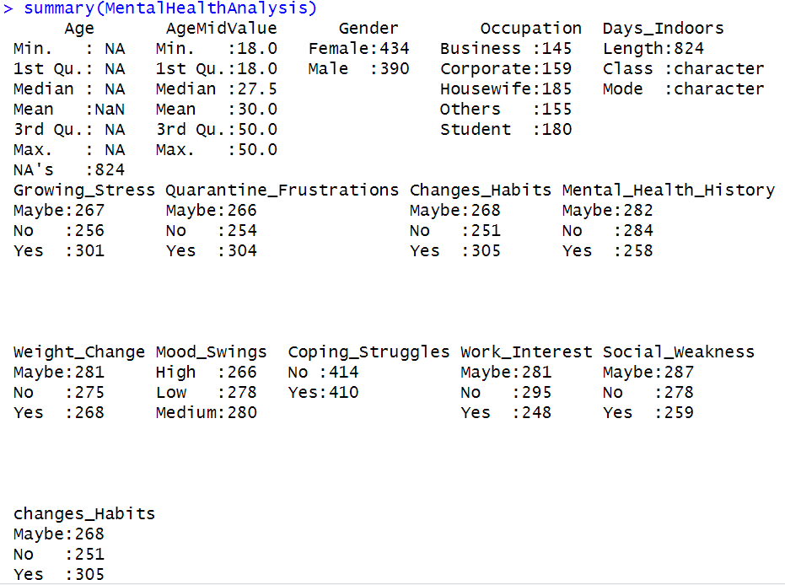

ageMidValue_summary <- summary(MentalHealthAnalysis$AgeMidValue)

gender_table <- table(MentalHealthAnalysis$Gender)

occupation_table <- table(MentalHealthAnalysis$Occupation)

growingStress_table <- table(MentalHealthAnalysis$Growing_Stress)

print("Summary for AgeMidValue:")

print(ageMidValue_summary)

print("Frequency table for Gender:")

print(gender_table)

print("Frequency table for Occupation:")

print(occupation_table)

print("Frequency table for Growing_Stress:")

print(growingStress_table)

#Histogram:

|  |
| --- |
| library(ggplot2)  >  > ggplot(MentalHealthAnalysis, aes(x = AgeMidValue)) +  + geom_histogram(binwidth = 1, fill = "blue", color = "black") +  + theme_minimal() +  + labs(title = "Histogram of Age Values", x = "Age Mid Value", y = "Count")  Histogram-1.png |
|  |
| |  | | --- | | #Box Plots:  # Make sure ggplot2 is installed and loaded  library(ggplot2)  # Generate a box plot of AgeMidValue for each Occupation category  ggplot(MentalHealthAnalysis, aes(x = Occupation, y = AgeMidValue)) +  geom_boxplot() +  theme_light() +  labs(title = "Box Plot of Age by Occupation", x = "Occupation", y = "Age Mid Value") +  theme(axis.text.x = element_text(angle = 45, hjust = 1)) # Rotate x-axis labels for readability | |

