

Sir Syed University of Engineering & Technology Department of Software Engineering

**Project Report of Programming Fundamentals**

**Project Title: Get Wifi Password**

|  |  |
| --- | --- |
| **Group Members:** | **Hasan Raza** |
| **Roll numbers:** | **129** |
| **Section:** | **C** |

**Purpose of Project:** The mean of making this Wifi Password is to get more familiar withpython.Here you will get the wifi password that are saved in your laptops it will help you to find out the password that are saved in your laptops and and when ever you forget the built-in password you will get through this for that you have to install python where you will write the code and get your built-in password easily

**Reference Code:**

From This link I Have modified my idea that how to complete this project and how to use the libraries and modules

<https://www.youtube.com/watch?v=OWVmTRc9V4Y>

**Way to get that Names without Password**

import subprocess

results = subprocess.check_output(["netsh", "wlan", "show", "network"])

#A little extra to just get SSID's.

results = results.decode("ascii") # needed in python 3

results = results.replace("\r","")

ls = results.split("\n")

ls = ls[4:]

ssids = []

x = 0

while x < len(ls):

if x % 5 == 0:

ssids.append(ls[x])

x += 1

print(ssids)

This is the code through whick You can get the Ids or Name of Wifi that are connected from your Pc or Laptop

**Output**

**Another way to get that Names (Modified)**

import subprocess

r = subprocess.run(["netsh", "wlan", "show", "network"], capture_output=True, text=True).stdout

ls = r.split("\n")

ssids = [k for k in ls if 'SSID' in k]

ssids = [v.strip() for k,v in (p.split(':') for p in ls if 'SSID' in p)]

print(ssids)

**Output**

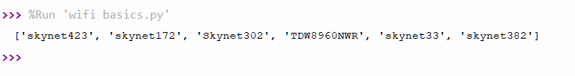

**Complete Code (Modified Code):**

Through this code you will find out the names of wifi with buit-in passwords

import tkinter

from tkinter import*

def kk():

import subprocess

data=subprocess.check_output(['netsh','wlan','show','profiles']).decode('utf-8',errors='backslashreplace').split('\n')

profiles=[i.split(':')[1][1:-1] for i in data if 'All User Profile'in i]

for i in profiles:

try:

results=subprocess.check_output(['netsh','wlan','show','profile',i,'key=clear']).decode('utf-8',errors='backslashreplace').split('\n')

results = [b.split(":")[1][1:-1] for b in results if "Key Content" in b]

try:

print('{:<30}| {:<}'.format(i,results[0]))

except IndexError:

print("{:<30}| {:<}".format(i, ""))

except subprocess.CalledProcessError:

print('{:<30}| {:<}'.format(i,'ENCODING ERROR'))

root=tkinter.Tk()

root.title("Get Wifi Password")

root.resizable(width=False, height=False)

root.geometry('600x350')

photo=PhotoImage(file='3.png')

label_display =Label(root, text="Click On the Image to get built-in Password",font=('chiller',30,'bold')).grid()

btn=Button(root,image=photo,command=kk,border=0,height=300,width=350).place(x=80,y=50)

**Project Output: (** Screenshots of My modified code**)**

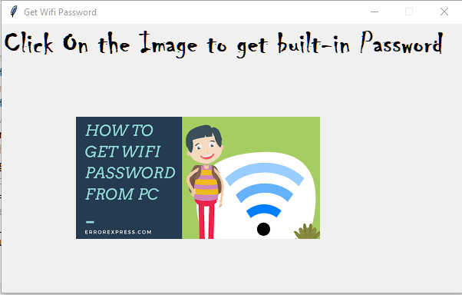

**Screenshot Of Modified Code**

