MCC Electrical Design Package
Motor Control Center Design — Small Commercial Building
Hammad Hasan • Electrical Engineering • Self-directed Project • July–August 2026
This package documents the electrical design of a motor control center (MCC) branch circuit for a small commercial building, developed end-to-end with the tools used in professional electrical design practice: Excel for load calculation and code-based sizing, Python to automate and verify that sizing, AutoCAD Electrical for the power and control schematic, and Revit for the physical equipment layout. Sizing follows NEC Table 430.250 (full-load current), NEC 430.22 (conductor sizing), and NEC 430.52 (breaker sizing).
Contents
Motor Load Schedule (Excel) 2
Load Calculation Automation (Python) 3
MCC Schematic (AutoCAD Electrical) 5
Equipment Layout (Revit) 7
Summary 8

Motor Load Schedule (Excel)
A six-motor load schedule was developed for the building's mechanical and rooftop equipment. All motors are 460V, three-phase, continuous duty.

Motor load schedule
Motor ID | Equipment | Location | HP | FLA (A)
M-1 | Supply Fan (AHU-1) | Mechanical Room | 5 | 7.6
M-2 | Return Fan (AHU-1) | Mechanical Room | 3 | 4.8
M-3 | Chilled Water Pump (P-1) | Mechanical Room | 20 | 27
M-4 | Exhaust Fan (EF-1) | Roof | 1 | 2.1
M-5 | Cooling Tower Fan (CT-1) | Roof | 25 | 34
M-6 | Air Compressor (AC-1) | Mechanical Room | 15 | 21
FLA per NEC Table 430.250, 460V column.

Cable sizing — NEC 430.22
Each conductor is sized to the smallest standard AWG whose 75°C copper ampacity meets or exceeds 125% of FLA.
Motor ID | FLA (A) | Min. Ampacity (125%) | Conductor | Ampacity (A)
M-1 | 7.6 | 9.5 | 14 AWG | 20
M-2 | 4.8 | 6.0 | 14 AWG | 20
M-3 | 27 | 33.75 | 10 AWG | 35
M-4 | 2.1 | 2.625 | 14 AWG | 20
M-5 | 34 | 42.5 | 8 AWG | 50
M-6 | 21 | 26.25 | 10 AWG | 35

Panel / breaker schedule — NEC 430.52
Breakers are sized to the smallest standard inverse-time breaker meeting or exceeding 250% of FLA, for motor starting inrush protection.
Circuit | Motor ID | FLA (A) | Max Breaker (250%) | Breaker (A) | Conductor
1-3 | M-1 | 7.6 | 19 | 20 | 14 AWG
4-6 | M-2 | 4.8 | 12 | 15 | 14 AWG
7-9 | M-3 | 27 | 67.5 | 70 | 10 AWG
10-12 | M-4 | 2.1 | 5.25 | 15 | 14 AWG
13-15 | M-5 | 34 | 85 | 90 | 8 AWG
16-18 | M-6 | 21 | 52.5 | 60 | 10 AWG

Load Calculation Automation (Python)
The same FLA lookup, cable sizing, and breaker sizing logic from the Excel workbook was reproduced in Python to validate the results programmatically and export a matching CSV report. Output was cross-checked against the Excel workbook and matches exactly.
"""Motor load calculation automation — mirrors the Excel workbook's FLA lookup, cable sizing, and breaker sizing logic (NEC 430.250 / 430.22 / 430.52)."""

from dataclasses import dataclass
from typing import List, Tuple
import csv

# Reference tables (same source data as the Excel workbook)

# NEC Table 430.250 - Full-Load Current (FLA) for 3-phase, 460V motors (A)
FLA_TABLE_460V = {
1: 2.1, 1.5: 3, 2: 3.4, 3: 4.8, 5: 7.6, 7.5: 11,
10: 14, 15: 21, 20: 27, 25: 34, 30: 40, 40: 52, 50: 65,
}

# NEC Table 310.16 - Conductor ampacity, 75C copper (A), ascending order
CABLE_AMPACITY_TABLE: List[Tuple[str, int]] = [
("14 AWG", 20), ("12 AWG", 25), ("10 AWG", 35), ("8 AWG", 50),
("6 AWG", 65), ("4 AWG", 85), ("3 AWG", 100), ("2 AWG", 115),
("1 AWG", 130), ("1/0 AWG", 150),
]

# Standard breaker sizes (A), ascending order
BREAKER_SIZES: List[int] = [
15, 20, 25, 30, 35, 40, 45, 50, 60, 70,
80, 90, 100, 110, 125, 150, 175, 200, 225, 250,
]

# Motor definition

@dataclass
class Motor:
"""One motor entry - mirrors a row in the Excel Motor Load Schedule."""
motor_id: str
description: str
location: str
hp: float
voltage: int = 460
phase: int = 3

@property
def fla(self) -> float:
"""Full-load amps, looked up from NEC Table 430.250."""
if self.hp not in FLA_TABLE_460V:
raise ValueError(f"No FLA entry for {self.hp} HP - add it to FLA_TABLE_460V.")
return FLA_TABLE_460V[self.hp]

# Sizing logic (equivalent to the INDEX/MATCH formulas in Excel)

def select_cable_size(fla: float) -> Tuple[str, int]:
"""Smallest conductor whose ampacity >= 125% of FLA (NEC 430.22)."""
min_ampacity = fla * 1.25
for awg, ampacity in CABLE_AMPACITY_TABLE:
if ampacity >= min_ampacity:
return awg, ampacity
raise ValueError("FLA exceeds the largest conductor in the table.")

def select_breaker_size(fla: float) -> int:
"""Smallest standard breaker >= 250% of FLA (NEC 430.52)."""
max_protection = fla * 2.5
for size in BREAKER_SIZES:
if size >= max_protection:
return size
raise ValueError("FLA exceeds the largest breaker in the table.")

# Project motor list (same 6 motors as the Excel workbook)

def build_motor_list() -> List[Motor]:
return [
Motor("M-1", "Supply Fan (AHU-1)", "Mechanical Room", 5),
Motor("M-2", "Return Fan (AHU-1)", "Mechanical Room", 3),
Motor("M-3", "Chilled Water Pump (P-1)", "Mechanical Room", 20),
Motor("M-4", "Exhaust Fan (EF-1)", "Roof", 1),
Motor("M-5", "Cooling Tower Fan (CT-1)", "Roof", 25),
Motor("M-6", "Air Compressor (AC-1)", "Mechanical Room", 15),
]

# Report generation

def generate_report(motors: List[Motor]) -> List[dict]:
report = []
for m in motors:
fla = m.fla
awg, _ = select_cable_size(fla)
breaker = select_breaker_size(fla)
report.append({
"Motor ID": m.motor_id,
"Description": m.description,
"HP": m.hp,
"FLA (A)": fla,
"Min Cable Ampacity (A)": round(fla * 1.25, 2),
"Cable Size": awg,
"Max Breaker (A)": round(fla * 2.5, 2),
"Selected Breaker (A)": breaker,
})
return report

def print_report(report: List[dict]) -> None:
headers = list(report[0].keys())
widths = [max(len(str(row[h])) for row in report + [dict(zip(headers, headers))]) + 2 for h in headers]

def fmt_row(values):
return "".join(str(v).ljust(w) for v, w in zip(values, widths))

print(fmt_row(headers))
print("-" * sum(widths))
for row in report:
print(fmt_row(row.values()))

def export_csv(report: List[dict], filename: str = "motor_load_report.csv") -> None:
with open(filename, "w", newline="") as f:
writer = csv.DictWriter(f, fieldnames=report[0].keys())
writer.writeheader()
writer.writerows(report)
print(f"\nExported: {filename}")

# Run

if __name__ == "__main__":
motors = build_motor_list()
report = generate_report(motors)
print_report(report)
export_csv(report)

MCC Schematic (AutoCAD Electrical)
Incoming three-phase power (L1/L2/L3) feeds through a disconnect (DISC1) and fuses (FU1) to the motor contactor (M1), overload relay (OL1), and motor (MTR1), with an equipment ground at the motor frame. A fused tap (FU2) feeds a control transformer (CPT1), stepping 480V down to 120V for the control circuit — a standard NEMA 3-wire, non-reversing starter rung: Stop in series with a Start/seal-in parallel branch, the overload contact, and the M1 coil.
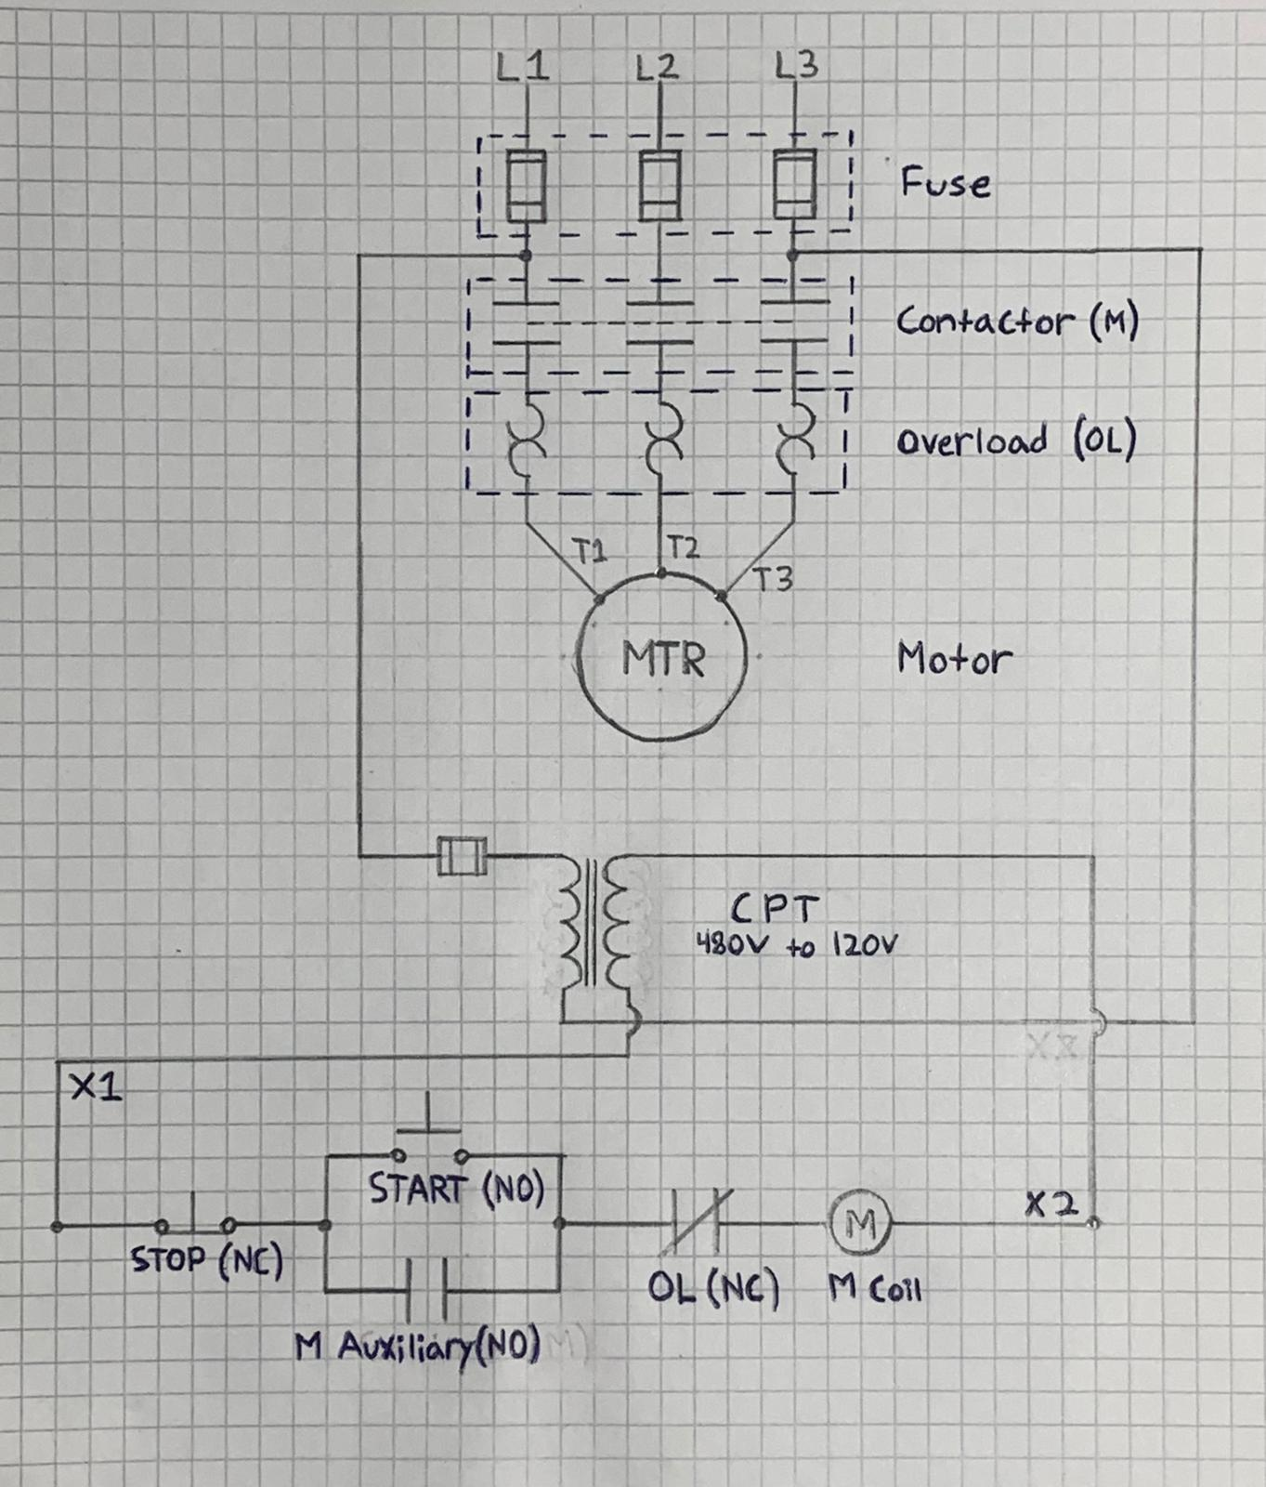
Figure 1 — Initial hand-drawn schematic
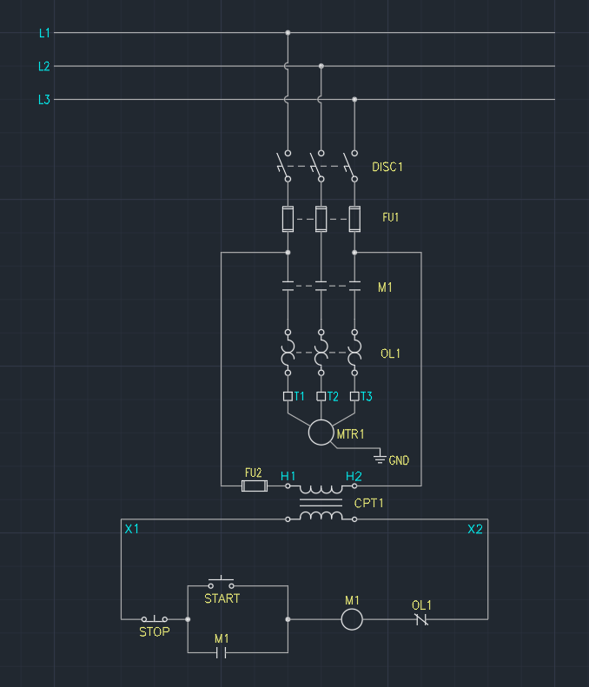
Figure 2 — Finalized power and control circuit, AutoCAD Electrical

Equipment Layout (Revit)
The MCC panel and motor were placed on a facility floor plan to document physical installation context — location, spacing, and the conduit run between them — complementing the schematic's electrical logic with a real-world spatial layout.
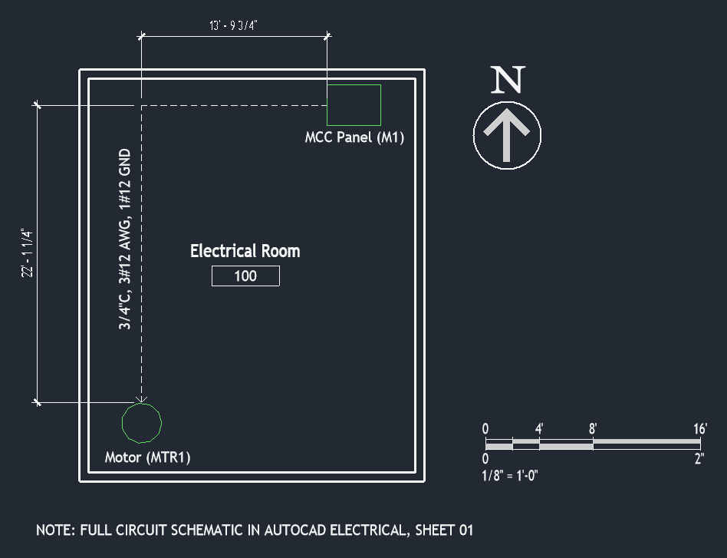
Figure 3 — Electrical room equipment layout, Revit
- MCC Panel (M1) and Motor (MTR1) tags match the AutoCAD Electrical schematic directly.
- Conduit run labeled 3/4"C, 3#12 AWG, 1#12 GND, sized per the cable schedule.
- Panel-to-motor offsets dimensioned in both axes for installation reference.

Summary
This project carried one motor circuit through a full electrical design workflow: code-based load calculation in Excel, programmatic validation in Python, schematic design in AutoCAD Electrical, and spatial equipment layout in Revit. The same motor tags, load values, and conductor sizes carry through every stage — the same coordination expected of a real design package.
- Excel workbook — motor load schedule, cable sizing, panel schedule
- Python script — automated load/cable/breaker calculation, CSV export
- AutoCAD Electrical drawing — MCC power and control schematic
- Revit model — equipment layout floor plan

Design Process
The schematic evolved through several sketches before reaching CAD. A few stages of that progression are shown below.
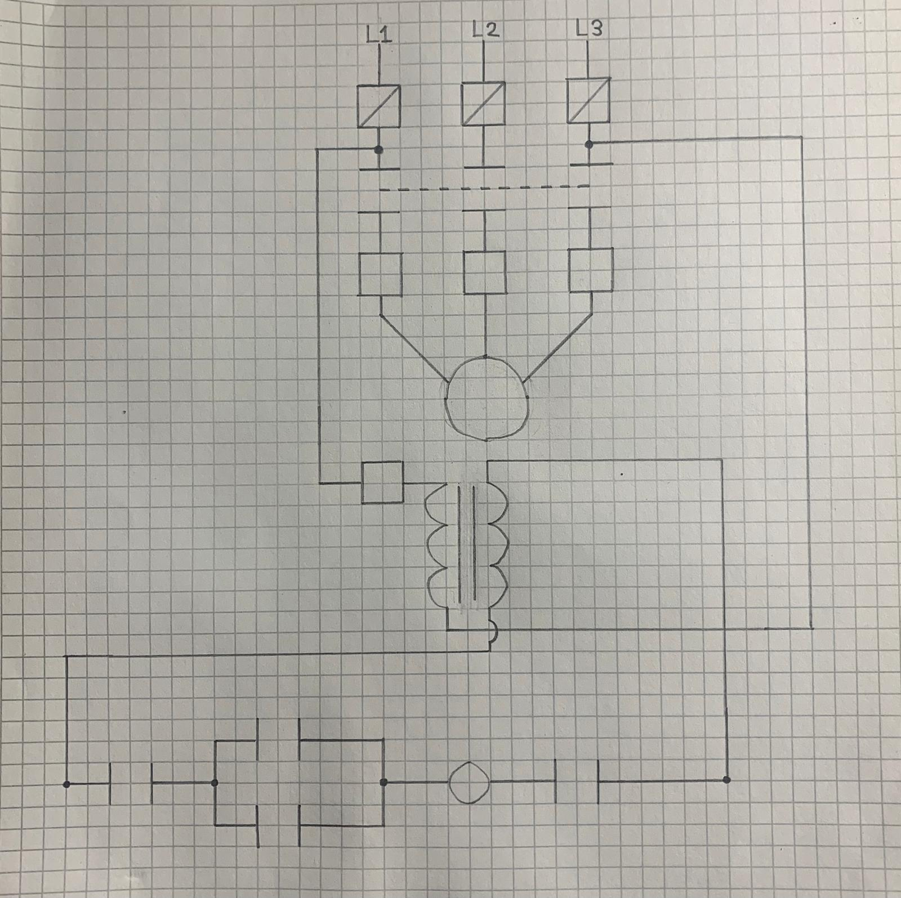  Figure 4 — Initial sketch | 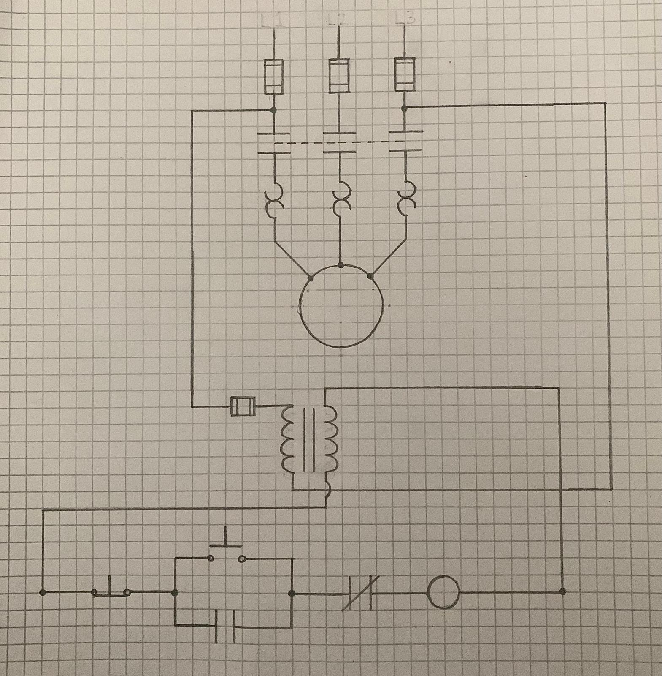  Figure 5 — Later revision, after adopting NEMA symbols | 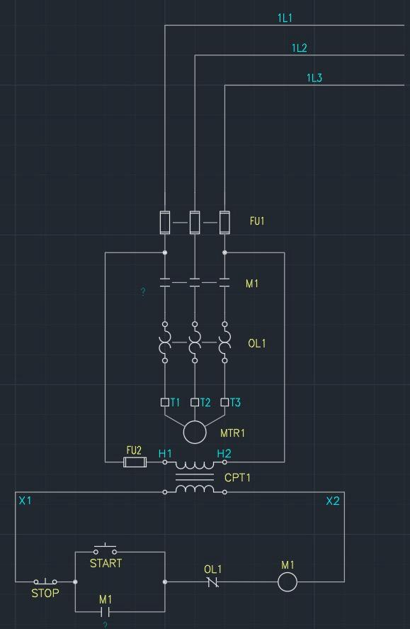  Figure 6 — First AutoCAD Electrical draft

