

**SIX WEEKS SUMMER TRAINING**

# REPORT

On

***(IOT:Arduino )***

Submitted by

# (Hasan Al Zaman Fatmi)

**Registration No: 11406619**

**Programme Name: BTECH CSE**

Under the Guidance of

**Name of the Industry Coordinator:Aiza Anjum**

**School of Computer Science & Engineering** **Lovely Professional University, Phagwara**

(June-July, 2017)

# DECLARATION

I hereby declare that I have completed my six weeks summer training at IBM-CEP Jalandhar (name and location of organization) from 10 June 2017 (start date) to 13 July 2017 (end date) under the guidance of Aiza Anjum (Name of Industry coordinator). I have declare that I have worked with full dedication during these six weeks of training and my learning outcomes fulfil the requirements of training for the award of degree of BTECH CSE , Lovely Professional University, Phagwara.

(Signature of student)

Hasan Al Zaman Fatimi

Registration no: 11406619

Date:

# ACKNOWLEDGEMENT

This training was supported by International Business Machine Career Education Partner (IBMCEP) and Lovely Professional University (LPU). I thank IBMCEP for providing insight and expertise that assisted me throughout the following six weeks and also in the proof of concept, although every concept given may not be agreed upon. I would also like to thank LPU for giving me the opportunity to indulge in this six week summer training. I’m sure the technology I learned will benefit me in every aspect of my career.

I thank Miss Aiza Anjum for her guidance and teachings regarding the topic. Her vision and teaching significantly improved this training and the proof of concept. Without her this may not have seemed possible.

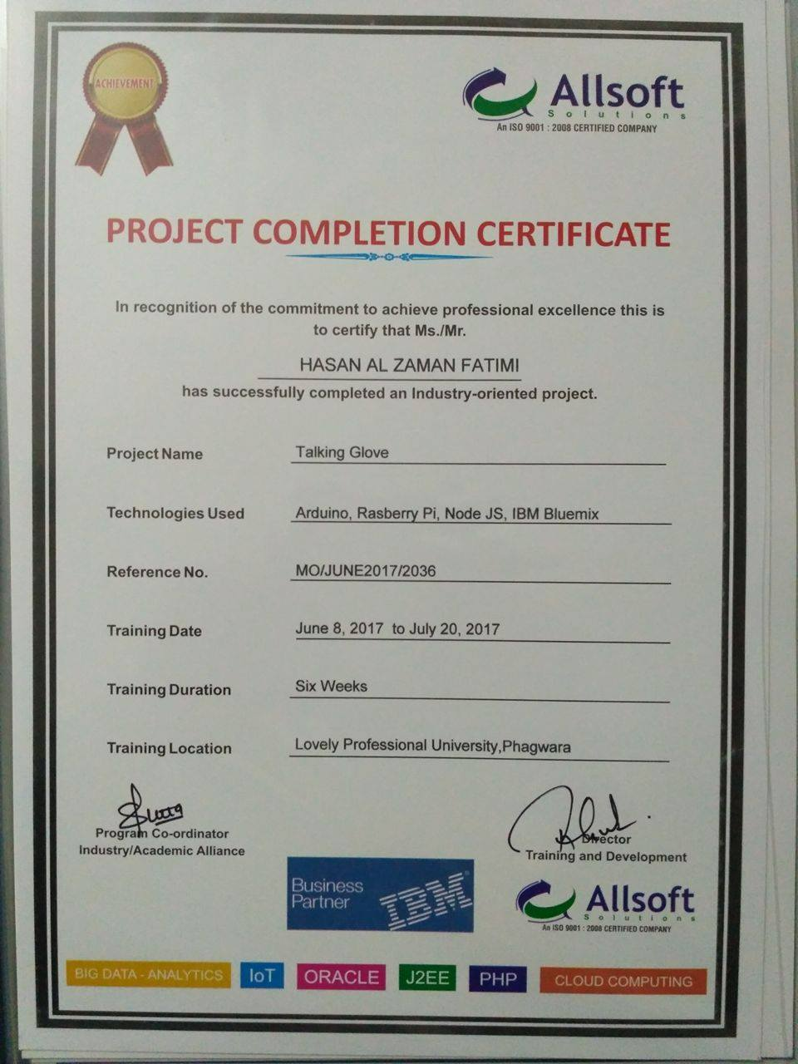

**TABLE OF CONTENTS**

1. INTRODUCTION TO ARDUINO.
2. INTRODUCTION TO PROJECT TALKING GLOVES.
3. COMPONENT LEARN DURING TRAINING
4. PSEUDOCODE
5. COMPONENT USED IN PROJECT
6. BLOCK DIAGRAM
7. PSEUDOCODE FOR PROJECT
8. DESIGN
9. GANTT CHART
10. PROJECT LEGACY
11. BIBLIOGRAPHY

# INTRODUCTION

The world is changing. With it the people and the technology. With the growing technology we are also witnessing that things are getting more smarter day by day . All these things are becoming the IOT(Internet of Thing). **Arduino** is an open source computer hardware and software company, project, and user community that designs and manufactures single-board microcontrollers and microcontroller kits for building digital devices and interactive objects that can sense and control objects in the physical world. The project's products are distributed as open-source hardware and software, which are licensed under the GNU Lesser Genera Public License (LGPL) or the GNU General Public License (GPL), permitting the manufacture of Arduino boards and software distribution by anyone. Arduino boards are available commercially in preassembled form, or as do-it-yourself kits.

I spent my last six weeks learning this piece of technology and building a working proof of concept applying it. My proof of concept is based on the print industry’s popularly used printing technique called as Rotogravure printing. In IOT I worked on Arduino hardware device it is a programmable device the program is written on Proteus8 software after writing program in Proteus8 you have to burn that program on Arduino device and check the processing

During the summer training program I learn working of seven segment display ,GSM Module,

Bluetooth module & wifi module .Using the Bluetooth module me and my team develop the a Talking Gloves in order to solve the problem of Dumb people the device it take input from the gloves and generate the text and produce the speech .

# INTRODUCTION TO PROJECT TALIKING GLOVES.

Communication is a backbone of life .We communicate with each other to share our feeling

Emotions, opinion on subject ,our views and points .Voice or a speaking power is gift of God but there are few people in this world who are not served with the a such a wonderful gift

God .In order to help those people me and my team decided to make an IOT based project .

We name that project Talking gloves .we use flex sensor to take the reading from gloves by a

Finger movement and that reading is send to Arduino in which we designed a code in such way that is generate a character according to finger movement than that character is display on LCD

And is pass to mobile by Buletooth module .

We develop a prototype model of a project with full working .we use a 3rd party app to convert text

into speech . In order to generate a character we use a binary conversion for that we use table .By

looking at that table we can generate the exact character we want .In that table 0 means. we have

to bend finger and one mean that we have to unbend the finger .As we bend or unbend the finger

it start taking the reading and generate the character .

This is how we try to solve the problem of dumb people by developing such an IOT project which is helping them out in order to communicate with people and making there life bit easier. Using this gloves they can also speak .we try to reduce the communication gap between us and them so that we can easily understand there language and they can easily express there feeling

# COMPONENT LEAR DURING TRAINING

During training we learn about :

1. Basic component of electronics
   * LED
   * LCD
   * Voltage regulator
   * Capacitor
   * Transformer
   * Relay
   * Power supply system.
   * Resistance
   * Diode
   * Triode
   * amplifier
2. Proteus8 software
3. Arduino UNO
4. Seven segment display
5. Switch
6. Keypad
7. DC geared motor
8. Stepper motor
9. IR sensor
10. Bluetooth Module
11. ADC (Analog to digital Converter)
12. Wifi model
13. DTMF (Dual Tone Multiple frequency)
14. GSM (Global System for Mobile Communication)

# PSEUDOCODE

1. **Sample code**

void setup() {

pinMode(13,OUTPUT);

}

void loop() {

// put your main code here, to run repeatedly:

digitalWrite(13,HIGH);

delay(2000);

digitalWrite(13,LOW);

delay(2000);

}

1. **Bluetooth**

void setup() {

Serial.begin(9600);

pinMode(13,OUTPUT);

pinMode(8,INPUT);

}

void loop() {

// put your main code here, to run repeatedly:

// Serial.print("HELLO");

if(Serial.available()>0)

{

char a=Serial.read();

if(a=='O')

{

digitalWrite(13,HIGH);

delay(1000);

}

if(a=='P')

{

digitalWrite(13,LOW);

delay(1000);

}

// Serial.print(a);

}

}

1. **WIFI**

#include<stdlib.h>

//#include <SoftwareSerial.h>

#define SSID "Data"

#define PASS "12345678"

#define IP "184.106.153.149" // thingspeak.com

//String GET = "GET /update?key=ORIBQ33FSM6IYZ6E&field1=";

String PUT = "GET /channels/181291/fields/1/last";

int count=0,store=0,length1=0;

char message[50];

char data[20];

char t=0,m=3,n=0;

void setup() {

Serial.begin(115200);

pinMode(7,OUTPUT);

pinMode(8,OUTPUT);

pinMode(9,OUTPUT);

digitalWrite(7,LOW);

digitalWrite(8,LOW);

digitalWrite(9,LOW);

sendDebug("AT");

delay(2000);

sendDebug("AT");

delay(2000);

delay(3000);

if(Serial.find("OK")){

//monitor.println("RECEIVED: OK");

Serial.println("RECEIVED: OK");

Serial.println("connected..");

delay(2000);

delay(5000);

connectWiFi();

delay(5000);

}

}

void loop() {

readTemp();

// delay(500);

// Serial.print("done");

if(Serial.find("+IPD"))

{

// Serial.print("done");

if(Serial.available()>0)

{

int length1=Serial.available();

for(int i=0;i<length1;i++)

{

message[i] = Serial.read();

Serial.print( message[i]);

//Serial.print( message[3]);

}

}

//t=message[3];

/* if(message[3]=='4')

{

digitalWrite(7,HIGH);

}

if(message[3]=='5')

{

digitalWrite(7,LOW);

}

if(message[3]=='6')

{

digitalWrite(8,HIGH);

}

if(message[3]=='7')

{

digitalWrite(8,LOW);

}

if(message[3]=='8')

{

digitalWrite(9,HIGH);

}

if(message[3]=='9')

{

digitalWrite(9,LOW);

}

*/

}

}

// delay(5000);

void readTemp(){

String cmd = "AT+CIPSTART=\"TCP\",\"";

cmd += IP;

cmd += "\",80";

sendDebug(cmd);

if(Serial.find("Error")){

//monitor.print("RECEIVED: Error");

//Serial.print("RECEIVED: Error");

return;

}

cmd = PUT;

cmd += "\r\n";

Serial.print("AT+CIPSEND=");

Serial.println(cmd.length());

if(Serial.find(">")){

Serial.print(cmd);

delay(500);

}

}

void sendDebug(String cmd){

//monitor.print("SEND: ");

//monitor.println(cmd);

Serial.println(cmd);

}

boolean connectWiFi(){

Serial.println("AT+CWMODE=1");

delay(2000);

String cmd="AT+CWJAP=\"";

cmd+=SSID;

cmd+="\",\"";

cmd+=PASS;

cmd+="\"";

sendDebug(cmd);

delay(5000);

if(Serial.find("OK")){

// monitor.println("RECEIVED: OK");

return true;

}else{

// monitor.println("RECEIVED: Error");

return false;

}

1. **GSM(Global System for Mobile Communication)**

void setup()

{

Serial.begin(9600);

Serial.println("AT");

delay(1500);

Serial.println("AT+CMGF=1");

//Serial.println("AT+CMGF=0");

delay(1500);

Serial.println("AT+CNMI=2,2,0,0,0");

delay(1500);

//Serial.println("ATD9041391825;");

//Serial.print("AT+CMGS=\"");

//Serial.print("+917986856448");

//Serial.println("\"");

delay(2000);

/*Serial.println("Detonate Bomb :) Jai Jihad");

Serial.write(0x1A);

Serial.write(0x0D);

Serial.write(0x0A);*/

//delay(2000);

pinMode(13,OUTPUT);

}

void loop() {

// put your main code here, to run repeatedly:

//call

// Serial.println("ATD9041391825;");

if(Serial.find("*YO#"))

{

//Serial.println("ATA");

//Serial.println("ATH");

digitalWrite(13,HIGH);

delay(500);

Serial.print("AT+CMGS=\"");

Serial.print("+919041391825");

Serial.println("\"");

delay(2000);

Serial.println("Detonate Bomb :) Jai Jihad");

Serial.write(0x1A);

Serial.write(0x0D);

Serial.write(0x0A);

delay(2000);

}

else if(Serial.find("*1NO#"))

{

//Serial.println("ATA");

//Serial.println("ATH");

digitalWrite(13,LOW);

delay(500);

}

/* if(Serial.find("RING"))

{

//Serial.println("ATA");

Serial.println("ATH");

}*/

// Serial.println("ATA");

//Serial.println("ATH");

//message

//Serial.println("AT+CMGS=+919041391825");

//Serial.println("AT+CMGR=3");

//Serial.println("AT+CMGD=1");

}

1. **IR Counter**

int c=0;

int k=0;

int h=0;

void setup() {

// put your setup code here, to run once:

pinMode(1,INPUT);

pinMode(2,INPUT);

}

void loop() {

// put your main code here, to run repeatedly:

int d1=digitalRead(1);

int d2=digitalRead(2);

if((d1==0) && (d2==1) && (k==0))

{

k++;

}

if((d1==0) && (d2==0) && (k==1))

{

k++;

}

if(d1==1 && d2==0 && k==2)

{

k++;

}

if(k==3)

{

c++;

k=0;

}

if((d1==1) && (d2==0) && (h==0))

{

h++;

}

if((d1==0) && (d2==0) && (h==1))

{

h++;

}

if(d1==0 && d2==1 && h==2)

{

h++;

}

if(h==3)

{

c--;

h=0;

}

Serial.println(c);

}

1. **DTMF(Duel Tone Multiple frequency)**

void setup() {

// put your setup code here, to run once:

pinMode(1,INPUT);

pinMode(2,INPUT);

pinMode(3,INPUT);

pinMode(4,INPUT);

Serial.begin(9600);

}

void loop() {

// put your main code here, to run repeatedly:

int d0=digitalRead(1);

int d1=digitalRead(2);

int d2=digitalRead(3);

int d3=digitalRead(4);

//Serial.println("HELLO");

if((d3==0) && (d2==0) && (d1==0) && (d0==1))

{

Serial.println('1');

}

if(d3==0 && d2==0 && d1==1 && d0==0)

{

Serial.println("2");

}

if(d3==0 && d2==0 && d1==1 && d0==1)

{

Serial.println("3");

}

if(d3==0 && d2==1 && d1==0 && d0==0)

{

Serial.println("4");

}

if(d3==0 && d2==1 && d1==0 && d0==1)

{

Serial.println("5");

}

if(d3==0 && d2==1 && d1==1 && d0==0)

{

Serial.println("6");

}

if(d3==0 && d2==1 && d1==1 && d0==1)

{

Serial.println("7");

}

if(d3==1 && d2==0 && d1==0 && d0==0)

{

Serial.println("8");

}

if(d3==1 && d2==0 && d1==0 && d0==1)

{

Serial.println("9");

}

if(d3==1 && d2==0 && d1==1 && d0==0)

{

Serial.println("0");

}

if(d3==1 && d2==0 && d1==1 && d0==1)

{

Serial.println("*");

}

if(d3==1 && d2==1 && d1==0 && d0==0)

{

Serial.println("#");

}

}

1. **ADC(Analog to digital converter)**

void setup() {

// put your setup code here, to run once:

Serial.begin(9600);

}

void loop() {

// put your main code here, to run repeatedly:

int a =analogRead(A0);

float b =(5*a)/1024;

Serial.println(b);

delay(500);

}

# COMPONENT USED IN A PROJECT

1. Arduino UNO
2. LCD
3. Battery 4V 1A
4. Flex Sensor
5. Bluetooth Model
6. Capacitor 10/25
7. Capacitor 100/25
8. Ribbon Wire
9. M2F
10. F2F
11. M2M
12. PCB board
13. 12V Adopter
14. 33K resistance
15. 1k resistance
16. Red LED
17. Glue GUN
18. Gloves
19. Solder
20. Cutter

# BLOCK DIAGRAM

In this block diagram I represent the data flow and inner circuit representation ,how the system work.

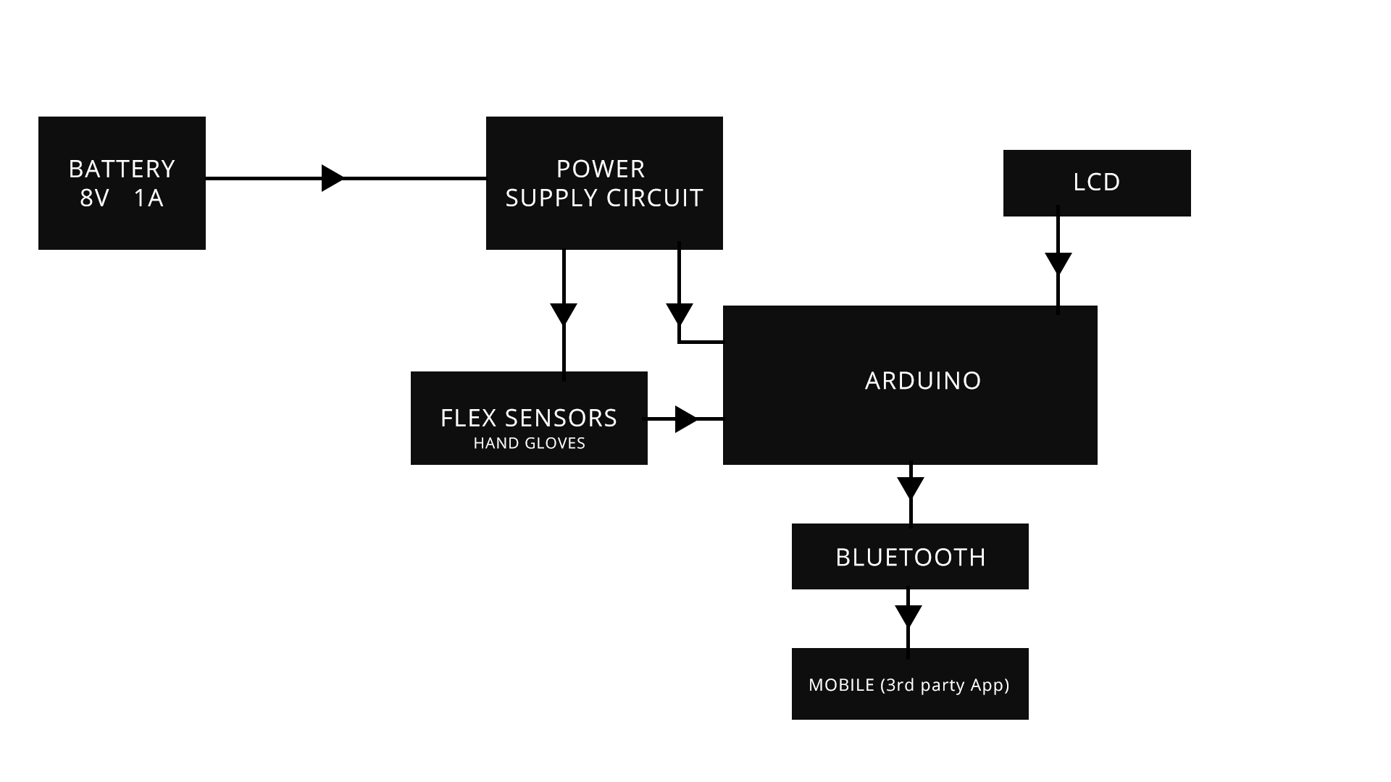

**TABLE**

|  |  |  |  |  |  |
| --- | --- | --- | --- | --- | --- |
| Character | Pinky  (16) | Ring Finger  ( 8 ) | Middle finger  ( 4 ) | Index finger  ( 2 ) | Thumb  ( 1 ) |
| A | 0 | 0 | 0 | 0 | 0 |
| B | 0 | 0 | 0 | 0 | 1 |
| C | 0 | 0 | 0 | 1 | 0 |
| D | 0 | 0 | 0 | 1 | 1 |
| E | 0 | 0 | 1 | 0 | 0 |
| F | 0 | 0 | 1 | 0 | 1 |
| G | 0 | 0 | 1 | 1 | 0 |
| H | 0 | 0 | 1 | 1 | 1 |
| I | 0 | 1 | 0 | 0 | 0 |
| J | 0 | 1 | 0 | 0 | 1 |
| K | 0 | 1 | 0 | 1 | 0 |
| L | 0 | 1 | 0 | 1 | 1 |
| M | 0 | 1 | 1 | 0 | 0 |
| N | 0 | 1 | 1 | 0 | 1 |
| O | 0 | 1 | 1 | 1 | 0 |
| P | 0 | 1 | 1 | 1 | 1 |
| Q | 1 | 0 | 0 | 0 | 0 |
| R | 1 | 0 | 0 | 0 | 1 |
| S | 1 | 0 | 0 | 1 | 0 |
| T | 1 | 0 | 0 | 1 | 1 |
| U | 1 | 0 | 1 | 0 | 0 |
| V | 1 | 0 | 1 | 0 | 1 |
| W | 1 | 0 | 1 | 1 | 0 |
| X | 1 | 0 | 1 | 1 | 1 |
| Y | 1 | 0 | 0 | 0 | 0 |
| Z | 1 | 0 | 0 | 0 | 1 |

**DATA FLOW DIAGRAM:**

The following diagram show the processing of the data throughout the Hadoop system.

# LEVEL 0 DFD

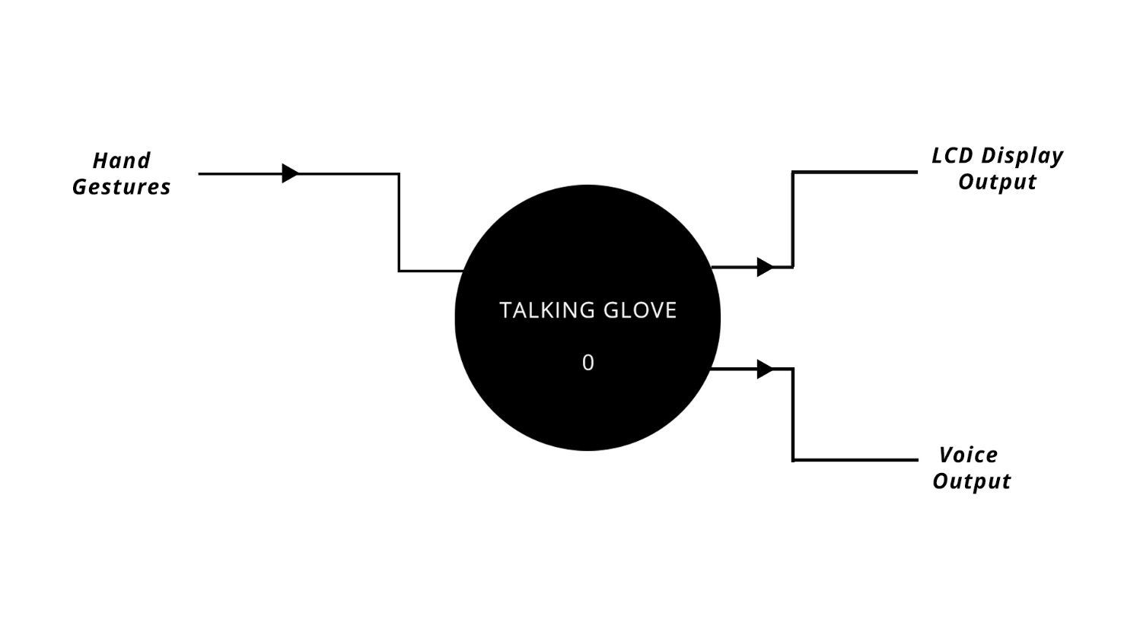

# LEVEL 1 DFD

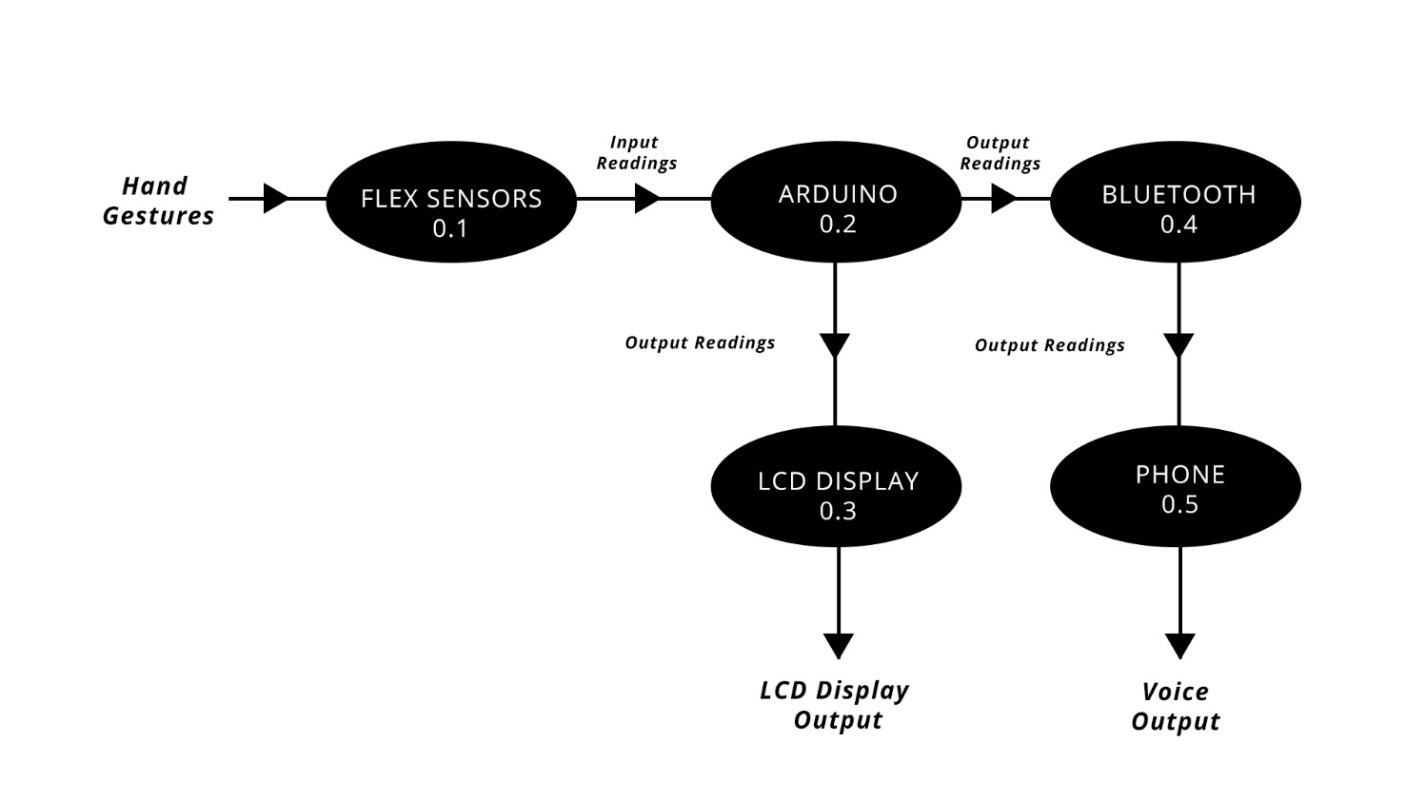

# PSEUDOCODE OF PROJECT

In this section I define the code for the project in and I am going to explain the working of code and its proper functioning .

#include <LiquidCrystal.h> //it is pre define lib for lcd

LiquidCrystal lcd(8,7,6,5,4,3); //digital pin used for reading

int thumb=A4;

int index=A3;

int middle=A2;

int ring=A1;

int little=A0;

bool flag = true;

bool steadyValue = false;

unsigned long time_old = 0;

int j = 0;

unsigned int thumb_threshold = 0;

unsigned int index_threshold = 0;

unsigned int middle_threshold = 0;

unsigned int ring_threshold = 0;

unsigned int little_threshold = 0;

int decVal;

char lookupTable[]={97,98,99,100,101,102,103,104,105,106,107,108,109,110,111,112,113,114,115,116,117,118,119,120,121,122,121,121,46,121,120,32};

int digiStore[5];

int temp[5];

char words[100];

char string[10];

void calibrate()

{

lcd.begin(16,2);

lcd.setCursor(0,0);

lcd.print("GESTURE TO " );

lcd.setCursor(0,1);

lcd.print("SPEECH CONVERTER" );

delay(2000);

lcd.clear();

lcd.setCursor(0,0);

lcd.print("Bend fingers");

delay(2000);

lcd.clear();

lcd.print("Starting Calibration ....");

lcd.clear();

lcd.print("Bend fingers");

delay(5000);

int t_low=analogRead(thumb);

int i_low=analogRead(index);

int m_low=analogRead(middle);

int r_low=analogRead(ring);

int l_low=analogRead(little);

lcd.clear();

lcd.setCursor(0,0);

lcd.print("Un-bend fingers");

delay(5000);

int t_high=analogRead(thumb);

int i_high=analogRead(index);

int m_high=analogRead(middle);

int r_high=analogRead(ring);

int l_high=analogRead(little);

thumb_threshold = (t_low + t_high)/2;

index_threshold = (i_low + i_high)/2;

middle_threshold = (m_low + m_high)/2;

ring_threshold = (r_low + r_high)/2;

little_threshold = (l_low + l_high)/2;

delay(1000);

Serial.print("HELLO WELCOME ");

delay(1000);

Serial.print("TO TALKING GLOVE");

lcd.clear();

}

void setup() {

// put your setup code here, to run once:

Serial.begin(9600);

pinMode(thumb, INPUT);

pinMode(index, INPUT);

pinMode(middle, INPUT);

pinMode(ring, INPUT);

pinMode(little, INPUT);

calibrate();

}

void loop() {

// put your main code here, to run repeatedly:

// char sentence[50];

delay(1000);

int t=analogRead(thumb);

if(t>=thumb_threshold){

digiStore[0]=1;

}

else{

digiStore[0]=0;

};

int i=analogRead(index);

if(i>=index_threshold){

digiStore[1]=1;

}

else{

digiStore[1]=0;

};

int m=analogRead(middle);

if(m>=middle_threshold){

digiStore[2]=1;

}

else{

digiStore[2]=0;

};

int r=analogRead(ring);

if(r>=ring_threshold){

digiStore[3]=1;

}

else{

digiStore[3]=0;

};

int l=analogRead(little);

if(l>=little_threshold){

digiStore[4]=1;

}

else{

digiStore[4]=0;

};

if(flag)

{

for(int k = 0; k<5; k++)

{

temp[k] = digiStore[k];

}

flag = false;

time_old = millis();

}

if(!flag)

{

if(millis() - time_old > 1100)

{

if(temp[0] == digiStore[0] && temp[1] == digiStore[1] && temp[2] == digiStore[2] && temp[3] == digiStore[3] && temp[4] == digiStore[4])

steadyValue = true;

else

steadyValue = false;

if(steadyValue)

{

decVal=16*digiStore[0]+8*digiStore[1]+4*digiStore[2]+2*digiStore[3]+1*digiStore[4];

//Serial.println(decVal);

if(j!= 0 && words[j-1] == 32 && decVal == 31)

{

}

else

{

words[j]=lookupTable[decVal];

// Serial.println(words[j]);

lcd.print(words[j]);

j++;

if(decVal == 31)

{

for(int k = 0; ;k++)

{

if(words[k]!= 32)

Serial.print(words[k]);

else

{

Serial.println("");

break;

}

}

}

if(decVal == 28)

{

for(int k = 0; ;k++)

{

if(words[k]!= 46)

Serial.print(words[k]);

else

{

Serial.print(words[k]);

words[k+1] = '\0';

Serial.println("");

strcpy(string,words);

j = 0;

break;

}}}}

time_old = millis();

steadyValue = false;

flag = true;

}

}}}

# GANTT CHART

The following Chart will tell us how I used this six weeks in my training to learn this technology and develop a proof of concept. There were seven topics according to the syllabus to be covered in this training. First it was the introductory session to IOT and Arduino than we get some over view on electronics component we work on proteus8 software we understand the working of GSM , Bluetooth ,wifi model and to connect it with Arduino uno .

# SIX WEEK SUMMER TRAINING GANTT CHART

|  |  |  |  |  |  |  |
| --- | --- | --- | --- | --- | --- | --- |
| **Activities** | **WEEK 1** | **WEEK 2** | **WEEK 3** | **WEEK 4** | **WEEK 5** | **WEEK 6** |
| Introduction to  IOT and  Arduino. |  |  |  |  |  |  |
| Introduction to electronics component |  |  |  |  |  |  |
| Working of  Arduino |  |  |  |  |  |  |
| GSM &Bluetooth |  |  |  |  |  |  |
| WiFi |  |  |  |  |  |  |
| Project And analysis |  |  |  |  |  |  |
| Report &  Presentation |  |  |  |  |  |  |

**BIBLOGRAPHY**

* <https://www.arduino.cc/en/Tutorial/HomePage>
* <http://www.tutorialspoint.com/arduino/>
* <http://www.ladyada.net/learn/arduino/>
* <http://discuss.littlebits.cc/t/introduction-to-arduino-programming-1-the-basics/22237>
* <http://forefront.io/a/beginners-guide-to-arduino/>
* <https://roboindia.com/tutorials/arduino>
* <https://learn.sparkfun.com/tutorials/tags/arduino?page=all>
* <http://www.robotshop.com/blog/en/arduino-5-minute-tutorials-lesson-2-basic-code-blink-led-2-3639>