**SECD 2613-15 SYSTEM ANALYSIS AND DESIGN**

**2023/2024 – SEMESTER 2**

**PROJECT PROPOSAL**

**RECIPE MANAGER**

**FACULTY OF MJIIT**

**Section 16**

**Supervised by: Dr Amy Hamidah**

**GROUP 1**

|  |  |
| --- | --- |
| **NAME** | **MATRIC ID** |
| HASAN AMMAR ABDULAZIZ AL-TALIB | A23MJ0018 |
| Mohamed G. S. Elmasharawi | A23MJ0009 |
| MAAROF SAQR YOUSEF HASAN | A23MJ4006 |

**Supervised By: Dr Amy Hamidah**

**Group**

**TABLE OF CONTENTS**

**1.0** **EXECUTIVE SUMMARY** 3

**2.0** **BACKGROUND** 3

**3.0** **OBJECTIVES** 3,4

**4.0** **AGILE METHODOLOGY** 4,5

**5.0** **RESOURCES** 5,6

**6.0** **BUDGET** 6,7

7.0  **MEASURMENT AND REPORTING**………………………………………………………………7

**8.0**   **RISKS**……………………………………………………………………………………………………8

**1.0 Executive Summary:**

Our proposal is creating a Recipe Manager application for users who will be able to collect, sort out and get access to their selected recipes. The culinary field has recently witnessed an upsurge in home-cooking. This together with a number of online recipes means that there is a clear need for a vacuum to coordinate kitchen activities optimally. With our Recipe Manager, users will have an ability to input data, modify, delete, and look for recipes based on either ingredients or categories. Our application plan is all about simplifying recipe management so as to empower the cooking process, expand users' culinary horizons and finally relieve their cookery burden.  
  
  
**2.0 Background:**

An organization known as ours, specialized in innovative software development, with a record of successful deployment of user-focused applications that aim to simplify the execution of complicated tasks. At the same time, we identify a rapid growth in the number of those who seek helpers in efforts to discover the possibilities of cooking art and to maintain order and clarity of their own kitchen gadgets. As enthusiasts of cooking we have also come across the difficulties that come with trying to hold recipes that have been scattered across mobile apps and sites. The Recipe Manager that we have envisaged is designed to meet these problems by having a simple user interface and a powerful feature set that can help in simplifying the procedure of storing and browsing recipes.  
  
  
**3.0 Objectives:**  
  
  
1. Centralized Recipe Management: Build a user-friendly interface that provides users with the ability to store their recipes, categorize them, and find them at the same place.  
  
2. Efficient Recipe Editing: Implement the features necessary for users can easily make, edit and delete recipes, allowing for the customization that guarantees a full personalization based on preferences.  
  
3. Intuitive Search Functionality: Integrate advanced search possibilities, allowing users to look up a recipe using a search filter by ingredients, categories, or keywords.  
  
4. Enhanced User Experience: Ensure ease of user experience bringing together simplistic design, user friendly navigation, and responsive performance across multiple platforms and devices.  
  
5. Promotion of Culinary Exploration: Encourage food exploration by permitting people to provide their friend's top recipes.  
  
6. Integration with Social Platforms: Consider applying social media platforms along with cooking recipes for groups integration, creating a community and support process for the users.  
  
7. Data Security and Privacy: Provide strong data security features to preserve users and recipes. Explain encryption, authentication and the regular security updates, among others.  
  
8. Scalability and Adaptability: Engineer the application architecture to have the ability to schedule upgrade, improvement, enhanced features plus scalability based on future users' needs and consequent technology progression.  
  
  
  
The aim that is sought to be achieved by our Recipe Manager is to fill in the gap that has been created due to the lack of recipe organization along with making a contribution towards vision of the organization that of empowering the users through digital solutions that are innovative and superior.

**4.0 Agile Methodology:**

The Recipe Manager project intends to produce an online and mobile application that will enable users to create, store, organize, and share recipes. The program will have user authentication, a searchable recipe database, the option to create personalized recipe collections, and social elements for sharing recipes with friends and family.

1. Sprint Planning:

* The duration of this phase will be 2 weeks. In this phase, a plan meeting will occur in the beginning of each sprint.
* Define the user stories and tasks for the forthcoming sprint using the product backlog.
* Sprint Backlog outlines the tasks to be done throughout the sprint.

1. Daily Stand-ups:

* Daily Stud-ups should occur, and it is preferred to be early.
* The duration will be around 20 minutes.
* Share progress updates, talk about any roadblocks, and prepare for the day.
* Each team member should provide answers to three questions: What did I do yesterday? What shall I do today? Any obstacles?

1. Sprint reviews:

* Review sessions ought to take place following each sprint.
* Sprint Review Meeting.
* Present finished user stories and get input from relevant parties.
* Feedback gathered for improvements shippable product increments and enhancements.

1. Sprint Retrospective:

* At the end of each sprint, after the Sprint Review.
* Retrospective Sprint Meetings every while to check up progress
* Examine the sprint procedure and note what worked, what needs improvement, and what concrete steps need to be taken for the following sprint.
* Process improvement action items are recorded, with modifications to be made for the upcoming sprint.

1. Iterative Development and testing:

* With each sprint, strive to deliver tiny, incremental enhancements as you develop the application.
* Regularly get input from stakeholders so that modifications and revisions can be incorporated into later iterations.
* Embrace change and adapt to evolving requirements throughout the development process.

**5.0 RESOURCES**

**Human Resources:**

* Project Manager
* Developers
* UX Designer
* Quality Assurance/Testers
* Scrum Master (if following Scrum methodology)

**Technical Resources:**

* Development Tools
* Server Infrastructure
* Database Management System
* Testing Tools

**Financial Resources:**

* Budget
* Funding Source

**Training and Support:**

* Training Plan
* Support Plan

**Legal and Compliance:**

* Intellectual Property
* Privacy and Data Security

**Risk Management:**

* Risk Register

**Communication Plan:**

* Communication Channels
* Stakeholder Engagement

**Appendices:**

* Any further supporting documents, diagrams, figures, or mockups for your idea.

**6.0 Budget:**  
  
1. Development Costs:  
  
* Software Development: $15,000  
  
* UX/UI Design: $8,000  
  
* Testing and Quality Assurance: $5000  
  
* Integration with Cloud Services: >>>$3,000  
  
2. Launch and Marketing Costs:2. Launch and Marketing Costs:  
  
* App Store Fees: $5.00  
  
* Marketing Campaigns: $10,000  
  
* Social Media Advertising: £ 5000  
  
3. Maintenance and Support Costs:3. Maintenance and Support Costs:  
  
* Server Hosting (per year): $2K  
  
* Ongoing Development (per year): $10K  
  
* Customer Support (per year): 5,000 $  
  
4. Contingency Fund:  
  
* Contingency: $3,000  
  
5. Total Budget:  
  
* Total Estimated Budget: $ 80 000  
  
  
This budget is dedicated to the production, launch, and maintenance of the Recipe Manager application, a solution that is planned to fulfill target users' needs through an optimized application. The adjustments will be made according to the specific need or the pre-existing preference.  
  
  
**7.0 Measurement and reporting:**

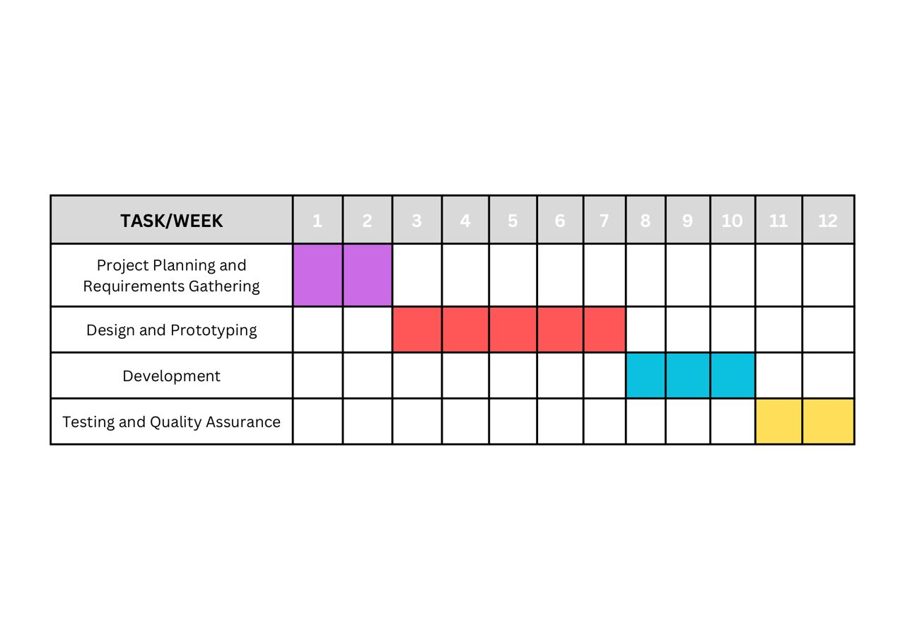

**8.0 Risks:**  
  
  
Here are some potential risks associated with developing a Recipe Manager application:Here are some potential risks associated with developing a Recipe Manager application:  
  
1. Technical Challenges: Challenges which are featured in managing different elements where recipe editing, searching are involved as examples.  
  
1. Data Security Concerns: The contents created, “User-generated” including “recipes”, must keep up with “robust data security” measures which will protect “user privacy” and prevent” unauthorized access”.  
  
2. User Adoption: The users need to be readily adopting the idea for there to be a success. Too complex or an application that does not address user concerns may lead to a lack of interest for the customers and loss of future users.  
  
3. Competitive Landscape: The current recipe management applications might have already spent long years building user base and maintaining a community. A major challenge would be to bring something significant to the table while there are many other market players.  
  
4. Platform Compatibility: It may be formally challenging to make sure that the products work seamlessly across different operating systems (iOS, Android, web) and it can be time-consuming to achieve the very same level of compatibility as the large tech corporations.  
  
5. Legal and Copyright Issues: This may involve cooking recipes being copyrighted and individuals unwittingly, for example, share this copyrighted content. Legal issues and copyright laws related compliance should are always the top priority.  
  
6. Data Integrity: A thorough recipe data area that contains precise ingredient portions and instructions is critical for user contentment Bugs or any grams thus may create doubt among users.