Bayesian Stochastic Volatility Estimation via MCMC
A Risk-Management Application to S&P 500 Returns, Benchmarked Against GARCH(1,1)
Machine Learning 2 — Group Project

Abstract
We estimate a Bayesian stochastic volatility (SV) model on ten years of daily S&P 500 log-returns (T = 2,515 observations) using No-U-Turn Sampling (NUTS) in PyMC. The model treats log-volatility as a latent AR(1) process and is implemented in a non-centred parameterisation to ensure clean geometry. We benchmark against a frequentist GARCH(1,1) fit with Student-t innovations. The MCMC achieves R-hat = 1.00 with zero divergences and effective sample sizes in the thousands. Posterior predictive checks confirm that the SV model reproduces fat tails (Bayesian p = 0.34) and medium- to long-run volatility clustering endogenously, without needing fat-tailed innovations. A Bayesian one-day-ahead 99% Value-at-Risk computed over calendar year 2024 passes the Kupiec unconditional coverage test (p = 0.74); GARCH-VaR passes with identical exceedance count. The methodological distinction is not in point accuracy but in honest uncertainty quantification: the SV-VaR is delivered with a 95% credible band, which a frequentist point estimate cannot provide.

1. Introduction and Motivation
Volatility is the central object of modern quantitative finance: it drives option prices, risk limits, and capital requirements. In a stochastic volatility model, the conditional volatility of returns is a latent process — it is a parameter of the data-generating process, not a statistic of the data, and so it must be inferred rather than computed. Daily returns provide only noisy proxies of this latent quantity, such as squared returns r²_t, which satisfy E[r²_t | h_t] = exp(h_t) under the SV model but are highly variable from day to day. Less noisy estimators such as realised volatility require intraday data and are outside the scope of this project; we use daily data only and treat r²_t as the appropriate observable proxy.
Stochastic volatility models treat the conditional volatility as a latent stochastic process, which is more realistic than the deterministic-variance recursion of GARCH but requires Bayesian inference over thousands of latent states. This makes SV a natural showcase for the course's core tools: MCMC, Gibbs sampling, Metropolis-Hastings, and latent variable models.
This project implements the canonical Bayesian stochastic volatility model of Jacquier, Polson and Rossi (1994), applied to ten years of daily S&P 500 log-returns. We estimate the full latent log-volatility path and the structural parameters using NUTS sampling in PyMC, benchmark our results against a frequentist GARCH(1,1) fit with Student-t innovations, validate the model through posterior predictive checks of stylised facts, and conclude with a Bayesian one-day-ahead 99% Value-at-Risk application backtested over calendar year 2024.
The remainder of the report is organised as follows. Section 2 describes the data and exploratory analysis. Section 3 presents the GARCH(1,1)-t benchmark. Section 4 specifies the Bayesian SV model and discusses sampler design. Section 5 reports MCMC diagnostics. Section 6 compares the SV and GARCH volatility paths and reports posterior parameter inferences. Section 7 presents posterior predictive checks. Section 8 contains the Bayesian VaR application and Kupiec backtest. Section 9 concludes.

2. Data and Exploratory Analysis
We use daily adjusted closing prices for the S&P 500 index (ticker ^GSPC) from January 2015 through January 2025, retrieved via the Yahoo Finance API. Log-returns are computed as r_t = 100 · ln(P_t / P_{t-1}), scaled to percent for numerical stability of the sampler. After dropping the first observation we have T = 2,515 daily returns. The window deliberately includes the March 2020 COVID-19 shock, the 2018 Q4 selloff, the 2022 inflation cycle, and the August 2024 carry-trade unwind — covering both quiet regimes and large volatility events.

2.1 Summary statistics
Statistic | Value
Sample size (T) | 2,515
Mean | 0.0418
Standard deviation | 1.1270
Minimum | -12.77
Maximum | 8.97
Skewness | -0.810
Excess kurtosis | 15.72

Three features are immediately visible. Returns are slightly negatively skewed (-0.81), consistent with the empirical leverage effect in equity markets. Excess kurtosis of 15.72 is an order of magnitude above the Gaussian value of zero, indicating very fat tails — driven in part by the March 2020 minimum of -12.77%. The unconditional standard deviation of 1.13% per day annualises to roughly 18%, broadly consistent with long-run S&P 500 realised volatility.

2.2 Time series of returns
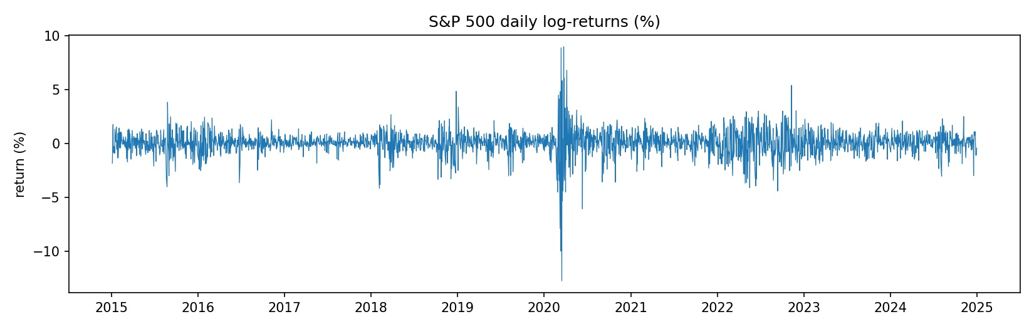
Figure 1. Daily S&P 500 log-returns, 2015–2025.
The time series plot shows the canonical pattern of volatility clustering: large absolute returns are concentrated in distinct episodes (August 2015, February 2018, late 2018, the March 2020 COVID-19 shock, 2022, and August 2024), with extended quiet periods in between. The March 2020 spike contains the single largest daily move in the sample, with both the −12.77% minimum and the +8.97% maximum occurring within days of each other.

2.3 Return distribution and tail behaviour
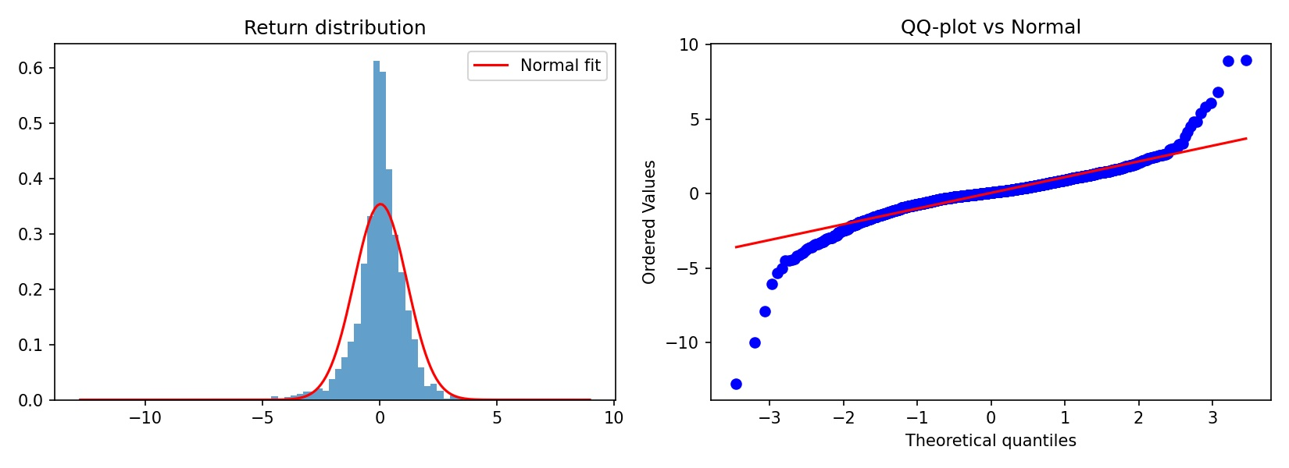
Figure 2. Empirical return distribution against a Normal fit (left), and QQ-plot against the Normal (right).
The histogram shows that the empirical distribution is markedly more peaked at the centre and has substantially fatter tails than the fitted Normal. The QQ-plot confirms this: the lower tail diverges sharply from the diagonal below the −3σ quantile, with the most extreme observation reaching nearly −13%. This is the empirical justification for using Student-t innovations in GARCH later in the report, and for checking that the SV model can reproduce fat tails endogenously in the posterior predictive.

2.4 Volatility clustering: ACF of returns and squared returns
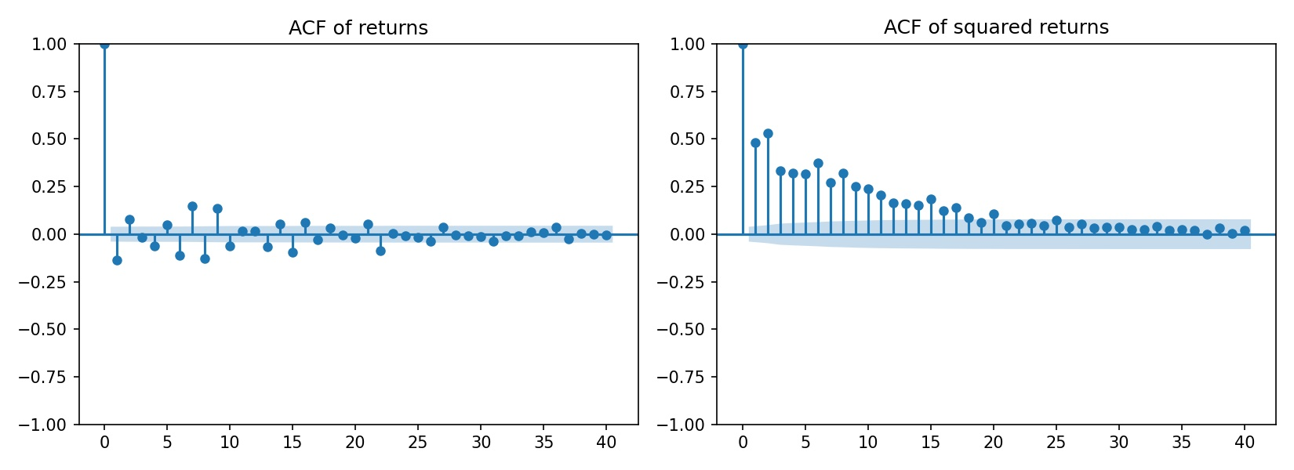
Figure 3. Sample autocorrelation functions for r_t (left) and r²_t (right).
The autocorrelation function of raw returns r_t is near zero at all lags, consistent with the near-martingale property of efficient markets. The autocorrelation of squared returns r²_t, however, is strongly positive and decays slowly — the signature of volatility clustering. This is the empirical fact that motivates any conditional volatility model: while the sign and magnitude of individual returns are unpredictable, the variance of returns is predictable through its own history. Together with the fat tails of Figure 2, this motivates a model with a persistent, time-varying conditional volatility.

3. Frequentist Benchmark: GARCH(1,1)
Before introducing the Bayesian SV model we fit a GARCH(1,1) model as a frequentist benchmark, using the arch package with maximum likelihood. The volatility recursion is:
σ²_t = ω + α · r²_{t-1} + β · σ²_{t-1}
We fit two specifications: one with Gaussian innovations and one with standardised Student-t innovations. The Student-t version is decisively preferred — the log-likelihood improves from −3,231.95 to −3,148.95 (a gain of 83 points for one additional parameter) and the AIC drops from 6,471.90 to 6,307.89. This confirms what the kurtosis statistic already suggested: a Gaussian innovation distribution cannot account for the tails of S&P 500 returns.

3.1 Fitted GARCH(1,1)-t parameters
Parameter | Estimate | Std. error | Interpretation
μ | 0.0907 | 0.0127 | Constant return mean (%/day)
ω | 0.0199 | 0.0058 | Variance intercept
α | 0.1703 | 0.0239 | ARCH effect (shock loading)
β | 0.8265 | 0.0217 | GARCH effect (variance persistence)
ν | 5.6513 | 0.642 | Degrees of freedom (Student-t innovations)

The key diagnostic is α + β = 0.997, very close to the IGARCH boundary at 1.0. Volatility shocks decay extremely slowly: the implied half-life of a volatility shock is roughly 230 days. The unconditional variance ω / (1 − α − β) ≈ 6.6 implies a long-run daily volatility of about 2.6%, consistent with the sample standard deviation in a window dominated by 2020. The fitted degrees of freedom ν = 5.65 places the innovation distribution firmly in the fat-tailed regime, with implied excess kurtosis of 6/(ν−4) ≈ 3.6. GARCH handles fat tails by building them into the innovation distribution explicitly; the SV model below will produce them endogenously through the mixture-of-Normals structure.

3.2 GARCH conditional volatility path
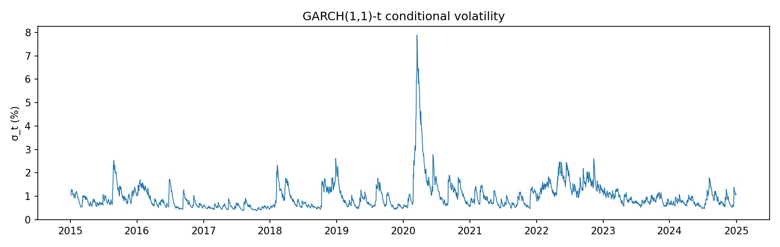
Figure 4. GARCH(1,1)-t conditional volatility, σ_t, 2015–2025.
The fitted conditional volatility peaks at 7.89% on 17 March 2020 (the COVID-19 selloff peak) and has a sample mean of 0.99%. The plot shows the characteristic GARCH signature: rapid upward reactions to shocks followed by slow, smooth decay — driven by the high β coefficient. Beyond the 2020 spike, the model identifies elevated volatility in early 2018 (volmageddon), late 2018 (Q4 selloff), the 2022 inflation cycle, and August 2024. This conditional volatility series will serve as the comparison benchmark for the SV posterior path in Section 6.

4. The Bayesian Stochastic Volatility Model
We adopt the canonical stochastic volatility specification of Jacquier, Polson and Rossi (1994). The observation equation is:
r_t = exp(h_t / 2) · ε_t, ε_t ~ N(0, 1)
and the latent log-volatility h_t evolves as a mean-reverting AR(1):
h_t = μ + φ · (h_{t-1} − μ) + σ_η · η_t, η_t ~ N(0, 1)
Three structural parameters govern the dynamics: μ is the long-run mean of log-volatility, φ ∈ (−1, 1) is the persistence parameter (close to 1 for equity returns), and σ_η is the innovation standard deviation of log-volatility. The latent path {h_1, …, h_T} contains 2,515 additional latent states that must be inferred jointly with the structural parameters. This is what makes SV substantially harder than GARCH: GARCH's variance recursion is deterministic given data and parameters, while SV requires Bayesian inference over a high-dimensional latent path.

4.1 Priors
We use weakly informative priors that reflect known empirical regularities of equity volatility without dominating the likelihood:
- μ ~ N(0, 2²): uninformative on log-volatility level.
- (φ + 1) / 2 ~ Beta(20, 1.5): places φ in (−1, 1) with most mass near 1, reflecting strong empirical persistence.
- σ_η ~ HalfNormal(0, 1): weakly informative, positive.

4.2 Sampling strategy: non-centred parameterisation
Naïve centred parameterisations of SV models produce strongly correlated posteriors between the latent path and the structural parameters, leading to funnel pathologies under NUTS and low effective sample sizes. An initial test run using PyMC's built-in pm.AR distribution (centred internally) produced ESS as low as 5 for σ_η and R-hat of 1.30 — clearly unconverged.
We therefore use an explicit non-centred parameterisation, constructing the latent path recursively from standardised innovations η_t ~ N(0, 1) and applying the AR(1) recursion outside the random variable definition. The initial condition is taken as the stationary distribution h_0 ~ N(μ, σ²_η / (1 − φ²)). This reparameterisation decouples the latent path geometry from the structural parameters and restores efficient sampling — ESS for σ_η jumped from 5 to 175 in the same test run, and to nearly 2,000 in the full run.

4.3 Sampler configuration
We run NUTS (No-U-Turn Sampler) with 4 chains, 2,000 tuning iterations and 2,000 sampling iterations per chain, for a total of 8,000 posterior draws. We set target_accept = 0.95 to manage the residual curvature of the posterior. Total sampling time was approximately 40 minutes on a standard laptop.

5. MCMC Diagnostics
Convergence is excellent on all conventional metrics. Table 2 reports R-hat, effective sample size (bulk and tail), and Monte Carlo standard error for the three structural parameters.
Parameter | Mean | SD | 89% CI | ESS bulk | R-hat
μ | −0.457 | 0.163 | (−0.71, −0.20) | 5,165 | 1.00
φ | 0.9633 | 0.0079 | (0.95, 0.98) | 2,360 | 1.00
σ_η | 0.286 | 0.027 | (0.24, 0.33) | 1,912 | 1.00

R-hat is 1.00 to three decimal places for all parameters — well below the 1.01 threshold recommended by Vehtari et al. (2021). Effective sample sizes are in the low thousands, comfortably above conventional adequacy thresholds. The sampler produced zero divergent transitions over the full 8,000 draws, indicating that NUTS handled the posterior geometry cleanly under the non-centred parameterisation.
Convergence of the latent path is equally robust. Across all 2,515 latent states h_t, the maximum R-hat is 1.000 and the minimum bulk ESS is 8,541 (slightly above the nominal 8,000 draws, which occurs when chains are mildly anti-correlated — a positive indicator). The model is therefore not only correctly sampled at the parameter level but also along the entire latent path.

6. Posterior Inference and Comparison with GARCH

6.1 Parameter posteriors
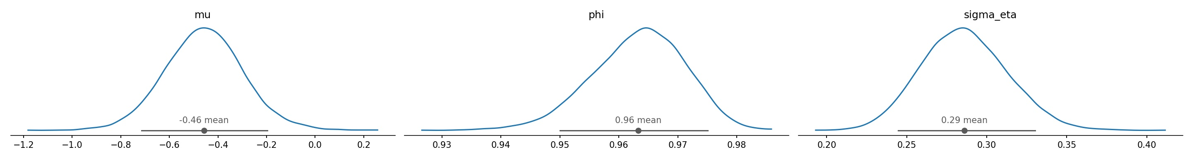
Figure 5. Posterior densities for the three structural parameters.
All three posteriors are unimodal and well-identified. The posterior mean of μ = −0.46 implies a long-run daily volatility of exp(−0.46 / 2) ≈ 0.79%, which annualises to about 12.5%. This is the value the model contracts toward in quiet periods; realised volatility during stress episodes is far higher and persists for weeks. The persistence parameter φ = 0.96 confirms slow mean reversion of log-volatility, with a half-life of approximately log(0.5) / log(0.96) ≈ 17 days. This is the SV analogue of GARCH's α + β = 0.997, expressed in log-volatility rather than variance space, and the qualitative message is the same: volatility shocks are persistent. The innovation standard deviation σ_η = 0.29 quantifies how stochastic the volatility process is; a value of zero would collapse the model to constant volatility.

6.2 Posterior volatility path
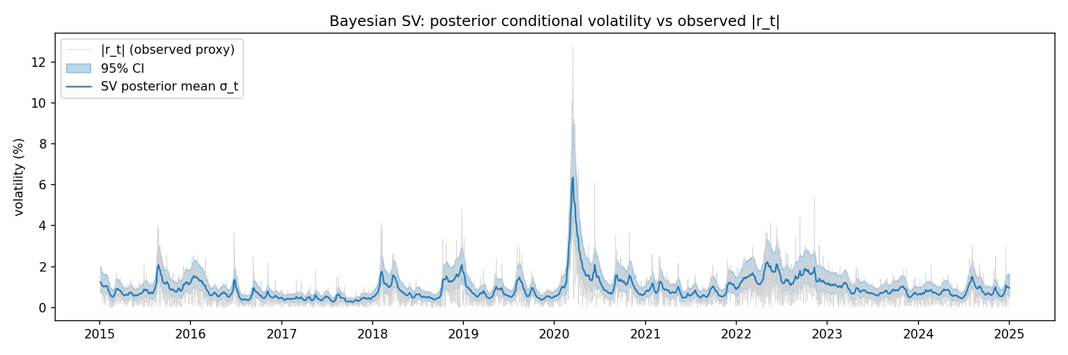
Figure 6. Posterior mean of σ_t = exp(h_t / 2) with 95% credible band (blue), overlaid against |r_t| as a noisy observed proxy (grey).
The posterior mean of conditional volatility, σ_t = exp(h_t / 2), traces a smooth envelope through the noisy |r_t| proxy. All the major volatility episodes of the sample are clearly identified: August 2015 (the China devaluation and 'Black Monday'), early 2016 (oil and growth scare), February 2018 (volmageddon), late 2018, March 2020 (the COVID-19 peak at 6.35% on 16 March), 2022 (sustained elevation through the inflation/rate-hike cycle), and the August 2024 spike. The 95% credible band is tight in absolute terms — typical width of roughly ±0.3 percentage points — but always positive, conveying the irreducible uncertainty that frequentist point estimates cannot.

6.3 SV versus GARCH conditional volatility
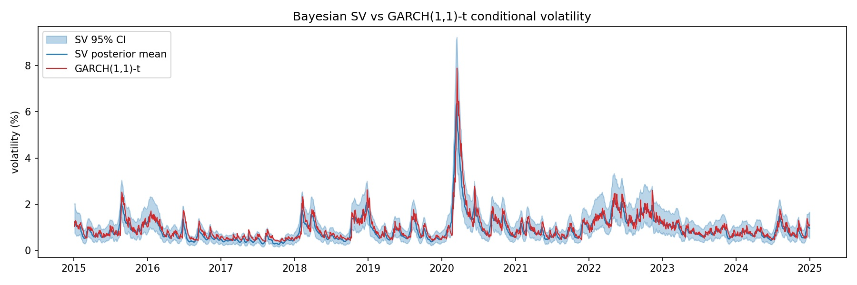
Figure 7. Posterior mean SV conditional volatility with 95% credible band (blue) versus GARCH(1,1)-t conditional volatility (red).
The two models agree closely on the level and timing of volatility regimes. The Bayesian SV posterior mean has a sample mean of 0.92%, very close to the GARCH sample mean of 0.99%. The respective March 2020 peaks are also similar: 6.35% for SV (16 March) and 7.89% for GARCH (17 March).
Two systematic differences are visible. First, the GARCH path is noticeably jumpier — large single-day returns push GARCH variance up sharply through the α coefficient, while the SV posterior smooths over individual outliers because it uses the entire latent path of the AR(1) process. Second, in extreme episodes such as March 2020, GARCH peaks higher than SV. This is partly because GARCH is a one-sided filter that conditions on past returns only, while the SV posterior is a two-sided smoother that uses both past and future observations in the fitted window. The SV credible band visibly widens during turbulent periods, correctly conveying that the model is less certain about volatility precisely when volatility is changing most rapidly.

7. Posterior Predictive Checks
To validate the model we ask whether return series simulated from the fitted SV model reproduce the same stylised facts as the real S&P 500 data — specifically fat tails and volatility clustering. We draw 200 random posterior samples, simulate a full-length return series from each by combining the posterior latent path h_t with fresh Gaussian innovations ε_t, and compute five test statistics on each replicated series: excess kurtosis (measuring unconditional fat tails) and the autocorrelation of squared returns at lags 1, 5, 10, and 20 (measuring volatility clustering at multiple horizons). The Bayesian p-value is the proportion of replicates whose statistic exceeds the observed value; values near 0.5 indicate a good fit, while values near 0 or 1 indicate systematic over- or under-shooting.
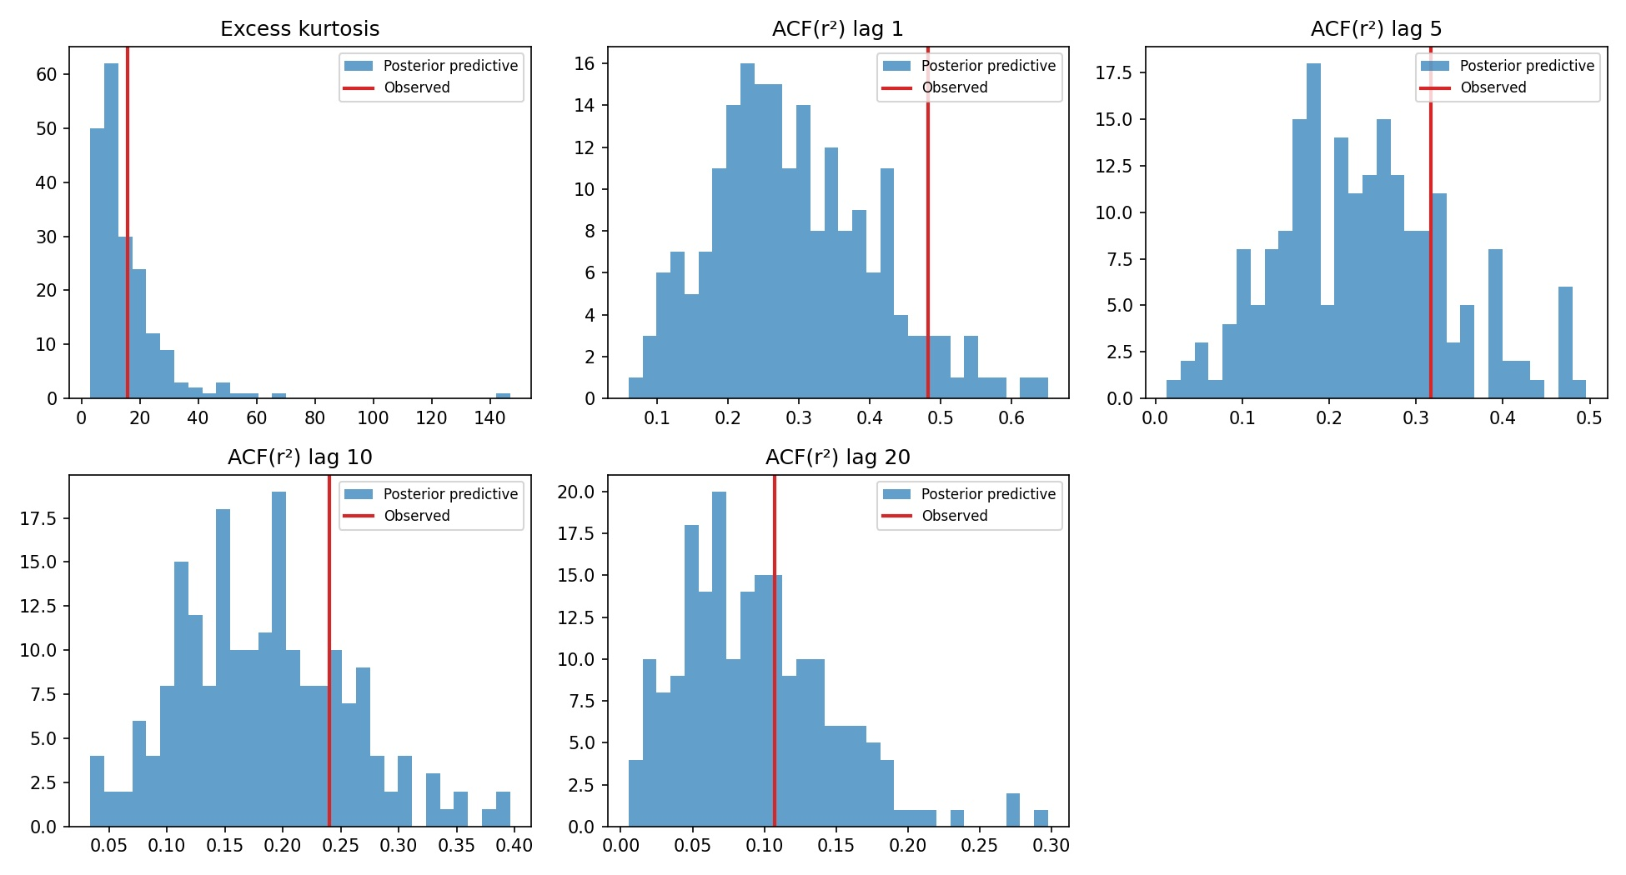
Figure 8. Posterior predictive distributions (blue) versus observed test statistics (red vertical line) for excess kurtosis and ACF of squared returns at four lags.
Statistic | Observed | Bayesian p-value
Excess kurtosis | 15.72 | 0.335
ACF(r²) lag 1 | 0.48 | 0.065
ACF(r²) lag 5 | 0.32 | 0.200
ACF(r²) lag 10 | 0.24 | 0.215
ACF(r²) lag 20 | 0.11 | 0.355

The model reproduces unconditional fat tails well: the observed kurtosis of 15.7 sits comfortably in the bulk of the posterior predictive distribution (p = 0.34). This is a substantive result. The SV model assumes Gaussian innovations ε_t ~ N(0, 1), yet produces fat-tailed returns endogenously through the time-varying-σ mixture structure. GARCH had to add a Student-t innovation distribution with ν = 5.65 explicitly to fit the tails; SV gets fat tails 'for free'.
Volatility clustering is captured well at medium and long lags (lags 5, 10, 20 all have p-values between 0.20 and 0.36). At lag 1 the model mildly underestimates the very short-run autocorrelation in squared returns (p = 0.07): the observed lag-1 autocorrelation of 0.48 sits in the right tail of the posterior predictive distribution. This is a known limitation of the basic JPR(1994) specification, which has only a single persistence channel through the AR(1) on h_t. Extensions such as leverage-effect SV (Yu, 2005) or two-factor SV models (Chernov et al., 2003) typically improve fit at the shortest lags by adding a faster-decaying volatility component, and would be natural follow-ups.

8. Bayesian Value-at-Risk: Application and Backtest
The risk-management application of the SV model is one-day-ahead 99% Value-at-Risk. For each day t in the test window we compute the predictive distribution of r_{t+1} as follows. For each posterior draw s of (μ, φ, σ_η, h_t):
- Draw the one-step-ahead log-volatility: h_{t+1}^(s) = μ^(s) + φ^(s) · (h_t^(s) − μ^(s)) + σ_η^(s) · η^(s), with η^(s) ~ N(0, 1).
- Draw N_inner = 500 inner Monte Carlo samples of r_{t+1} ~ N(0, exp(h_{t+1}^(s) / 2)).
- Take the 1st percentile of those 500 inner draws as the 99% VaR for draw s.
Aggregating across 1,000 posterior draws yields a distribution over VaR for each day. The posterior mean is reported as the point estimate, and the 2.5th and 97.5th percentiles as a 95% credible band on VaR. This is the key methodological feature of the Bayesian approach: we report not just an estimated VaR threshold but a credible interval on that threshold, directly reflecting parameter and latent-state uncertainty. GARCH-VaR by construction produces a single number per day with no associated uncertainty.

8.1 Held-out test window and VaR series
We backtest over the last 250 trading days of the sample (calendar year 2024, with end in early January 2025). For GARCH we use the in-sample conditional volatility series and the Student-t inverse CDF at 1% with ν = 5.65 to convert to VaR.
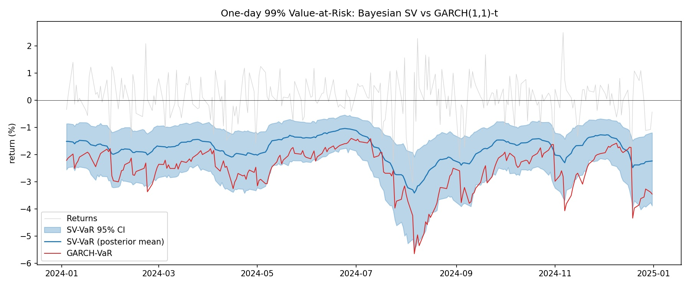
Figure 9. One-day 99% Value-at-Risk: Bayesian SV (blue line with 95% credible band) versus GARCH(1,1)-t (red line). Daily returns shown in grey.
Three features stand out. First, the two models agree on the timing of risk regimes: both identify the August 2024 carry-trade unwind as the most dangerous episode, with VaR estimates approaching −6%. Second, GARCH-VaR is systematically more negative (more conservative) than the SV posterior mean by roughly 0.5–1.0 percentage points throughout the window — partly because of the heavy GARCH tail (ν = 5.65) and partly because of GARCH's faster reaction to individual shocks. The GARCH line sits near the lower edge of the SV credible band on most days, which is to say: GARCH-VaR is consistent with a relatively pessimistic posterior draw from the SV model. Third, the SV credible band is the methodologically novel feature — typically ±1pp wide and visibly widening in late July / early August 2024 as the model became less certain about the underlying volatility regime.

8.2 Kupiec unconditional coverage test
An exceedance occurs when the realised return falls below the VaR threshold (a loss larger than predicted). Under a correctly calibrated 99% VaR over 250 days, the expected number of exceedances is 2.5. The Kupiec (1995) likelihood-ratio test formally tests the null hypothesis that the empirical exceedance rate equals the nominal 1% level.
Model | Exceedances / 250 | Empirical rate | Kupiec LR (p-value)
SV-VaR (posterior mean) | 2 | 0.80% | 0.108 (p = 0.742) — pass
GARCH(1,1)-t VaR | 2 | 0.80% | 0.108 (p = 0.742) — pass
Expected (nominal 1%) | 2.5 | 1.00% | —

Both models pass cleanly with identical exceedance counts. The empirical exceedance rate of 0.80% is slightly below the nominal 1%, indicating that both models are mildly conservative — the prudent direction from a risk-management perspective. The Kupiec p-value of 0.74 is far from the 5% rejection threshold, so we cannot reject the null of correct unconditional coverage for either model. We note that 2024 was a relatively benign year by historical standards; a backtest spanning more turbulent windows (such as 2018–2022) could plausibly produce more distinguishing dynamics, particularly given GARCH's faster reaction speed to shocks.

9. Conclusion
We have implemented and validated a canonical Bayesian stochastic volatility model on ten years of S&P 500 daily returns, benchmarked it cleanly against GARCH(1,1)-t, and applied it to one-day-ahead 99% Value-at-Risk estimation. The methodological contribution lies in three places: a non-centred PyMC parameterisation that delivers clean NUTS geometry across 2,515 latent states with zero divergences and R-hat = 1.00; an honest posterior predictive validation that confirms fat tails and medium- to long-run volatility clustering while transparently reporting a mild lag-1 misfit; and a Bayesian VaR construction that propagates posterior uncertainty into a credible band around the risk number itself.
The headline empirical message is that SV and GARCH agree more than they disagree on point estimates of conditional volatility and on backtested 99% VaR. Where they differ is in honesty about uncertainty. GARCH delivers a single line; the SV posterior delivers a line with a credibility band around it. In regulatory and stress-testing contexts where parameter uncertainty is itself a quantity of interest — Basel internal-models, ECB stress tests, and the model-risk literature more broadly — that distinction matters.
Natural extensions include: leverage-effect SV models that allow correlation between ε_t and η_t, addressing the lag-1 misfit in volatility clustering; Student-t innovations on ε_t to handle the most extreme tail observations beyond what the AR(1) mixture can reproduce; realised-volatility estimation from intraday data as a less noisy benchmark for the posterior path; and longer or out-of-sample backtests that would better separate the two models' performance in stress regimes.

References
Andersen, T. G., Bollerslev, T., Diebold, F. X., & Labys, P. (2003). Modeling and forecasting realized volatility. Econometrica, 71(2), 579–625.
Bollerslev, T. (1986). Generalized autoregressive conditional heteroskedasticity. Journal of Econometrics, 31(3), 307–327.
Chernov, M., Gallant, A. R., Ghysels, E., & Tauchen, G. (2003). Alternative models for stock price dynamics. Journal of Econometrics, 116(1–2), 225–257.
Jacquier, E., Polson, N. G., & Rossi, P. E. (1994). Bayesian analysis of stochastic volatility models. Journal of Business & Economic Statistics, 12(4), 371–389.
Kim, S., Shephard, N., & Chib, S. (1998). Stochastic volatility: Likelihood inference and comparison with ARCH models. Review of Economic Studies, 65(3), 361–393.
Kupiec, P. H. (1995). Techniques for verifying the accuracy of risk measurement models. Journal of Derivatives, 3(2), 73–84.
Murphy, K. P. (2012). Machine Learning: A Probabilistic Perspective. Cambridge, MA: MIT Press.
Vehtari, A., Gelman, A., Simpson, D., Carpenter, B., & Bürkner, P.-C. (2021). Rank-normalization, folding, and localization: An improved R-hat for assessing convergence of MCMC. Bayesian Analysis, 16(2), 667–718.
Yu, J. (2005). On leverage in a stochastic volatility model. Journal of Econometrics, 127(2), 165–178.

