INFO3068-LAB_02_Setup_ Hassan Ihsan

Your screenshot should also show that Apache and MySQL have successfully started, are running on ports 80, 443, 3306, and received a Process ID number.

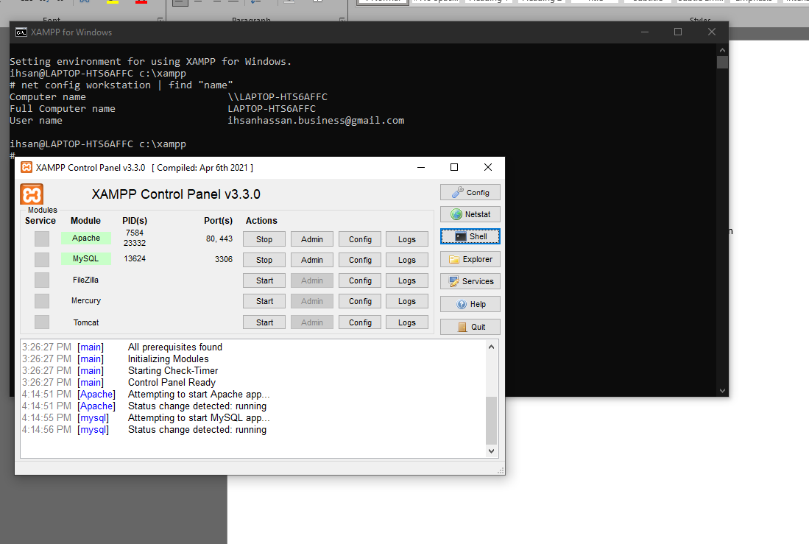

Open your browser and surf to http://localhost/helloworld.php Take a screenshot, save it to a graphic, and upload it to the FOL submission folder

