**Install Required boards in Arduino IDE**

Open Board Manager by navigating to the Tool>>Board

Search for **Arduino SAMD Boards** and install the **Arduino SAMD Boards**

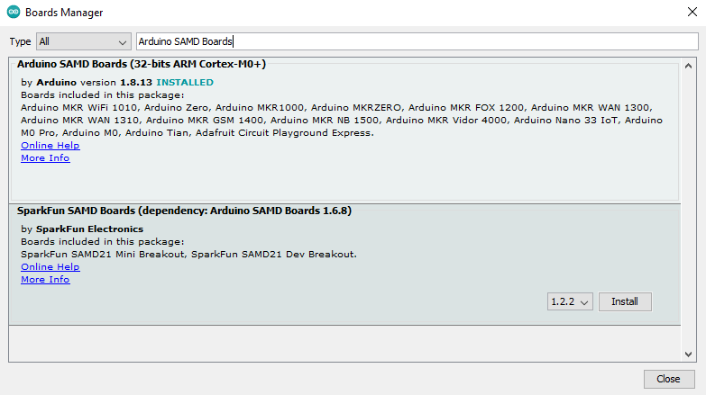

Now search for **Adafruit SAMD** andinstall **Adafruit SAMD Boards**

Now if you are using Windows 7 or 8 you need to download and install the driver from the link.

<https://github.com/adafruit/Adafruit_Windows_Drivers/releases>

**Install Required Libraries**

Open Library Manager by navigating to the Sketch>> Include Library.

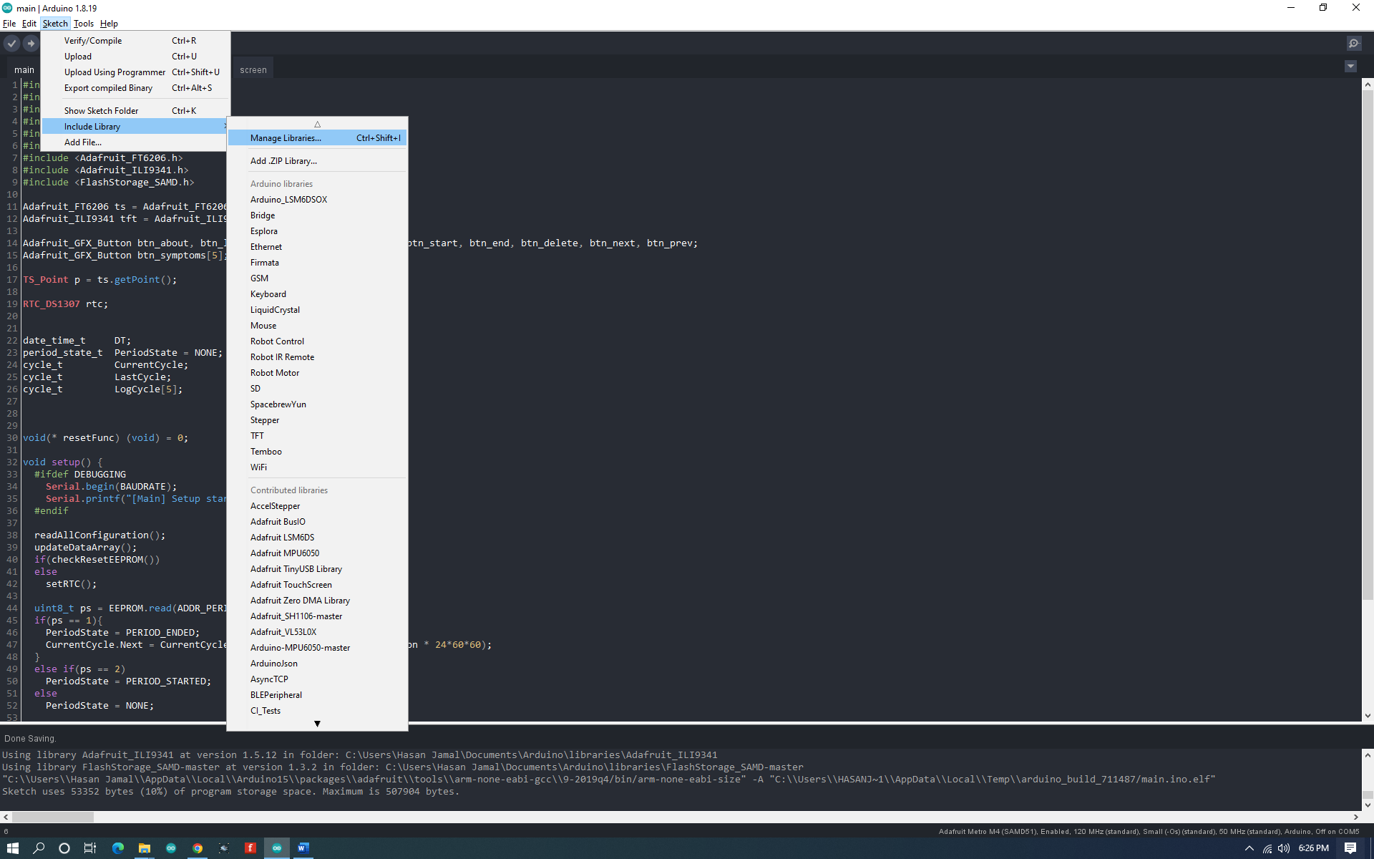

Search for the **Adafruit_GFX** and click install.

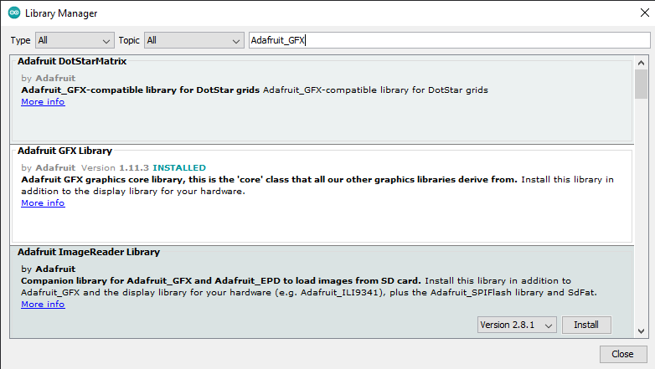

Search for the **Adafruit_FT6206** and click install.

Search for the **Adafruit_ILI9341** and click install.

Search for **RTCLib.h**

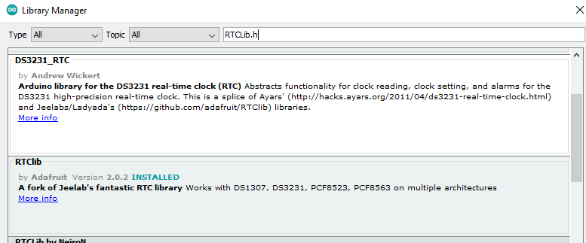

Search for **TimeLib.h**

Now go to Sketch >> Include Library >> ADD .ZIP library

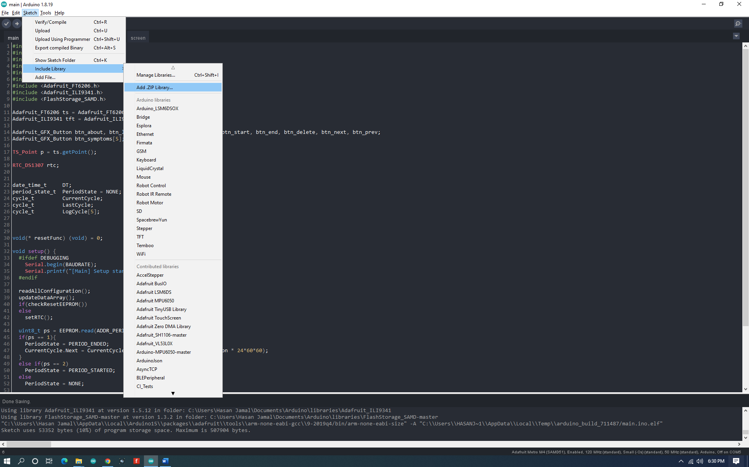

Navigate the Library folder provided with this folder and select **FlashStorage_SAMD.zip** file.

Now restart Arduino IDE.

**Connections**

Connect LCD and RTC with Arduino Board.

**Connections of RTC with Arduino.**

|  |  |
| --- | --- |
| **RTC Pins** | **Arduino Metro M4 Pins** |
| VCC | 5v |
| GND | GND |
| SDA | SDA |
| SCL | SCL |

Upload the code in Arduino.

RTC will set its time when the first-time code is uploaded in Arduino.

If you want to delete old data from the memory there is a variable (MAGIC_NUMBER) in config.h file,

Change its value to random number between 100-200.



