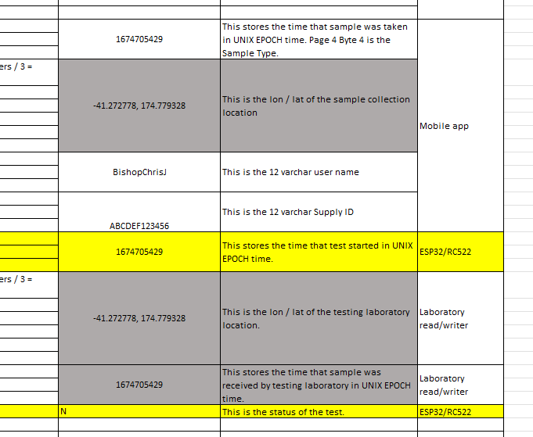



Which location I have to send to API endpoint from above image.

Use the sample collection location.

Supply ID is same as UID?

The supplyID is different from the UID. It relates to the water network that the sample is taken from. This is updated by the app so just pass this supplyID field through as well as the UID.

{

    "UID": "8628FE7C-A4E9-4056-91BD-FD6AA7817E39",

"UID_hash": "D952EB9F-7AD2-4B1B-B3CE-386735205990"

    "Red": "255",

    "Green": "253",

    "Blue": "251",

    "Millis": "123456",

    "Test": "EC",

    "Test_status": "E",

    "Media": "Colitag",

    "Datetime": "2023-01-11 23:21:01"

    "Red": "171",

    "Green": "55",

    "Blue": "238",

    "Longitude": "-41.292",

    "Latitude": "174.762”,

    "User": "bishopc"

    "Sample_datetime": "2023-01-10 13:21:01",

    "Receipt_location": "",

    "Receipt_datetime": "",

    "Test_start_datetime": "2023-01-10 17:32:11"

}

What are these?

Receipt_location

Receipt_datetime

This would be used only when someone sends a sample to us for testing. We will update the location and the receipt date time when we receive the sample. Just pass this data through. In most cases the fields will be null.

There are two sets of Red, Green and Blue keys in above example.

One is for Target color and other is for current color. Am I right?

Not quite. The first Red Green Blue values relate to the E. coli test using the UV LED. The second set relate to the total coliforms test using the White LED. Perhaps we need to change the field names. To ecRed, ecGreen, ecBlue, ecMillis, tcRed, tcGreen, tcBlue, tcMillis.



As the test will have two results one for E coli and other is for Total coliform so this field will have 2 byte of data first byte is for E coli result second is for Total coliform result.

No. Test status codes can be:

* N - Not started
* S - Started
* E - Positive E. coli
* T - Positive Total Coliforms only
* A - Absent
* F - Failed