Download and Install **Arduino IDE 2.x** from the following link.

<https://docs.arduino.cc/software/ide-v2/tutorials/getting-started/ide-v2-downloading-and-installing>

Add ESP32 board in IDE.

Go to File >> preferences.

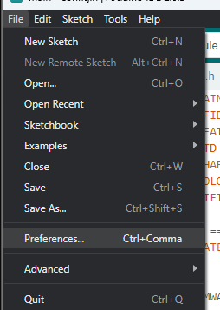

Add following link in **Additional boards manager URLs.**

<https://raw.githubusercontent.com/espressif/arduino-esp32/gh-pages/package_esp32_dev_index.json>

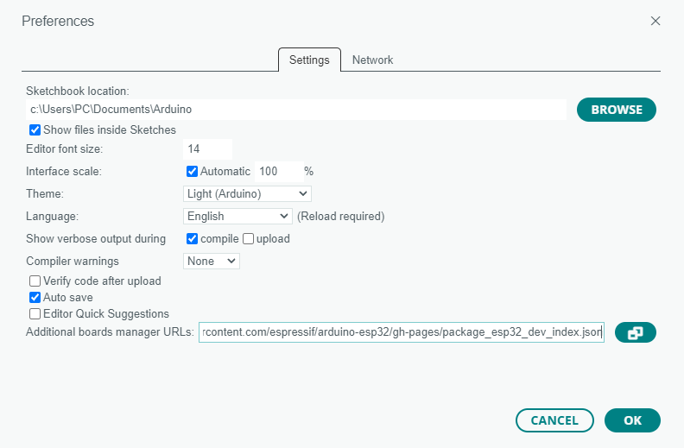

Click Ok.

Now go to **Tools >> Boards >> Board Manager** and search for **ESP32** and install **1.0.6** version.

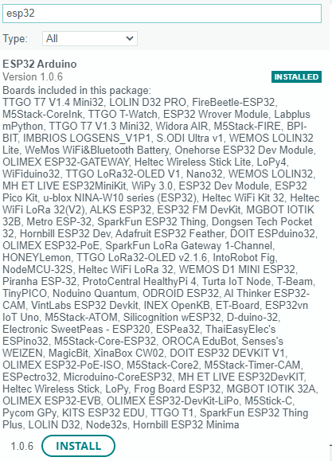

Adding Libraries

Open library manager.

Search for veml6040 and install. At time of this document **0.3.1** is the latest version.



Search for TimeLib and install. At time of this document **1.6.0** is the latest version.

Search for NTPClient and install. At time of this document **3.2.1** is the latest version.

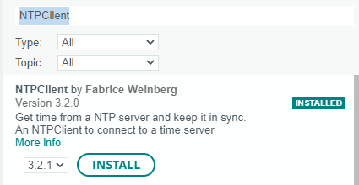

Search for MFRC522 and install. At time of this document **1.4.9** is the latest version.



Search for Adafruit_MAX31865 and install. At time of this document **1.5.0** is the latest version.

Update **Config.h** file.

Update Wi-Fi **ssid** and **password**.



Endpoints for different data.

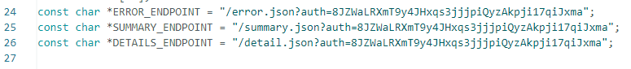

Change **RREF**, **RNOMINAL** and **TOLERANCE** according to your need.

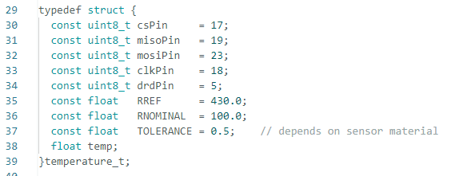

Change **thermalPower** of the material.

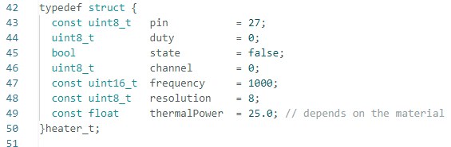

Update LUX value when code checks if Lid is open or not it will compare measured LUX with this LUX value and if measured LUX is greater than this LUX it will send error.

Adjust time in milli seconds. Intervals of White and UV Led.

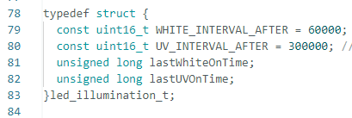

These are the different tests comparator color values.

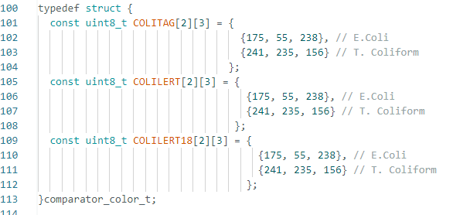

You can enable DEBUG messages by settings them true or disable them y setting their value fasle.

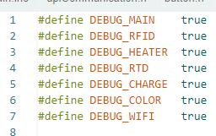

**Baudrate** is set 115200 for DEBUG messages.

If you disable **DEBUG_MAIN** no debug will show

Upload code

Connect ESP32 with PC.

Select COM port at which ESP is connected.

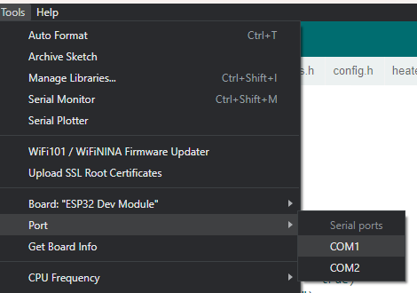

Select ESP32 board.

