**Arduino IDE Setup**

You can download IDE from this link make sure to download **version 1.8.19**.

<https://www.arduino.cc/en/software>

After installing the IDE. Add ESP32 board and required libraries in IDE.

Open Arduino IDE.

Go to **Files >> Preferences**

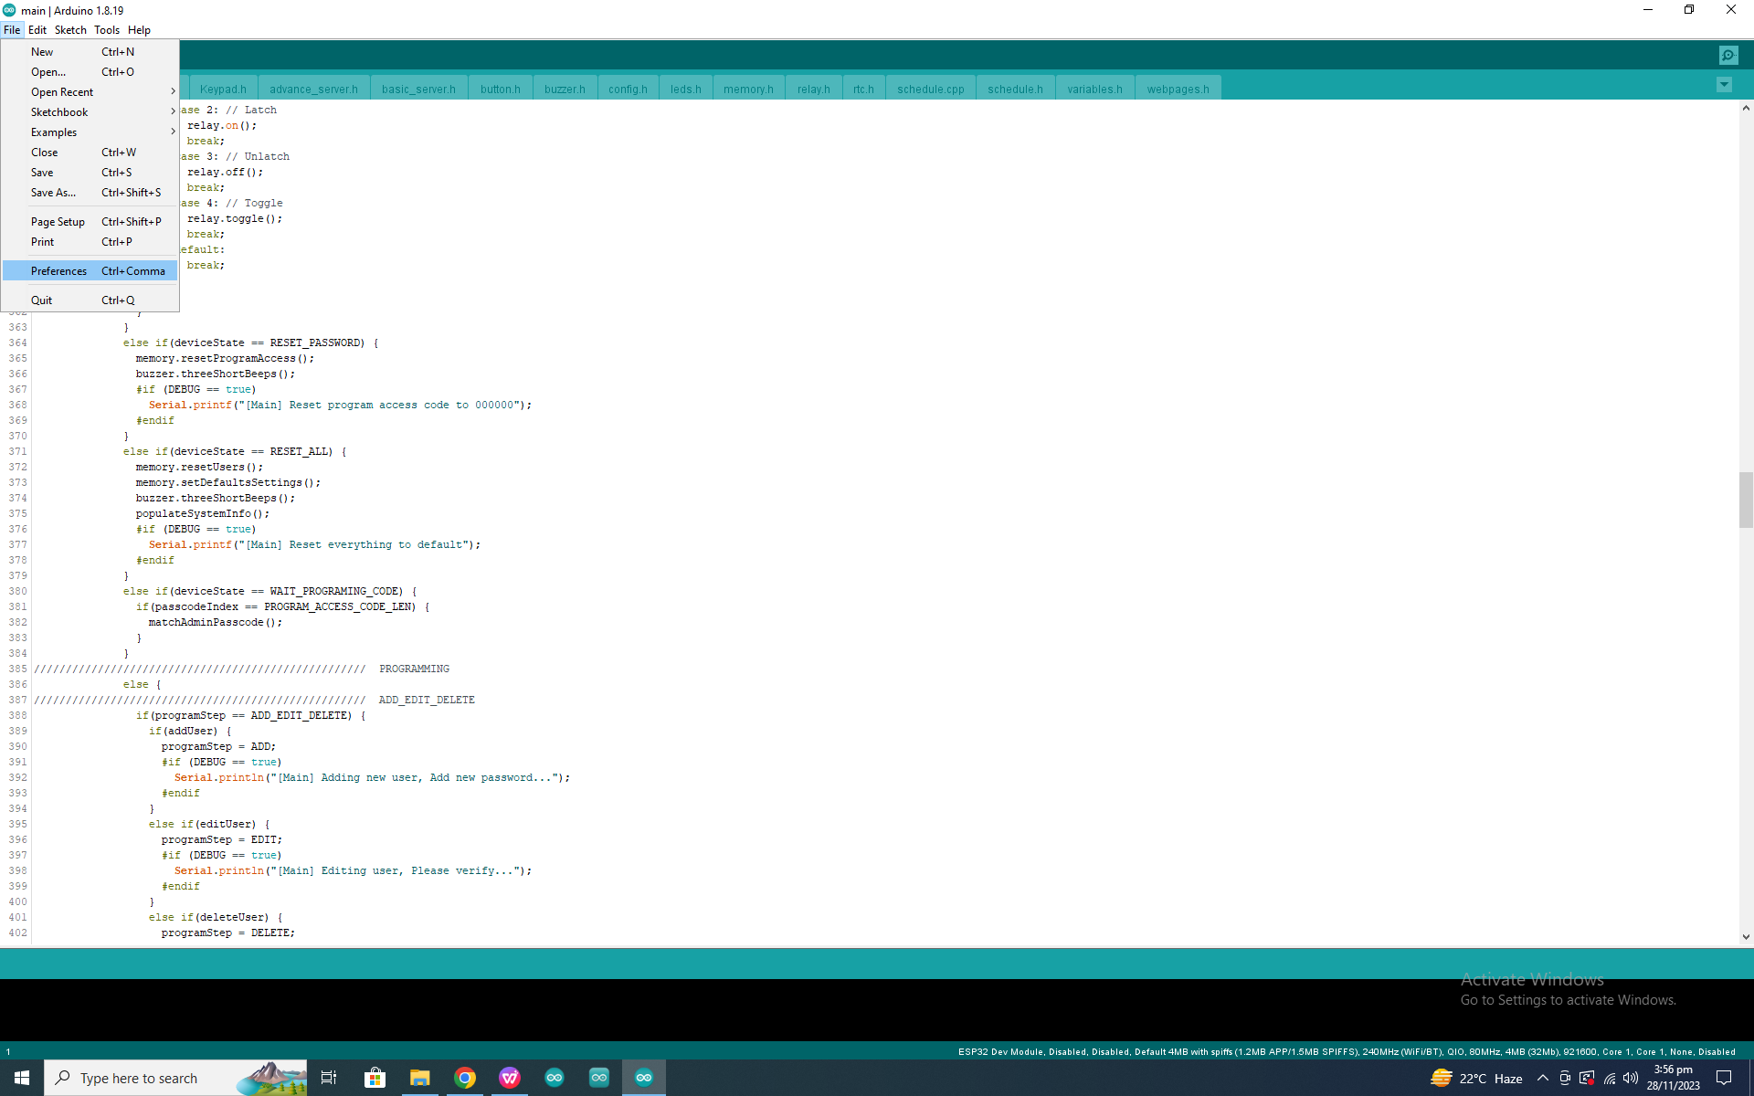

Add following link in **Additional Board URLs**

<https://raw.githubusercontent.com/espressif/arduino-esp32/gh-pages/package_esp32_dev_index.json>

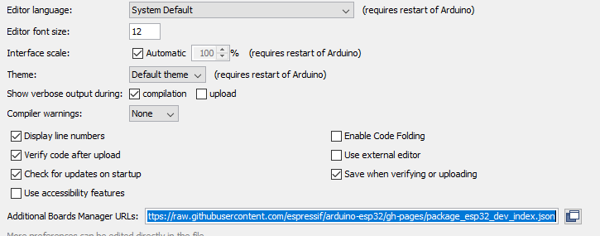

Click **Ok**.

Go to **Tools >> Boards >> Board Manager**

Search for **ESP32** and install **version 2.0.14**

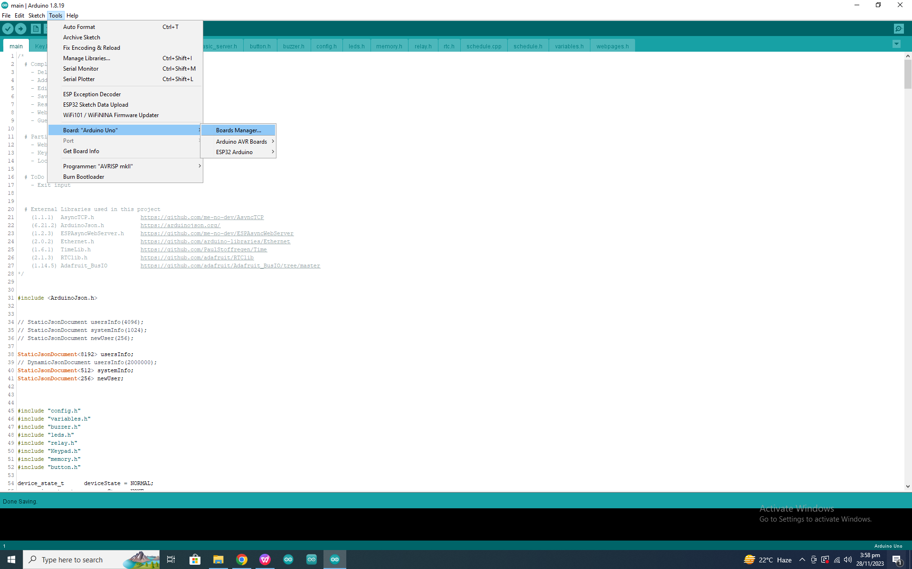

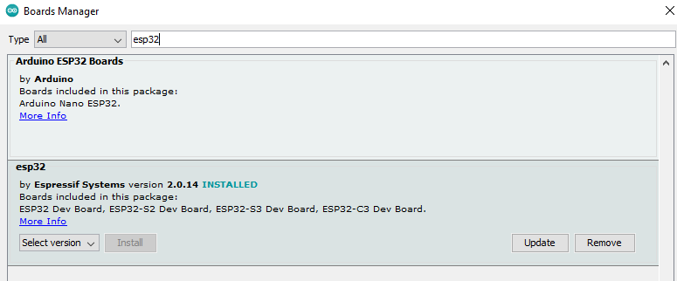

Download libraries from the following GitHub links.

*<https://github.com/me-no-dev/AsyncTCP>*

*<https://arduinojson.org/>*

*<https://github.com/me-no-dev/ESPAsyncWebServer>*

*<https://github.com/PaulStoffregen/Time>*

*<https://github.com/adafruit/RTClib>*

*<https://github.com/adafruit/Adafruit_BusIO/tree/master>*

Go to **Sketch >> Include Libraries >> Add .ZIP Libraries**.

Navigate to the directory where you downloaded the libraries.

Add them **one by one**.

After adding libraries now connect ESP32 with PC. Select **Port** which ESP32 is connected and **Board**.

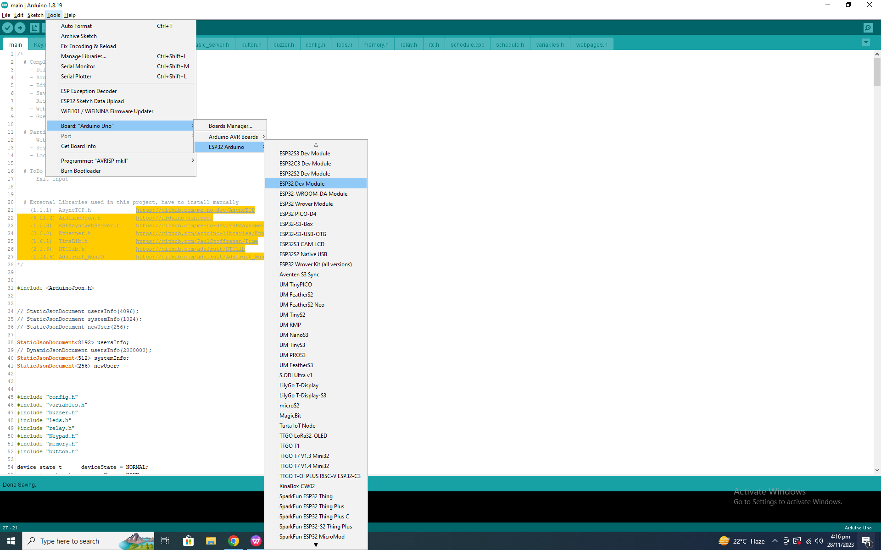

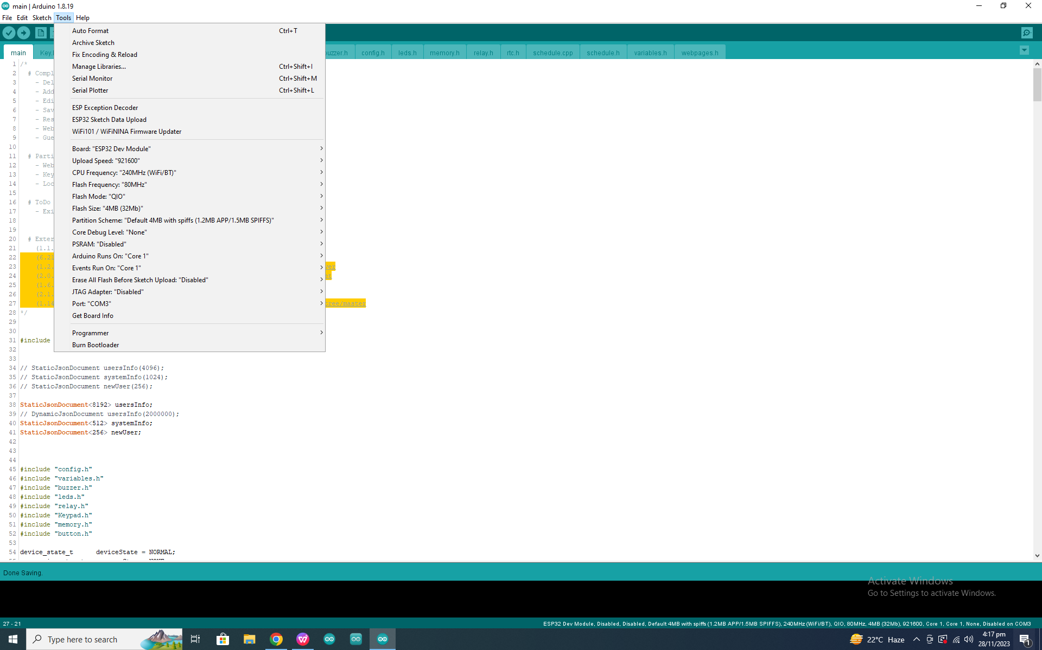

**Note:**

Make sure your Relay is set to active LOW, means jumper shown in image should be connected to LOW and COM pin.

In image it is connected with HIGH and COM.

