**Prayer Reminder**

**Install Arduino IDE:**

Download IDE from this link make sure to download version 1.8.19

<https://www.arduino.cc/en/software>

after downloading follow the installation process.

**Add ESP board in Arduino IDE:**

1. In Arduino IDE, go to **File> Preferences**

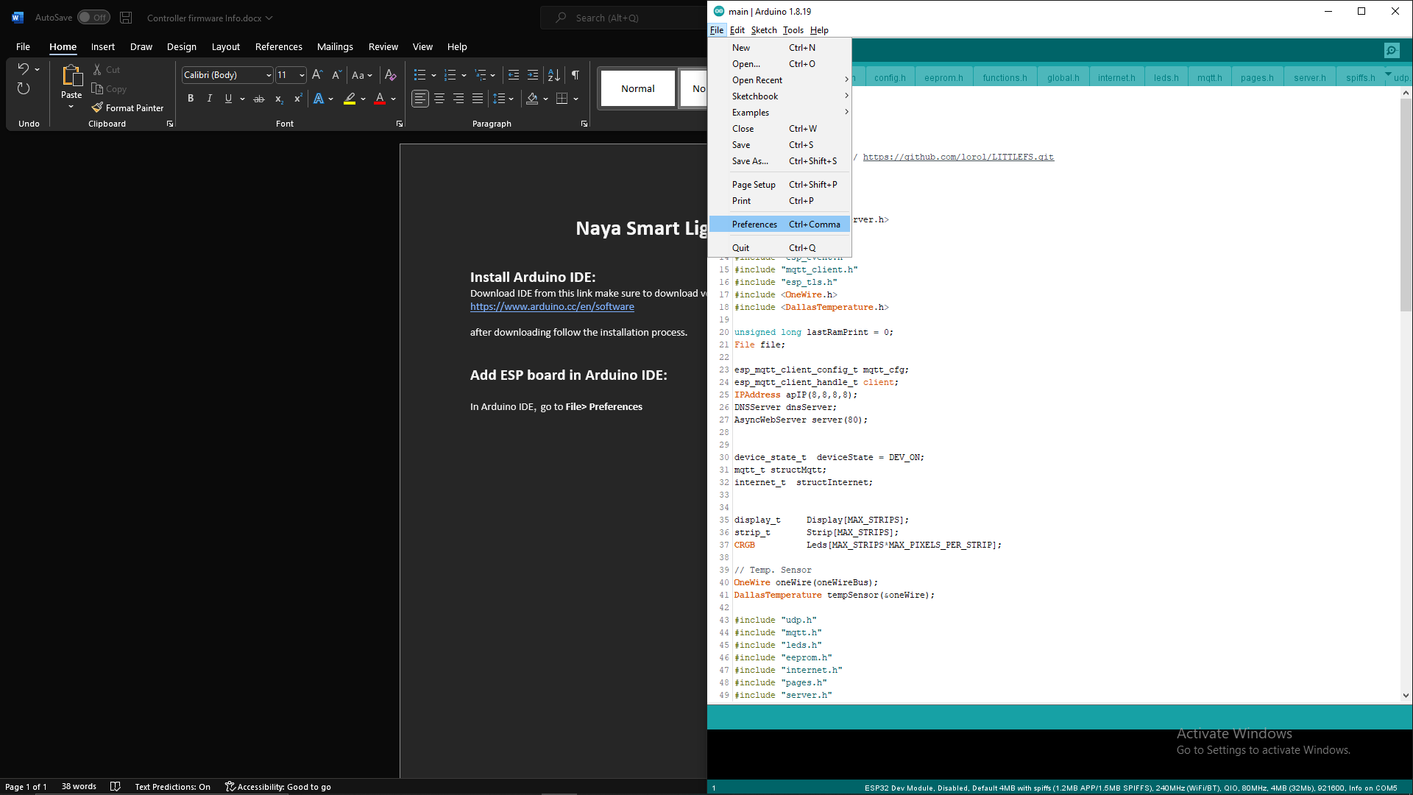

1. Enter the following into the **Additional Board Manager URLs** field and click Ok:

<https://raw.githubusercontent.com/espressif/arduino-esp32/gh-pages/package_esp32_index.json>

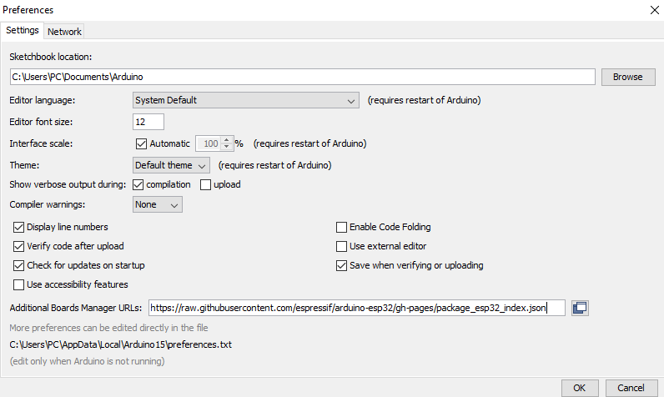

1. Open the Boards Manager. Go to **Tools** > **Board** > **Boards Manager…**

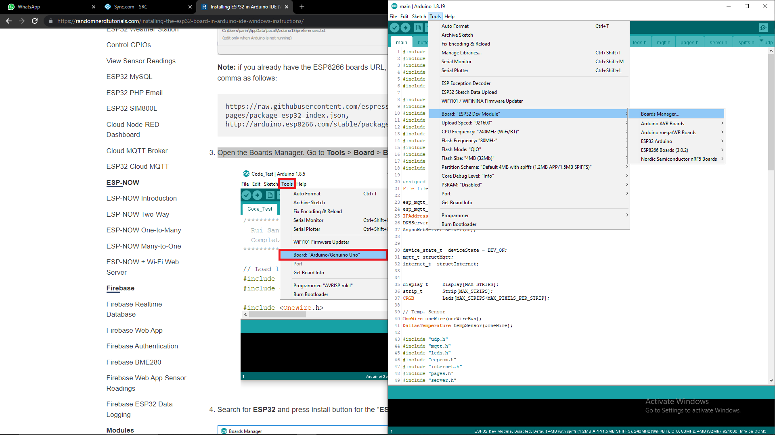

1. Search for **ESP32, s**elect **1.0.6 version** and click install

**Install Required Libraries:**

All the required libraries added with documentation have to be added in Arduino IDE.

Go to **Sketch >> Include Library >> Add .ZIP Library…**

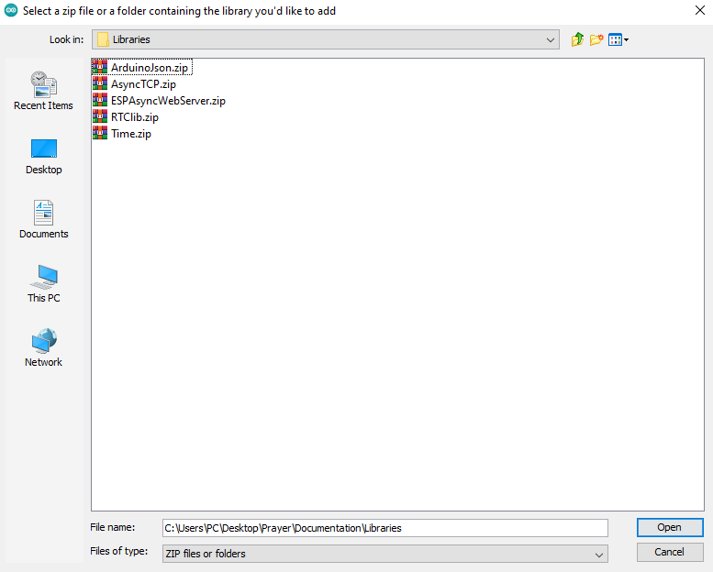

To the Libraries added with this documentation and select any one of the libraries.

Follow the same for others.

In **config.h** file you can enable/disable debugging of the code.

Uncomment these lines to enable debugging.

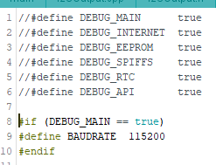

Debugging will be shown on **Serial Monitor**. Make sure in final version comment these lines to save memory and processing power of the controller.

**How to upload code in Controller**

Connect controller with PC.

Select following settings in IDE.

**Port** will be the **COM port** at which your ESP Controller is connected.

Click on upload button and code should upload in the controller after compiling.





**How to upload files (Audio/Setup) in ESP Memory**

1. Go to the following link and download the highlighted file

<https://github.com/me-no-dev/arduino-esp32fs-plugin/releases/>

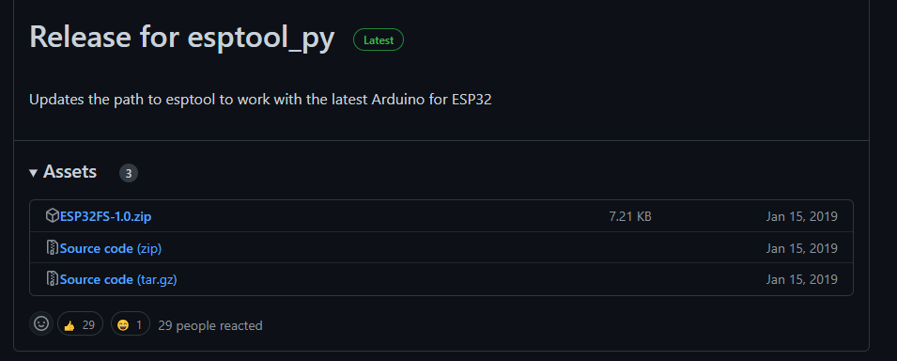



1. After downloading, in Arduino IDE go to **Files>>Preferences.** Go to Sketchbook location, yours may be different.



1. Create **tools** folder. And extract the files in downloaded in **step 1** in **tools** folder.

Your directory will look like this.

Restart Arduino IDE.

To check if the plugin was successfully installed, open your Arduino IDE. Select your ESP32 board, go to **Tools**and check that you have the option **ESP32 Sketch Data Upload**.

Now click on this option it will upload the Audio and setup files in ESP.

While uploading these files make sure your serial monitor is not running.

**Circuit Diagram**

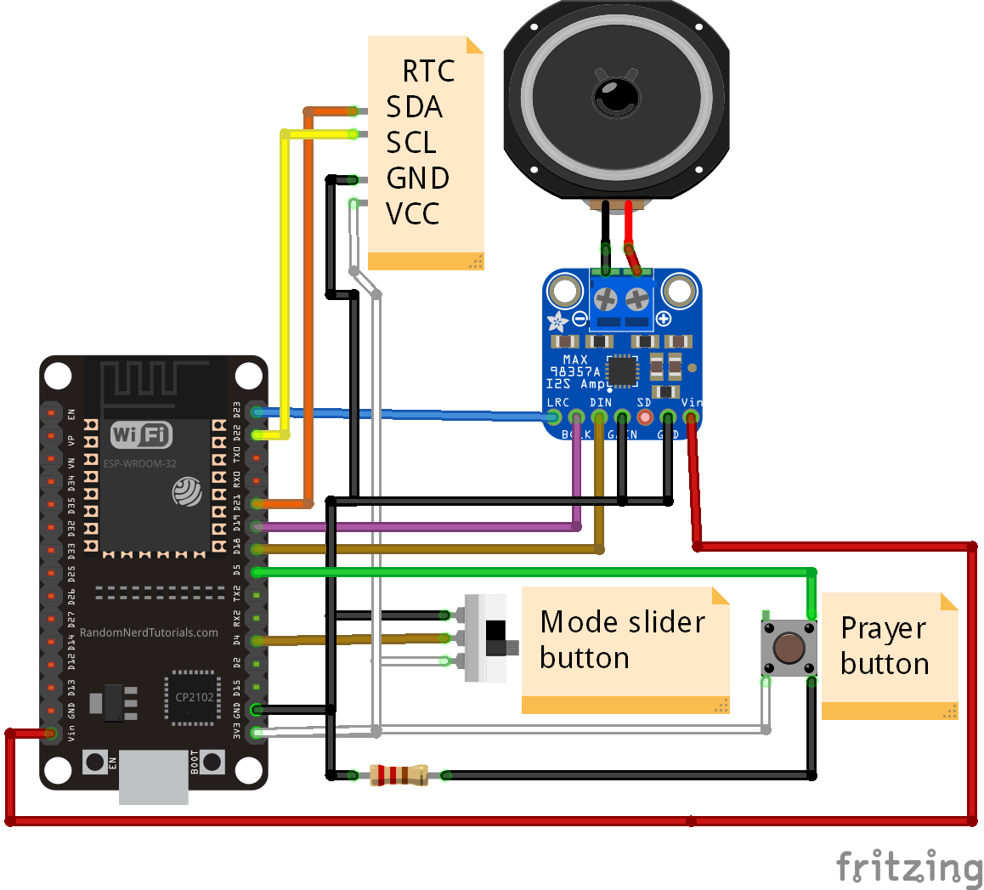

Device has two modes

1. Setup mode
2. Watch mode

Slider mode button will select the mode of the device.

If the slider is towards black wire side device will be in Watch mode.

If the slider is towards white wire side device will be in Setup mode.

In setup mode device will create its hotspot and user will connect to it using his mobile.

After connected to device’s hotspot webpage will open where user can set country, city, time of the device and Wi-Fi. In order to download the prayer time user first connect the device to stable Wi-Fi connection from Wi-Fi settings page. Then user should set Time of the device if needed and then user should select country and city than start the download process, download progress will be shown in country settings page. Prayer data will depend on current year and location selected by user. So, if user changes his location or next year has been started, user has to download the data again. once data is downloaded user will not require Wi-Fi connection.

In Watch mode whenever user presses **Prayer button** device will tell the Prayer time, provided that user first downloaded the data.

**Note:**

If you do not have the slide button Just connect the D4 pin on ESP32 to GND pin of ESP32 to start the Setup mode

Or connect D4 to pin of ESP32 to 3.3V of ESP32 to start the Watch mode.

Make sure D4 is connected to either GND or 3.3v if it connected to both of them then ESP may get damage.