Burn Image on SD-Card.

Use Raspberry Imager software.

You can download using the following link.

<https://www.raspberrypi.com/software/>

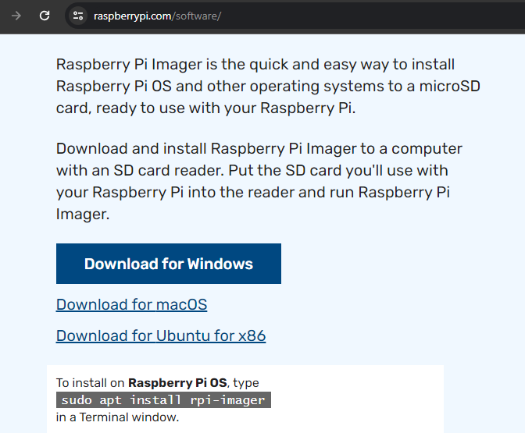

Insert SD-Card in PC and open Raspberry Pi Imager software.

Choose OS and Storage(SD-Card).

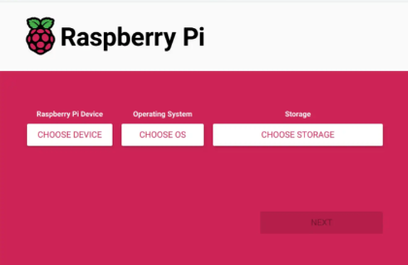

In OS select the Highlighted one.

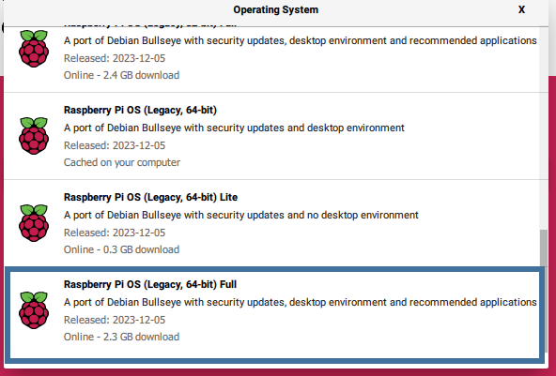

After Image is burned on SD-Card, insert it into Raspberry Pi, connect Keyboard, mouse and display than power the Raspberry Pi.

After completing the initial setup.

Open terminal and run this command

*sudo raspi-config*

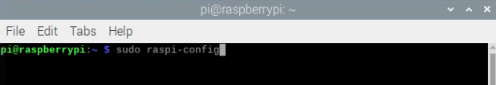

Select **Interface Options >> Legacy Camera >> Yes**

This will enable the Pi Camera

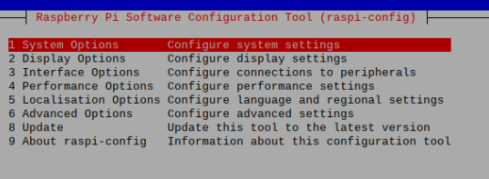

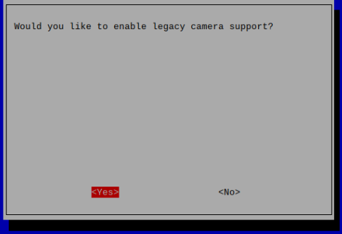

Change audio output to **AV Jack**

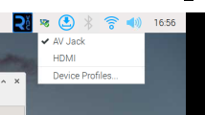

Copy the Code file with this document in Raspberry Pi at Desktop.

In **ColorDetection.py** file specify the location of the audio file.

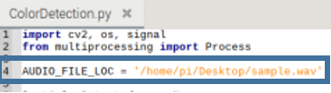

Connect the speaker with the Audio Jack of Raspberry Pi

Open terminal and run following command to install **open cv** on Raspberry Pi.

*sudo apt-get install python3-opencv*

Run the color detection code with this command.

*sudo python3 Desktop/ColorDetection.py*

Complete audio will play after detection of RED and GREEN color.

You can close the script by pressing **ESC** button of the keyboard.