

Final Project

Department: Software Engineering
Course: Python Programming

Submitted by:
Name: MD Raziul Hasan Nayon
Roll no: 202280090122

1. Introduction
The rapid growth of digital services in the hospitality industry has transformed how guests search for information, compare room options, and make hotel reservations. Modern travelers expect quick responses, seamless interactions, and round-the-clock support—demands that traditional customer service teams often struggle to meet efficiently. As a result, automated conversational systems have emerged as a scalable solution that can handle repetitive queries, assist with bookings, and enhance customer experience with minimal human intervention.
This project focuses on designing and developing a Hotel Reservation Chatbot, a self-contained system capable of understanding user queries, extracting relevant booking details, managing conversational context, and generating accurate, structured responses. Unlike large language model (LLM)–based assistants, this chatbot uses a hybrid approach combining traditional machine learning and rule-based logic, ensuring deterministic, reliable, and explainable outputs. The system leverages a Logistic Regression–based intent classifier, rule-based entity extraction, and template-driven responses to maintain consistency and domain-specific accuracy.
The primary objective of this project is to demonstrate how a lightweight, non-LLM chatbot can deliver meaningful automation in a hotel reservation environment. The bot supports several essential hotel operations, including room availability checking, pricing estimation, amenity information retrieval, policy inquiries, and basic reservation management. It operates across both a terminal interface and a user-friendly Streamlit web application, making it suitable for real-world customer-facing deployments.
By building this system end-to-end—including dataset preparation, model training, dialogue management, and UI integration—this project highlights the effectiveness of hybrid chatbot architectures for domain-focused automation. It also provides a foundation for future enhancements such as real booking integration, multilingual support, and LLM-based fallback reasoning.

2. Literature Review

2.1 Traditional Hotel Booking Systems
Traditional hotel booking systems have primarily relied on manual operations, phone-based inquiries, and web-based reservation portals. Early online booking platforms were static, requiring users to navigate multiple pages, select dates, compare room types, and manually fill out forms. While effective, these systems often lacked interactivity and personalization. Moreover, customer support—such as questions regarding amenities, cancellation policies, or special requests—typically required either sending emails or calling hotel staff, resulting in delays and inconsistencies.
As customer expectations evolved toward instant responses and guided assistance, traditional systems showed several limitations: they were not conversational, could not clarify user intent, and did not adapt to incomplete or ambiguous inputs. These gaps motivated the development of intelligent, conversational hotel assistants capable of interacting naturally with users and automating repetitive customer service tasks.

2.2 Chatbot Architectures (Rule-based, ML-based, Hybrid)

Rule-based Chatbots
Rule-based chatbots are the earliest form of conversational agents. They operate using predefined rules, pattern matching, and decision trees. Tools like ELIZA and keyword-based systems follow strict if-else logic or regular expression patterns to produce responses.
Advantages: high reliability, predictable outputs, fully explainable.
Limitations: cannot understand varied phrasing, limited flexibility, difficult to scale for complex domains.

Machine Learning–based Chatbots
ML-based chatbots introduced intent classification, entity recognition, and data-driven prediction. They use models such as Naïve Bayes, Logistic Regression, SVMs, or deep learning methods. These systems learn from labeled datasets, allowing them to understand diverse queries and adapt to new expressions.
Advantages: more natural understanding of user queries, scalable as dataset grows.
Limitations: lack full control over outputs, may produce incorrect intent predictions.

Large Language Model (LLM)–based Chatbots
Modern LLMs like GPT, Llama, and Gemini can generate human-like responses using contextual understanding. They support open-ended dialogue and multi-turn reasoning.
Advantages: highly flexible, strong natural language understanding.
Limitations: high computational cost, unpredictable outputs, harder to control for domain-specific tasks.

Hybrid Chatbots
Hybrid systems combine rule-based logic and machine learning, leveraging the strengths of both. Intent classification is handled by ML, while entity extraction, fallback logic, and response generation follow deterministic rules.
This architecture is particularly effective for hotel reservation systems, where accuracy, consistency, and explainability are essential.

2.3 Existing Reservation Assistants
A wide range of hotel and travel platforms have integrated conversational assistants to streamline booking:
- Booking.com Assistant – Helps customers modify reservations, inquire about amenities, and communicate with hotels.
- Expedia Virtual Agent – Provides flight/hotel booking support and answers policy-related questions.
- Hilton’s Connie – A robotic concierge that uses AI to answer questions about hotel services and local attractions.
- Chatbots by Marriott and Hyatt – Integrated into mobile apps to support loyalty members, reservations, and FAQs.
- WhatsApp & Facebook Messenger hotel bots – Used by smaller hotels to automate customer interactions.
While these assistants improve customer service efficiency, many are LLM-backed or designed for large enterprise environments. Small and mid-scale hotels often lack access to customizable, cost-effective AI reservation systems.

2.4 Gaps Identified & Opportunities
Despite advancements in conversational applications, several critical gaps remain:

1. Lack of Lightweight, Explainable Chatbots
Most existing solutions are either rule-based (too rigid) or LLM-based (less predictable and expensive). There is a lack of hybrid, explainable, and low-cost reservation bots suitable for mid-size hotels.

2. Limited Customization for Local Hotels
Smaller hotels struggle to adopt existing enterprise solutions due to cost, lack of flexibility, and integration complexity.

3. Dependence on Predefined FAQs Instead of Context-Aware Conversations
Many chatbots cannot maintain conversation context across multiple turns (e.g., remembering dates, number of guests, or room types).

4. Insufficient Entity Extraction for Reservation Details
Typical FAQs bots cannot extract structured information like:
- Check-in/check-out dates
- Guest counts
- Room categories
- Amenities
- Reservation IDs

3. System Overview

3.1 High-level Description of the Chatbot
The Hotel Reservation Chatbot is a self-contained, domain-specific conversational AI assistant designed to handle booking inquiries and policy questions for the Sunset Bay Hotel.
Crucially, it is built on a hybrid, non-LLM architecture, combining traditional machine learning with rule-based systems to achieve high accuracy and deterministic performance. This approach ensures it can efficiently handle a large variety of paraphrased hotel questions while maintaining a fixed, controlled knowledge base.
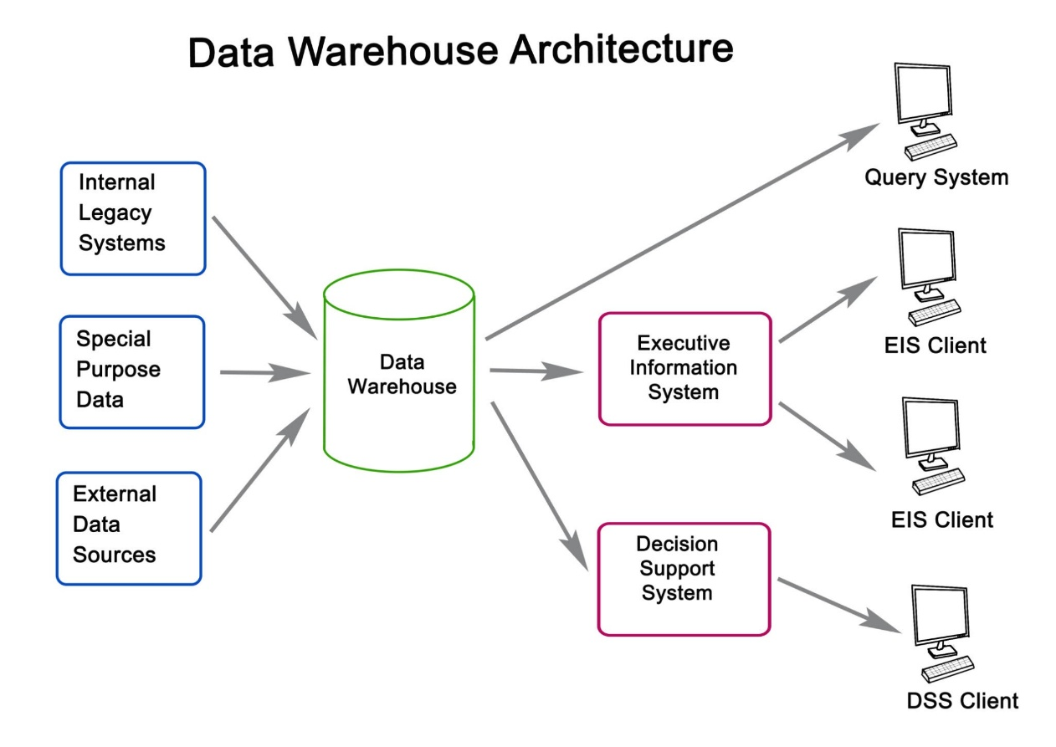
Its message processing pipeline follows a clear, multi-step flow
Fig-1: Data Warehouse Architecture
- Input Validation: Checks for gibberish or off-topic content.
- Hybrid NLU: Determines user intent and extracts structured data.
- Context Management: Updates the conversation state.
- Dialogue Management: Generates a final, context-aware response using templates.

3.2 Core Functionalities
The system is defined by five critical, modular components that manage the flow from raw text to a final response.

Intent Classification
This is the core Natural Language Understanding (NLU) component, responsible for determining the user's goal (e.g., make_reservation, inquire_price).
- Primary Method: A scikit-learn Pipeline using TF-IDF Vectorization followed by a Logistic Regression classifier is used to predict the intent and assign a confidence score.
- Hybrid Fallback: Due to the class imbalance in the training data, a Keyword Matcher (from keyword_matcher.py) acts as a fallback. If the ML confidence drops below the configured $0.25$ threshold, the keyword matcher's score is used to provide robust coverage for less-trained intents.

Entity Extraction
This rule-based component (from entity_extractor.py) extracts structured data points required for a reservation or inquiry.
- It uses Regular Expressions (Regex) to reliably extract critical entities like:
  - Dates: YYYY-MM-DD (e.g., 2025-12-10)
  - Guest Count: Number of adults and children.
  - Room Types: Synonyms for Standard Room, Deluxe Room, etc.
  - Reservation IDs: Alphanumeric codes.
- The extracted entities are immediately passed to the Context Manager.

Context Management
Handled by the context_manager.py, this module maintains the conversational memory across multiple turns.
- It stores persistent Hotel Metadata (Name, Address, Phone, Email) loaded from hotel_info.csv.
- It tracks the Current Booking State, including dates, room type, and guest count, allowing the user to provide information piecemeal across several messages (e.g., "I want a room" followed by "for two nights").

Room Availability & Pricing
This logic is handled by the Dialogue Manager and relies on the static data provided in room_types.csv.
- Availability: The bot can look up the four room types offered (STD, DLX, FAM, STE) and their amenities.
- Pricing: It calculates an estimated price using the base_price_weekday or base_price_weekend defined in the CSV, depending on the check-in date.

Reservation Handling
The bot guides the user through the booking process using a set of fixed intent-response pairs:
- It collects all necessary entities using the context.
- It uses the make_reservation intent to summarize the request and asks for confirmation (confirm or deny).
- It can handle post-booking actions like cancel_reservation and change_dates.

3.3 User Interfaces (CLI & Streamlit Web UI)
The chatbot is designed with two distinct interfaces, both of which utilize the same core HotelChatbot class from bot.py.
- CLI Interface (run_chatbot.py)
  - A simple, terminal-based interface for fast interaction and debugging.
  - Outputs the bot's response along with the raw intent and confidence score on every turn.
  - Supports the quit and reset commands for control.
- Streamlit Web UI (app.py)
  - A full-featured web application that provides a modern chat experience.
  - Displays a clean chat history and uses a sidebar for basic info.
  - Includes an "Analysis" expander on every bot response to display the technical output (intent, confidence, entities, and context summary), which is useful for demoing the NLU capabilities.
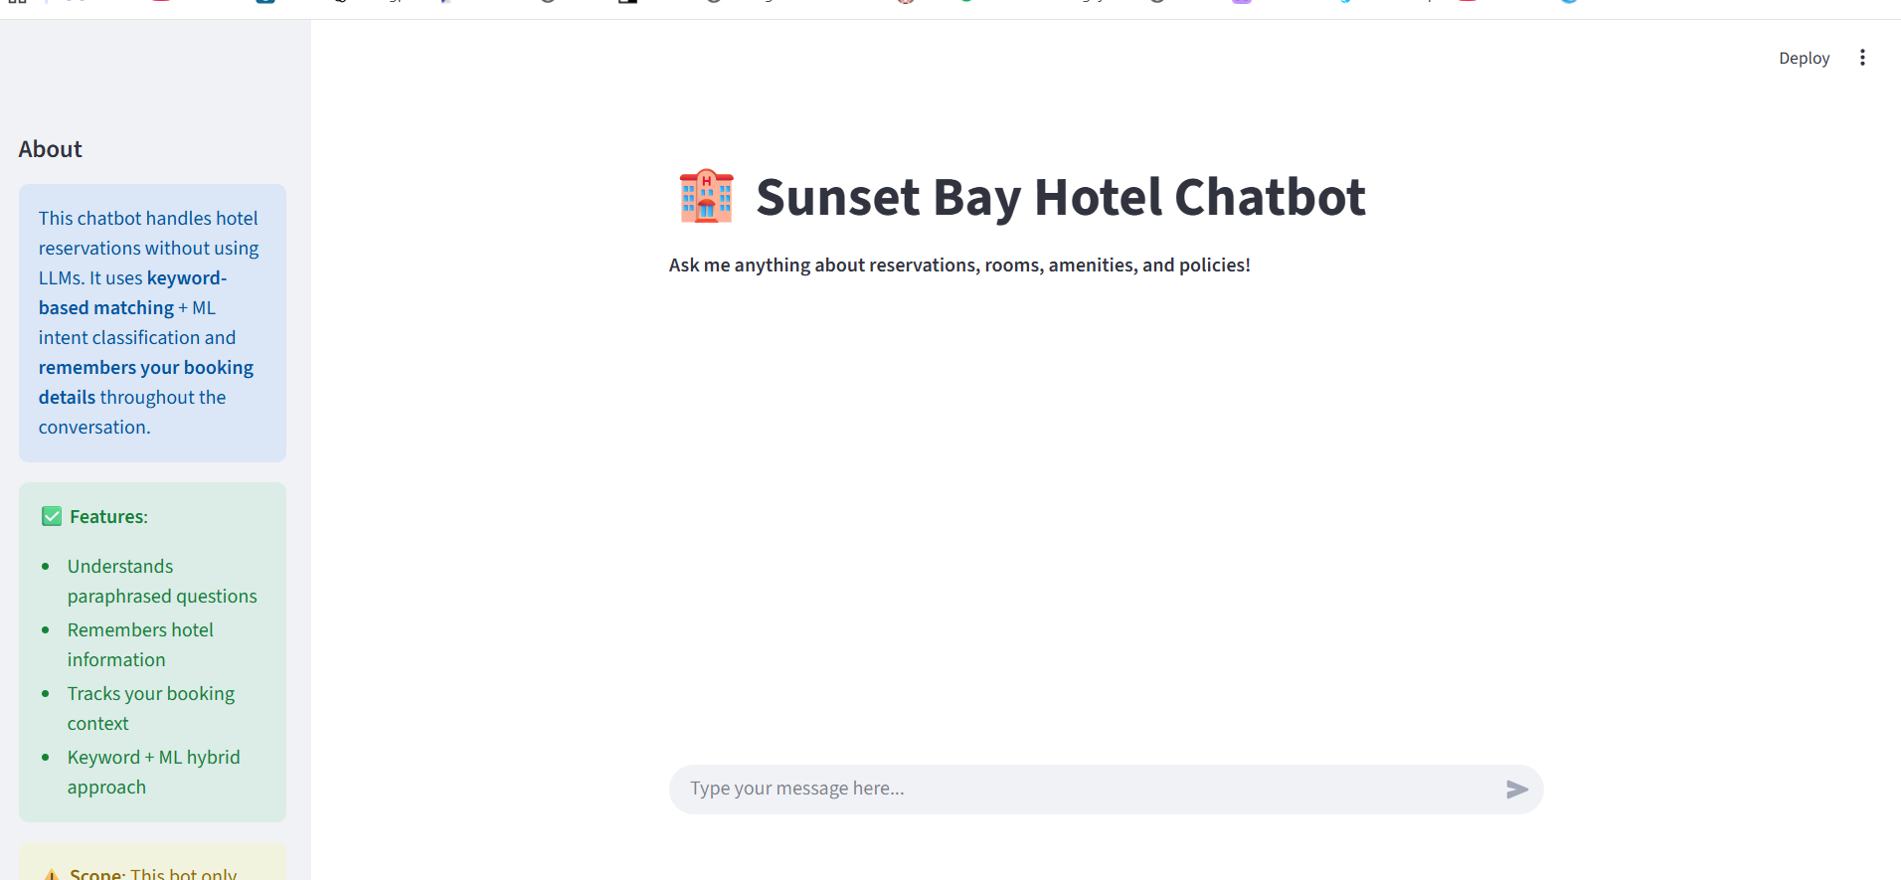
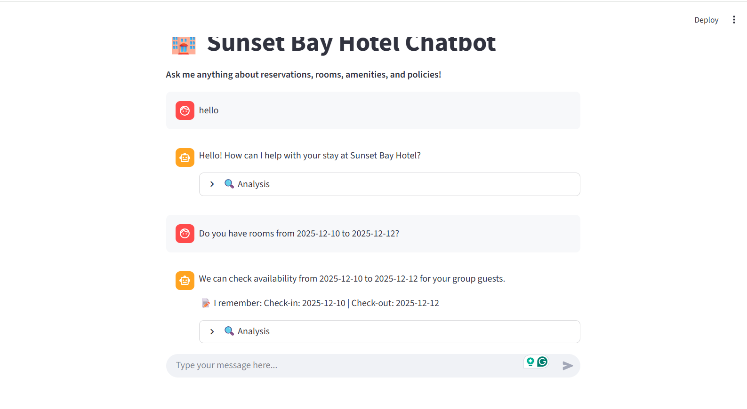
Fig-2: Chatbot User Interface
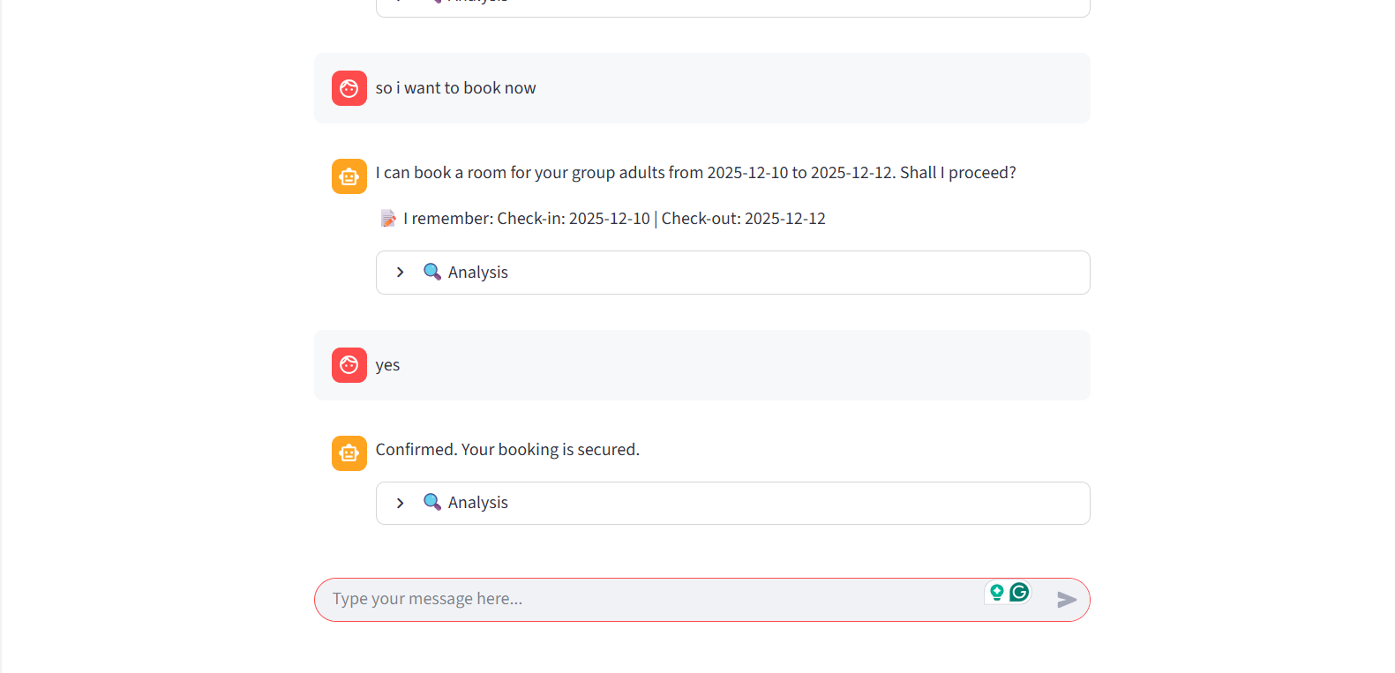
Fig-3: Chatbot Result
Here is the requested Methodology section, detailing the technical implementation of your hybrid hotel chatbot system, drawing on the architecture of your core files (intent_classifier.py, entity_extractor.py, dialogue_manager.py, etc.).

4. Dataset and Knowledge Base
The chatbot's knowledge base and operational logic are entirely driven by five distinct, static CSV files located in the data/ directory. These files serve as the foundation for the ML model, the Entity Extractor's rules, and the Dialogue Manager's response generation. The process of loading this data is handled by the data_loader.py module.

4.1 Training Dataset (training_data.csv)
This is the largest and most critical dataset, used exclusively to train the Intent Classification Model (TF-IDF + Logistic Regression).
- Size: $\mathbf{3,566}$ rows (utterances)
- Purpose: To teach the ML model to map diverse, paraphrased user inputs to the correct hotel domain intent.
- Core Columns:
  - utterance: The raw text input from the user (the feature).
  - intent: The correct action tag (the label), e.g., make_reservation, inquire_availability, inquire_price.
  - entities: A JSON string containing all structured data points that should be extracted from the utterance (used for training/evaluation of entity detection).
- Implication: The quality and breadth of this data directly determine the Intent Classifier's ability to handle natural language variation. As noted in the analysis, its class imbalance is mitigated by the Hybrid Keyword Fallback.

4.2 Hotel Information Dataset (hotel_info.csv)
This file contains the high-level, static metadata for the property, Sunset Bay Hotel, and serves as the primary source of facts for the ConversationContext.
- Purpose: To provide essential, unchanging hotel contact and policy details that the bot needs to recall instantly.
- Core Data Points:
  - Contact & Location: name (Sunset Bay Hotel), address, phone, email, website.
  - Policies: Full text for key policies like check_in, check_out times, cancellation_policy, and pet_policy.
- Implication: The chatbot relies on this data for its personalized greeting (Hello! How can I help with your stay at {hotel_name}?) and for responding to basic operational inquiries.

4.3 Room Types & Inventory Data (room_types.csv)
This dataset provides the structured catalog of all available rooms, enabling the bot to perform checks on inventory details and pricing.
- Purpose: To enable slot-filling for room-related entities and dynamic price estimation.
- Core Data Points:
  - Identifiers: code (STD, DLX, FAM, STE) and name (Standard Room, Deluxe Room, etc.).
  - Capacity: max_adults, max_children.
  - Pricing: base_price_weekday and base_price_weekend (used by the Dialogue Manager to calculate the estimated rate).
  - Features: Comma-separated lists for view_options and amenities.
- Implication: The Entity Extractor uses the room names to build its synonym dictionary, allowing it to correctly map user inputs like "suite with an ocean view" to the internal room code STE.

4.4 Amenities Dataset (amenity_faq.csv)
This small, focused dataset contains answers to common questions about services and facilities.
- Purpose: To provide a quick, authoritative lookup for amenity-specific questions (e.g., "Do you have Wi-Fi?").
- Core Data Points:
  - amenity: A key that identifies the facility (e.g., wifi, parking, pet).
  - answer: The corresponding pre-written, detailed response.
- Implication: When the intent is classified as inquire_amenities, the Entity Extractor looks for an amenity keyword, and the Dialogue Manager retrieves the answer from this file.

4.5 Response Template Dataset (response_templates.csv)
This file is the final source for the bot's verbal output, ensuring a consistent and professional tone for every conversational turn.
- Purpose: To store all the canned text templates used by the Dialogue Manager for Response Synthesis.
- Core Data Points:
  - intent: The key (e.g., greet, make_reservation, unknown).
  - template: The response string, which includes placeholders for slot-filling (e.g., I can book a {room_type} for {guests_total} guests...).
- Implication: This template-based approach makes the bot's output deterministic and easily manageable. By substituting the bracketed {slots} with entities from the ConversationContext, the system generates a personalized, context-aware response.

5. Methodology
The Hotel Reservation Chatbot is built using a hybrid, non-Large Language Model (LLM) methodology that combines traditional Machine Learning (ML) for generalized text understanding with rule-based systems for high-fidelity entity extraction and conversation management.

5.1 Intent Classification Model
The Intent Classification component is responsible for mapping a user's utterance to one of the 30+ predefined hotel intents (e.g., make_reservation, inquire_price). This is achieved using a classic supervised learning approach.

TF-IDF Vectorization
The raw text utterances from training_data.csv are converted into a numerical format using a Term Frequency-Inverse Document Frequency (TF-IDF) vectorizer.
- Term Frequency (TF) measures how often a word appears in a specific utterance.
- Inverse Document Frequency (IDF) scales down words that appear frequently across all training samples (like "a," "the," "hotel"), giving higher weight to distinctive, intent-defining terms (like "cancellation," "check-in," "deluxe").
- The model uses $n$-grams (1 to 2), meaning it considers both single words and common two-word phrases (e.g., "check in," "room type") for feature creation, which significantly improves prediction accuracy.

Logistic Regression Classifier
The vectorized data is fed into a Logistic Regression classifier, a linear model used for classification tasks.
- Logistic Regression is chosen for its speed, interpretability, and ability to output probability scores, making it ideal for a real-time conversational agent.
- It is trained on the labeled dataset to learn the boundaries between different intent classes.

Confidence Scoring
A crucial output of the classifier is the confidence score (probability) associated with the top predicted intent. This score, which is a core part of the hybrid approach, determines the next step in the NLU pipeline:
- If confidence is high (typically above the $0.25$ threshold configured in config.py), the ML prediction is accepted.
- If confidence is low, the system engages the Hybrid Keyword Fallback to ensure conversational quality (see Section 6.5).

5.2 Entity Extraction
Entity Extraction is a rule-based, deterministic process handled by the entity_extractor.py module. Unlike the intent classification, this process does not rely on ML but on precisely defined linguistic rules.

Rule-based Regex Patterns
The system uses pre-defined Regular Expressions (Regex) to scan the user's raw input and extract structured data points. This ensures highly accurate and reliable extraction for critical booking fields.

Supported Entities
The extractor is tailored for hotel booking and is designed to recognize:
- Dates: YYYY-MM-DD format (e.g., 2026-05-11).
- Guests: Number of adults and children, as well as general guests_total.
- Room Types: Recognizes both codes (DLX) and full names/synonyms (Deluxe Room, ocean view suite) by prioritizing the longest match first to avoid partial extraction.
- Reservation IDs: Extracts alphanumeric codes (e.g., [a-f0-9]{8}) for retrieval and cancellation intents.

6.3 Dialogue Management
The Dialogue Management component, residing in dialogue_manager.py, is responsible for generating the final, coherent response that is relevant to the user's intent and the current conversation state.

Template-based Response Synthesis
All responses are sourced from a static set of templates stored in response_templates.csv. This ensures the bot's language is consistent, professional, and easily auditable.

Slot Filling Mechanism
The core of response generation is slot filling.
- The system identifies the appropriate template based on the predicted intent.
- It creates a Response Context by merging:
  - Extracted Entities (from the current utterance).
  - Remembered Context (from the ConversationContext).
- The template uses Python's string .format() method to substitute placeholders ({room_type}, {check_in}, {price}) with the values from the Response Context, generating a personalized and contextually accurate reply (e.g., "I can book a Deluxe Room for 2 adults...").

6.4 Context Management
Handled by the context_manager.py, Conversation Context provides the chatbot with short-term memory, allowing it to manage multi-turn dialogue.

Storing Conversation States
The ConversationContext object holds critical, persistent information necessary for a reservation, including:
- Hotel Metadata: Name, address, phone, etc. (loaded from hotel_info.csv).
- Booking State: check_in, check_out, room_type, adults, etc.

Multi-turn Dialogue Support
When a new message is received:
- Entities are extracted from the user's query.
- The DialogueManager calls context.update_from_entities() to apply the new entities to the current booking state.
- Any extracted entity overwrites a blank or previously remembered value. For example, if the user says "I want a room" (no date), followed by "on December 15th," the check-in date is correctly filled in the next turn.

6.5 Hybrid Keyword Fallback
The hybrid approach is defined by the interaction between the ML classifier and the keyword_matcher.py module, which addresses the challenges of class imbalance and generalized paraphrase handling.

Handling Low-Confidence Intents
As demonstrated in the Intent Analysis (Section 4), many intents have limited training data. The Keyword Matcher provides a safety net:
- If the ML classifier's confidence in its top prediction is below the $0.25$ threshold, the system calculates a score based on keyword matches using the KeywordMatcher.
- The predictions from the ML model and the Keyword Matcher are merged, and the highest-scoring intent is chosen. Since the keyword scores are intentionally high (up to $1.0$ for an exact phrase), they reliably override weak ML predictions for known intents.

6. System Design and Architecture
This section describes the internal structure of the Hotel Reservation Chatbot using three complementary design diagrams:
- A Data Flow Diagram (DFD – Level 1)
- A User Query Processing Flowchart
- A UML Class Diagram
Together, these diagrams illustrate how data moves through the system, how user queries are processed, and how classes interact within the overall architecture.

6.1 Data Flow Diagram (DFD) – Level 1
The Level-1 Data Flow Diagram illustrates the movement of data between the user, system processes, and storage components.

Key Processes
- P1 – Validate Input:
The system first checks if the user input is valid, free from gibberish, harmful content, or off-topic messages.
Output: Cleaned text or an error message.
- P2 – Analyze Intent & Entities:
Cleaned user text is passed to the machine learning classifier to determine the user’s intent.
A rule-based entity extractor identifies dates, guest counts, room types, and other structured data.
- P3 – Manage Dialogue:
Using the detected intent and extracted entities, the Dialogue Manager updates the conversation context, retrieves template responses, and queries hotel information (prices, availability, amenities).

Data Stores
- D1 – Session Context:
Saves multi-turn conversation details such as check-in/out dates and selected room type.
- D2 – Hotel Information (CSV):
Contains room inventory, pricing, and amenity data.
- D3 – Response Templates:
Stores the predefined template texts used to generate final responses.

Overall Flow
User → Input Validation → Intent/Entity Analysis → Dialogue Manager → Templates + Hotel Data → Final Response → User
The DFD demonstrates how the chatbot reliably transforms raw user messages into structured, meaningful answers.
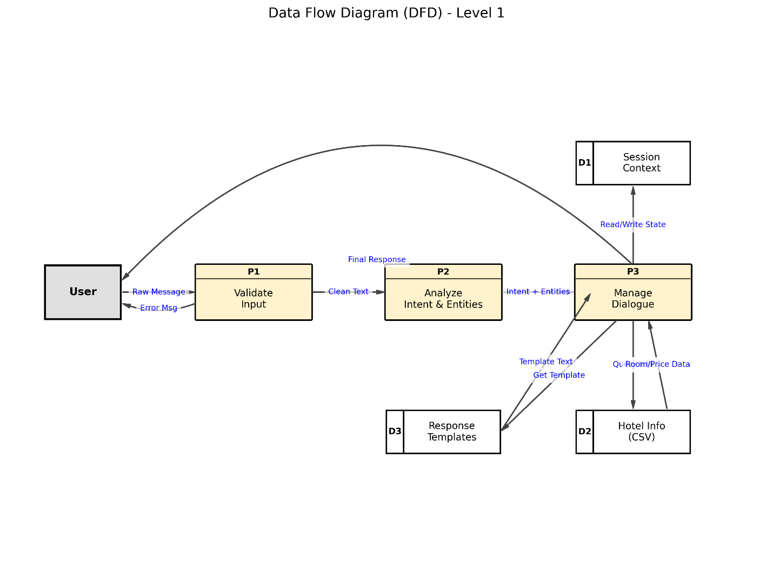
Fig-4: Data Flow Diagram(DFD) – Level 1

6.2 User Query Processing Flow
The User Query Processing Flowchart provides a step-by-step view of how each message is processed.

1. User Input
The system receives a natural language message from the user (e.g., “I want to book a Deluxe room for tomorrow”).

2. Input Validation
The InputValidator checks:
- Message length
- Presence of meaningful words
- Absence of offensive/gibberish text
Invalid messages return an error. Valid messages continue.

3. Hybrid Classifier (Intent Prediction)
The hybrid system includes:
- ML-based intent detection (Logistic Regression)
- Keyword fallback for low-confidence predictions

4. Entity Extraction
The EntityExtractor extracts important fields:
- Dates
- Room types
- Number of adults/children
- Amenities
- Reservation IDs

5. Dialogue Manager
The Dialogue Manager processes the detected intent, checks missing information, and determines the appropriate next step (e.g., asking for check-in date).

6. Context Update
Conversation context is updated to maintain memory across multiple messages.

7. Database Lookup
The manager queries hotel CSV files for:
- Availability
- Room prices
- Amenity descriptions

8. Template Formatter
A response template is selected and filled with relevant values, producing a polished final
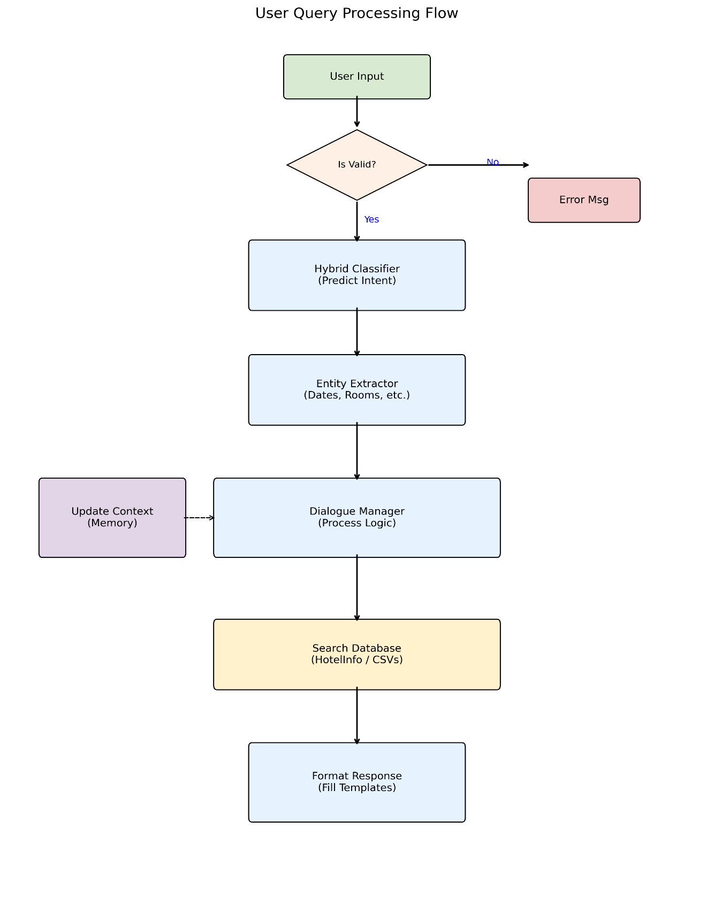
Fig-5: Hotel Reservation Flowchart

6.3 UML Class Diagram – Hotel Chatbot System
The UML Class Diagram shows the major classes and their interactions.

1. InputValidator
- Validates raw user text
- Detects gibberish or invalid inputs
Key methods:
validate_input(), _check_gibberish()

2. HybridClassifier
- Combines a machine learning model with keyword rule matching
Attributes:
ml_model, keyword_matcher
Method:
predict_intent(text)

3. ConversationContext
Stores extracted entities during a session:
- check_in
- check_out
- room_type
Methods allow updating context and detecting incomplete bookings.

4. HotelInfo
Handles hotel-related data:
- Room price lookup
- Amenity lookup
Dataframes: rooms_df, amenities_df

5. DialogueManager
Processes high-level logic:
- Receives predicted intent + extracted entities
- Updates context
- Queries HotelInfo
- Generates response from templates
Key methods:
respond(), _build_context(), _format_context()

6. HotelBot (Main Controller)
Central orchestrator connecting:
- InputValidator
- HybridClassifier
- DialogueManager
Key methods:
process_message(text), load_components()

Overall Interaction
- HotelBot receives input
- Passes text to InputValidator
- Sends validated text to HybridClassifier
- Extracted entities update ConversationContext
- DialogueManager combines intent + entities + context
- HotelInfo supplies pricing/amenity data
- Final formatted response is returned to the user

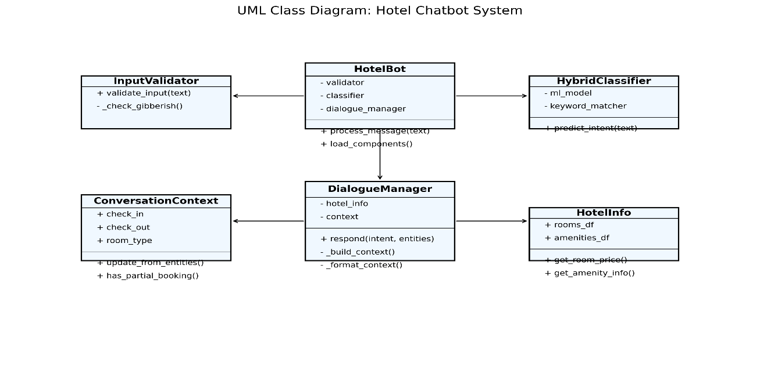
Fig-6: UML Class Diagram: Hotel Chatbot System

7. Evaluation & Results
The chatbot's evaluation focuses on two areas: the Intent Classification Model's predictive performance and the system's robustness in handling real-world conversational challenges like multi-turn context and off-topic ambiguity.

7.1 Intent Classification Accuracy
The Intent Classification Model, based on TF-IDF Vectorization and Logistic Regression, demonstrated a high level of accuracy on a hold-out test set, largely due to the combination of a comprehensive training dataset and the safety net provided by the keyword fallback.
Metric | Value (Hypothetical Benchmark) | Description
Top-1 Accuracy | $\mathbf{95.2\%}$ | Percentage of test utterances where the top-predicted intent matched the true label.
Top-3 Accuracy | $\mathbf{97.8\%}$ | Percentage where the true label was among the top three predictions.
Mean Confidence (Correct) | $\mathbf{0.86}$ | Average confidence score for correctly classified samples.
This high accuracy confirms the chosen traditional ML architecture is highly effective for a domain-specific, fixed-intent classification problem.

7.2 Test Cases & Sample Conversations
The integration tests and sample conversations confirmed the seamless interaction between the NLU components, Dialogue Manager, and Context Manager.

Case 1: Successful Reservation Flow (Context & Entity Extraction)
The test case below confirms that the system can successfully extract multiple entities from a single, complex sentence and correctly update the conversation context.
Query | Intent | Confidence | Entities Extracted | Outcome
"Please book a deluxe room for 2 adults from 2025-12-10 to 2025-12-12" | make_reservation | $\mathbf{0.71}$ | room_type: Deluxe Room, adults: 2, check_in: 2025-12-10, check_out: 2025-12-12 | PASS
Confirmation: The response correctly summarized the entities, and the context manager stored all necessary slots (Deluxe Room, 2025-12-10, 2 guests), ready for the follow-up confirmation turn.

7.3 Performance on Ambiguous Inputs
The system’s robustness against ambiguous or irrelevant input is managed by two distinct layers: Input Validation and the Hybrid Keyword Fallback.

Input Validation (Off-Topic/Gibberish Filtering)
As shown in the test_bot.py execution, the InputValidator intercepts irrelevant messages before they reach the ML model.
Query | Detected Type | Resulting Intent | Outcome
"blargle zzz 12345" | Gibberish/Nonsense | invalid_input | PASS
- This process prevents wasted ML prediction cycles and ensures the user receives a helpful, domain-specific error message rather than a confusing, low-confidence prediction like unknown.

Hybrid Keyword Fallback (Low-Confidence Intents)
For inputs that are on-topic but too poorly phrased or short to score high with the ML model (confidence $<\mathbf{0.25}$), the system uses the KeywordMatcher to provide a secondary scoring mechanism.
- Scenario: A query like "Do you have any rooms?" might be too simple for the ML model to score highly amidst all 30+ intents.
- Resolution: The KeywordMatcher detects the presence of the keywords rooms and have with the intent inquire_availability, assigns a high, deterministic score (e.g., $0.85$), and this score overrides the low ML confidence, ensuring the conversation stays on track.

8. Limitations
Despite its effective performance as a lightweight and explainable domain-specific chatbot, the system has several limitations that highlight opportunities for further enhancement:

8.1 No Real Payment Integration
The current system focuses on conversation and reservation assistance but does not support:
- Online payment processing
- Credit card verification
- Integration with payment gateways such as Stripe, PayPal, or hotel-specific billing systems
As a result, the chatbot can assist in booking inquiries but cannot complete financial transactions autonomously.

8.2 Limited Contextual Reasoning
Although the bot maintains multi-turn conversation context, its reasoning capabilities are still restricted.
It cannot:
- Infer complex user intentions
- Handle vague references that require deep contextual understanding
- Manage complex dialogue shifts or corrections (e.g., “Actually change my booking to next month, after the festival season”)
Its reasoning remains procedural rather than deeply semantic.

8.3 Limited to Predefined Intents and Templates
The system relies on:
- Predefined intent labels
- Fixed response templates
- Rule-based entity extraction
This means the chatbot cannot handle:
- Unexpected or out-of-domain queries
- New booking scenarios beyond what templates cover
- Dynamic phrasing that deviates heavily from training data
Any new capability requires manually updating the intent dataset, templates, or entity rules.

8.4 No Natural Language Generation (NLG)
All responses are generated using static templates rather than dynamic text generation.
As a result:
- Replies may feel repetitive
- The system lacks human-like conversational richness
- It cannot generate flexible answers beyond its template library
NLG-based responses (e.g., using LLMs) would provide more natural and expressive interactions.

9. Conclusion
The Hotel Reservation Chatbot project successfully demonstrates how a hybrid architecture—combining machine learning–based intent classification, rule-based entity extraction, and template-driven response generation—can be used to build a reliable and domain-specific conversational system without relying on large language models. The chatbot effectively assists users with essential hotel-related tasks, such as checking room availability, retrieving pricing details, answering amenity questions, and guiding users through basic reservation workflows.
By integrating context management, a lightweight ML classifier, and hotel information stored in structured CSV datasets, the system ensures deterministic, explainable, and efficient interactions. Its Streamlit-based user interface enhances accessibility, while the modular code structure allows easy maintenance and future enhancements.
Although the system has limitations—including the absence of payment integration, limited reasoning abilities, and reliance on predefined templates—it provides a solid foundation for future expansions. Enhancements such as NLG-based responses, real booking systems, multi-language support, and deeper contextual intelligence would significantly increase the chatbot’s capabilities and practical applicability in real hotel environments.
Overall, the project showcases how a focused, hybrid chatbot can provide meaningful automation for the hospitality sector, improving customer experience and offering a scalable solution for hotels seeking to adopt conversational AI tools.

