

Ref: DPE/07(Recruitment)/ATR(Revenue)/2014/249

Government of the People's Republic of Bangladesh

**Directorate of Primary Education**

**Admit Card - Assistant Teacher Recruitment (Revenue) - 2014**

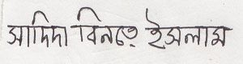

Applicant's Signature

19 (KISHORGONJ)

12 (PAKUNDIA)

1931711

SADIDA BINTE ISLAM MD. TAZUL ISLAM KOHINUR BEGUM

WALINEOWJ KHAN COLLEGE, KISHOREGONJ

01 JUNE 2018, 10:00 AM

District Code Upazila/Thana Code Roll No

Name

Father's Name Mother's Name Exam Centre Exam Date/Time

Date: 2018-05-20 16:09:30 User ID: QJTVZY | System ID: A152CB62296DBB3F8C179FABFA1D30D3

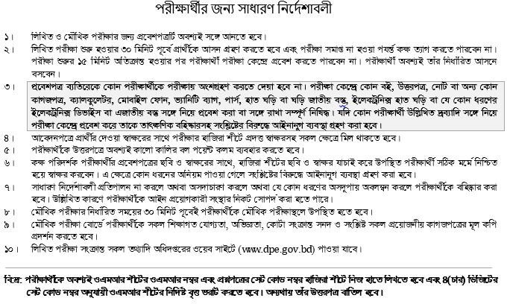

District Primary Education Officer (KISHORGONJ)



©2018 DPE, Directorate of Primary Education, All Rights Reserved. Powered by