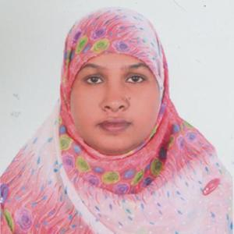**Curriculum Vitae**

**Mamataz Rahman**

Contact : 01759-249189

**Career Objective:**

Intend to work in challenging and competitive environment where strong sense responsibility and commitment requires, where dignity of work provides job satisfaction and place of work provides potential avenues for learning and growing and to achieve top level in respective field.

**Scholastic Records:**

**Masters of Science (M.Sc)**

Name of the Subject : Fisheries

Name of the Institute : Bhawal Badre Alam Govt. College

Duration of Course : 1 year

Result : 2nd Class

Passing Year : 2010 (Held on 2013)

**Bachelor of Science (B.Sc)**

Name of the Subject : Zoology

Name of the Institute : Bhawal Badre Alam Govt. College

Duration of Course : 4 year

Result : 2nd Class

Passing Year : 2009

**Higher Secondary Certificate (H.S.C)**

Name of Degree : H.S.C

Group : Science

Name of Institute : Bhawal Badre Alam Govt. College

Name of the Board : Dhaka

Result : G.P.A- 3.00

Passing Year : 2005

**Secondary School Certificate(H.S.C)**

Name of Degree : S.S.C

Group : Science

Name of Institute : Bhabanipur High School

Name of the Board : Dhaka

Result : G.P.A- 3.38

Passing Year : 2002

**Computer Proficiency:**

* Basic Computer Education
* Internet Browsing, Mailing etc.

**Language Skills:**

* Bengali : Better Reading, Writing & Speaking.
* English : Good Reading, Writing & Speaking
* Hindi : Good Reading & Speaking.

**Personal Profile:**

Name : Mamataz Rahman

Father’s Name : Mizanur Rahman

Mother’s Name : Ferdowsi Rahman

Permanent Address : Vill: Nayapara (Monipur), P.O: Bhabanipur

P.S: Gazipur Sadar, Dist.: Gazipur

Present Address : Ahalia, Uttara, Dhaka- 1230

Date of Birth : 1st January 1986

Nationality : Bangladeshi (By Born)

Religion : Islam

Sex : Female

Marital Status : Married

**Working Experience:**

i)

Name of the Institute : Shaheen School & College

Position : Assis. Teacher

Duration : Presently working from last year

ii)

Name of the Institute : Parashmoni Laboratory School

Position : Assis. Teacher (Science)

Duration : 4 years

**Extra Skill :**

* **Beautiful Hand Writing Expert**

**Declaration :**

I hereby declare that the information given above by me is true, complete and convict to the best of my knowledge.

____________________

**Date: Mamataz Rahman**