**Muhammad Hassan Tahir**

**02-131222-129**

**BSE 7B**

**Software Construction Documentation**

**Smart Home Automation**

**Vision Statement:**

For tech-savvy homeowners and individuals seeking convenience, who want to monitor, control, and automate their household devices remotely and securely. The Smart Home Automation System is a centralized, user-friendly platform that orchestrates lighting, temperature, security, and appliances through a mobile or web interface. Unlike traditional manual systems or disjointed device apps, our solution integrates everything seamlessly in one hub with AI-enhanced control and real-time feedback.

**Project Definition:**

The Smart Home Automation System is designed to transform modern homes into intelligent living environments by enabling remote control, automation, and monitoring of home appliances and systems. The system enhances energy efficiency, security, and comfort through a centralized interface that communicates with sensors, actuators, and devices across the home.

This system serves as a bridge between digital innovation and physical space, offering real-time interaction and automation for users via smartphones or voice assistants.

**Functional Requirements:**

* **User Authentication**

Register and login using email/password or biometric login (if applicable).

* **Device Management**

Add, remove, and configure smart devices (lights, thermostats, cameras).

* **Remote Control**

Turn on/off and adjust devices via mobile/web interface.

* **Scheduling Automation**

Set routines and automation based on time, location, or triggers (e.g., motion).

* **Real-Time Monitoring**

View live sensor data (e.g., temperature, motion) and device status.

* **Voice Assistant Integration**

Control devices via Alexa, Google Assistant, etc.

* **Notifications**

Send alerts for unusual activity (e.g., break-in detected, smoke).

* **Energy Consumption Reports**

Show usage stats and energy-saving suggestions.

* **Scene Setting**

Group device actions (e.g., “Movie Night” dims lights and turns on TV).

* **User Role Management**

Admin, Guest, and standard user access levels.

**Non-Functional Requirements:**

* **Usability**

Intuitive UI/UX for both technical and non-technical users.

* **Reliability**

System uptime should be 99.9% or higher.

* **Scalability**

Able to support up to 100 connected devices per household.

* **Security**

End-to-end encryption for all communications. Two-factor authentication for user login.

* **Performance**

Response time for device control should be <1 second.

* **Maintainability**

Modular architecture for easy updates and troubleshooting.

* **Portability**

Cross-platform support (Android, iOS, web).

* **Accessibility**

Compatible with screen readers and voice controls.

* **Localization**

Support multiple languages for global users.

* **Compliance**

Adheres to IoT and data protection standards (e.g., GDPR).

**UML Diagrams:**

* **Class Diagram:**

* **Sequence Diagram:**

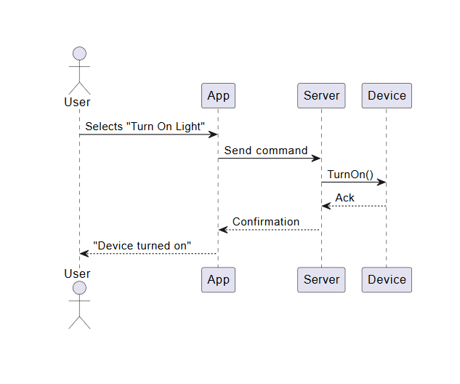

* **ERD Diagram :**

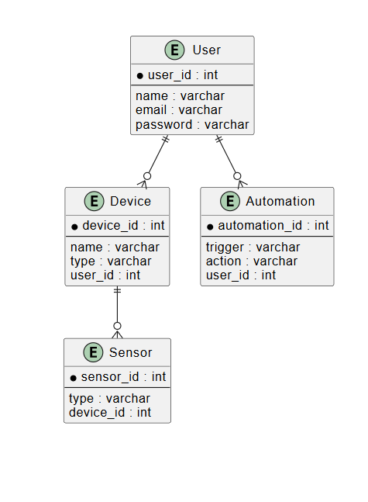

* **Use Case Diagram:**

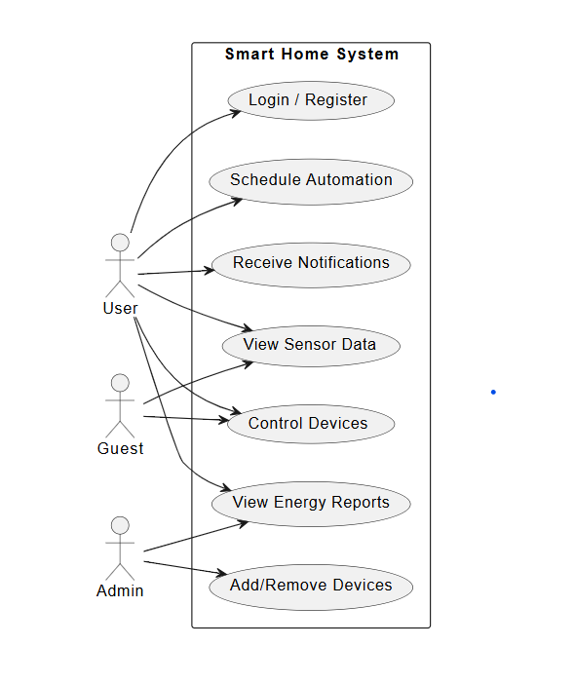

**Prototypes:**

* **Low Fidelity:**

**Link:** [**https://balsamiq.cloud/s78q5es/p1k3djn**](https://balsamiq.cloud/s78q5es/p1k3djn)

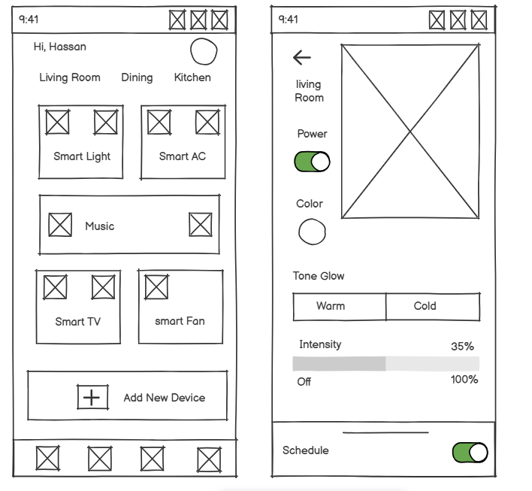

* **High Fidelity:**

**Link:** [**https://www.figma.com/proto/WReXlQ3QwV92vwMLBYm5TQ/Smart-Home-Automation?node-id=0-1&t=XLXGAlVqjgqmhY3U-1**](https://www.figma.com/proto/WReXlQ3QwV92vwMLBYm5TQ/Smart-Home-Automation?node-id=0-1&t=XLXGAlVqjgqmhY3U-1)

