**Python - practice number 5**

1. In some communal settlement, one wants to check whether it is worthwhile to establish a high school in the settlement or whether the students of the settlement should attend schools in nearby settlements. For this purpose, the current year must be entered and then the years of birth of all the children of the settlement must be entered. The birth years of the children must be recorded until a negative number is recorded. Check how many children are aged 15, 16 and 17 (according to the year only). If there are at least 80* children in each such age group, a notice must be issued that a high school can be established in the settlement. Also, it must be printed how many of the children are 15 years old, how many are 16 years old, and how many are 17 years old. Otherwise, a notice must be issued that it cannot be established in the settlement. S high school in the settlement.

No input checks are required.

**\* For the purpose of testing/running the program, check if there are at least 3 children in each age group (instead of 80**

**as indicated in the question).**

1. A tracking table must be built for the input:
2. 32004X3X2005 3X2006 2021 (left to right)

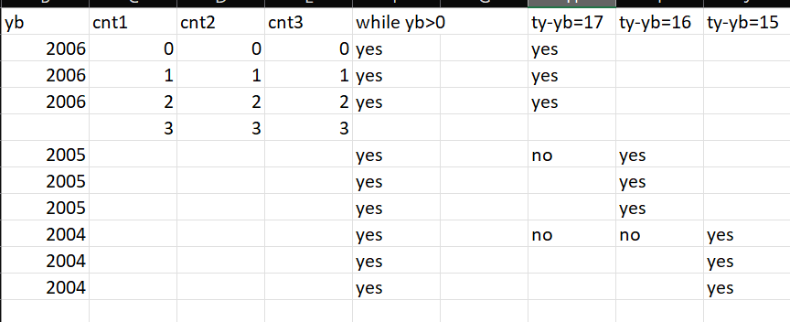

3. In an annual college course, students receive an intermediate grade at the end of the first semester and a final grade at the end

this year The score is an actual number in the 40-100 range (*an input check must be performed and make sure the score

OK, make input until it's OK).

The math lecturer rounds the grade at the end of the first semester but keeps the broken part for the grade

the final Write a program that receives as input intermediate grades of students (a real number) and displays as output

the rounded score and the broken part that is saved for the end of the year (positive or negative depending on why

received). The number of students for whom the process is carried out isN (3-constant) as a number

The students in the course.

Examples:

Input: 96.4 Output: The rounded score: 96, the part saved for the end of the year: 0.4+

Input: 67.8 Output: The rounded score: 68, the part retained for the end of the year: -0.2

4. A tracking table must be built for the inputs shown in the example.

5. In the theory exam at the licensing office they were testedN people. It is known that in order to pass the exam it is forbidden

There will be a mistake in the traffic signs, and at most 3 mistakes in the rest of the questions.

Write a program that captures the number of examineesN, and for each we will examine the number of mistakes he had

at traffic lights, and the number of mistakes he had in the other questions. The program will display as output:

1. the number of people who passed the exam.
2. the percentage of people who passed the exam.

6. A number is called "perfect" if the sum of its parts (not including the number itself) is equal to the number itself.

For example, 28 is a perfect number because: 28 = 1+2+4+7+14

Write a program that finds all the perfect numbers in the range 1-1000. The program will print:

the perfect numbers found in this field and their number (how many perfect numbers

were found).

**Remarks:**

* Input checks must be performed where there is an asterisk (*).
* The input and output must be accompanied by text explaining the printed data.
* Variables must be given meaningful names.

Nice work