**Python - exercise number 6**

1. A. Write a function that accepts a positive integer and returns the number of its even digits.

B. Write a plan that capturesn positive integers. The output is the number containing the

The largest number of even digits. Assume there is only one such number. must be used

In the function from section A.

1. Write a function that calculates the integer part of any positive or negative real number.

Write a piece of code that takes a number and calls the function.

**Note:**Do not use any ready-made mathematical function that returns these values.

For example: the whole part of 10.2 is 10

The whole part of 10.7 is 10

The integer part of 11.2- is 11-

1. Create a follow-up table for the previous question for the following inputs: 5.435, 3.82-

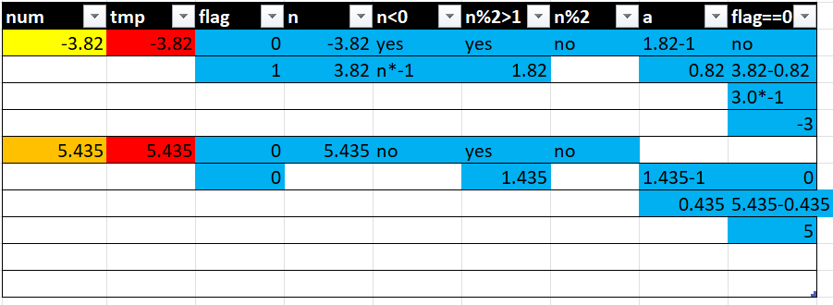

1. A. Write a function that accepts an integer and calculates positives and returns the sum of its digits.

B. Write a function that checks if a positive whole number is divisible by 3 according to the sum of its digits. as per

The principle explained in the examples (use the function from section A to write the code of

Section B):

third. Write a piece of code that receives a positive whole number and checks with the help of the two functions from sections A and

B. If the number is divisible by 3 without a remainder.

Examples:

123=> the sum of the digits: 6= 1+2+3

0= 6-3-3 => the number is divisible by 3

999=> The sum of the digits 27 = 9+9+9 The sum of the digits 9 = 2+7

0 = 9-3-3-3 => the number is divisible by 3.

d. A tracking table must be created for the number 999

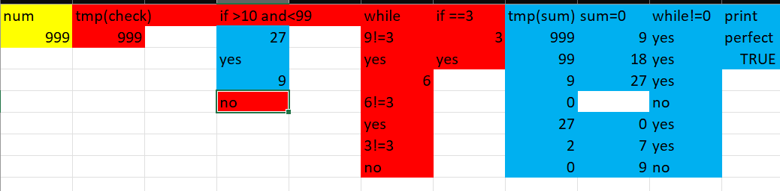

**Remarks:**

* The input and output must be accompanied by text explaining the printed data.
* Variables must be given meaningful names.

Nice work