ת.ז:212530711
שם:חסן דיאב

שאלה 1

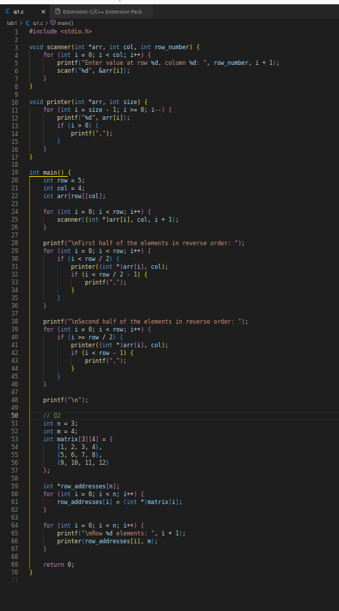

#include <stdio.h>

void scanner(int *arr, int col, int row_number) {
for (int i = 0; i < col; i++) {
printf("Enter value at row %d, column %d: ", row_number, i + 1);
scanf("%d", &arr[i]);
}
}

void printer(int *arr, int size) {
for (int i = size - 1; i >= 0; i--) {
printf("%d", arr[i]);
if (i > 0) {
printf(",");
}
}
}

int main() {
int row = 5;
int col = 4;
int arr[row][col];

for (int i = 0; i < row; i++) {
scanner((int *)arr[i], col, i + 1);
}

printf("\nFirst half of the elements in reverse order: ");
for (int i = 0; i < row; i++) {
if (i < row / 2) {
printer((int *)arr[i], col);
if (i < row / 2 - 1) {
printf(",");
}
}
}

printf("\nSecond half of the elements in reverse order: ");
for (int i = 0; i < row; i++) {
if (i >= row / 2) {
printer((int *)arr[i], col);
if (i < row - 1) {
printf(",");
}
}
}

printf("\n");

// Q2
int n = 3;
int m = 4;
int matrix[3][4] = {
{1, 2, 3, 4},
{5, 6, 7, 8},
{9, 10, 11, 12}
};

int *row_addresses[n];
for (int i = 0; i < n; i++) {
row_addresses[i] = (int *)matrix[i];
}

for (int i = 0; i < n; i++) {
printf("\nRow %d elements: ", i + 1);
printer(row_addresses[i], m);
}

return 0;
}
שאלה 2

func | ptr | main | x | pX | myFunc | x | y | z | main | x | y | z
 | 99 |  | 30 | &x |  |  |  |  |  | 3 | *y | *z
 |  |  |  | 99 |  |  |  |  |  | y | z
‘
הפונקציה משנה המצפיע ששלחנו אותו ל 99 בצקום 30 - 1

2- הפונקצהלר תקינה אין ערכים של Y ן Z

3-#include <stdio.h>

void countDivisibleBy3(int arr[], int size, int *count);

int main() {
int arr[] = {0, 1, 2, 3, 4, 5, 6, 7, 8, 9};
int count = 0;

countDivisibleBy3(arr, sizeof(arr) / sizeof(arr[0]), &count);

printf("The number of elements divisible by 3 is: %d\n", count);
return 0;
}

void countDivisibleBy3(int arr[], int size, int *count) {
*count = 0;
for (int i = 0; i < size; i++) {
if (arr[i] % 3 == 0) {
(*count)++;
}
}
}

