Software Design and Architecture (COE692)
Software installation guide

Introduction
In this document, we describe installing required softwares for deploying docker containers on Google Cloud.

Requirements
- The environment that has been set up in Lab 1.
- An active Google Cloud account (Please make sure that you have registered for a free tier account before starting this lab)

Part 1: Installing Docker
The complete guide for installing docker on the Debian system (The linux Virtual machine we set up at Lab 1) can be found in the following address:
https://docs.docker.com/engine/install/debian/
All instructions are for amd64.

The details are as follows:
- Open a terminal
- Run the following command:
sudo apt update
sudo apt-get update

- And then run the following command. Do not forget to enter Y when it asks you are OK to continue? (Y/n):
sudo apt-get install \ apt-transport-https \ ca-certificates \ curl \ gnupg \ lsb-release | 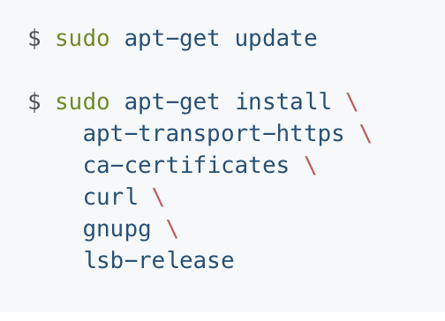

- And then the following:
curl -fsSL https://download.docker.com/linux/debian/gpg | sudo gpg --dearmor -o /usr/share/keyrings/docker-archive-keyring.gpg

- And then:
echo \
"deb [arch=amd64 signed-by=/usr/share/keyrings/docker-archive-keyring.gpg] https://download.docker.com/linux/debian \
$(lsb_release -cs) stable" | sudo tee /etc/apt/sources.list.d/docker.list > /dev/null
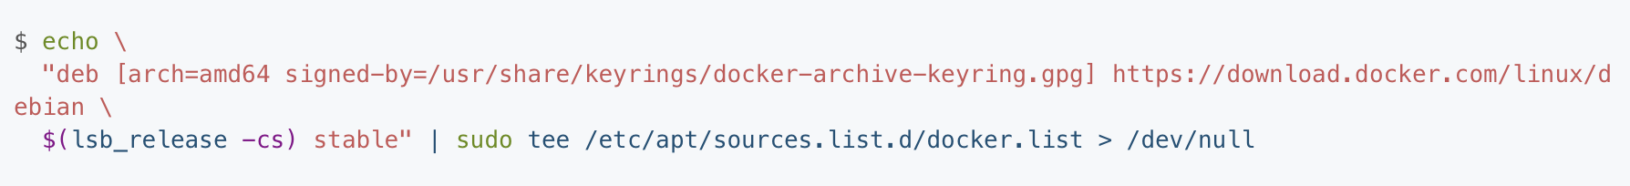

- And then:
sudo apt-get update
sudo apt-get install docker-ce docker-ce-cli containerd.io
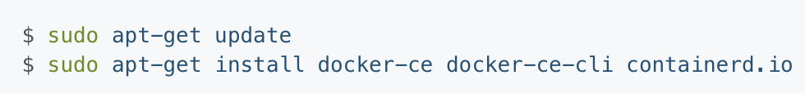
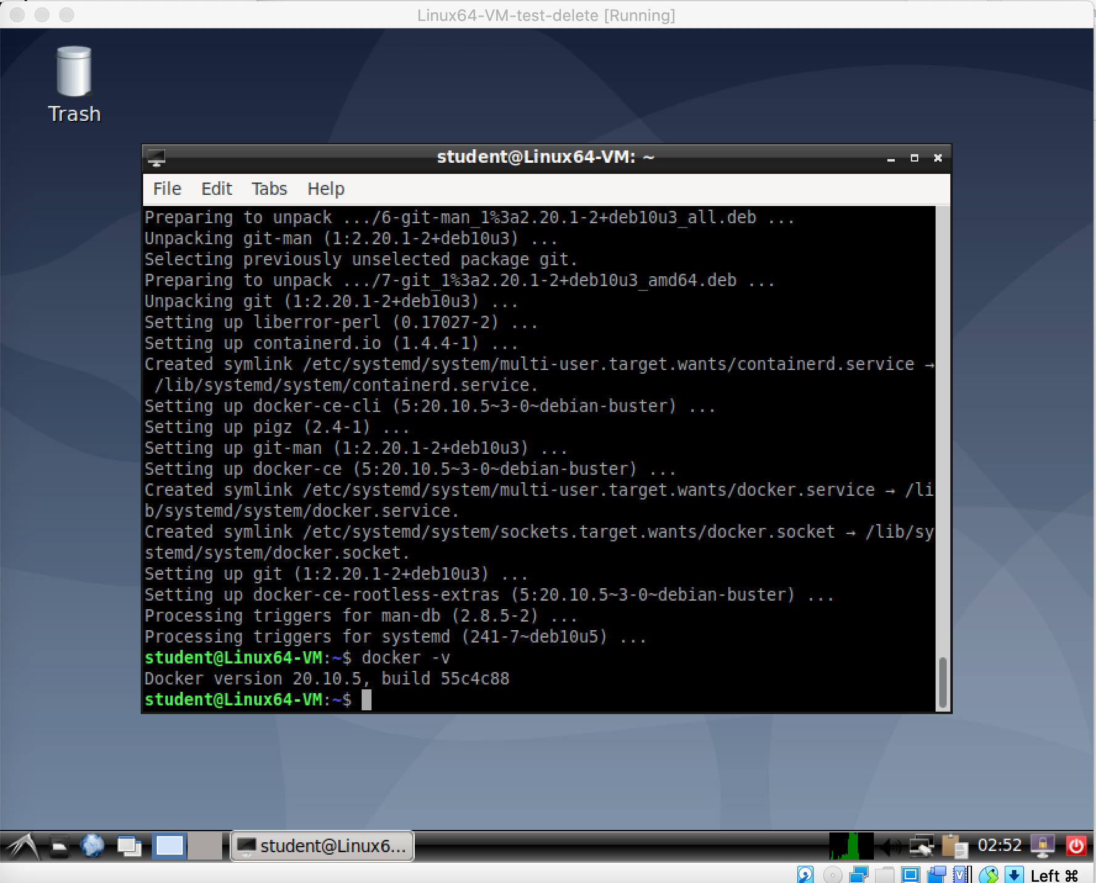
Figure 1

After completing all steps, the following command will give you the version of the installed docker:
docker -v (Please see Figure 1)

Part 2: Installing Google Cloud
The next step is to install google cloud sdk. I assume you have an active google cloud account.
The detailed instruction can be found here: https://cloud.google.com/sdk/docs/quickstart#deb
Use Ubuntu/Debian tab for our lab virtual machine.
Follow the following steps in an open terminal
- Run the following:
echo "deb [signed-by=/usr/share/keyrings/cloud.google.gpg] https://packages.cloud.google.com/apt cloud-sdk main" | sudo tee -a /etc/apt/sources.list.d/google-cloud-sdk.list

- And then:
sudo apt-get install apt-transport-https ca-certificates gnupg

- And then:
curl https://packages.cloud.google.com/apt/doc/apt-key.gpg | sudo apt-key --keyring /usr/share/keyrings/cloud.google.gpg add -

- And Then:
sudo apt-get update && sudo apt-get install google-cloud-sdk

- Finally initialize your google cloud:
gcloud init

That opens a page at firefox where you can login into your google account:
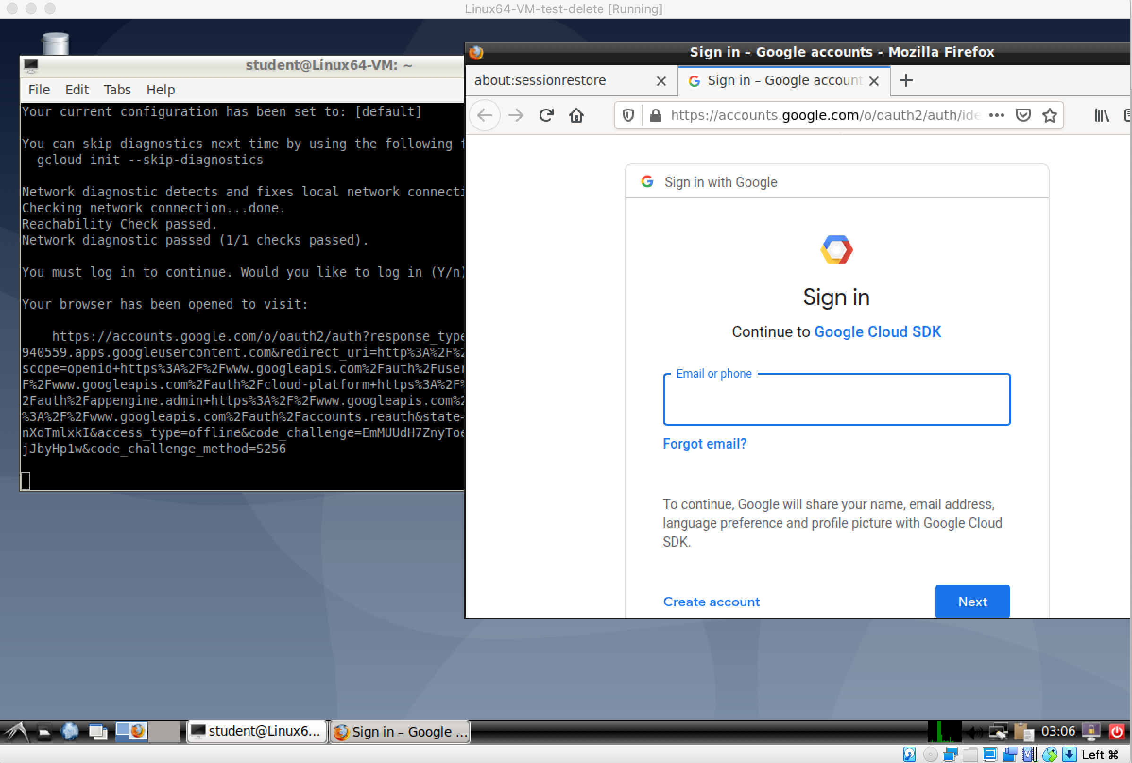
Figure 2

After entering your username and password, a new page aske you allow Google Cloud SDK to perform tasks: (Figure 3)
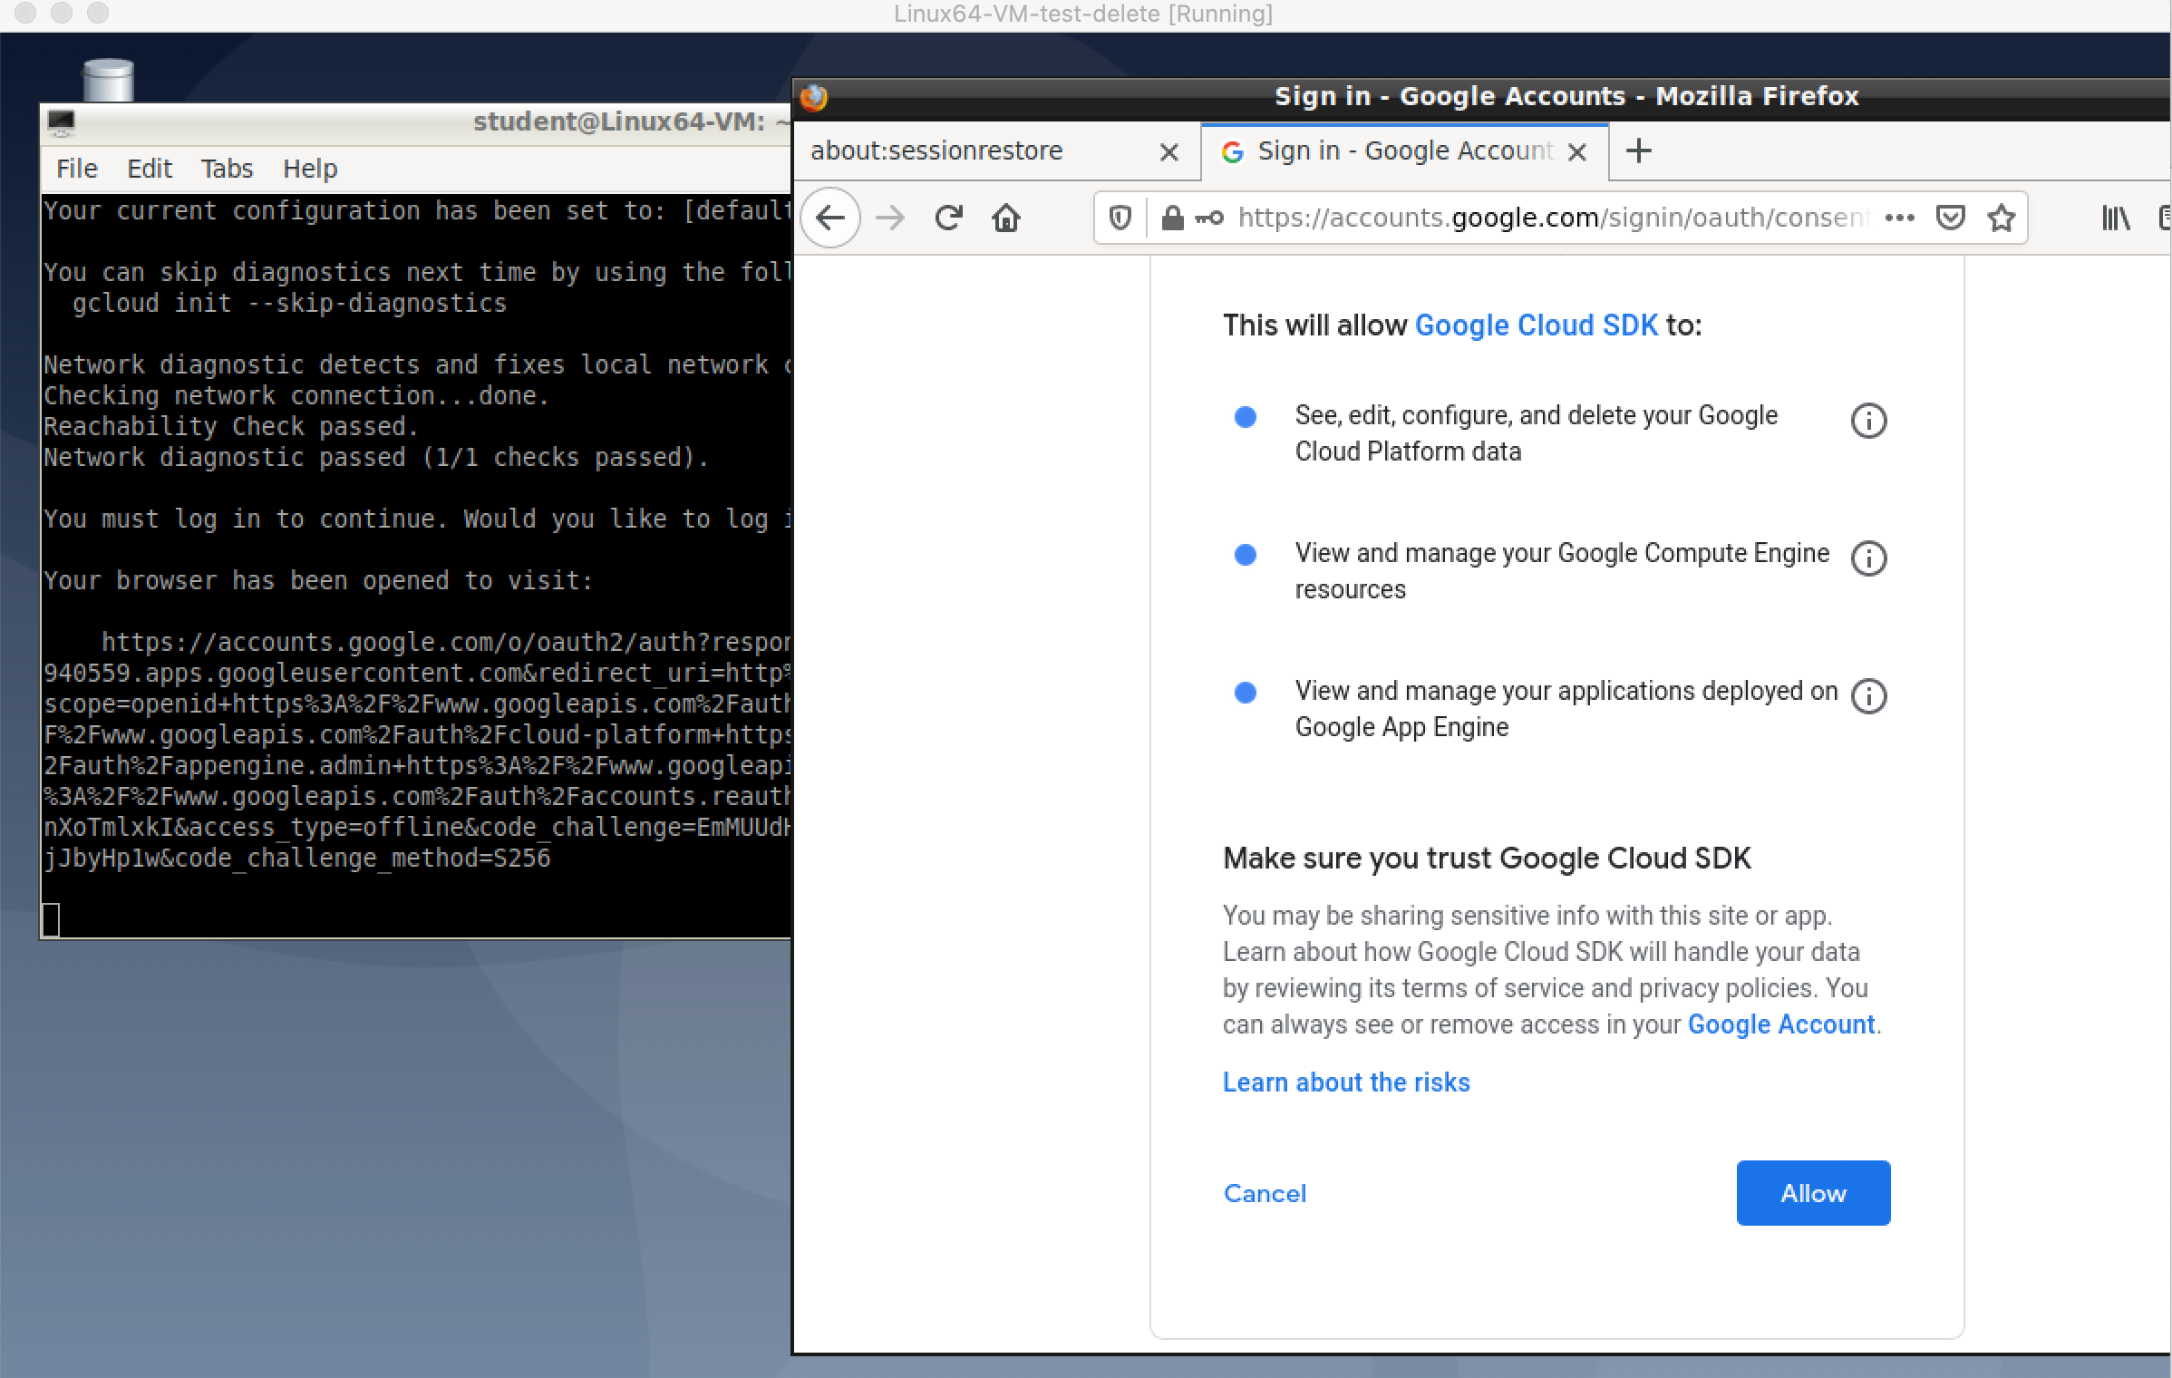
Figure 3
The Next step, Google cloud SDK asks you to select your Project (Figure 4). These projects are listed from those you have created in your Google Cloud Council (Please review Lecture at Week 10)
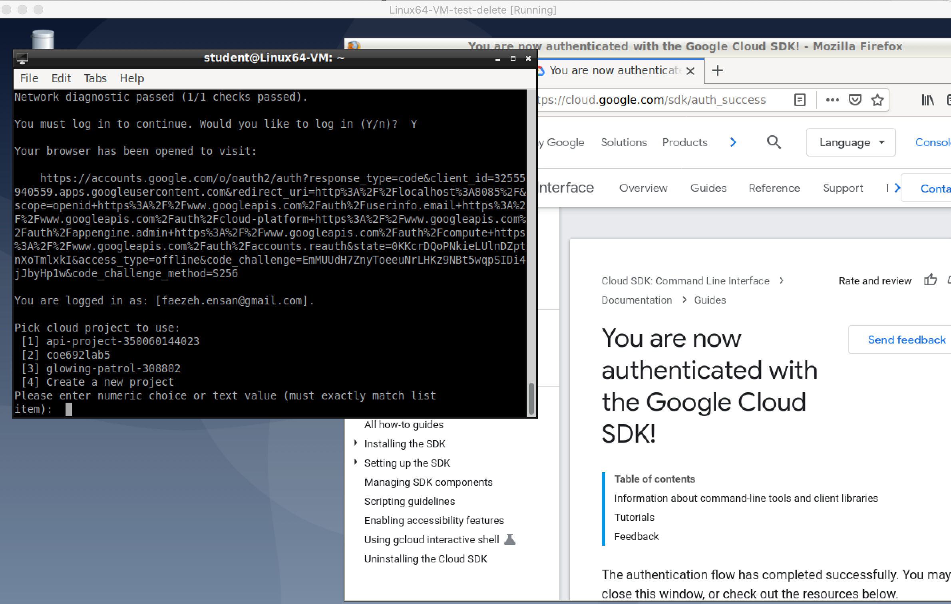
Figure 4
Use appropriate number to select the project.

The next step is to select Zone. Please enter northamerica-northeast1-a

Part 3: Kubernetes and setting Kubernetes on Google Cloud
- Ensure you have enabled Kubernetes on your google account project. Please visit the following page: https://cloud.google.com/kubernetes-engine/docs/how-to/cluster-access-for-kubectl
And click on the following blue button: 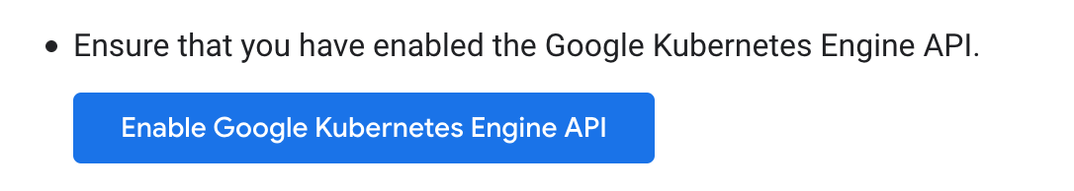

That leads to a new page, when you need to select Enable. You can select from existing project or create a new project. Select the same project you have selected when initializing gcloud. Wait for the API and related services to be enabled. This can take several minutes.

- Install Kubectl with the following command:
sudo apt-get install kubectl
Now configure Google Cloud Kubernetes Cluster

- First, make sure you are logged in your google cloud by running:
gcloud auth login
That opens a web page like the one you saw in gcloud init command. Enter your google account username and password and you will be set.
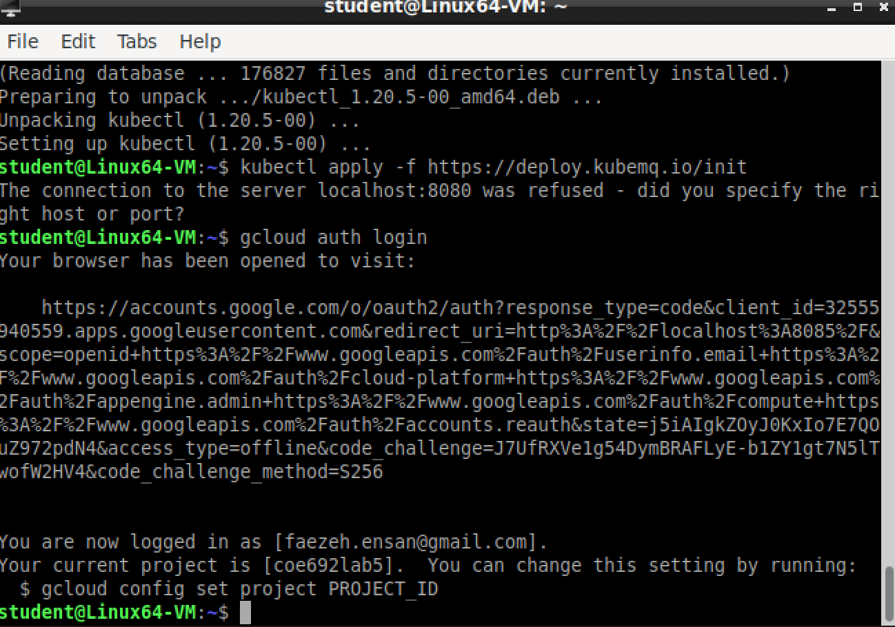
- If you are not happy with project that has been selected, you can change It with the following command:

gcloud config set project PROJECT_ID

When PROJECT_ID must be replaced by your desired google cloud project id.

- Now create a Google Cloud Kubernetes cluster by running the following command:
gcloud container clusters create coe692lab5-cluster --num-nodes=3

Replace lab5-cluster with your desired name for the cluster.
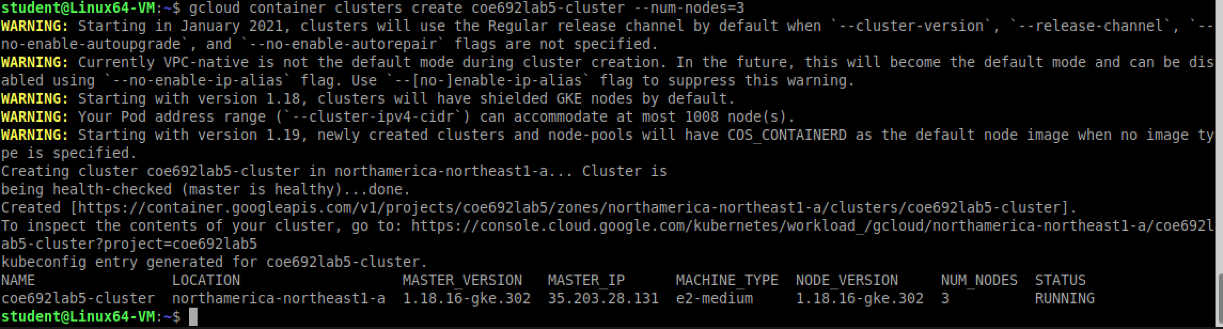

- Finally set credentials of the kuberenetese cluster with running the following command:

gcloud container clusters get-credentials coe692lab5-cluster --zone=northamerica-northeast1-a

Part 4: KubeMQ
Kubemq is a mechanism for sending and receiving messages in Kubernetes clusters.

Please follow instruction in the following link:
https://docs.kubemq.io/getting-started/quick-start

- First Obtain KubeMQ Registration Token

- Please visit: https://account.kubemq.io/login/register and register for a license token.
- Wait for an email confirmation with your license token
- run
kubectl apply -f https://deploy.kubemq.io/init
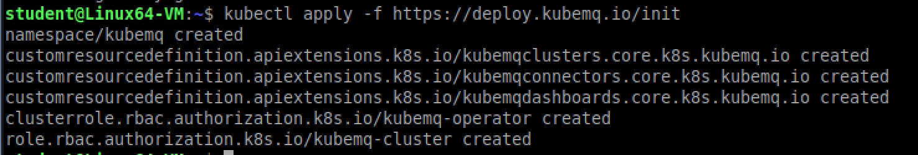

- Run
kubectl apply -f https://deploy.kubemq.io/key/<kubemq-registration-token>
replace <kubemq-registration-token> with the token you got when registering for KubeMQ.

- Run the following to install kubemqcli:

sudo curl -sL https://get.kubemq.io/install | sudo

- Use the following command to make sure your kubemqcli works well:

kubemqctl get cluster describe

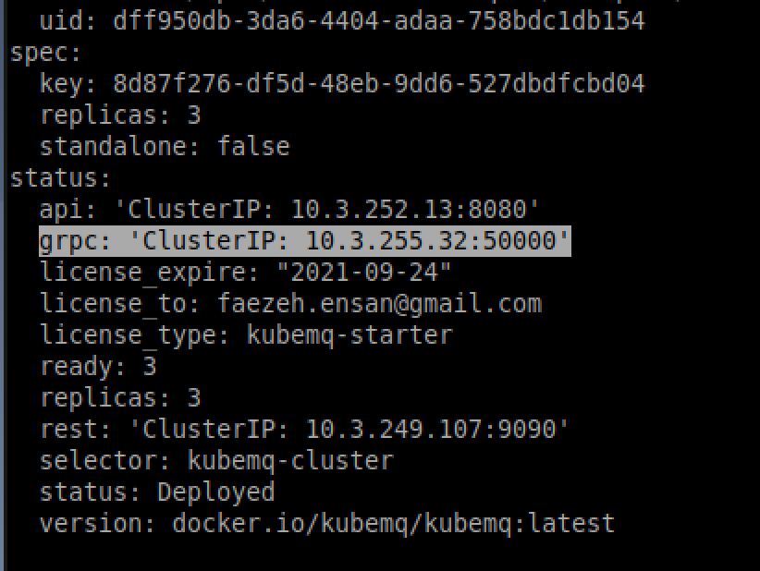

Take note of the grepc ClusterIP (It could be different for your project than mine). We are going to use it in future!

- If your java project needs to send and receive messages with KubeMQ, insert the following dependencies to your maven file:

<!-- https://mvnrepository.com/artifact/io.kubemq.sdk/kubemq-sdk-Java -->
<dependency>
<groupId>io.kubemq.sdk</groupId>
<artifactId>kubemq-sdk-Java</artifactId>
<version>1.0.3</version>
</dependency>

VERY IMPORTANT: Please copy-paste commands from the original website (https://docs.docker.com/engine/install/debian/) not from this word document. Sometimes, some formatting has been changed in the word document, which makes troubles in running commands.

