KING FAHD UNIVERISTY OF PETROLEUM AND MINERALS
DEPARTMENT OF INFORMATION COMPUTER SCIENCE

ICS334 – DATABASE SYSTEMS

TERM - 041

SECTION 02 – 11-11:50 AM SMW

Question | Maximum Marks | Marks Scored
1 | 18
2 | 12
3 | 25
4 | 20
Total | 75

Problem 1 [Points 18]

- Match the following terms and definitions. 6 Points

Choice
 | super type | A subset of supertype
 | subtype | B entity belongs to two subtypes
 | specialization | C subtype gets supertype attributes
 | subtype discriminator | D rule on which actions are limited
 | attribute inheritance | E business rule that influesnces an action
 | overlap rule | F create delete update or read
 |  | G calculated using an algorithm
 |  | H generalized entity type
 |  | I static structure of organization
 |  | J creating subtypes for an entity type
 |  | K a group of associated entity types and relationships
 |  | L locates target subtype for an entity

b. 12 points
Consider the figure shown below. Assume that an employee may work in up to two departments, but may also not be assigned to any department. Assume that each department must have one and may have up to three phone numbers. Supply (min,max) constraints on this diagram. State clearly any additional assumptions if necessary. Under what conditions would the relationship HAS_PHONE be redundant in the above example?

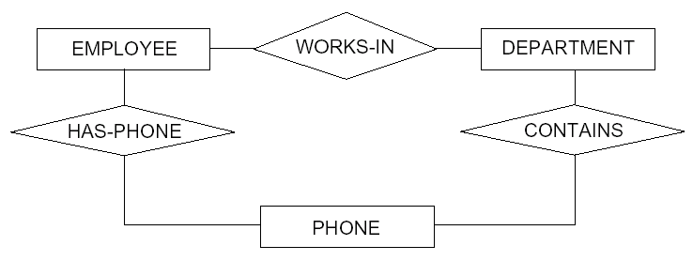
Problem 2 Tuple Relational Calculus 10 Points

Consider the relational schema as shown below:

branch (branch-name, branch-city, assets)
customer (customer-name, customer-street, customer-city)
account (account-number, branch-name, balance)
loan (loan-number, branch-name, amount)
depositor (customer-name, account-number)
borrower (customer-name, loan-number)

Relational Calculus | SQL
{t | ∃s ∈ borrower(t[customer-name] = s[customer-name])
∧ ∃u ∈ depositor(t[customer-name] = u[customer-name])

 | Select branch-name from loan where branch-name = 'DHAHRAN' and amount > 850;

Problem 3 Mapping the ER to relational schema _____ _
Problem a [Points 15]
The figure shows an ER schema for a database that may be used to keep track of transport shops and their locations. Map this schema into a relational schema and specify all primary keys and foreign keys.

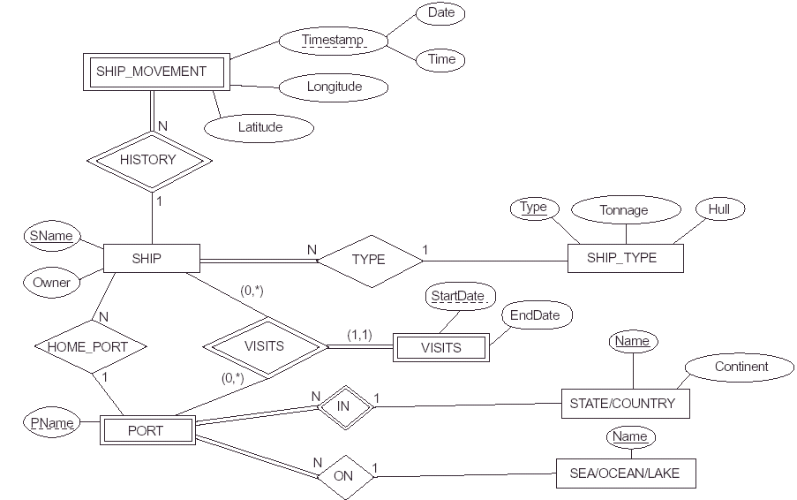
Problem b [Points 10]
Map the following EER segment into relational schema and justify the option used in mapping.
PERSON
SSN
Name
Address
City/State/Zip
Telephone
O
DONOR
VOLUNTEER
EMPLOYEE
Date_Hired
Skill
Donates
ITEM
Person_Type
E?
D?
V?
E?=“Y”
V?=“Y”
D?=“Y”
Person_Type:
Problem 4 Develop an ER [Points 20]

A hospital has a large number of registered physicians. Attributes of PHYSICIAN include physician_id(the identifier) and specialty. Patients are admitted to the hospital by physicians. Attributes of PATIENT include patient_id(the identifier) and patient_name. Any patient who is admitted must have exactly one admitting physician. A physician may optionally admit any number of patients. Once admitted, a given patient must be treated by atleast one physician. A particular physician may treat any number of patients or may not treat any patients. Whenever a patient is treated by a physician, the hospital wishes to record the details of the treatment (Treatment_details). Components of Treatment_details include Date, Time, and Results.

