**Implementation of Smart Home Network in PT:**

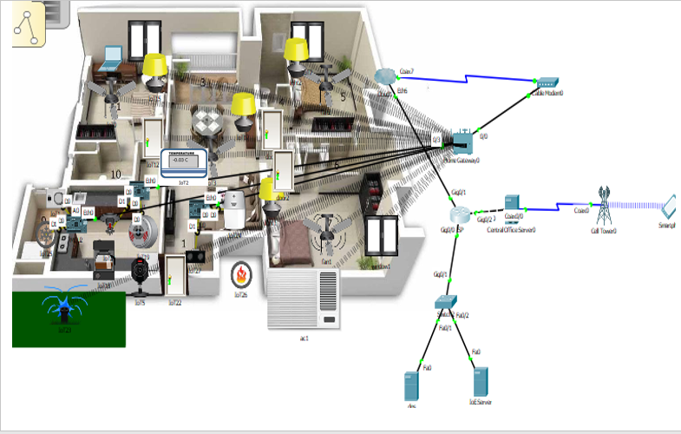

**Description:**

A smart home is one in which the various electric and [electronic](http://www.explainthatstuff.com/electronics.html) appliances are wired up to a central [computer](http://www.explainthatstuff.com/howcomputerswork.html) control system so they can either be switched on and off at certain times or if certain events happen.

In this project we implemented many smart devices inside the home. Smart devices are light, fan, door, window, ac, fire sprinkler, lawn sprinkler microcontroller, fire monitor, smoke sensor, siren, camera, temperature monitor, air cooler, laptop. We can control this smart devices using laptop or mobile phone. we can turn on or off a device like door open or ac on etc.

Some devices are automatically controlled by a microcontroller. Suppose when smoke sensor sense smoke or for a given temperature the microcontroller turn on the air cooler.

Smart devices are connected with home gateway. Home gateway is connected with ISP through a cable modem. Two server DNS and IoT server are connected with ISP and a central office server is connected with ISP.

Home gateway is a device that allows a [local area network](https://en.wikipedia.org/wiki/Local_area_network) (LAN) to connect to a [wide area network](https://en.wikipedia.org/wiki/Wide_area_network) (WAN) via a [modem](https://en.wikipedia.org/wiki/Modem).

Domain Name Servers (DNS) are the Internet's equivalent of a phone book. They maintain a directory of domain names and translate them to Internet Protocol (IP) addresses.  
This is necessary because, although domain names are easy for people to remember, computers or machines, access websites based on IP addresses. Information from all the domain name servers across the Internet are gathered together and housed at the Central Registry. When we type in a web address, e.g., [www.iot.com](http://www.iot.com), Internet Service Provider views the DNS associated with the domain name, translates it into a machine friendly IP address (for example 216.168.224.70 is the IP for iot.com) and directs Internet connection to the correct website.

The IoT servers have different purposes, like administration, monitoring, data gathering and analysis. They are completely modular, based on open-source enterprise platforms that provide the capabilities that are needed for the server-side of the IoT architecture, to connect to devices. The data that is transmitted through the server gateway is processed and stored securely using big data analytics. This data is then used when performing intelligent actions on our devices, in essence, making them ‘smart.’ Reliability is another aspect of IoT servers, being vastly more reliable than traditional servers due to the sheer availability of servers.

A cell tower is connected with central office server. Cell towers are usually placed so that they can cover a wide area. One can control the iot divices used inside the home using cell phone.