

Computer Networks Laboratory

CSE-324

Section: A

United International University

Dhaka, Bangladesh

APRIL 2019

**Digital Hospital with Smart Health Care**

**MD. RAFI UL ISLAM**

**Student Id: 011 141 029**

**SADIA AFRIN NOVA**

**Student Id: 011 151 248**

**MD. HASANUR RAHMAN**

**Student Id: 011 152 015**

**MOHYMINUL ISLAM SHIBLY**

**Student Id: 011 152 179**

Contents

1. Characteristics & Features of the Devices: 1
2. 2.1 Conclusion 4
3. 2.2 Future Goal 4

**Figure 1:Hospital** 2

**Figure 3: Monitoring Room** 3

**Figure 2: Patient Room** 3

Abstract

The internet of things, or **IoT**, is a system of interrelated computing devices, mechanical and digital machines, objects, animals or people that are provided with unique identifiers and the ability to transfer data over a network without requiring human-to-human or human-to-computer interaction.

Our digital hospital is also a IoT based project where any one can monitor the patient room sitting on the monitor room. There is also a fire sprinkler which puts out fire. There is a motion detector by which any motion or any one entering or leaving person or anything will be detected with it and the person sitting on the monitor room can see throughout the webcam which is also in the patient room. Also one can see the total monitoring system from anywhere.

Acknowledgement

First of all, we would like to thank the Almighty ALLAH for giving us the ability and enough courage to do this project.

After that we would like to express our deepest gratitude to our course faculty, **MOHAMMAD MAMUN ELAHI**, Assistant Professor, United International University, for his continuous guidance and encouragement, and for giving us the opportunity to do this project under his supervision.

Chapter 1

# Characteristics & Features of the Devices:

FIRE MONITOR:

Registration Server Compatible.

Detects flames by checking for a property and finding if the "IR" property value is in the range the detector considers a fire and outputs a digital signal.

MCU:

Smart Things are physical objects that can connect to the Registration Server or Home Gateway through a network interface.

Components are physical objects that connect to microcontroller (MCU-PT) or single boarded computers (SBC-PT).

FIRE SPRINKLER:

Registration server compatible.

Raises the water level.

MOTION DETECTOR:

Registration server compatible.

Detects motion from mouse movement.

Automatically deactivates after 5 seconds without any mouse movement.

WEBCAM:

Registration Server Compatible.

On/Off.

Video Recording.

ROUTER:

To interconnect the networks.

CENTER SERVER:

Used to connect the cellular system to the router.

PC:

Connect the default gateway to access smart object.

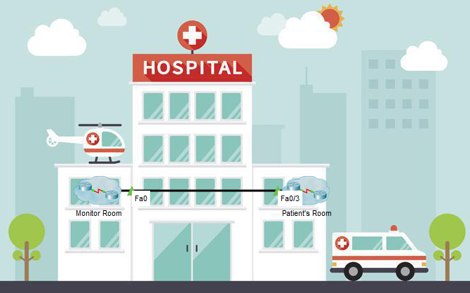

**Figure 1:Hospital**

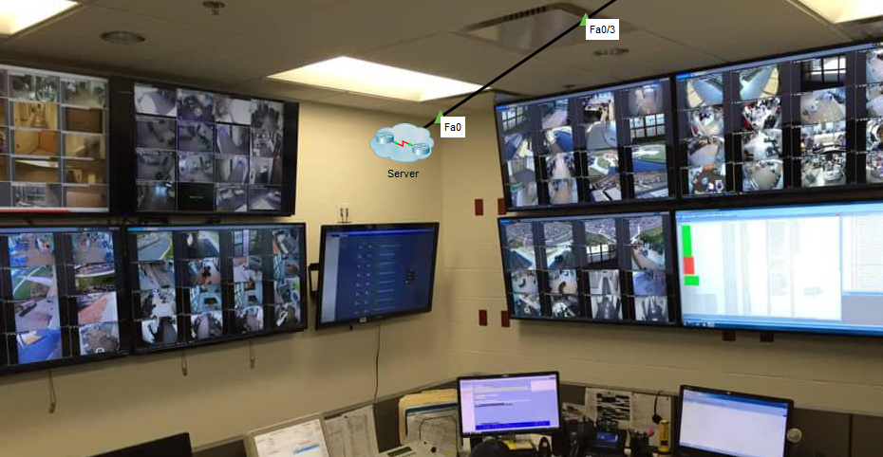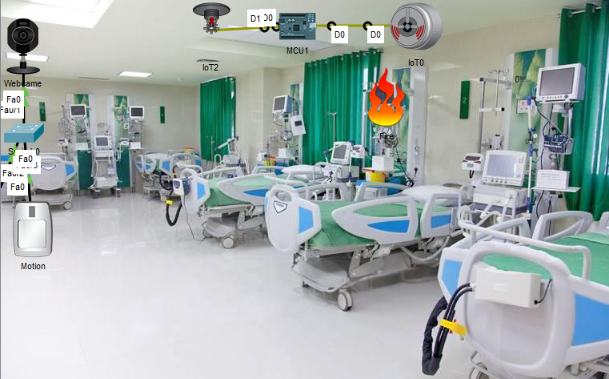

**Figure 3: Monitoring Room**

**Figure 2: Patient Room**

Chapter 2

# 2.1 Conclusion

Ours digital hospital & patent monitoring system will help many of us. Today’s world is totally depending on Internet Of Things though which sitting in our home we can control our overall system.

# 2.2 Future Goal

We want to develop the fully hospital based system. We want to control each and every device in the hospital by sitting in our home or anywhere in the world.