Prompt #1: my intro
Prompt : hi. my name is Hasana Fatima and my roll no is i26-3089. i am a first semester software engineering student at FAST.
Result: 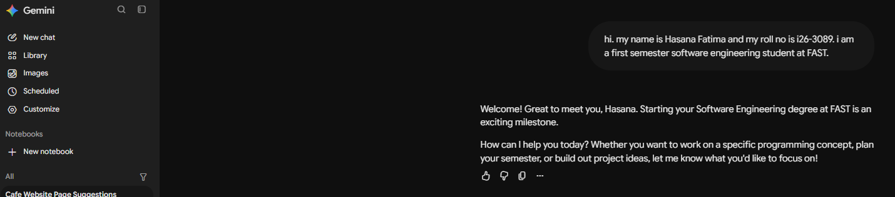
Prompt # 2:
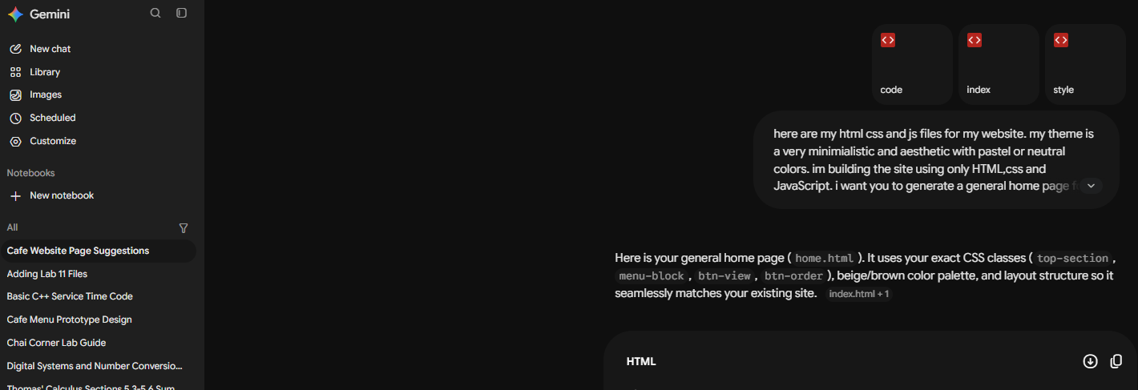
Prompt : here are my html css and js files for my website. my theme is a very minimialistic and aesthetic with pastel or neutral colors. im building the site using only HTML,css and JavaScript. i want you to generate a general home page for the site according to the theme. donot change the theme or anything
Result: the results were given. I got the code

