
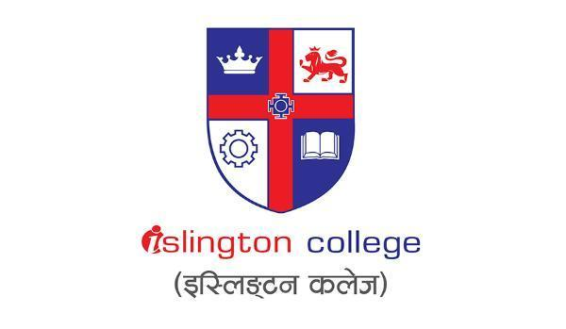
SM6P07NI Digital Media Project

20% Research and Proposal

2018-19 Autumn

Student Name: Enter your Full Name Here
London Met ID: E.g. 18053646
College ID: E.g. NP01MM0474747
External Supervisor: Enter your External Supervisor Name Here
Internal Supervisor Enter your Internal Supervisor Name Here
Assignment Due Date: Click or tap to enter a date.
Assignment Submission Date: Click or tap to enter a date.
Word Count: 768

I confirm that I understand my coursework needs to be submitted online via Google Classroom under the relevant module page before the deadline in order for my assignment to be accepted and marked. I am fully aware that late submissions will be treated as non-submission and a marks of zero will be awarded.

Abstract
- Give a brief summary of what the project is about, and the contents included in this documentation. (Words not counted)
Contents
1 Introduction 1

Introduction

Research

Pre-Production

Concept Development
“I am plastic” is a picture book designed for children portrays the positive and negatives impacts of plastic with the solutions. The idea of adapting the book into an educational video was developed to enhance the book content, making it more comprehensive to children; creating a fun-learning environment and engaging educational digital media.

Source Material Analysis
Before developing the narration, script and visual designs, it is necessary to analysis the source material.
Pros
- The book uses photographs and drawings as visual elements.
- The content is written in English and Nepali languages.
- The genre is Picture Book, interactive book.
- The book uses first person narration.
Cons
- Some vocabularies: Global warming, degrade, haphazardly are hard for kids to understand.
- Some visual graphics are pixelated.
In the conclusion, it is essential to make some contents more comprehensive by keeping the vocabularies simple. Maintaining consistency in visual elements. All these changes will not affect the theme and message of the book.

Script
For this project, the voiceover script and the script for the motion graphics are prepared.

Voiceover script
Phase 1
From the source material, the vocabularies which are hard for children to understand where selected. Some of the contents in the book where children are need to write down the things, those contents are not mentioned to keep the flow of the narration of the book. The rough voiceover script is hand written.
Phase 2
The voiceover script is finalized.

