a=int(input("Son kiriting a="))

b=int(input("Son kiriting b="))

c=int(input("Son kiriting c="))

if a<b<c or c<b<a :

print("a va c sonlar orasida b soni mavjud",b)

else:

print (b,'soni a va c ni oralig\'ida emas')

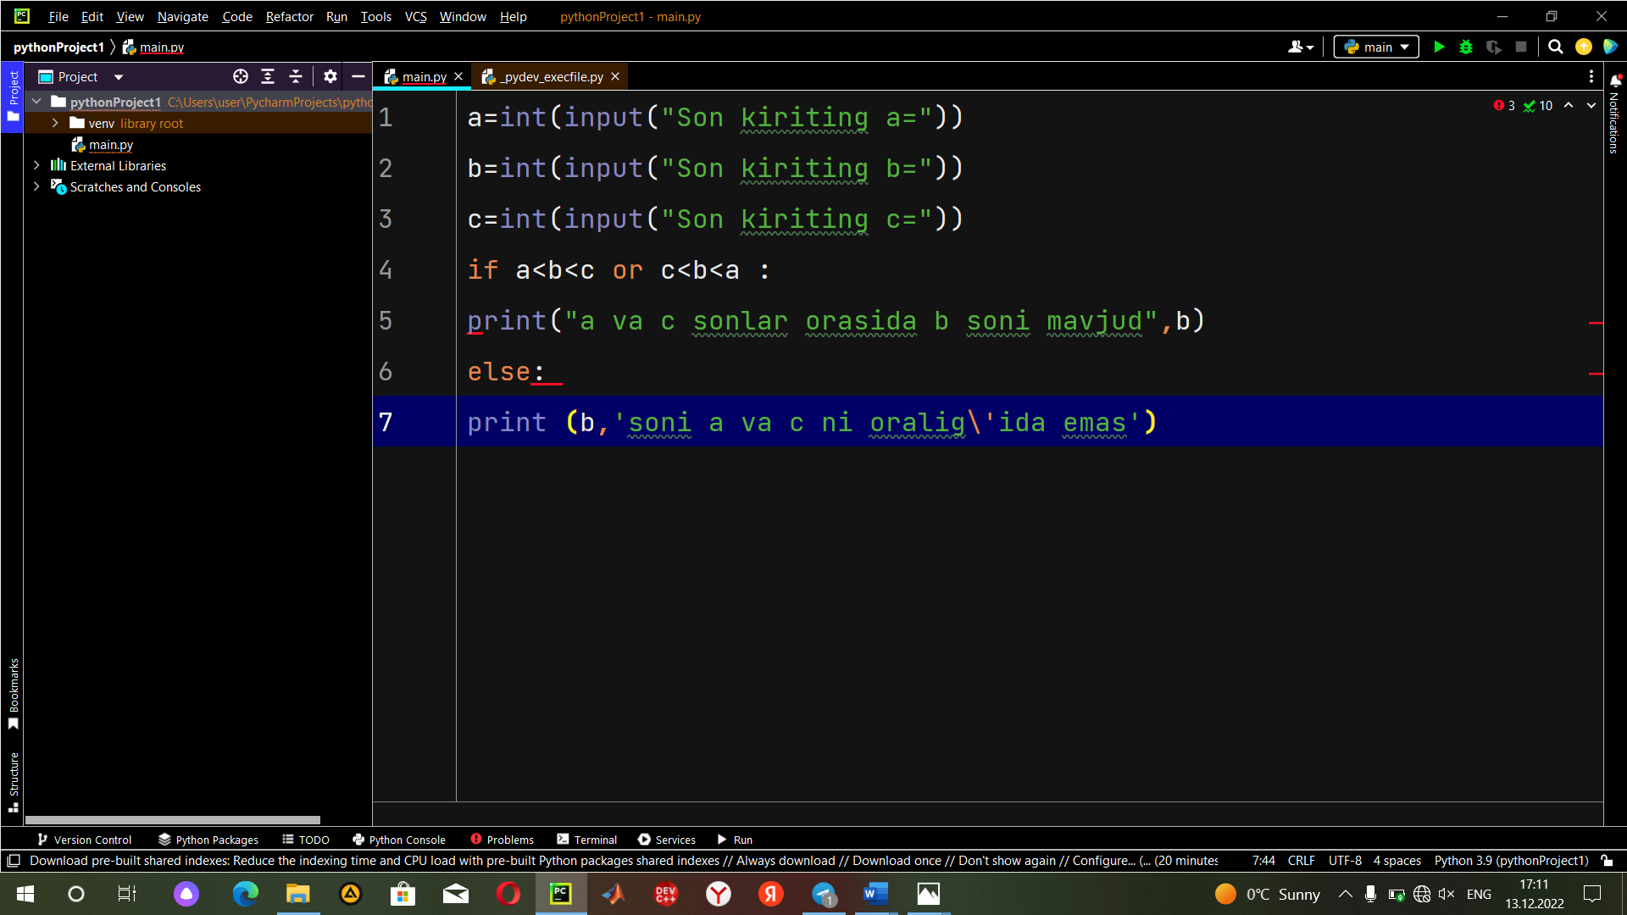

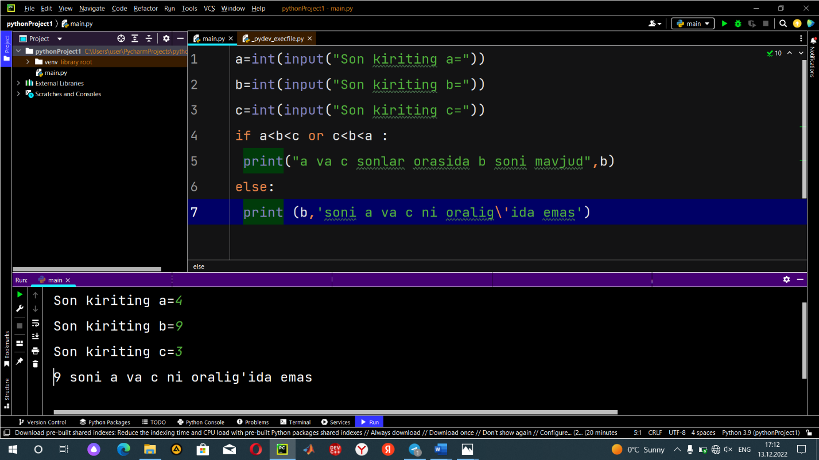

import math

n=int(input("n="))

A=float(input("A="))

s=0

for i in range(1,n+1):

s=s+math.pow((-1),i)\*math.pow(A,i)

print("S=",s)

