1. Output the Title, Publisher, and City of all books.

CREATE TABLE P1 AS SELECT Title FROM Books;

CREATE TABLE P2 AS SELECT \* FROM P1, Publishers WHERE publisher = name;

SELECT \* FROM P2;

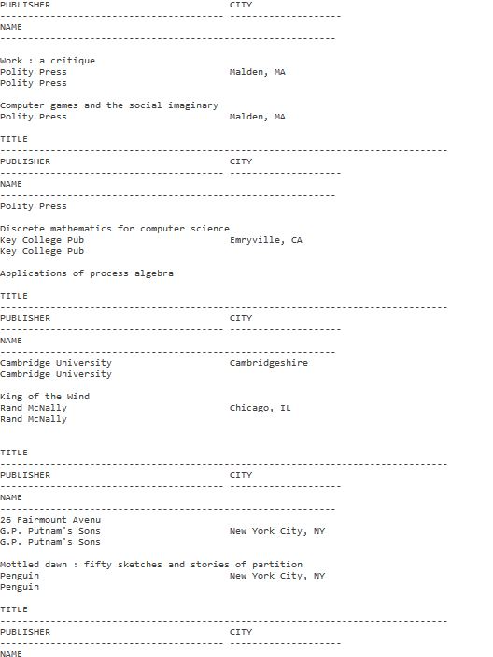

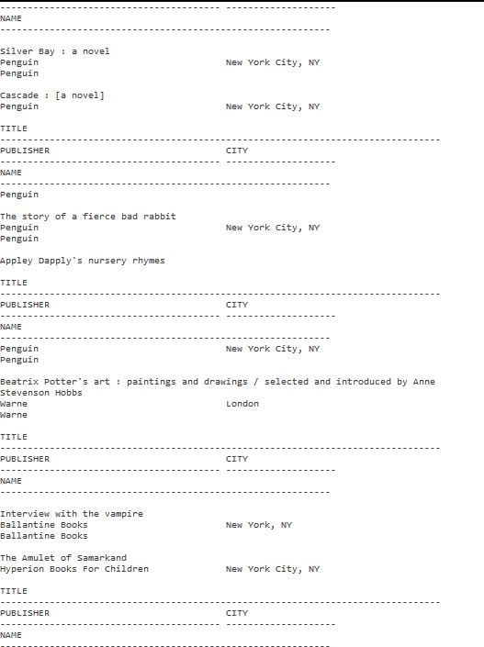

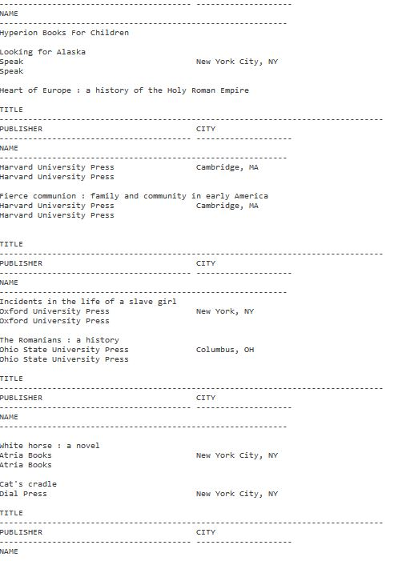



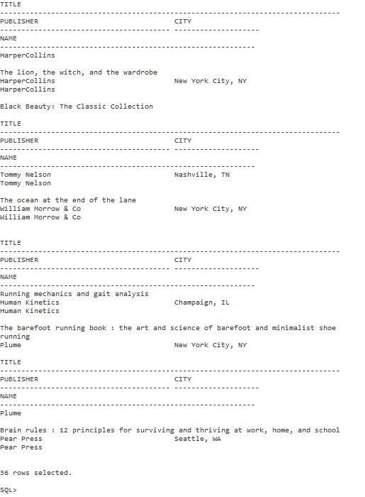

1. Obtain the SSN of any student worker who checkout a Journal.

CREATE TABLE P3 as SELECT ucaid FROM journal WHERE ucaid > 0 ;

CREATE TABLE P4 as SELECT SSN FROM P3, studentworkers WHERE P3.ucaid=studentworkers.ucaid;

SELECT SSN FROM P4;

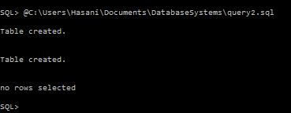

1. Obtain the Titles of movies whose studio is located in California.

CREATE TABLE P1

AS

SELECT name FROM Studio WHERE city = 'California';

CREATE TABLE R1

AS

SELECT title FROM P1, movies WHERE movies.studio=P1.name;

SELECT \* FROM R1;



1. Retrieve all the uca ids and names of the members who checked out a book or a movie

CREATE TABLE R1 AS SELECT ucaid FROM movies WHERE ucaid > 0 ;

CREATE TABLE R2 AS SELECT ucaid FROM books WHERE ucaid > 0 ;

CREATE TABLE R3 AS SELECT r1.ucaid, Fname, Minit, Lname FROM R1, Members WHERE R1.ucaid = Members.ucaid;

CREATE TABLE R4 AS SELECT r2.ucaid, Fname, Minit, Lname FROM R2, Members WHERE R2.ucaid = Members.ucaid;

CREATE TABLE Results AS SELECT \* FROM R3 UNION SELECT \* FROM R4;

SELECT ucaid, fname, minit, lname from Results;

DROP TABLE R1;

DROP TABLE R2;

DROP TABLE R3;

DROP TABLE R4;

DROP TABLE Results;

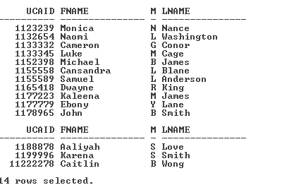

1. Obtain the names of members who have checked out a movie whose studio is in California

CREATE TABLE P1

AS

SELECT name from studio WHERE city= 'California';

CREATE TABLE R1

AS

SELECT \* FROM movies, P1 WHERE movies.studio = P1.name;

CREATE TABLE R2

AS

SELECT ucaid FROM R1 WHERE ucaid >= 0;

CREATE TABLE R3

AS

SELECT Lname, Minit, Fname FROM members, R2 WHERE members.ucaid=R2.ucaid;

select \* from r3;

drop table p1;

drop table r1;

drop table r2;

drop table r3;

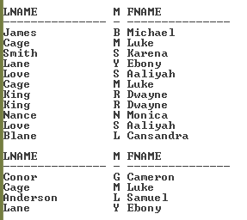

1. Output all staff members with three or more dependents.

DROP TABLE countdeps;

CREATE TABLE countdeps

AS

SELECT staffssn, COUNT(staffssn) counter

FROM dependents

GROUP BY staffssn;

SELECT name, ssn, counter

FROM staff, countdeps

WHERE counter>=3 and staffssn=ssn;

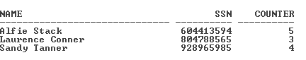

1. Find the person who donated the largest number of materials; output their name and the Title of all materials donated.

--If I don’t use natural joins Oracle runs out of the temporary storage it uses when creating

--tables. I know you don’t like us to use them, but it was necessary.

--Also, there was miscommunication for how to do DonatorType, hence the no results.

CREATE TABLE T0

AS

SELECT UCAID, Count(UCAID) CountID FROM DonatorType GROUP BY UCAID;

CREATE TABLE R1

AS

SELECT UCAID, MAX(CountID) maxid

FROM T0

GROUP BY T0.UCAID;

CREATE TABLE R2

AS

SELECT UCAID, MovieEIDR, BookISBN, JournalID, AudioBookISBN

FROM R1 NATURAL JOIN DonatorType;

DROP TABLE T0;

DROP TABLE R1;

--The following will be sequentially joined together based on R2.

--Creating tables with fewer columns than the original tables since only these

--columns are needed

CREATE TABLE TMovies

AS

SELECT EIDR MovieEIDR, Title MovieTitle FROM Movies;

CREATE TABLE TBooks

AS

SELECT ISBN ISBN, Title BookTitle FROM Books;

CREATE TABLE TJournals

AS

SELECT JournalID, Title JournalTitle FROM Journal;

CREATE TABLE TAudioBooks

AS

SELECT ISBN AudioBookISBN, Title AudioBookTitle FROM AudioBooks;

CREATE TABLE TMembers

AS

SELECT UCAID, Fname, Lname FROM Members;

--Now join everything together, use one statement to condense the relational algebra

CREATE TABLE R3a AS SELECT \* FROM R2 NATURAL JOIN TMovies;

CREATE TABLE R3b AS SELECT \* FROM R3a NATURAL JOIN TBooks;

DROP TABLE R3a;

CREATE TABLE R3c AS SELECT \* FROM R3b NATURAL JOIN TJournals;

DROP TABLE R3b;

CREATE TABLE R3d AS SELECT \* FROM R3c NATURAL JOIN TAudioBooks;

DROP TABLE R3c

CREATE TABLE R3e AS SELECT \* FROM R3d NATURAL JOIN TMembers;

DROP TABLE R3d;

SELECT Fname, Lname, MovieTitle, BookTitle, JournalTitle, AudioBookTitle FROM R3e;

--Now delete all the tables

DROP TABLE R2;

DROP TABLE TMovies;

DROP TABLE TBooks;

DROP TABLE TJournals;

DROP TABLE TAudioBooks;

DROP TABLE TMembers;

DROP TABLE R3e;



1. From all movies currently checked out, output the title, studio name and city, name of the person checking it out, and the name of the donor.

CREATE TABLE R1

AS

SELECT EIDR MovieEIDR, Studio, Title, UCAID BorrowerID FROM Movies

WHERE UCAID > 0;

CREATE TABLE R2

AS

SELECT \* FROM R1, Studio WHERE R1.Studio = Studio.Name;

CREATE TABLE T1

AS

SELECT UCAID DonorID, MovieEIDR MEIDR FROM DonatorType;

CREATE TABLE R3

AS

SELECT \* FROM R2, T1 WHERE R2.MovieEIDR = T1.MEIDR;

CREATE TABLE T2

AS

SELECT Fname, Lname, UCAID FROM Members;

CREATE TABLE R4

AS

SELECT MovieEIDR, Name, Title, BorrowerID, City, DonorID, Fname BorrowerFn, Lname

BorrowerLn, UCAID BorrowerUCAID

FROM R3, T2 WHERE R3.BorrowerID = T2.UCAID;

CREATE TABLE R5

AS

SELECT MovieEIDR, Name, Title, BorrowerID, City, DonorID, BorrowerFn, BorrowerLn,

BorrowerUCAID, Fname DonorFn, Lname DonorLn, UCAID DonorUCAID

FROM R4, T2 WHERE R4.DonorID = T2.UCAID;

SELECT Title, Name, City, BorrowerFn, BorrowerLn, DonorFn, DonorLn FROM R5;

DROP TABLE r1;

DROP TABLE r2;

DROP TABLE r3;

DROP TABLE r4;

DROP TABLE r5;

DROP TABLE t1;

DROP TABLE t2;

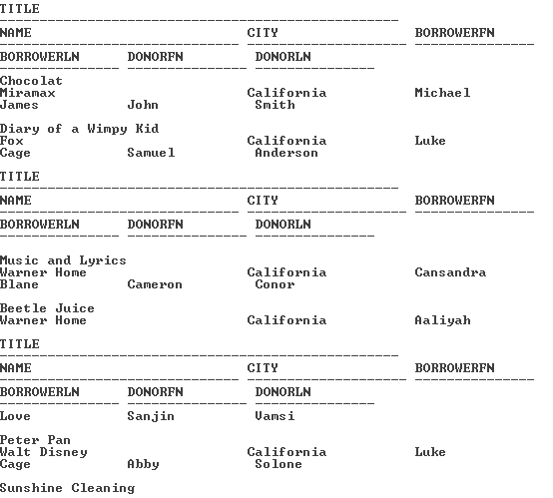

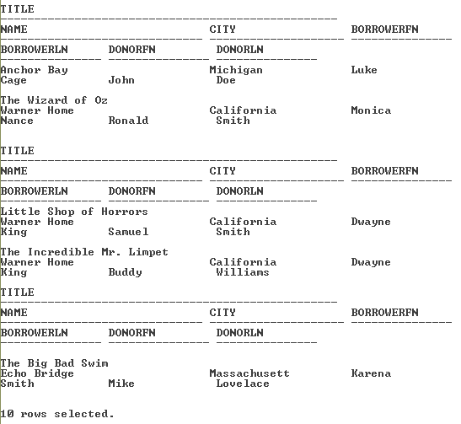

1. Output studentworkers that have donated.

drop table StudentDonators;

create table StudentDonators

AS

SELECT Donators.UCAID

FROM Donators, StudentWorkers

WHERE Donators.UCAID=StudentWorkers.UCAID;

Select fname, lname, members.UCAID

From members, StudentDonators

Where members.UCAID=StudentDonators.UCAID;

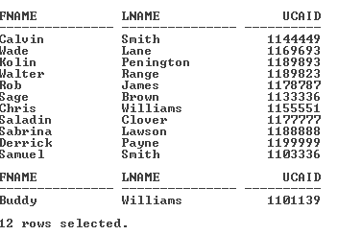

1. Retrieve the social security number and pay of the staff whose pay was $25,000 or higher

Select ssn, pay

From staff

Where pay >= 25000;

