VISIONCART MVP DOCUMENT PACK

Technical Architecture & Technology Decisions
  - Recommended stack, boundaries, data flow, operations and explicit exclusions
Project | VisionCart (Working product name - replace before public launch)
Document ID | VC-TECH-003
Version | 1.0
Date | 18 July 2026
Audience | Technical leads, mobile engineers, backend, DevOps, security and QA

Document purpose
This document captures agreed MVP decisions from product discovery. It is a controlled baseline, not a promise that every experimental capability will ship in the first release.

Contents
Use Word's Navigation Pane to jump through the numbered headings.
1. Architecture Decision Summary
2. High-Level Architecture
3. Mobile Application Architecture
4. Native Platform Architecture
5. Backend and Data Architecture
6. API and Data Contracts
7. Security and Privacy Controls
8. Observability and CI/CD
9. Scaling and Cost Strategy
10. Use / Do Not Use Matrix
11. Architecture Decision Records
12. Official Technical References

1. Architecture Decision Summary
Layer | Selected approach | Reason
Application shell | React Native + TypeScript, New Architecture | Fast shared product UI while preserving native performance-sensitive engines.
Native integration | Turbo Native Modules / Fabric-compatible native view with Codegen contract | Typed shared surface and lower interop overhead; camera frames remain native.
iOS try-on | Swift + ARKit/RealityKit; MediaPipe fallback where required | Native face tracking/rendering quality with broader fallback path.
Android try-on | Kotlin + CameraX + MediaPipe Tasks + Filament; ARCore where useful | Broad camera compatibility, on-device landmarks, efficient GLB rendering.
Backend | FastAPI, Python, stateless containerized service | Strong API ergonomics and future AI/reconstruction ecosystem.
Primary database | PostgreSQL | Relational catalog, versions, assets, users, sessions, permissions and auditability.
Identity / mobile services | Firebase Authentication, FCM, Crashlytics/Analytics | Managed mobile auth, messaging, crash and product telemetry.
3D delivery | GLB 2.0 source, USDZ derivative for RealityKit, optimized GLB for Android | Interoperable source format with platform-native runtime variants.
Storage | S3-compatible object storage + CDN + signed URLs | Large immutable assets, versioned delivery, controlled access and caching.

Core boundary
React Native never receives raw video frames or per-frame landmark arrays. The native SDK owns camera, inference, smoothing, anchoring, rendering and capture; JavaScript receives lifecycle events and final results.

2. High-Level Architecture
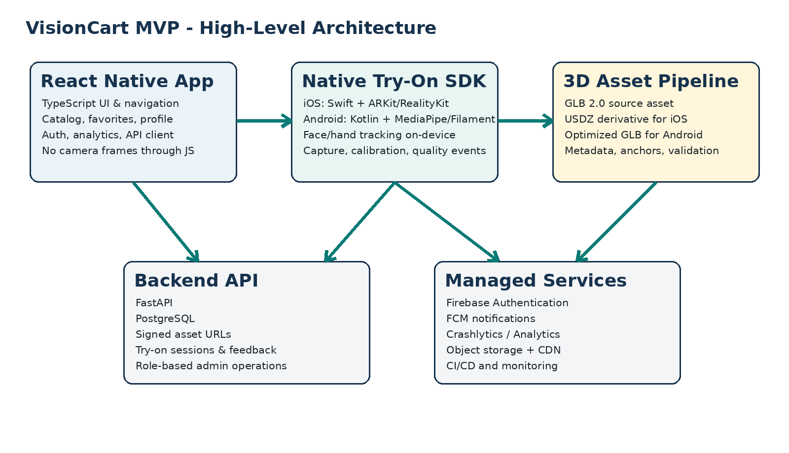
Figure 1 - Proposed MVP architecture and system boundaries.

2.1 Request and render flow
1 | React Native requests product metadata and approved asset versions from FastAPI.

2 | The app downloads or resolves signed CDN URLs and starts the native try-on session through the typed module contract.

3 | Native code owns camera input, capability checks, landmark inference, smoothing, 3D rendering, capture, and session state.

4 | Only coarse events such as ready, quality, capture path, close, and typed errors cross into JavaScript.

5 | The app sends non-image analytics and optional session feedback to the API/analytics platform.

3. Mobile Application Architecture

3.1 React Native responsibilities
- Navigation, onboarding, catalog, search, product detail, favorites, profile and settings.
- Authentication UI and secure token acquisition.
- API client, caching, feature flags, analytics, localization and accessibility.
- Initiating native sessions and handling typed results.
- No real-time landmark calculation, camera frame manipulation, or 3D rendering.

3.2 Recommended application modules
mobile/
├── src/
│ ├── app/ # navigation, providers, environment
│ ├── features/
│ │ ├── auth/
│ │ ├── catalog/
│ │ ├── product/
│ │ ├── tryon/
│ │ ├── favorites/
│ │ └── settings/
│ ├── services/ # API, auth, analytics, storage
│ ├── state/ # server cache + limited client state
│ ├── design-system/
│ └── native-contract/ # generated/typed TryOn SDK interface
├── ios/TryOnKit/
└── android/tryonkit/

3.3 State and networking
Concern | Recommendation
Server state | Use a query/cache library such as TanStack Query; keep normalized API data out of global UI state.
Client state | Use a small predictable store for session preferences, filters, guest identity, and flags.
HTTP | Typed API client generated or validated from OpenAPI; retry idempotent requests only.
Asset cache | Native or shared disk cache keyed by asset version and checksum.
Secrets | No long-lived secrets inside the app; use short-lived tokens and signed URLs.

4. Native Platform Architecture

4.1 iOS
Component | Technology | Notes
Language | Swift | All camera and rendering paths use native concurrency and lifecycle controls.
Face engine | ARKit face tracking where supported; MediaPipe Face Landmarker fallback | Capability check selects engine; do not assume every device supports the same ARKit face mode.
Hand engine | MediaPipe Hand Landmarker primary; Vision hand pose benchmark/fallback | Use one landmark contract across ring and watch where possible.
Rendering | RealityKit | Platform-native PBR, anchoring, 3D composition and capture.
Camera fallback | AVFoundation | Required when not using an ARKit-managed session.
Runtime asset | USDZ/USD derivative plus metadata | Generated from the approved GLB source asset.

4.2 Android
Component | Technology | Notes
Language | Kotlin | Coroutines and lifecycle-aware components.
Camera | CameraX | Preview and image-analysis use cases provide broad device support.
Face engine | MediaPipe Face Landmarker primary; ARCore Augmented Faces optional | MediaPipe provides consistent landmarks; ARCore can be evaluated for mesh/pose on supported devices.
Hand engine | MediaPipe Hand Landmarker | Shared 21-point hand contract with confidence and handedness.
Rendering | Filament + gltfio | Efficient PBR runtime for optimized GLB assets.
Depth/occlusion | ARCore Depth or custom segmentation where supported | Optional enhancement; not a blocking MVP dependency.

4.3 Smoothing and quality layer
- Normalize landmark output into category-independent coordinate and confidence structures.
- Apply temporal smoothing such as adaptive exponential smoothing or One Euro filtering.
- Reject large single-frame jumps and recover with controlled interpolation.
- Expose a quality score based on landmark confidence, motion, visibility, lighting proxy, and asset readiness.
- Freeze or fade the object when quality is below threshold; do not continue unstable rendering.

5. Backend and Data Architecture

5.1 Backend components
Service | Purpose | MVP status
FastAPI application | Catalog, products, assets, favorites, sessions, feedback, admin operations | Required
PostgreSQL | Authoritative relational data and audit fields | Required
Object storage + CDN | 3D assets, thumbnails, optional user-approved captures | Required
Firebase Authentication | User identity tokens verified by backend | Required
FCM | Optional notifications and future engagement | Optional in first beta
Redis / queue | Background imports, conversion, cache or scanning jobs | Deferred until workload requires it
Asset worker | GLB validation, conversion to USDZ, thumbnails, optimization checks | Required as CLI or background job

5.2 Core entities
Entity | Important fields
User | id, firebase_uid, guest_id, locale, status, created_at
Product | id, category, name, brand, seller_url, status, attributes
ProductVariant | id, product_id, color/material, dimensions_mm, availability
AssetVersion | id, variant_id, source_glb, ios_usdz, android_glb, checksum, status
AnchorProfile | asset_version_id, category, nodes, default transform, adjustment limits
Favorite | user_or_guest_id, product_id, created_at
TryOnSession | id, product_id, category, platform, engine, device_tier, outcome, timings
TryOnFeedback | session_id, rating, reason_code, optional comment
AssetLicense | asset_version_id, source, license_type, evidence_path, commercial_use
AuditLog | actor, action, entity, before/after summary, timestamp

6. API and Data Contracts

6.1 Representative endpoints
Method | Endpoint | Purpose
GET | /v1/categories | Supported categories and display configuration
GET | /v1/products | Search/filter approved products
GET | /v1/products/{id} | Product, variant, dimensions and try-on availability
POST | /v1/assets/{version}/resolve | Short-lived platform-specific asset URLs
GET/POST/DELETE | /v1/favorites | Manage favorites for account or guest identity
POST | /v1/try-on/sessions | Create/record a session summary
POST | /v1/try-on/sessions/{id}/feedback | Record user quality feedback
POST | /v1/admin/products/import | Controlled catalog import
POST | /v1/admin/assets/validate | Validate metadata and schedule asset checks

6.2 Shared try-on configuration
{
"sessionId": "uuid",
"productId": "prod_123",
"variantId": "var_black",
"category": "glasses",
"platformAsset": {
"url": "signed-cdn-url",
"format": "usdz",
"checksum": "sha256",
"version": 4
},
"dimensionsMm": { "width": 142, "height": 48, "depth": 145 },
"anchorProfile": {
"version": 2,
"defaultScale": 1.0,
"positionOffset": [0.0, 0.002, 0.006],
"rotationOffsetDeg": [0.0, 0.0, 0.0],
"adjustmentLimits": { "scale": [0.85, 1.15] }
}
}

7. Security and Privacy Controls
Control | Implementation
Authentication | Verify Firebase ID tokens at the API; map to internal user and roles.
Authorization | Role-based admin endpoints; product read endpoints expose approved versions only.
Asset access | Signed URLs, immutable versioned keys, checksums and CDN caching.
Uploads | Content-type allowlist, size limits, malware scan where available, validation worker.
Camera privacy | Live frames stay on-device in normal operation; no hidden recording.
Capture privacy | Save or upload only after explicit user action and clear purpose.
Transport | HTTPS everywhere; secure headers and certificate validation.
Database | Least-privilege credentials, backups, encryption at rest, migrations and audit logs.
Abuse prevention | Rate limits, bot controls for public endpoints, signed admin actions.
Data minimization | Store session timings and quality buckets, not raw landmark streams.

8. Observability and CI/CD
Area | Recommendation
Mobile crashes | Firebase Crashlytics; tag native engine, category, asset version and device tier.
Product analytics | Firebase Analytics or equivalent; documented event dictionary.
Backend telemetry | Structured JSON logs, request IDs, metrics, traces and health endpoints.
Performance | Track asset download/load time, FPS buckets, time-to-stable, dropped frames, memory warnings.
CI | Lint, type-check, unit tests, native tests, API contract tests, GLB validation and build artifacts.
CD | Separate dev/staging/production; signed mobile builds; database migration gate; asset promotion gate.
Feature flags | Remote flags for category rollout, device denylist, asset versions and fallback modes.

9. Scaling and Cost Strategy
- Normal try-on inference and rendering occur on-device, avoiding per-frame cloud GPU charges.
- 3D assets are immutable and versioned, making CDN caching effective.
- The API remains stateless; scale instances horizontally when catalog/session traffic increases.
- PostgreSQL begins as one managed primary with backups and connection pooling; add read scaling only when measured.
- Product scanning and 3D reconstruction, if approved later, run as asynchronous GPU jobs with quotas and separate unit economics.
- Do not introduce Kubernetes, event streaming, or microservices until operational metrics justify them.

10. Use / Do Not Use Matrix
Use | Do not use in MVP | Reason
React Native for business UI | React Native/JS for per-frame camera processing | Keep product velocity without sacrificing camera/render performance.
Swift + RealityKit on iOS | Unity/Unreal embedded as the primary engine | Avoid large runtime, duplicated UI, and complex lifecycle integration.
Kotlin + CameraX/MediaPipe/Filament | WebView or browser-based AR engine | Native access, predictable performance and offline inference.
Turbo Modules/Codegen contract | Chatty legacy bridge with landmark events every frame | Typed high-level lifecycle interface.
PostgreSQL | Firestore as authoritative catalog/asset relational database | Transactions, relations, versioning and auditability.
Firebase Auth/Crashlytics/Analytics | Building auth, crash pipeline and push infrastructure from scratch | Reduce non-differentiating MVP work.
GLB source + platform derivatives | Random unversioned 3D files inside app bundle | Validated delivery, updates and reproducibility.
On-device landmark models | Cloud inference for live face/hand landmarks | Privacy, latency, reliability and cost.
Existing models + calibration | Custom ML training from day one | Benchmark real gaps before funding data collection and training.
Modular monolith backend | Early microservices and Kubernetes | Lower operational complexity at MVP scale.

11. Architecture Decision Records
ID | Decision | Status | Rationale
ADR-001 | React Native shell with native try-on SDK | Accepted | Shared product development plus native camera/rendering control.
ADR-002 | No per-frame JS bridge | Accepted | Prevents serialization, scheduling and lifecycle bottlenecks.
ADR-003 | On-device tracking | Accepted | Latency, privacy and unit economics.
ADR-004 | GLB master with USDZ iOS derivative | Accepted | Interoperable authoring plus platform-native runtime.
ADR-005 | FastAPI + PostgreSQL modular monolith | Accepted | Appropriate MVP complexity and future AI integration.
ADR-006 | Product scanning deferred | Accepted | Requires separate reconstruction, cleanup, cost and UX validation.
ADR-007 | MediaPipe as consistent cross-platform landmark baseline | Provisional | Must be benchmarked against ARKit/Vision/ARCore by category.

12. Official Technical References
R1. React Native - Turbo Native Modules Introduction - Native platform modules and New Architecture.
R2. React Native - About the New Architecture - JSI and architecture overview.
R3. Apple - Tracking and Visualizing Faces - ARFaceAnchor face pose and geometry.
R4. Apple - RealityKit - Native rendering and AR framework.
R5. Apple - Detecting Hand Poses with Vision - Native hand-pose capability.
R6. Google AI Edge - Face Landmarker - On-device face landmarks for images/video/live streams.
R7. Google AI Edge - Hand Landmarker - On-device hand landmarks.
R8. ARCore - Augmented Faces - Face regions and mesh for AR overlays.
R9. Android - CameraX Overview - Recommended Jetpack camera API for new Android apps.
R10. Google Filament - PBR rendering and glTF runtime.
R11. Khronos - glTF Runtime 3D Asset Delivery - Open standard for efficient 3D asset delivery.
R12. FastAPI - Python API framework and OpenAPI support.
R13. Firebase Authentication - Managed mobile identity.

