VISIONCART MVP DOCUMENT PACK

Native Try-On SDK Specification
  - Swift/Kotlin engine design and React Native integration contract
Project | VisionCart (Working product name - replace before public launch)
Document ID | VC-SDK-004
Version | 1.0
Date | 18 July 2026
Audience | iOS, Android and React Native engineers; QA and technical artists

Document purpose
This document captures agreed MVP decisions from product discovery. It is a controlled baseline, not a promise that every experimental capability will ship in the first release.

Contents
Use Word's Navigation Pane to jump through the numbered headings.
1. Goals and Boundaries
2. SDK Public Contract
3. Session Lifecycle
4. Shared Internal Components
5. Category Engines
6. iOS Implementation
7. Android Implementation
8. Performance and Quality Budgets
9. Errors and Recovery
10. Capture and Privacy
11. Calibration and Feature Flags
12. Testing Strategy

1. Goals and Boundaries
- Provide one stable TypeScript-facing contract for five category engines across iOS and Android.
- Own camera, landmarks, smoothing, rendering, capture, capability checks and native session UI.
- Avoid high-frequency data transfer between native and JavaScript.
- Support asset versioning, calibrated anchor profiles, manual adjustment and typed errors.
- Allow future extraction into a retailer-facing SDK without rewriting the core engines.
Non-goal
The SDK does not browse products, authenticate users, manage favorites, perform checkout, or reconstruct 3D products.

2. SDK Public Contract

2.1 TypeScript types
export type TryOnCategory =
| 'glasses'
| 'watch'
| 'ring'
| 'earring'
| 'nose_pin';
export type TryOnSide = 'left' | 'right' | 'both';
export type TrackingEngine = 'arkit' | 'mediapipe' | 'arcore' | 'vision';
export interface TryOnConfig {
sessionId: string;
productId: string;
variantId: string;
category: TryOnCategory;
asset: PlatformAsset;
dimensionsMm: ProductDimensions;
anchorProfile: AnchorProfile;
initialSelection?: {
side?: TryOnSide;
hand?: 'left' | 'right';
finger?: 'thumb' | 'index' | 'middle' | 'ring' | 'pinky';
};
captureEnabled: boolean;
analyticsContext?: Record<string, string | number | boolean>;
}
export interface TryOnResult {
sessionId: string;
outcome: 'captured' | 'closed' | 'failed' | 'unsupported';
engine?: TrackingEngine;
captureUri?: string;
durationMs: number;
trackingQualityBucket?: 'low' | 'medium' | 'high';
error?: TryOnError;
}

2.2 Public methods and events
Surface | Purpose
isSupported(category) | Returns support, selected engine, and device tier without opening camera.
open(config) | Presents the full native try-on experience.
preload(asset) | Optionally warms asset download/parse/cache.
clearCache(criteria) | Removes stale or oversized asset versions.
onReady | Session prepared, asset loaded, camera active.
onQualityChanged | Low-frequency quality bucket or guidance code; not raw landmarks.
onCapture | Capture succeeded and local URI is available.
onClosed | Final typed result; only one terminal event.
onError | Recoverable or terminal typed error.

Bridge rule
Do not expose startCamera(), detectFace(), renderFrame(), or landmark arrays as separate JavaScript calls. open(config) starts one cohesive native session.

3. Session Lifecycle
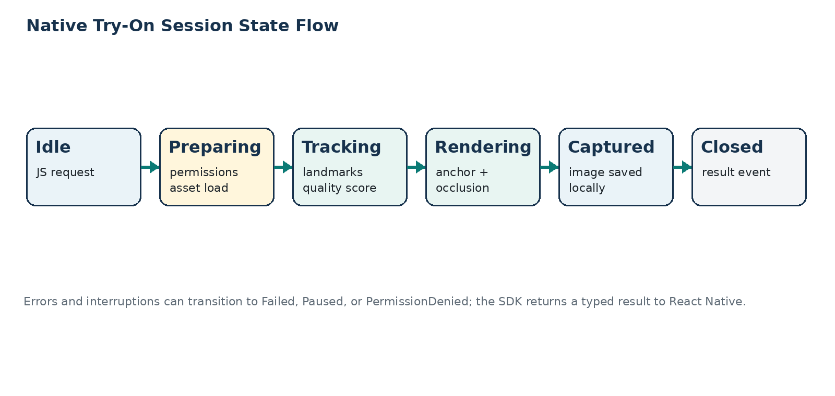
Figure 1 - Native session lifecycle and terminal result.
State | Entry condition | Allowed next states
Idle | No active session | Preparing
Preparing | Config validated; permission and asset checks running | Tracking, PermissionDenied, Unsupported, Failed
Tracking | Camera active; landmarks not yet stable | Rendering, Paused, Failed, Closed
Rendering | Stable or acceptable quality; product visible | Tracking, Captured, Paused, Failed, Closed
Captured | Image produced locally | Rendering, Closed
Paused | App inactive, interruption, or camera unavailable | Preparing, Tracking, Closed, Failed
Failed | Terminal error | Closed
Closed | Resources released; result returned | Idle

4. Shared Internal Components
Component | Responsibility
CapabilityResolver | Select engine and quality tier by platform, OS, camera, GPU and category.
AssetLoader | Download/cache/verify checksum; load platform runtime asset.
LandmarkAdapter | Convert ARKit/MediaPipe/ARCore/Vision outputs to internal coordinates.
TemporalFilter | Smooth positions, rotations and scale; reject outliers.
QualityEvaluator | Compute confidence, visibility, movement and guidance codes.
AnchorSolver | Build category transform from landmarks, dimensions and profile offsets.
OcclusionProvider | Face/hand mesh, depth or segmentation mask where available.
Renderer | PBR lighting, product entity, camera composition and capture.
AdjustmentController | Apply bounded user offsets and reset to calibrated defaults.
TelemetryBuffer | Aggregate FPS/timing/quality buckets and emit low-frequency summary.

5. Category Engines

5.1 Glasses and sunglasses
- Primary transform: head pose plus nose/eye region and face-width measurements.
- Scale basis: calibrated real frame width relative to face-width estimate.
- Occlusion: face mesh can hide temples or bridge regions where supported.
- Materials: lenses require controlled transparency; avoid expensive physically exact refraction in MVP.
- Controls: scale, vertical offset, depth offset, reset and product switch.

5.2 Watch
- Primary transform: wrist landmark, hand plane, forearm direction and wrist-width estimate.
- User selects left or right wrist; renderer flips the calibrated orientation when required.
- MVP strap is rigid or mildly approximated; no full cloth/soft-body simulation.
- Controls: scale, rotation around wrist, longitudinal offset and reset.

5.3 Ring
- Primary transform: selected finger segment between hand landmarks with a local axis and width estimate.
- User chooses hand and finger; default finger may be ring finger.
- Occlusion is approximated using hand mesh/segmentation/depth where available.
- Controls: scale, slide along finger, rotation and reset; never label the result as guaranteed ring size.

5.4 Earrings
- Primary transform: head pose with estimated ear anchor offsets calibrated from face mesh geometry.
- User may show left, right or both earring assets.
- Hair occlusion is limited; quality guidance asks the user to expose the ear when necessary.
- Dangling motion is optional and must be stable; rigid placement is acceptable for first release.

5.5 Nose pin
- Primary transform: nose mesh landmark region with left/right side selection.
- High smoothing and confidence thresholds are required because the asset is very small.
- Use micro-adjustment controls with bounded X/Y/Z offsets.
- If tracking is poor, fade or freeze; visible jitter is worse than temporary unavailability.

6. iOS Implementation
Area | Implementation decision
UI container | Native view controller or SwiftUI/RealityView hosted by a Fabric-compatible component or modal module.
Face session | ARFaceTrackingConfiguration where supported; otherwise AVFoundation + MediaPipe Face Landmarker.
Hand session | AVFoundation + MediaPipe Hand Landmarker; benchmark Vision hand pose for selected fallback cases.
Rendering | RealityKit entities, calibrated transforms, material overrides and capture.
Lifecycle | Handle backgrounding, interruptions, permission changes, thermal state and memory pressure.
Concurrency | Camera/inference work off main thread; rendering updates synchronized with native frame loop.
Assets | Load approved USDZ/USD derivative; verify version and checksum before session.

7. Android Implementation
Area | Implementation decision
UI container | Native Activity/Fragment or Fabric-compatible native view managed by the module.
Camera | CameraX Preview + ImageAnalysis with backpressure strategy that keeps the newest frame.
Face landmarks | MediaPipe Face Landmarker; optional ARCore Augmented Faces benchmark.
Hand landmarks | MediaPipe Hand Landmarker with handedness and world/image coordinates where available.
Rendering | Filament engine with gltfio, camera texture composition and optimized GLB assets.
Lifecycle | Bind camera to lifecycle; release GPU/model resources on close and low-memory events.
Assets | Load approved optimized GLB; validate checksum and compatible extensions.

8. Performance and Quality Budgets
Metric | Target | Fallback behavior
Frame rate | 30 FPS target; 24 FPS minimum acceptable on supported tier | Reduce optional effects or inference frequency.
Time to first camera preview | < 1.5 seconds on warm permission path | Show deterministic loading state.
Asset ready time | < 2.5 seconds cached; network path separately measured | Preload or show lightweight placeholder.
Time to stable tracking | < 1 second in normal light after subject is visible | Show precise guidance until stable.
Event frequency to JS | Lifecycle events; quality updates no more than a few per second | Aggregate native telemetry.
Memory | No unbounded frame copies; release textures/models at close | Evict LRU assets and lower texture tier.
Thermal behavior | No persistent high-thermal state during normal session | Reduce inference/render rate and notify telemetry.

9. Errors and Recovery
Code | Meaning | User / SDK behavior
PERMISSION_DENIED | Camera permission not granted | Explain settings path; return non-crash result.
UNSUPPORTED_DEVICE | Required capability missing | Show product without try-on; log capability reason.
ASSET_INVALID | Format, checksum, metadata or load failure | Retry approved version or stop with product-specific message.
CAMERA_UNAVAILABLE | Another app/session or hardware issue | Pause/retry or close safely.
TRACKING_LOST | Landmarks unavailable for timeout | Guidance, freeze/fade, retry.
LOW_LIGHT | Quality proxy below threshold | Ask user to improve light; do not invent stable placement.
MEMORY_PRESSURE | Asset or texture exceeds budget | Unload optional resources or close typed error.
CAPTURE_FAILED | Image composition/write failed | Keep session active and allow retry.
INTERNAL_ERROR | Unexpected native exception | Release resources, record diagnostics, return terminal result.

10. Capture and Privacy
- Compose the camera image and virtual product entirely in native code.
- Return a local temporary URI; React Native decides whether to save, share, or discard.
- Do not automatically upload captures. If future cloud backup exists, require explicit opt-in and documented retention.
- Strip unnecessary metadata such as precise location from generated captures.
- Release frame buffers, landmarks, textures and temporary files according to session and cache policy.

11. Calibration and Feature Flags
Configuration | Level
Engine selection and fallback order | Remote feature flag by platform/category/device tier
Smoothing constants and confidence thresholds | Versioned native configuration
Asset anchor offsets and adjustment limits | Per AssetVersion AnchorProfile
Occlusion and advanced material effects | Feature flag by device tier
Category rollout and denylist | Remote configuration without app release
Debug landmarks/FPS overlay | Internal build only

12. Testing Strategy

12.1 Automated tests
- Contract tests for TypeScript Codegen types and native implementations.
- Unit tests for transform math, smoothing, bounds, category selection and error mapping.
- Golden tests for asset metadata and anchor-profile parsing.
- Instrumented camera/render smoke tests on representative physical devices.
- Memory and resource-release tests across repeated session open/close cycles.

12.2 Visual QA matrix
Dimension | Coverage
Lighting | Bright indoor, low light, side light, backlight, daylight
Movement | Still, slow turn, fast turn, partial exit/re-entry
Appearance | Different face shapes, skin tones, hair styles, hand sizes, nails and jewelry
Accessories | Small/large frames, reflective metal, transparent lenses, studs and dangling earrings
Devices | Minimum tier, typical tier and premium tier for both platforms
Orientation | Portrait baseline; rotation behavior explicitly supported or locked
Interruptions | Calls, backgrounding, permission changes, camera conflict, low memory

