VISIONCART MVP DOCUMENT PACK

3D Asset Specification, QA & Roadmap
  - Mobile-ready models, metadata, anchors, validation and future scanning research
Project | VisionCart (Working product name - replace before public launch)
Document ID | VC-ASSET-005
Version | 1.0
Date | 18 July 2026
Audience | 3D artists, technical artists, mobile engineers, backend, QA and catalog operations

Document purpose
This document captures agreed MVP decisions from product discovery. It is a controlled baseline, not a promise that every experimental capability will ship in the first release.

Contents
Use Word's Navigation Pane to jump through the numbered headings.
1. Asset Strategy
2. Package Structure
3. Geometry and Coordinate Standard
4. Materials and Textures
5. Category Budgets
6. Anchor and Pivot Requirements
7. Metadata Schema
8. Processing Pipeline
9. Validation and QA
10. Licensing and Governance
11. Product-Scanning R&D
12. Asset Delivery Roadmap

1. Asset Strategy
Every published product variant must have a controlled, versioned 3D package. A visually attractive model is not sufficient: real dimensions, orientation, pivots, category anchors, mobile performance, license evidence, and platform runtime variants are mandatory.
Source-of-truth decision
Use glTF 2.0 binary (.glb) as the canonical interchange/source asset. Produce a RealityKit-compatible USDZ/USD derivative for iOS and an optimized GLB runtime asset for Android. Never edit runtime derivatives manually; regenerate them from the approved source package.

2. Package Structure
asset-package/
├── source/
│ ├── product_master.blend # optional editable source
│ └── product_source.glb # approved canonical asset
├── runtime/
│ ├── ios/product_v004.usdz
│ └── android/product_v004.glb
├── textures/
│ ├── basecolor.webp
│ ├── normal.webp
│ ├── orm.webp # occlusion / roughness / metallic
│ └── transmission.webp # only when required
├── metadata/
│ ├── product.json
│ ├── anchors.json
│ ├── validation.json
│ └── license.json
└── previews/
├── thumbnail.webp
└── turntable.mp4 # optional internal QA

3. Geometry and Coordinate Standard
Rule | Requirement
Coordinate system | Canonical GLB follows glTF: right-handed, +Y up, +Z forward; front of asset faces +Z.
Units | All canonical geometry uses meters. Product metadata also records human-readable millimeter dimensions.
Origin | Category-defined attachment pivot at or near world origin; transforms applied/frozen before export.
Scale | Object scale should be 1,1,1 after applying transforms; real dimensions verified against reference.
Rotation | Default rotation should be identity after normalization; platform conversion handles coordinate differences.
Mesh quality | No non-manifold geometry, duplicate faces, unintended holes, reversed normals or hidden high-poly objects.
Hierarchy | Predictable node names; no cameras, lights, helper geometry or unused animations in runtime assets.
Variants | Color/material variants reuse geometry where possible and are independently versioned.

4. Materials and Textures
- Use physically based metallic-roughness materials compatible with glTF 2.0.
- Prefer a packed occlusion/roughness/metallic texture when the runtime pipeline supports it.
- Use 1K textures by default; 2K only when close-up testing proves visible benefit. Avoid 4K in MVP assets.
- Use transparent/transmission materials sparingly. Glasses lenses must be tested on both renderers because blending differs.
- Avoid baked environment reflections tied to one scene; use renderer lighting and neutral material values.
- Diamonds and gemstones should use an MVP-appropriate approximation rather than expensive multi-bounce optical simulation.
- Use compressed image formats supported by the asset pipeline, and generate platform-safe fallbacks when required.

5. Category Budgets
Category | Triangle target | Texture target | Runtime file target | Notes
Glasses / sunglasses | 8k-30k | 1K; optional 2K hero | <= 8 MB | Thin temples and lens material need careful topology.
Watch | 15k-45k | 1K-2K | <= 12 MB | Avoid hidden movement internals; simplify strap underside.
Ring | 5k-20k | 1K | <= 6 MB | Preserve silhouette and gemstone setting; small asset needs clean normals.
Earring pair | 5k-25k total | 1K | <= 7 MB | Separate left/right nodes or mirrored-safe geometry.
Nose pin | 2k-12k | 512-1K | <= 4 MB | Small silhouette and highlight behavior matter more than dense geometry.

These are starting budgets, not absolute truths. QA may approve a larger asset when it delivers visible value and still meets device performance targets.

6. Anchor and Pivot Requirements
Category | Required nodes / anchors | Default pivot concept
Glasses | frame_root, bridge_anchor, left_temple, right_temple, lens nodes where separate | Center of bridge aligned to face-forward axis.
Watch | watch_root, dial_center, strap_axis, optional clasp | Center of case on wrist contact plane.
Ring | ring_root, ring_center, band_axis, optional gem_center | Center of inner ring opening; band axis aligned to finger.
Earrings | earring_left_root, earring_right_root or mirror-safe single root, hook/post | Attachment post at origin; vertical drop on local axis.
Nose pin | nose_pin_root, attachment_point, gem_center | Skin contact point at origin; outward normal defined.

6.1 Naming rules
- Use lowercase snake_case for stable runtime node names.
- Do not depend on Blender-generated suffixes such as .001.
- Required anchor names are validated before asset approval.
- Material names should describe function and variant, not artist workspace history.
- Changing an anchor name or coordinate requires a new asset version and matching AnchorProfile version.

7. Metadata Schema
{
"schemaVersion": 1,
"assetVersion": 4,
"productId": "prod_123",
"variantId": "var_black",
"category": "glasses",
"dimensionsMm": {
"width": 142.0,
"height": 48.0,
"depth": 145.0
},
"source": {
"format": "glb",
"sha256": "...",
"coordinateSystem": "gltf_y_up_z_forward",
"linearUnit": "meter"
},
"runtime": {
"ios": { "format": "usdz", "sha256": "...", "sizeBytes": 4123456 },
"android": { "format": "glb", "sha256": "...", "sizeBytes": 3567890 }
},
"anchors": {
"root": "frame_root",
"primary": "bridge_anchor",
"left": "left_temple",
"right": "right_temple"
},
"defaultTransform": {
"positionM": [0, 0.002, 0.006],
"rotationDeg": [0, 0, 0],
"scale": 1.0
},
"adjustmentLimits": {
"scale": [0.85, 1.15],
"positionMm": { "x": [-8, 8], "y": [-8, 8], "z": [-10, 10] }
},
"licenseId": "license_abc",
"status": "approved"
}

8. Processing Pipeline
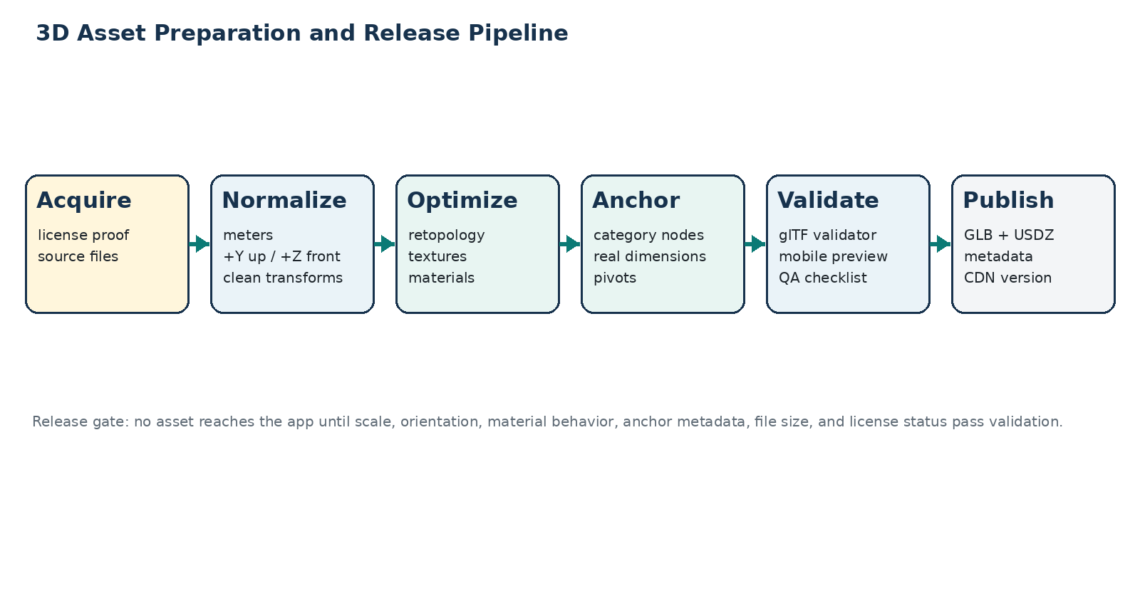
Figure 1 - Controlled asset preparation and publication pipeline.
1 | Acquire source model and record creator, source URL/file, license, permitted use and proof.

2 | Open in Blender or approved DCC tool; remove extra objects and normalize scale, orientation and origin.

3 | Measure against real product dimensions or trusted manufacturer specifications.

4 | Retopologize/decimate while preserving silhouette; repair normals, UVs and material assignments.

5 | Create required anchor nodes and category metadata.

6 | Export canonical GLB and run Khronos glTF validation.

7 | Generate iOS USDZ and Android optimized GLB derivatives using a reproducible script/toolchain.

8 | Run automated file, texture, naming, dimension, checksum and extension validation.

9 | Preview on representative iOS and Android devices inside the actual try-on engine.

10 | Approve and publish immutable versioned assets to object storage/CDN.

9. Validation and QA
Gate | Checks
Legal | License recorded, commercial use allowed, attribution requirements known, no trademark misuse.
File | Expected format, checksum, size, no missing external resources, no unsupported extension.
Geometry | Triangle budget, transforms applied, no broken normals/non-manifold defects, bounds sensible.
Dimensions | Measured width/height/depth match metadata within agreed tolerance.
Anchors | Required node names exist and align with real attachment points.
Materials | No black/missing textures, excessive transparency, or platform-inconsistent appearance.
Performance | Load time, FPS and memory pass device-tier benchmark.
Visual placement | Looks correct at neutral pose and during movement; manual adjustment remains bounded.
Regression | Approved screenshots/turntable compared after pipeline or engine changes.

9.1 Asset status workflow
draft -> technical_review -> device_qa -> approved -> published -> deprecated

10. Licensing and Governance
- A downloadable model is not automatically permitted for commercial redistribution. Verify the individual asset license.
- Store license evidence with the asset version: receipt, license text, creator attribution, source and date acquired.
- Do not use recognizable luxury-brand models, logos, trade dress, or product names without authorization.
- Prototype-only assets must be marked and blocked from production publication.
- When an asset is replaced or revoked, deprecate the version and invalidate its public delivery URL where feasible.
- Every transformation or derivative remains linked to its original source and license record.

11. Product-Scanning R&D
The future "scan a physical product and try it" feature requires a separate pipeline. The result of photogrammetry or neural reconstruction is not automatically a try-on-ready asset.
Research step | Question / acceptance signal
Capture UX | Can an ordinary user collect enough coverage in a shop without moving the product or causing blur?
Reconstruction | Can rigid accessories be reconstructed with usable thin parts, reflections and transparent regions?
Scale | Can real-world dimensions be recovered or must the user provide a reference object/measurement?
Cleanup | How much automated hole repair, retopology, texture cleanup and material inference is reliable?
Anchors | Can category attachment points be generated automatically and verified?
Latency | Is the total processing wait acceptable for an in-store use case?
Cost | What is the cost per successful, approved model including failed scans and GPU time?
Rights | Does the user have permission to digitize and store the physical product?

Recommended R&D order
Begin scanning research with a larger rigid object such as a watch, then glasses, ring, earrings, and finally nose pins. Small reflective and transparent objects are the hardest.

12. Asset Delivery Roadmap
Milestone | Target asset set | Exit criterion
A0 - Engine samples | 1 asset per category | Loads and renders in platform prototype.
A1 - Vertical slice | 3 glasses + 2 watches | Dimensions, anchors and materials validated on both platforms.
A2 - Hand categories | 3 watches + 3 rings | Hand/wrist/finger placement and performance accepted.
A3 - Small face accessories | 3 earring sets + 3 nose pins | Small-object stability and calibration accepted.
A4 - MVP catalog | Minimum 3 approved assets per category | All license, QA and publication gates pass.
A5 - Beta expansion | 10+ assets per category | Pipeline handles variants and repeatable artist delivery.

Appendix A - Official Format Reference
R1. Khronos glTF 2.0 Specification - Coordinate system, units, nodes, materials and binary GLB standard.
R2. Khronos glTF Overview - Runtime 3D asset delivery and ecosystem.
R3. Google Filament - Android GLB/PBR runtime reference used by the recommended renderer.
R4. Apple RealityKit - iOS 3D and AR runtime used by the recommended renderer.

