**Stage 1**

Our primary idea is to generate power from a PMDC machine whose input is taken from wind energy .This input wind energy speed is utilised as input torque to the generato which is given in the form of pulses using the pulse generator whose amplitude is 5.3rad/sec (NOTE: The wind speed available is around 3.84m/s). Using PMDC eliminates the necessity of auxilary power to the field.

The voltage across the armature windings is around 16 volts.

The parameters of DC machine like speed , armature current and torque can also be measured.

The wind generator used has a capacity of 100watt.

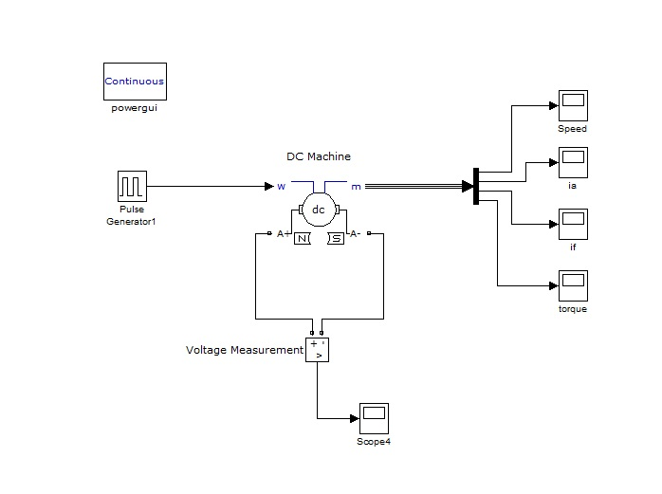

**Stage 2**

This generated power from the DC machine is used to charge a lead acid battery whose nominal voltage is 15v and capacity is 60Ah. This battery is connected across the armature terminals of the DC generator.

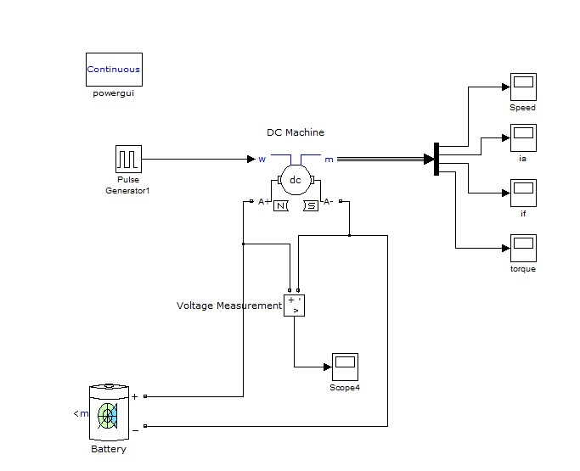

**Stage 3**

The stored power in the battery is given as input to the inverter which converts this DC to AC. A Universal Bridge which is a two armed-4 thyristor single phase inverter model is implemented. A pulse width modulated signal is a high frequency sinusoidal gate pulse which is given as a gate signal to the universal bridge in order to obtain proper sinusoidal output .

**PWM explanation**

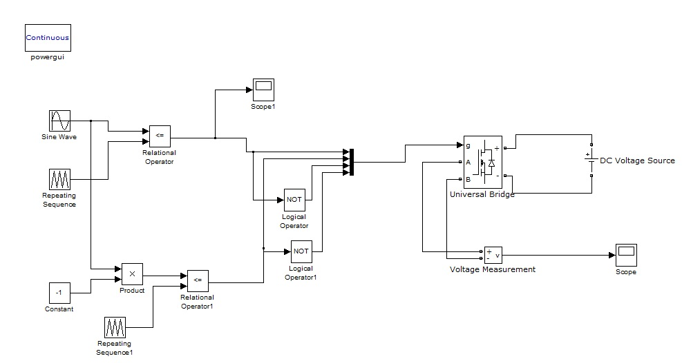

**Stage 4**

The output of the universal bridge is very less due to which a linear transformer is used to step up the voltage . This stepped up voltage is boosted using a feedback circuit. Instead of using a single battery, a two battery system is used so that the back up time of inverter is increased.

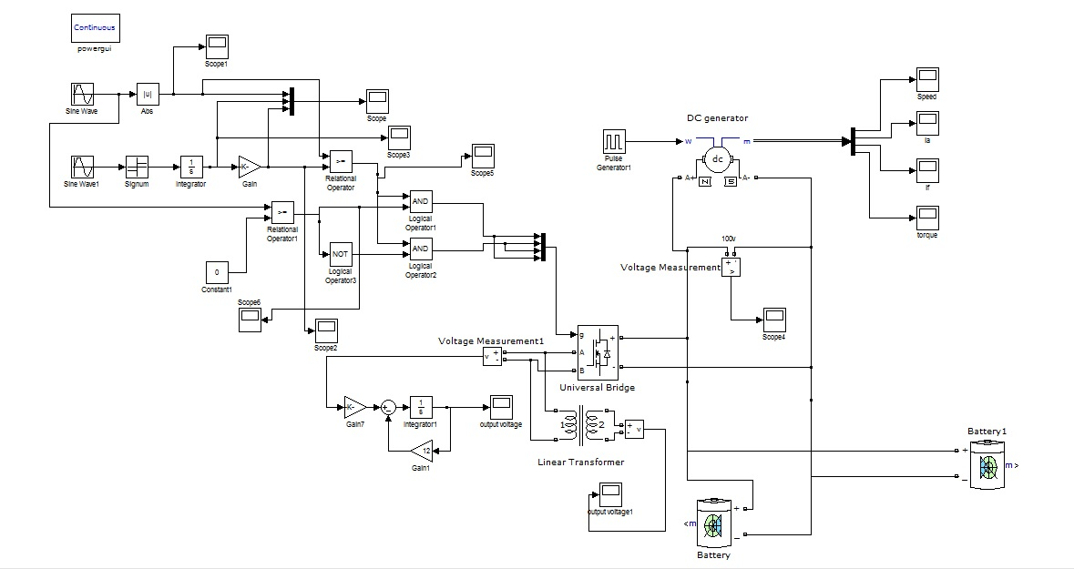

**Stage 5**

In this model a closed loop control is implemented for the battery using switching circuits that is if the voltage in the battery is less than 15V then the battery is charged through the generator else it acts as input to the inverter terminals and thus to the load.

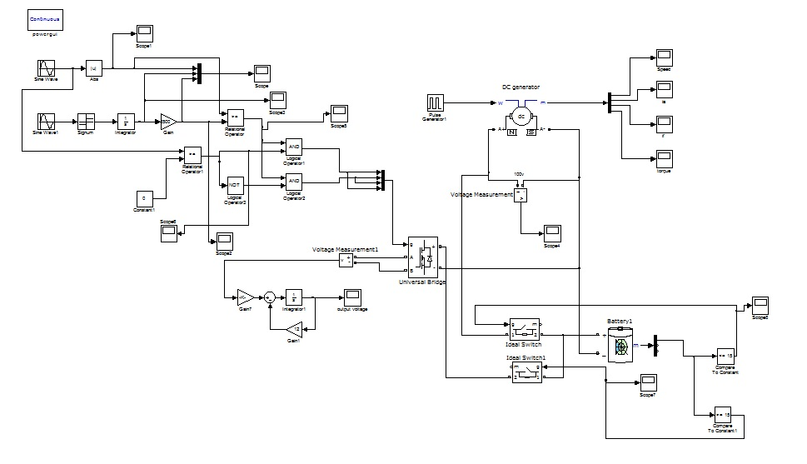

**Stage 6**

In addition to the closed loop control of the battery a thermal sensor is placed in the form of pulse generator to avoid the over heating of the inverter and the parameters are set such that for every 2 hours of working, the inverter is switched off for 12 minutes. In order to eliminate the ripples in the output voltage a low pass filter is connected across the linear transformer.

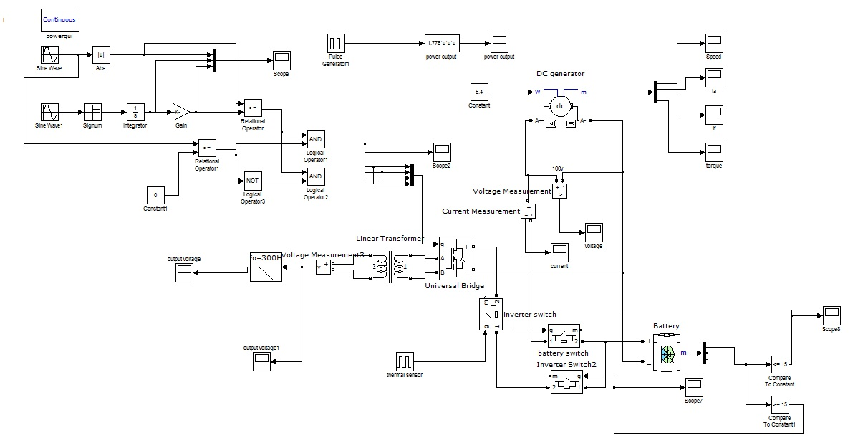

**Stage 7**

The use of a linear transformer introduces distortions in the ac output voltage which is replaced by an analog filter design. The output voltage from the low pass filter is multiplied with a gain to obtain the desired output voltage.

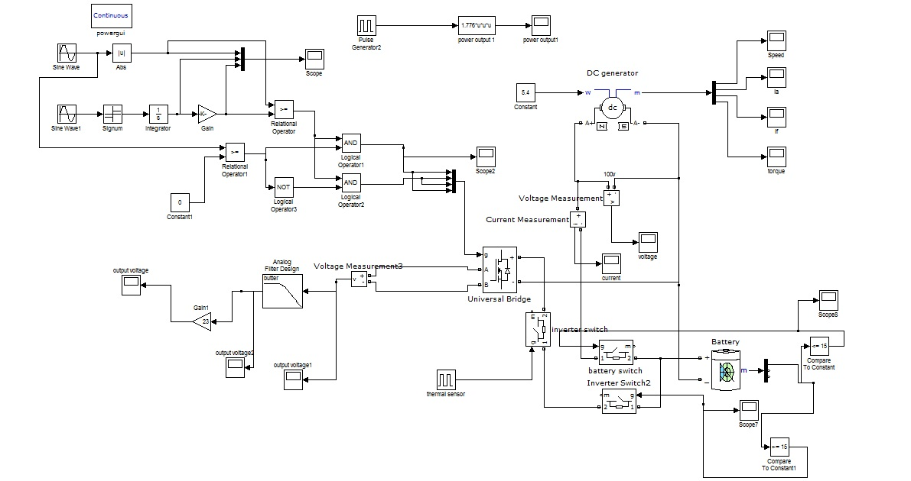

**Stage 8**

The ac output of the inverter is fed to a tank circuit which eliminates dissipation of energy due to resistors. This is boosted up by a linear transformer and power is absorbed by the load connected in series to the secondary of the transformer.

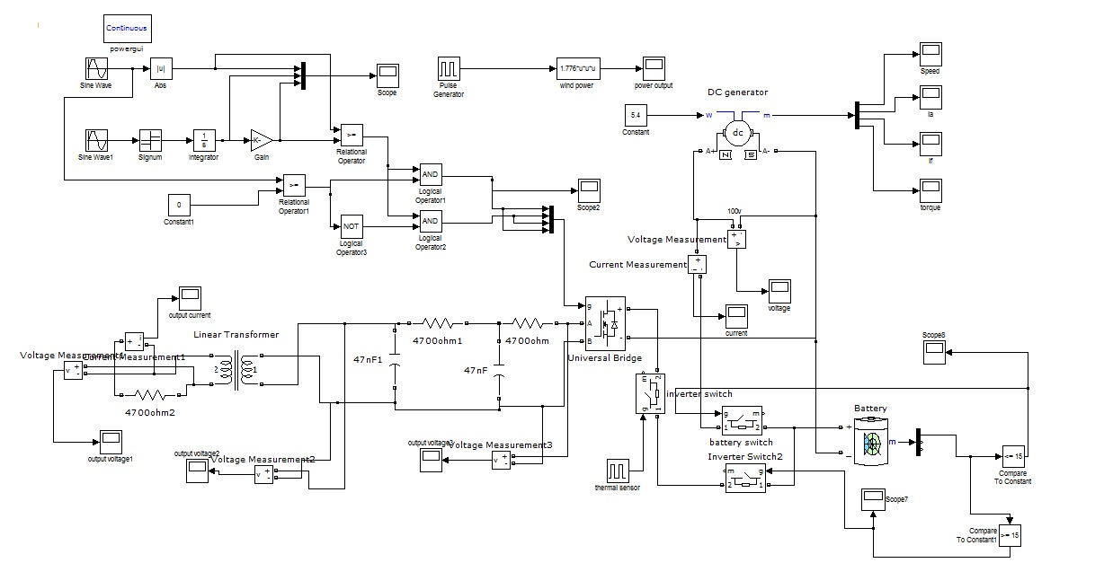

**Stage 9**

The tank circuit is modified from the previous design for the accuracy in voltage. Variations in load and their corresponding changes in the current are measured.

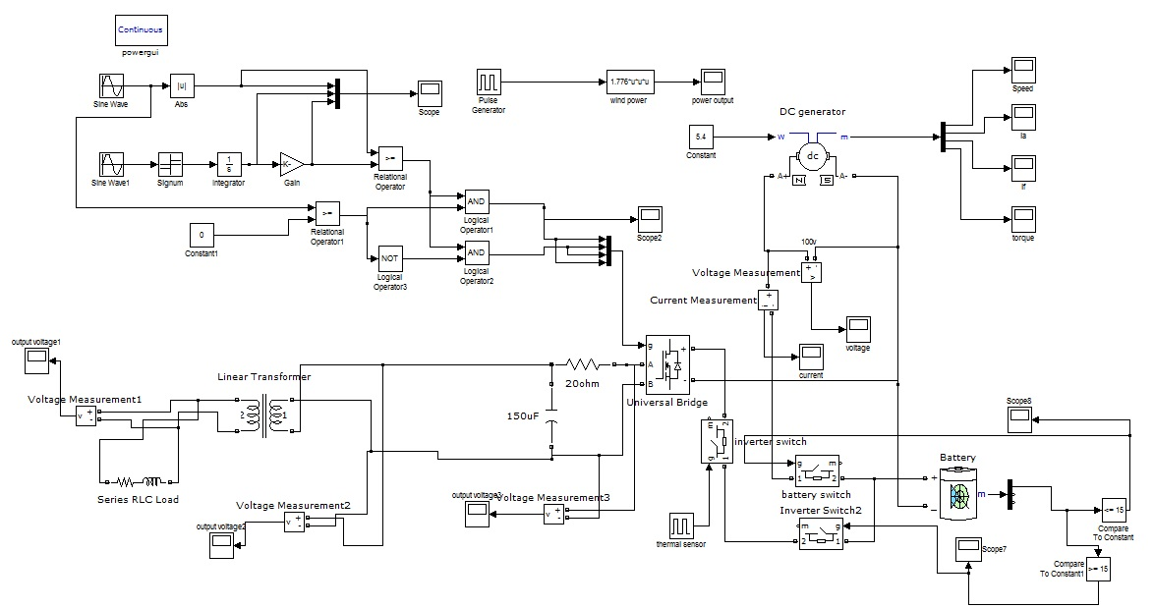

**Stage 10**

Apart from the wind power there is inclusion of solar power in the form of solar panels. These two renewable energy sources together are used to charge the battery. The tentative design of the solar model is pre-defined in MATLAB. A discrete PWM generator is pre-defined in simulink which solves the purpose of gate signal to the inverter. A closed loop control of a two battery system is implemented.

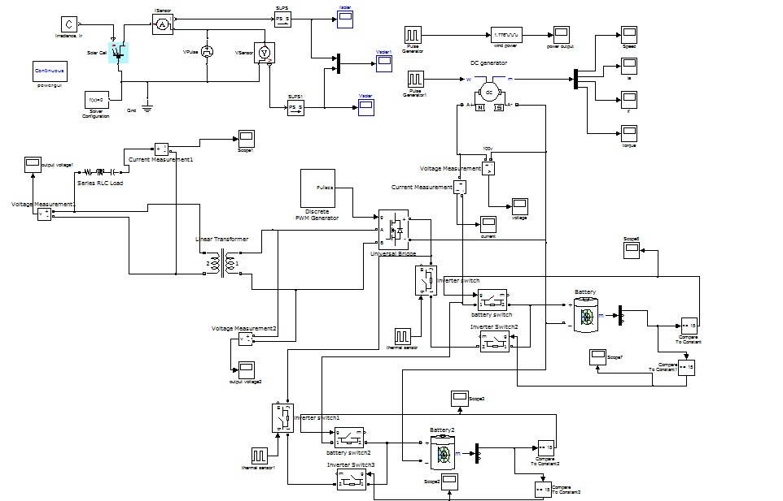

**Stage 11**

A controlled current source is connected across the solar panel which monitors the output current and voltage value for a resistive load of 7ohm. The output current from solar panels is around 2A so the voltage across the load becomes 14V which is used to charge the battery. Active and Passive power is also measured across the load with the help of simulink model.

