**MAT092-MFA**

Class-1

Date: 27-05-2023

**Number System:**

1. **Natural Number:** The set of counting numbers is the natural number. It is denoted by “N”.

**Ex:** N= {1, 2, 3, 4, ………., **∞}**

1. **Whole Number:** The set of natural numbers including 0 is the whole number. It is denoted by “W”.

**Ex:** W= {0, 1, 2, 3, 4, ………., **∞**}

1. **Integer Number:** The natural numbers, 0 and the negative of natural numbers are the integers. It is denoted by “Z”.

**Ex:** Z= {-**∞, ………, -4, -3, -2, -1, 0, 1, 2, 3, 4, ……., ∞}**

1. **Rational Number:** The number which can be expressed in the form of $\frac{q_{1}}{p};$ p,q $∈$ Z, q $≠$ 0 is called rational number. This set is denoted by “Q”.

**EX:** Q= { *-***∞, …………,**-5, 0, 0.5, 5, 6, 32, ………, **∞}**

1. **Irrational Number:** The number which can not be expressed in the form of $\frac{q_{1}}{p}$ is called irrational number. This set is denoted by Q`.

Three types of numbers are irrational:

* Decimal,
* Non- terminating,
* Non- repeating.

**Ex:** Q`= {$\sqrt{2}, \sqrt{3}, \sqrt{5},$ π, $ⅇ$, $\sqrt{8}$}

1. **Real Number:** The totality of rationals and irrationals is the set of real number. It is denoted by “R”.

N $⊂$ W $⊂$ Z $⊂$ Q $⊂$ R

Q $⊂$ ` R

**Real Line:** The real line is a straight line on which we can incorporate real numbers.

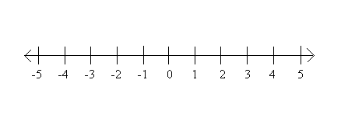

**Interval:**

1. Open interval: (,)
2. Closed interval: [,]

X $∈$ (a, b) $⇒$ a < x < b

X $∈$ [a, b] $⇒$ a $≤$ x $≤$ b

**Absolute Value:** The absolute value of a number x is defined as

$\left|x\right|$ = { x, x $≥$ 0

-x, x < 0

[Absolute value is always positive.]

--------o--------