**MAT092-MFA**

Class-2

Date: 29-05-2023

**Inverse:**

1. Additive inverse,
2. Multiplicative inverse.

**Function:** Let X and Y are two sets. Then a function f is a relation or a correspondence from X to Y such that **for each** element in X, there is **a unique** element in Y. Here **X is called domain, Y is called co-domain,** and the set of related elements of Y is called range.

# If f is a function, then for each x $∈$ X, there is a unique y $∈$ Y such that,

y = f(x)

Which is read as y in function of x.

# y = x2 D = ; Range = [0, ∞)

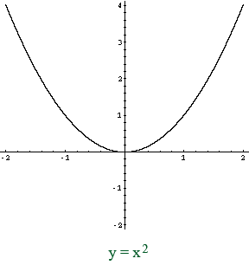

Fig-1

# y = x3 D = ; Range = $R$

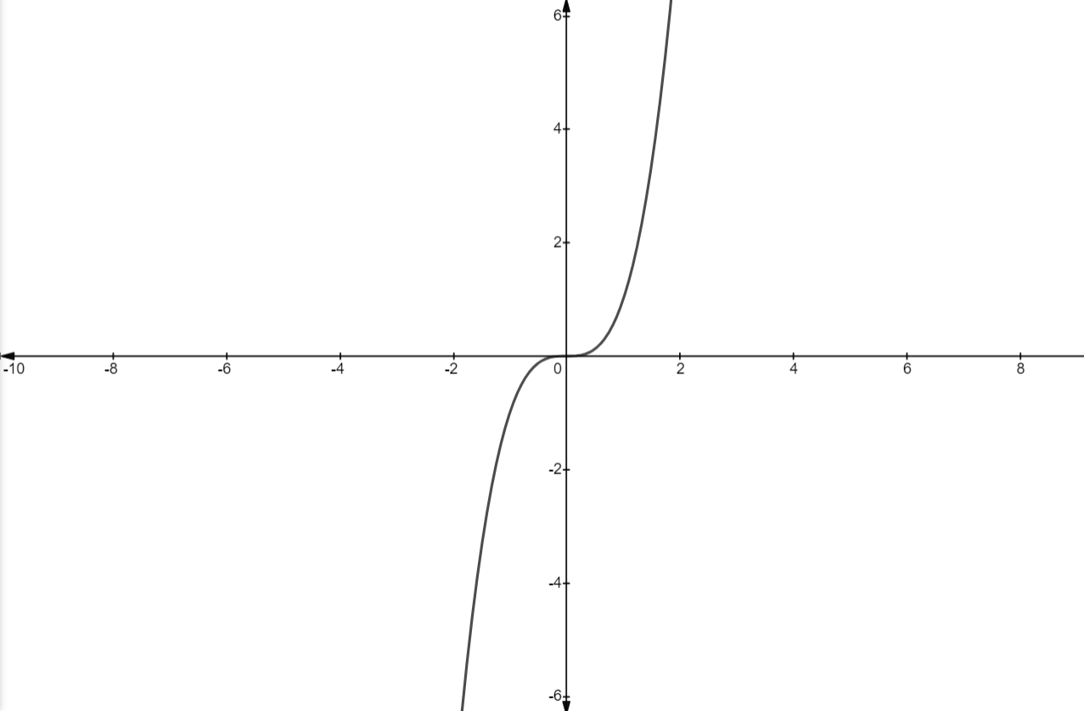

Fig-2

# y = |x| D = $R$; Range = [0, ∞)

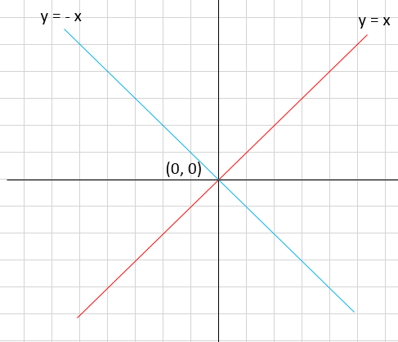

Fig-3

# y = x + 4 $⇒$ D = $R$; Range =

# y = -x2 D = ; Range = (-∞, 0]

**Inverse of fig-1**

# y = |x| + 2 $⇒$ D = $R$; Range = [2, ∞)

--------o--------