

Department of Information and Communication Technology
Faculty of Technology
University of Ruhuna

Object Oriented Programming Practicum
ICT 2132
Mini Project
2026 – B09
Group 5

Submitted to: Mr.P.H.P. Nuwan Laksiri
Submitted by: TG/2024/2095 - K.H.M. Hasaranga
TG/2024/2096 - N.V.S. Himansana
TG/2024/2080 - I.A.S. Sandeepani
TG/2024/2127 - D.S.R.N. Dahanayaka

Contents
Abstract 4
1. Introduction 5
1.1 Problem Statement 5
1.2 Proposed Solution 5
2. System Design and Architecture 6
2.1 System Architecture 6
2.2 Role-Based System View 7
2.3 Database Design 8
2.4 Entity Relationship (ER) Diagram 8
2.5 Class Diagram 10
2.6 Object-Oriented Concepts Applied 11
3. Methodology 12
3.1 Development Approach 12
3.2 Team Collaboration 12
3.3 Development Tools 12
4. Implementation (Selected Code) 13
4.1 User Hierarchy and Role Routing 13
4.2 Authentication 14
4.3 Database Access Layer 15
5. User Interface Screenshots 16
5.1 Login Screen 16
5.2 Administrator Screens 17
5.3 Lecturer Screens 19
5.4 Technical Officer Screens 20
5.5 Undergraduate Screens 22
6. Database Details and Query Results 24
6.1 Database Overview 24
6.2 Users and Accounts 25
6.3 Courses 25
6.4 Attendance and Medical Records 26
6.5 Marks, Eligibility and Grades 26
6.6 Database Security 27
7. Security 28
7.1 Security Requirements and Implementation 28
7.2 Additional Safeguards 28
8. Conclusion 29
8.1 Project Summary 29
8.2 Achievements 29
8.3 Limitations and Future Enhancements 29
9. Individual Contributions 30
TG/2024/2095 - K.H.M. Hasaranga (Group Leader) 30
9.2 TG/2024/2096 - N.V.S. Himansana 31
TG/2024/2080 - I.A.S.S. Appuhami 32
TG/2024/2127 - D.S.R.N. Dahanayaka 33
10. GitHub Project Link 34
11. References 35
12. Appendices 36
12.1 Hardware Requirements 36
12.2 Software Requirements 36
12.3 Setup and Run Instructions 36

Abstract
This project implements a Faculty Management System for the Faculty of Technology, University of Ruhuna, as a desktop application written in Java. The graphical interface is built with JavaFX (FXML and CSS) and all data is stored in a central MySQL database that is accessed through JDBC. The system replaces manual record keeping by managing user profiles, courses, undergraduate records, attendance, medical submissions, marks, grades, notices, timetables and course materials in one place.
Four roles are supported – Administrator, Lecturer, Technical Officer and Undergraduate – and each role is taken to its own dashboard after login and can only perform the operations that belong to it. The application calculates attendance percentages for theory, practical and combined sessions, identifies the five attendance scenarios required by the project brief, checks exam eligibility (attendance of at least 80% and CA marks of at least 40%), and produces grade points together with SGPA and CGPA for each undergraduate.
The code follows a layered architecture (GUI → Controller → Service → DAO → JDBC → MySQL) and demonstrates the main object-oriented concepts: classes and objects, inheritance, abstraction, polymorphism, encapsulation and exception handling. Security is addressed through BCrypt password hashing, role-based access control, input validation, parameterised SQL statements, a least-privilege database user and session clearing on logout.

1. Introduction

1.1 Problem Statement
Students, lecturers and staff of the Faculty of Technology need to access academic information every day, but there is no single place where each user can see the information that belongs to him or her. The main problems are:
- Students cannot check their GPA. There is no simple way for an undergraduate to see grades, grade points, SGPA and CGPA.
- Lecture notes are hard to find. There is no single place where students can find the course materials uploaded by their lecturers.
- Students cannot view the timetable of their courses, and notices do not reach the right students.
- Lecturers cannot view their students’ details. A lecturer cannot easily see the profile, attendance, medical, CA marks and eligibility of the students of his or her courses.
- Attendance, medical and marks records are scattered, so checking whether an undergraduate is eligible for the final examination (attendance of at least 80% and CA marks of at least 40%) is slow and error-prone.
- Different users need different views of the same data (administrators, lecturers, technical officers and students), but access is not controlled by role.
There is therefore a need for one integrated application that gives every user the information and functions that their role needs, calculates attendance, eligibility, grades and GPA automatically, and protects passwords and personal data.

1.2 Proposed Solution
To solve these problems we developed the Faculty Management System, a JavaFX desktop application backed by a MySQL database that keeps everything in one place. Students can view their GPA, course materials, timetable, attendance and notices; lecturers can view their students’ details; and every role works only with the data that belongs to it. The main parts of the solution are:
Multi-role access control
- Administrator: creates and maintains users, courses, notices and timetables, and can view attendance, marks and medical data.
- Lecturer: updates own profile (except username and password), manages course materials, uploads marks for all evaluation types, and views student details, eligibility, results, attendance, medicals and notices.
- Technical Officer: adds and maintains attendance and medical records, approves or rejects medicals, and views notices and the timetable of the department.
- Undergraduate: views own courses, attendance, medicals, grades and GPA, timetable and notices, and updates only contact details and profile picture.
Core functionalities
- Login with BCrypt-verified passwords and automatic routing to the dashboard of the user’s role.
- Attendance for 15 sessions of every theory and practical component, with medical linking and batch/individual summaries.
- CA summary, exam eligibility, grades, SGPA and CGPA for individuals and the whole batch.

2. System Design and Architecture

2.1 System Architecture
The system is a standalone desktop application with a layered architecture. Each layer only talks to the layer below it, which keeps the interface independent from the database and makes the code easier to maintain.
Layer / package | Responsibility
controller | JavaFX controllers (LoginController and the dashboard + section controllers of every role). They read user input, call services and update the screen.
service | Business rules: authentication, role checks, mark validation, eligibility, attendance calculation, GPA, session handling.
dao | Data access interfaces and their JDBC implementations. All SQL lives here and uses PreparedStatement.
model | Plain Java classes: User → Staff → Admin / Lecturer / TechnicalOfficer, Undergraduate, Course, Attendance, MedicalRecord, MarkEntry, Notice, enums.
config, util, exception | DBConnection, PasswordUtil (BCrypt), Validator, FileStorageUtil, DataSeeder, and custom exceptions (AuthenticationException, ValidationException, ServiceException).
resources | FXML layouts, CSS style sheets and images for every dashboard.

2.2 Role-Based System View
After a successful login, the User object that was loaded from the database is asked for its own dashboard (getDashboardFxml()). Because every subclass overrides this method, the application does not need any role-specific if/else chain to choose the screen. Figure 2.2 shows the four role views and the sections available in each.

Role | Main permissions | Restrictions
Administrator | Create/update/deactivate users, courses, notices, timetables; view attendance, marks, medicals. | Highest access; still logs in through the same BCrypt check.
Lecturer | Materials, marks (0–100), eligibility, results, student details, attendance and medicals of own courses, notices, timetable. | Cannot change username/password; services accept only courses assigned to the lecturer.
Technical Officer | Add/maintain attendance and medicals, approve or reject medicals, view notices and department timetable. | No access to marks or user administration.
Undergraduate | View own courses, attendance, medicals, grades/GPA, timetable, notices. | May edit only contact details and profile picture.

2.3 Database Design
The database faculty_db has 16 tables and uses InnoDB with foreign keys, CHECK constraints and UNIQUE constraints. The shared user information is kept in the users table; Undergraduate and Staff are subtypes (shared primary key), and Admin, Lecturer and Technical Officer are subtypes of Staff. This mirrors the class hierarchy in the code. The most important tables are summarised below.
Table | Purpose | Key columns and rules
users | Login and personal data of every person | user_id (PK), username (UNIQUE), password_hash (BCrypt), role ENUM(ADMIN, LECTURER, TECHNICAL_OFFICER, UNDERGRADUATE), email (UNIQUE), is_active, profile_picture_path
undergraduate | Student-specific data | stu_id (PK, FK → users), reg_number (UNIQUE), batch, status ENUM(REGULAR, REPEAT, BATCH_MISSED), dep_id (FK)
course | Course details | course_id (PK), course_code (UNIQUE), credits_theory, credits_practical, semester, course_type, lecture_id (FK → lecturer), created_by (FK → admin)
enrollment | Student ↔ course (M:N) | stu_id, course_id, academic_year; UNIQUE(stu_id, course_id, academic_year) lets repeat students re-enrol
attendance | One row per student per session | stu_id, course_id, session_id CHECK 1–15, session_type, session_date, status (PRESENT/ABSENT), session_hours = 2.0, medical_id (FK), to_id (FK)
medical_record | Medical submissions | stu_id, session_date, document_path, approval_status ENUM(PENDING, APPROVED, REJECTED), approved_by (FK → technical_officer)
marks | Evaluation marks | stu_id, course_id, evaluation_type, mark_category ENUM(CA, FINAL), marks_value CHECK 0–100
grade | Final mark, grade and grade point | stu_id, course_id, final_mark, grade, grade_point CHECK 0–4, semester (used for SGPA/CGPA)

2.4 Entity Relationship (ER) Diagram
The EER diagram prepared by the group (Figure 2.3, next page) shows the User supertype with its Staff and Undergraduate subtypes, and the relationships between Department, Course, Attendance, Medical Record, Marks, Grade, Notice and Timetable. The physical schema in db/schema.sql was derived directly from this diagram; a few columns that the application needs (for example profile_picture_path, is_active, reg_number, file_path and mark_category) were added during implementation.

Figure 2.3 – ER / EER diagram of the Faculty Management System (faculty_db)

2.5 Class Diagram
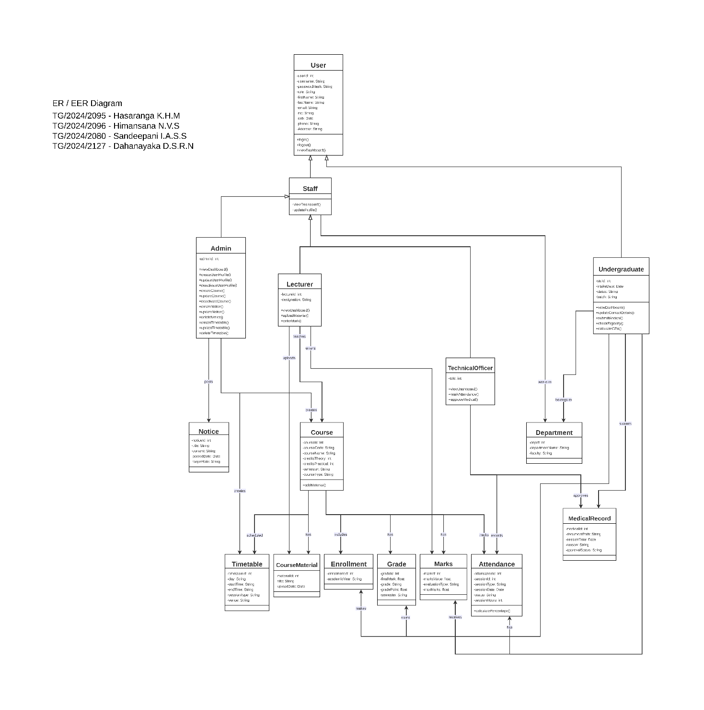
Figure 2.4 shows the domain classes of the application and Figure 2.5 shows how the controller, service and DAO classes cooperate. Both diagrams were drawn from the final source code on the dev branch.

Figure 2.4 – Domain class diagram (model classes and relationships)

2.6 Object-Oriented Concepts Applied
Concept | Where it is used
Classes and Objects | Model classes such as Undergraduate, Lecturer, Course, Attendance and MedicalRecord; each database row is mapped to an object by the DAO layer.
Inheritance | User ← Staff ← Admin / Lecturer / TechnicalOfficer, and User ← Undergraduate. Shared fields and methods are written once in User.
Abstraction | User and Staff are abstract; DAO interfaces (UserDAO, LecturerMarksDAO, MedicalDAO, ...) hide the JDBC details from services and controllers.
Polymorphism | getDashboardFxml() and getDashboardTitle() are overridden in every role class, so the login code treats all users through the User type.
Encapsulation | All model fields are private with getters/setters; DBConnection, PasswordUtil and AttendanceCalculator are final utility classes with private constructors.
Exception handling | AuthenticationException, ValidationException and ServiceException; SQLException is caught in DAO/service code and converted to friendly messages; SecurityException is thrown for forbidden operations.
Database handling | JDBC with try-with-resources, PreparedStatement and a central DBConnection.
GUI | JavaFX scenes defined in FXML, styled with CSS and driven by controller classes.

3. Methodology

3.1 Development Approach
The project followed an iterative approach that matched the deadlines of the course unit:
Phase | Period | Work done
Planning and requirements | Early Sep 2026 | Project brief analysed; repository and branches created; SRS written (submitted 13 Sep).
Design | Mid Sep 2026 | EER diagram, class diagram and MySQL schema prepared (submitted 20 Sep).
Core development | Sep – Oct 2026 | Database layer, login and role routing, user hierarchy, admin dashboard.
Role modules | Oct 2026 | Lecturer, Technical Officer and Student modules built in parallel on separate branches.
Integration | Mid – late Oct 2026 | Pull requests reviewed and merged into the dev branch; seed data for all attendance scenarios added.
Refinement and documentation | Late Oct 2026 | Bug fixes, UI polish, final report (due 1 Nov).

3.2 Team Collaboration
The team used Git and GitHub. Every member worked on a personal branch (TG2095_Hasaranga, TG2096_Himansana, TG2127_Sandaru and TG2080_Sudeshika). Finished work was merged into the shared dev branch through pull requests that were reviewed and merged by the group leader, who also resolved merge conflicts. The history of the dev branch contains 33 merged pull requests between 6 September and 30 October 2026.

3.3 Development Tools
- Language: Java 17 (OpenJDK)
- GUI: JavaFX 21.0.2 with FXML and CSS
- Database: MySQL 8.0+ with mysql-connector-j 8.4.0 (JDBC); XAMPP or Docker for local servers
- Security library: jBCrypt 0.4
- Build tool: Apache Maven (javafx-maven-plugin 0.0.8)
- IDE: IntelliJ IDEA;
- Version control: Git and GitHub;
- Diagrams: draw.io, Graphviz
- Documentation: Microsoft Word, PDF

4. Implementation (Selected Code)
This chapter shows short, simplified extracts from the source code. Comments and unrelated lines have been trimmed to keep the extracts readable.

4.1 User Hierarchy and Role Routing
User is an abstract base class. Each role overrides the two abstract methods, which is how the login screen finds the correct dashboard without any role-specific conditions.

public abstract class User {
private int userId;
private String username;
private String passwordHash;
private UserRole role;
// ... other private fields with getters/setters

public abstract String getDashboardFxml(); // polymorphism
public abstract String getDashboardTitle();

public String getFullName() {
return firstName + " " + lastName;
}
}

public class Lecturer extends Staff {
private String designation;

@Override
public String getDashboardFxml() {
return "/fxml/lecture/lecturer_dashboard.fxml";
}
@Override
public String getDashboardTitle() {
return "Lecturer Dashboard";
}
}

4.2 Authentication
AuthService verifies the password with BCrypt. The same error message is returned for an unknown user and a wrong password so that an attacker learns nothing, and deactivated accounts cannot log in.

public User login(String username, String password)
throws AuthenticationException, SQLException {
User user = userDAO.findByUsername(username);

if (user == null
|| !PasswordUtil.verify(password, user.getPasswordHash())) {
throw new AuthenticationException(
"Invalid username or password.");
}
if (!user.isActive()) {
throw new AuthenticationException(
"This account is deactivated.");
}
return user;
}

// PasswordUtil
public static String hash(String plain) {
return BCrypt.hashpw(plain, BCrypt.gensalt(12));
}

4.3 Database Access Layer
All SQL is written in DAO classes with ? placeholders. The DAO also builds the correct subclass of User according to the role column, which completes the polymorphic design.

public User findByUsername(String username) throws SQLException {
try (Connection con = DBConnection.getConnection();
PreparedStatement ps =
con.prepareStatement(FIND_BY_USERNAME)) {
ps.setString(1, username); // ... WHERE u.username = ?
try (ResultSet rs = ps.executeQuery()) {
return rs.next() ? mapRow(rs) : null;
}
}
}

switch (role) { // inside mapRow()
case ADMIN -> user = new Admin();
case LECTURER -> user = new Lecturer();
case TECHNICAL_OFFICER -> user = new TechnicalOfficer();
default -> user = new Undergraduate();
}

5. User Interface Screenshots
This chapter shows the graphical user interface of the Faculty Management System for every role. All screenshots were taken from the running application using the demo data in db/seed_data.sql.

5.1 Login Screen
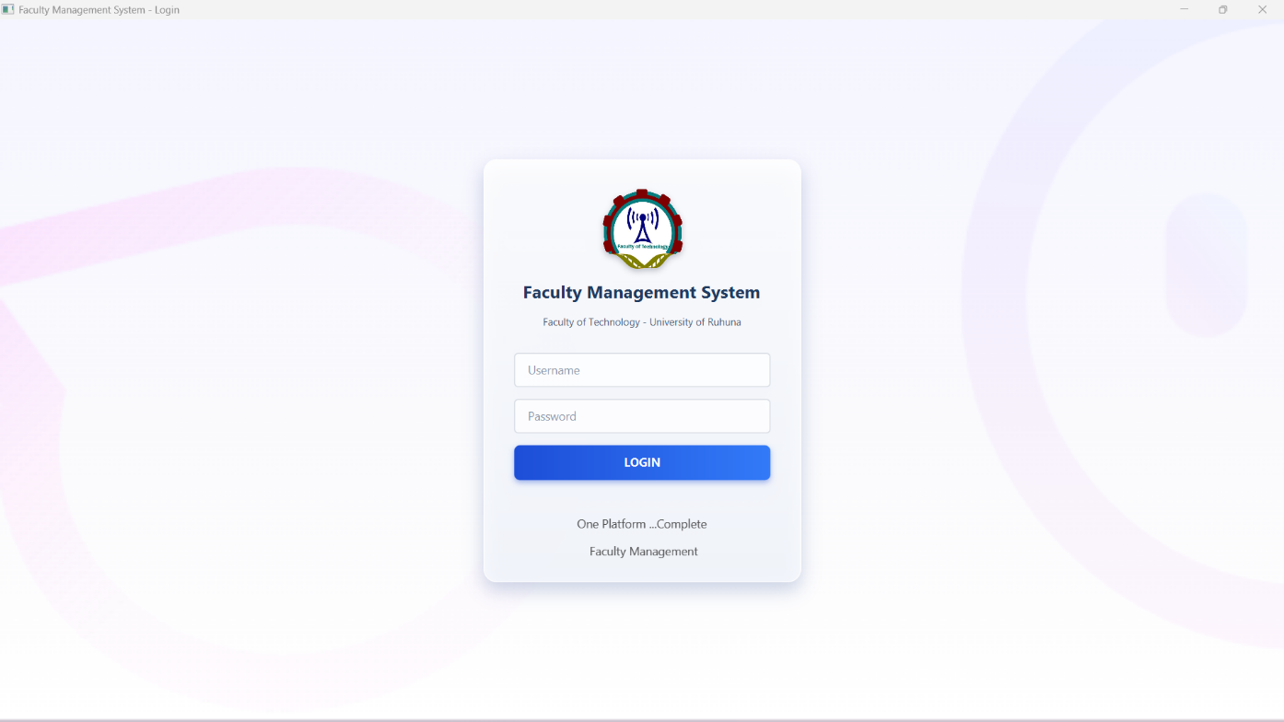 Figure 5.1 – Login screen
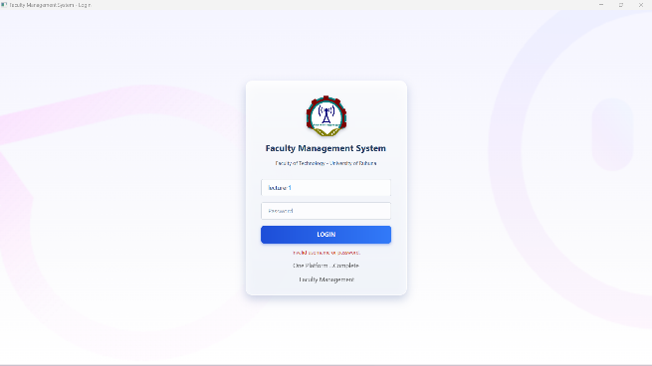
Figure 5.2 – Login error message for a wrong password

5.2 Administrator Screens
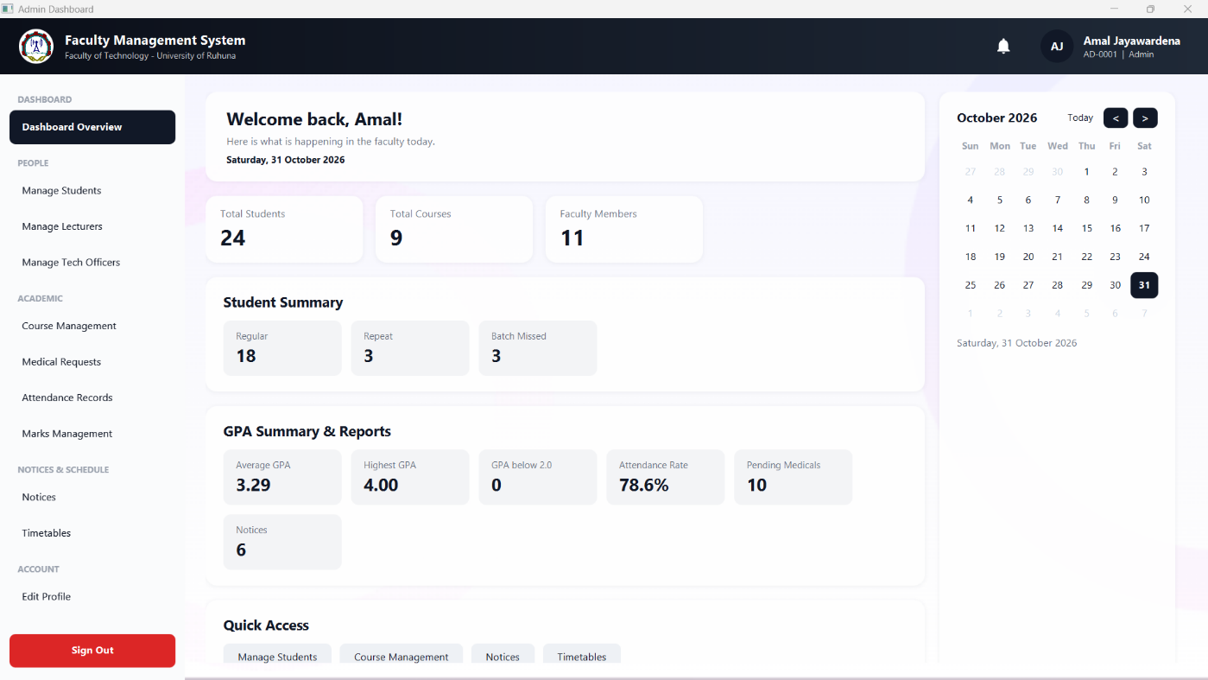 Figure 5.3 – Admin dashboard (home)
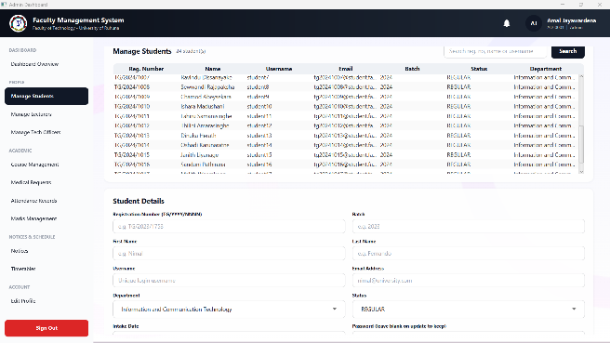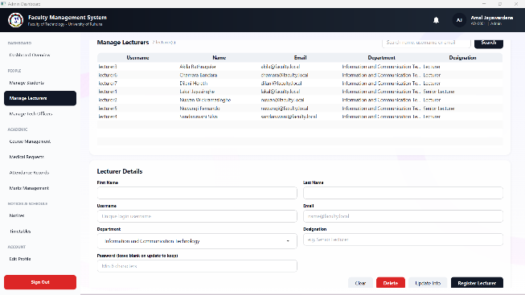
Figure 5.4 – Students section (list and add/edit form) Figure 5.5 – Lecturers section
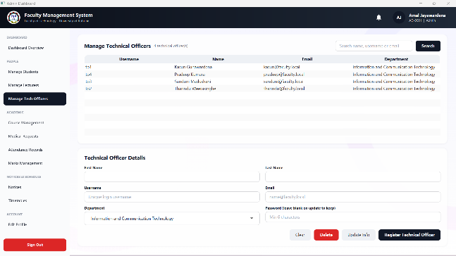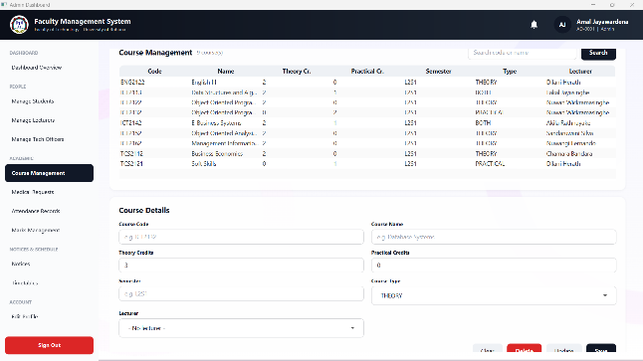
Figure 5.6 – Technical Officers section Figure 5.7 – Courses section
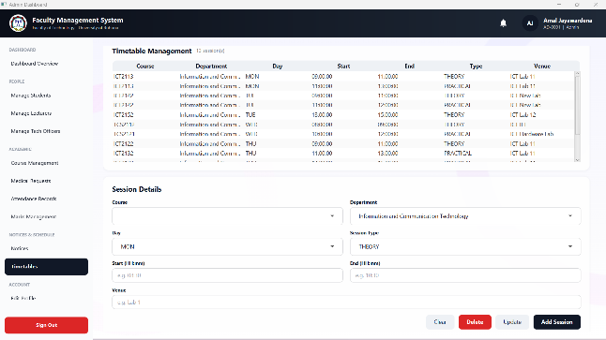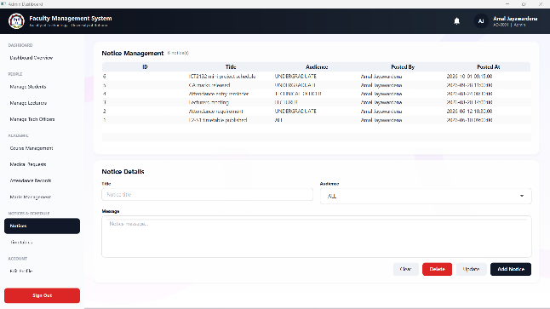
Figure 5.8 – Timetables section Figure 5.9 – Notices section
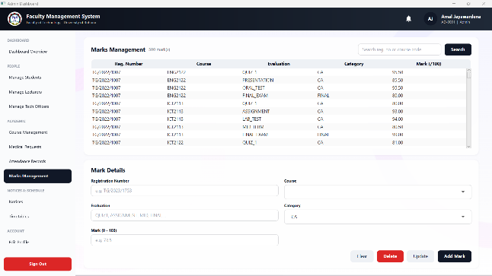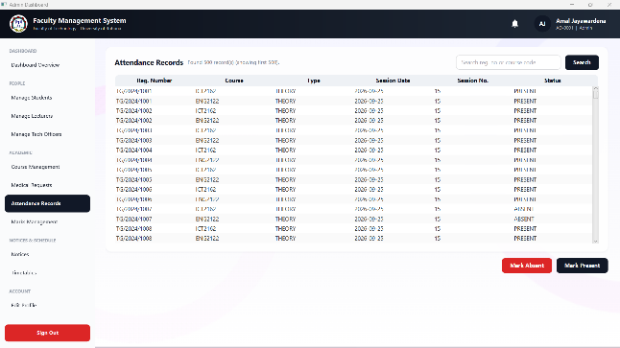
Figure 5.10 – Marks view Figure 5.11 – Attendance view
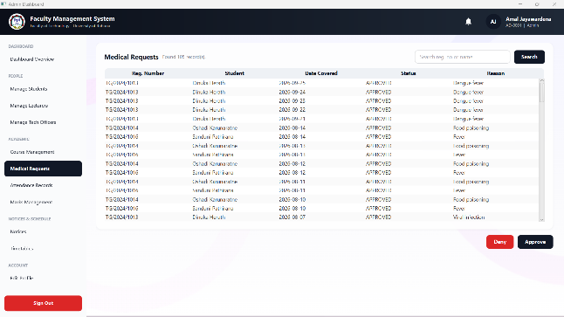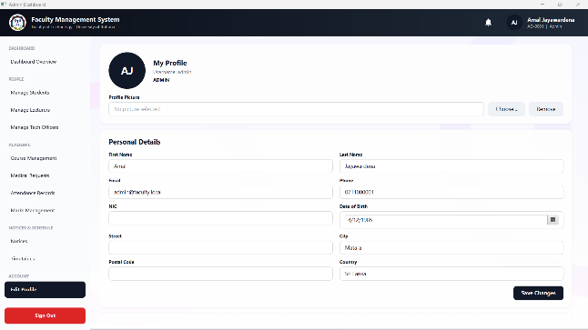
Figure 5.12 – Medical view Figure 5.13 – Admin profile

5.3 Lecturer Screens
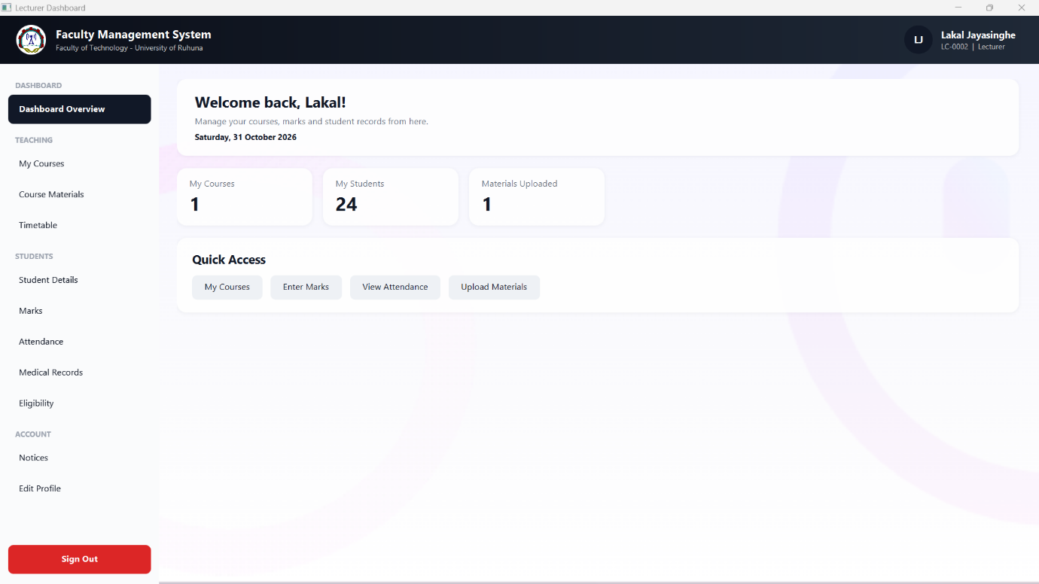 Figure 5.14 – Lecturer dashboard (home)
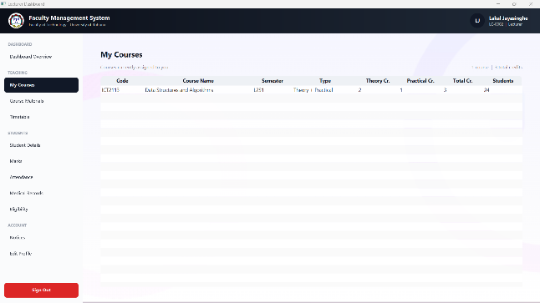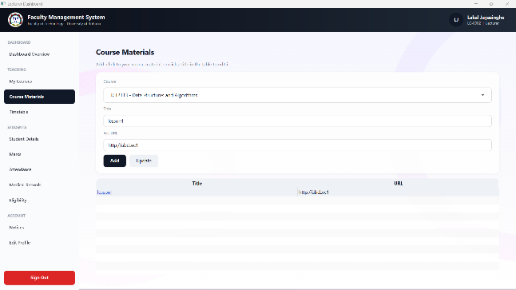
Figure 5.15 – My Courses Figure 5.16 – Course Materials (upload / modify)
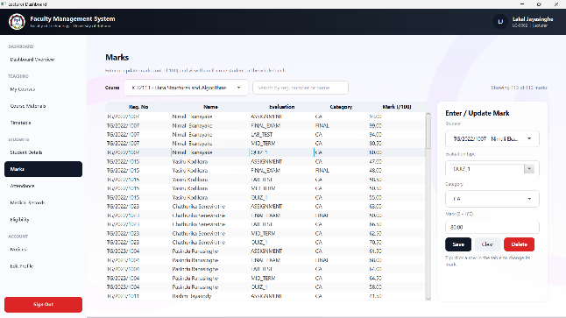
Figure 5.17 – Marks entry (adding a mark)

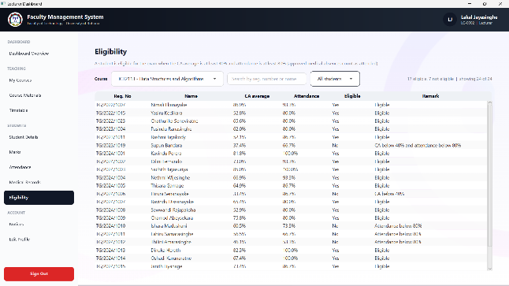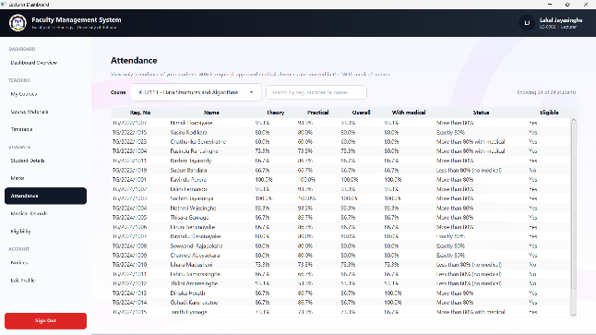
Figure 5.19 – Exam Eligibility (batch view) Figure 5.20 – Attendance summary (batch and individual)
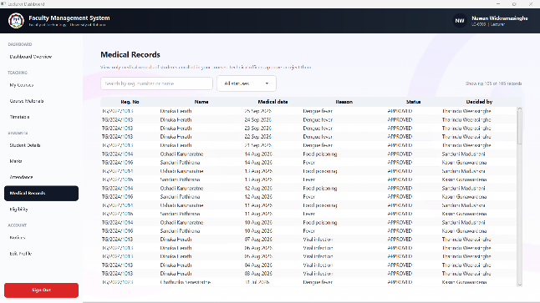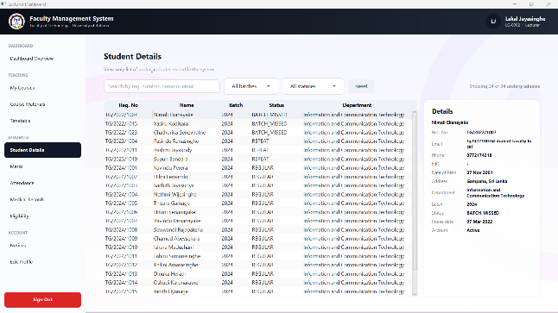
Figure 5.21 – Medical records view Figure 5.22 – Student details
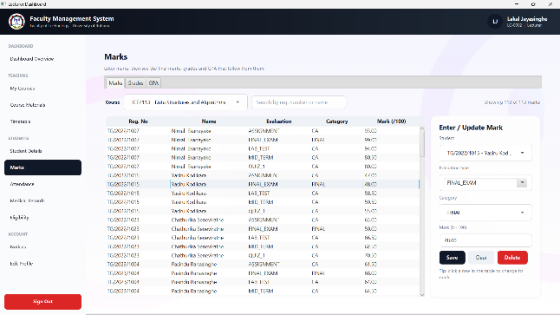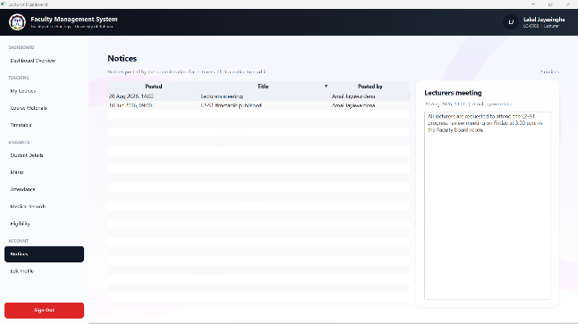
Figure 5.23 – Results – grades and GPA Figure 5.24 – Notices

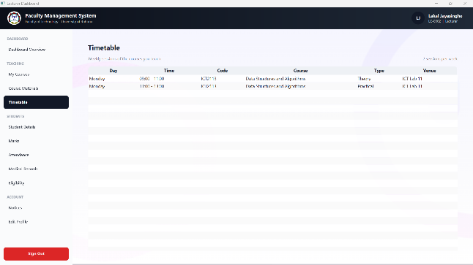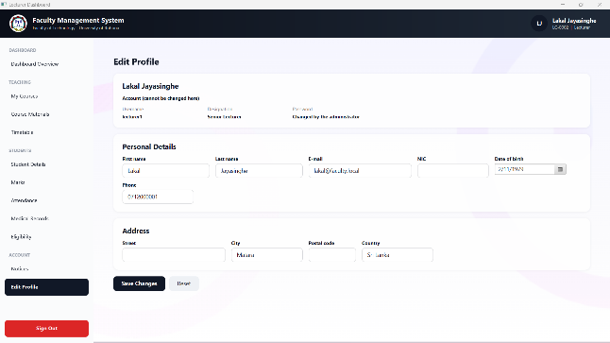
Figure 5.25 – Timetable Figure 5.26 – Lecturer profile

5.4 Technical Officer Screens
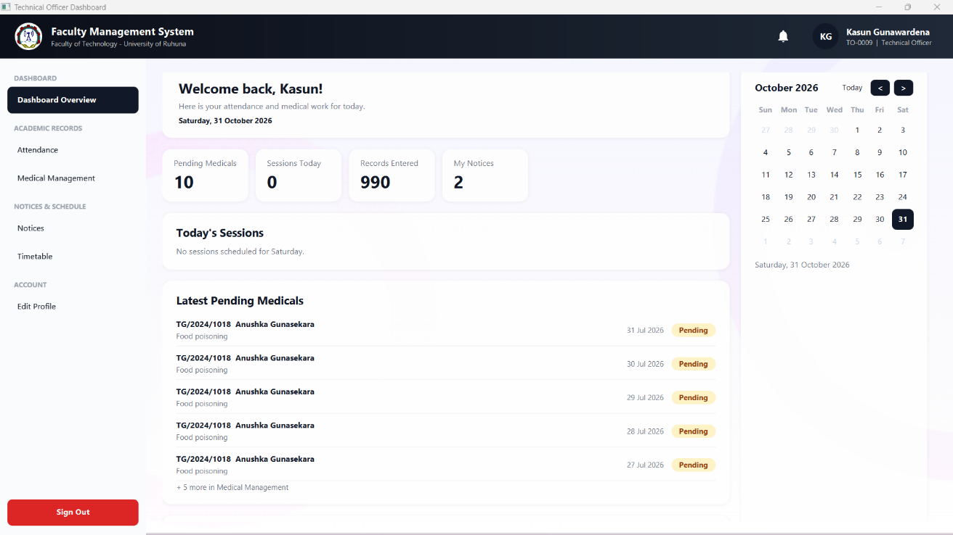Figure 5.27 – Technical Officer dashboard (home)
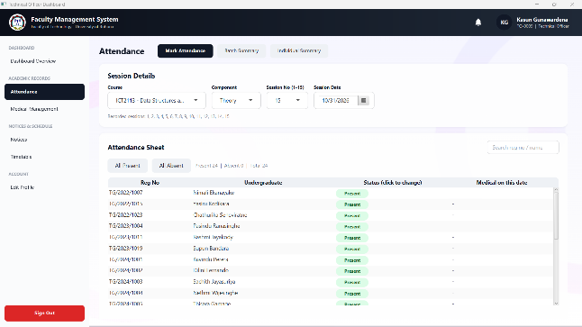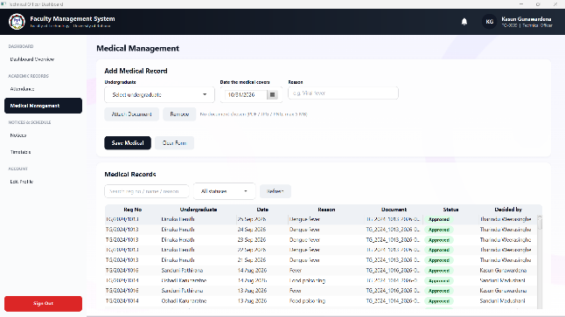
Figure 5.28 – Attendance sheet Figure 5.29 – Medical records – approve / reject
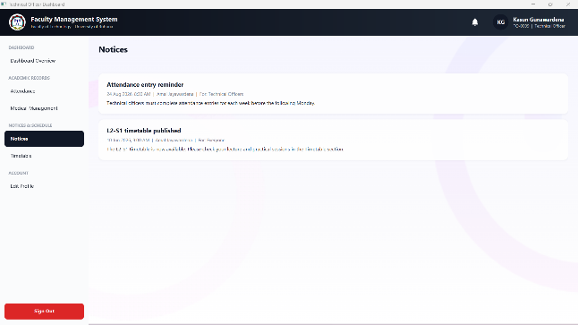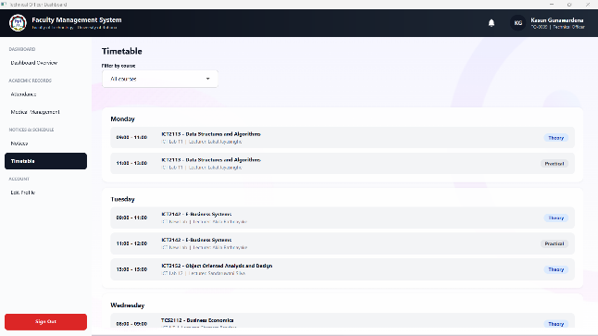
Figure 5.30 – Notices Figure 5.31 – Department timetable
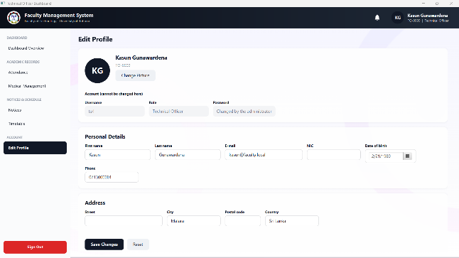
Figure 5.32 – Technical Officer profile

5.5 Undergraduate Screens
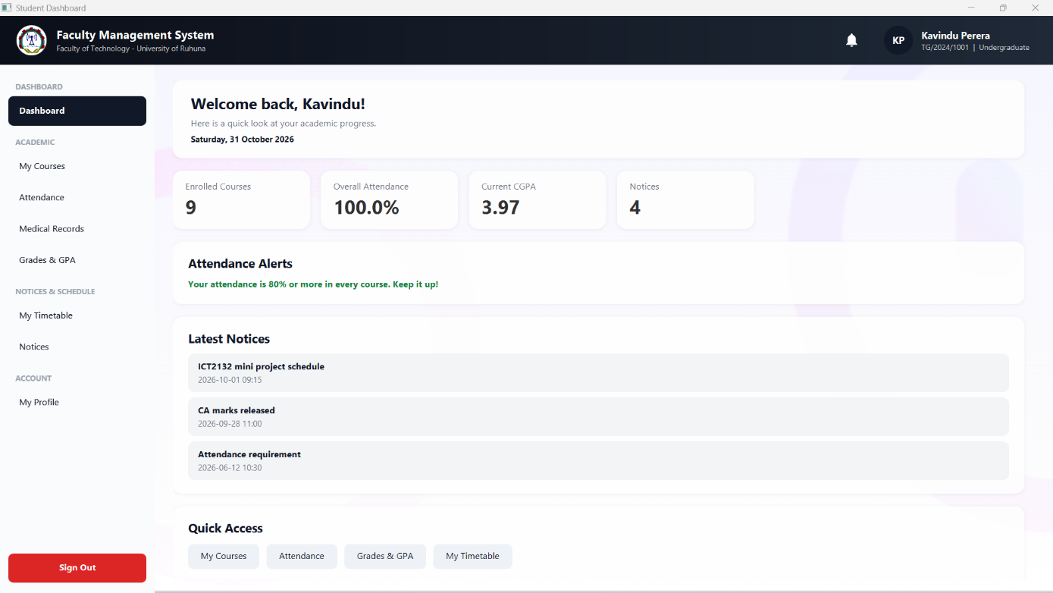Figure 5.33 – Student dashboard (home)
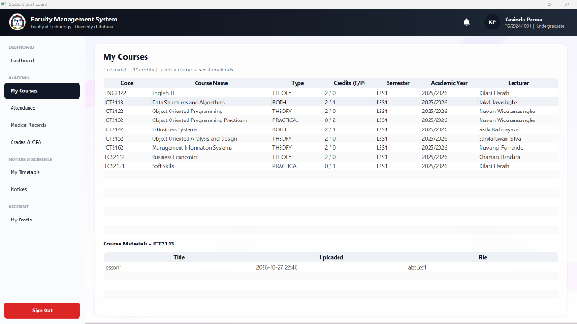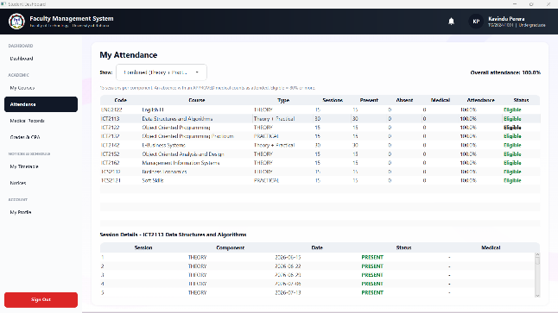
Figure 5.34 – My Courses Figure 5.35 – Attendance (theory / practical / combined)
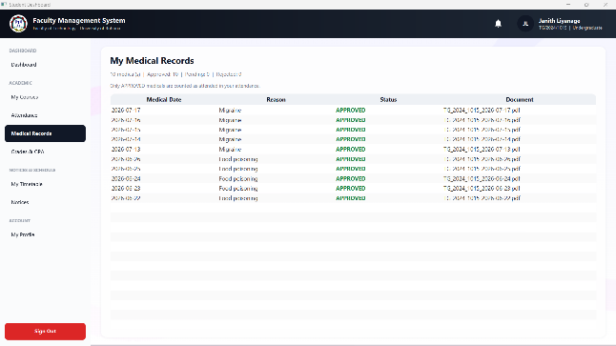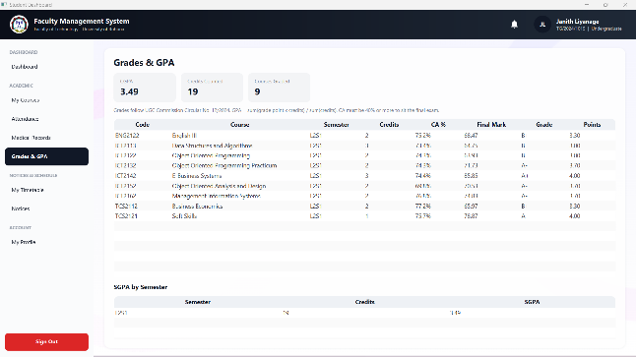
Figure 5.36 – Medical records and approval status Figure 5.37 – Grades, SGPA and CGPA
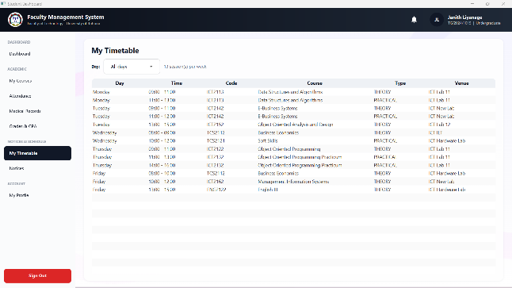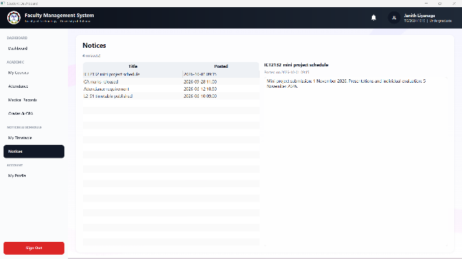
Figure 5.38 – Timetable Figure 5.39 – Notices
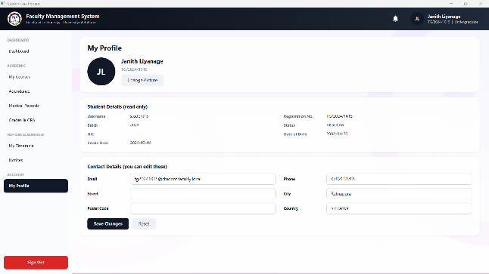
Figure 5.40 – Profile (contact details and picture only)

6. Database Details and Query Results
This chapter presents the faculty_db database as it exists after running db/schema.sql and db/seed_data.sql. Each query was executed in MySQL (Workbench, phpMyAdmin or the mysql client) and the result is shown below the query.

6.1 Database Overview
+----------------------+
| Tables_in_faculty_db |
+----------------------+
| admin |
| attendance |
| course |
| course_material |
| department |
| enrollment |
| grade |
| lecturer |
| marks |
| medical_record |
| notice |
| staff |
| technical_officer |
| timetable |
| undergraduate |
| users |
+----------------------+
Figure 6.1 – Tables of faculty_db

+-------------------+--------+------------+
| TABLE_NAME | ENGINE | TABLE_ROWS |
+-------------------+--------+------------+
| admin | InnoDB | 0 |
| attendance | InnoDB | 3960 |
| course | InnoDB | 9 |
| course_material | InnoDB | 0 |
| department | InnoDB | 0 |
| enrollment | InnoDB | 216 |
| grade | InnoDB | 157 |
| lecturer | InnoDB | 7 |
| marks | InnoDB | 853 |
| medical_record | InnoDB | 105 |
| notice | InnoDB | 6 |
| staff | InnoDB | 12 |
| technical_officer | InnoDB | 4 |
| timetable | InnoDB | 13 |
| undergraduate | InnoDB | 24 |
| users | InnoDB | 36 |
+-------------------+--------+------------+
Figure 6.2 – Database diagram from the MySQL tool
Query Q1: Row count of the main tables
Shows how much demo data is stored in each important table.
+----------------+------+
| tbl | n |
+----------------+------+
| users | 36 |
| undergraduate | 24 |
| course | 9 |
| enrollment | 216 |
| attendance | 3960 |
| medical_record | 106 |
| marks | 853 |
| grade | 157 |
| notice | 6 |
| timetable | 13 |
+----------------+------+
Result 1 – Row count of the main tables

6.2 Users and Accounts
Query Q2: Users per role
Confirms the required data: 1 admin, at least 5 lecturers, at least 4 technical officers and at least 20 undergraduates.
+-------------------+-------+
| role | total |
+-------------------+-------+
| ADMIN | 1 |
| LECTURER | 7 |
| TECHNICAL_OFFICER | 4 |
| UNDERGRADUATE | 24 |
+-------------------+-------+
Result 2 – Users per role
Query Q3: Undergraduates by status
Shows that regular, repeat and batch-missed students are stored.
+--------------+-------+
| status | total |
+--------------+-------+
| REGULAR | 18 |
| REPEAT | 3 |
| BATCH_MISSED | 3 |
+--------------+-------+
Result 3 – Undergraduates by status
Query Q4: Password hashes (BCrypt)
Proves that passwords are stored only as BCrypt hashes ($2a$ / $2b$ prefix, 60 characters), never as plain text (SEC-01).
+-----------+----------+-------------+-------------+
| username | role | hash_prefix | hash_length |
+-----------+----------+-------------+-------------+
| admin | ADMIN | $2a$12$ | 60 |
| lecturer1 | LECTURER | $2a$12$ | 60 |
| lecturer2 | LECTURER | $2a$12$ | 60 |
| lecturer3 | LECTURER | $2a$12$ | 60 |
| lecturer4 | LECTURER | $2a$12$ | 60 |
| lecturer5 | LECTURER | $2a$12$ | 60 |
| lecturer6 | LECTURER | $2a$12$ | 60 |
| lecturer7 | LECTURER | $2a$12$ | 60 |
+-----------+----------+-------------+-------------+
Result 4 – Password hashes (BCrypt)

6.3 Courses
Query Q5: Courses of the semester
Lists the Level 2 Semester 1 courses with theory and practical credits.
+-------------+---------------------------------------+----------------+-------------------+----------+-------------+
| course_code | course_name | credits_theory | credits_practical | semester | course_type |
+-------------+---------------------------------------+----------------+-------------------+----------+-------------+
| TCS2112 | Business Economics | 2 | 0 | L2S1 | THEORY |
| ICT2113 | Data Structures and Algorithms | 2 | 1 | L2S1 | BOTH |
| ICT2122 | Object Oriented Programming | 2 | 0 | L2S1 | THEORY |
| ICT2132 | Object Oriented Programming Practicum | 0 | 2 | L2S1 | PRACTICAL |
| ICT2142 | E-Business Systems | 2 | 1 | L2S1 | BOTH |
| ICT2152 | Object Oriented Analysis and Design | 2 | 0 | L2S1 | THEORY |
| ICT2162 | Management Information Systems | 2 | 0 | L2S1 | THEORY |
| ENG2122 | English III | 2 | 0 | L2S1 | THEORY |
| TCS2121 | Soft Skills | 0 | 1 | L2S1 | PRACTICAL |
+-------------+---------------------------------------+----------------+--------------------------------------------+
Result 5 – Courses of the semester

6.4 Attendance and Medical Records
Query Q6: Medical records by approval status
Shows that medicals can be pending, approved or not approved.
+-----------------+-------+
| approval_status | total |
+-----------------+-------+
| APPROVED | 85 |
| REJECTED | 10 |
| PENDING | 11 |
+-----------------+-------+
Result 6 – Medical records by approval status
Query Q7: Attendance scenarios for one course
Shows raw attendance and attendance including approved medicals. Together they cover the five scenarios: more than 80%, exactly 80%, less than 80% without medical, more than 80% with medical and less than 80% with medical. Change course_id to check another course.
+--------------+--------------+---------+---------------------------+---------------+
| reg_number | status | raw_pct | approved_medical_absences | effective_pct |
+--------------+--------------+---------+---------------------------+---------------+
| TG/2024/1001 | REGULAR | 100.0 | 0 | 100.0 |
| TG/2024/1003 | REGULAR | 100.0 | 0 | 100.0 |
| TG/2024/1002 | REGULAR | 93.3 | 0 | 93.3 |
| TG/2024/1004 | REGULAR | 93.3 | 0 | 93.3 |
| TG/2022/1007 | BATCH_MISSED | 93.3 | 0 | 93.3 |
| TG/2024/1005 | REGULAR | 86.7 | 0 | 86.7 |
| TG/2024/1006 | REGULAR | 86.7 | 0 | 86.7 |
| TG/2024/1013 | REGULAR | 86.7 | 2 | 100.0 |
| TG/2024/1014 | REGULAR | 86.7 | 2 | 100.0 |
| TG/2023/1011 | REPEAT | 86.7 | 0 | 86.7 |
| TG/2024/1007 | REGULAR | 80.0 | 0 | 80.0 |
| TG/2024/1008 | REGULAR | 80.0 | 0 | 80.0 |
| TG/2024/1009 | REGULAR | 80.0 | 0 | 80.0 |
| TG/2022/1015 | BATCH_MISSED | 80.0 | 0 | 80.0 |
| TG/2024/1010 | REGULAR | 73.3 | 0 | 73.3 |
| TG/2024/1015 | REGULAR | 73.3 | 2 | 86.7 |
| TG/2024/1016 | REGULAR | 73.3 | 3 | 93.3 |
| TG/2023/1004 | REPEAT | 73.3 | 2 | 86.7 |
| TG/2024/1011 | REGULAR | 66.7 | 0 | 66.7 |
| TG/2023/1019 | REPEAT | 66.7 | 0 | 66.7 |
| TG/2024/1017 | REGULAR | 60.0 | 2 | 73.3 |
| TG/2022/1023 | BATCH_MISSED | 60.0 | 3 | 80.0 |
| TG/2024/1012 | REGULAR | 53.3 | 0 | 53.3 |
| TG/2024/1018 | REGULAR | 53.3 | 2 | 66.7 |
+--------------+--------------+---------+---------------------------+---------------+
Result 7 – Attendance scenarios for one course

6.5 Marks, Eligibility and Grades
Query Q8: CA average and CA eligibility
CA part must be 40% or more to sit the final exam. Change course_id to check another course.
+--------------+-------------+--------+-----------+
| reg_number | course_code | ca_avg | ca_status |
+--------------+-------------+--------+-----------+
| TG/2023/1019 | TCS2112 | 39.83 | CA FAIL |
| TG/2022/1015 | TCS2112 | 42.67 | CA OK |
| TG/2024/1012 | TCS2112 | 44.00 | CA OK |
| TG/2024/1017 | TCS2112 | 50.83 | CA OK |
| TG/2024/1018 | TCS2112 | 51.00 | CA OK |
| TG/2024/1011 | TCS2112 | 53.67 | CA OK |
| TG/2023/1011 | TCS2112 | 53.83 | CA OK |
| TG/2024/1008 | TCS2112 | 58.00 | CA OK |
| TG/2024/1006 | TCS2112 | 58.83 | CA OK |
| TG/2024/1010 | TCS2112 | 61.33 | CA OK |
| TG/2024/1016 | TCS2112 | 62.67 | CA OK |
| TG/2024/1005 | TCS2112 | 63.50 | CA OK |
| TG/2024/1007 | TCS2112 | 68.00 | CA OK |
| TG/2024/1014 | TCS2112 | 68.83 | CA OK |
+--------------+-------------+--------+-----------+
Result 8 – CA average and CA eligibility
Query Q9: Grade distribution
Number of students for each grade (UGC Circular 12-2024 scale).
+-------+-------+
| grade | total |
+-------+-------+
| A+ | 22 |
| A | 28 |
| A- | 24 |
| B+ | 20 |
| B | 20 |
| B- | 23 |
| C+ | 11 |
| C | 8 |
| D+ | 1 |
+-------+-------+
Result 9 – Grade distribution
Query Q10: SGPA per student and semester
Credit-weighted SGPA calculated from grade points and course credits.
+--------------+----------+------+
| reg_number | semester | sgpa |
+--------------+----------+------+
| TG/2024/1003 | L2S1 | 4.00 |
| TG/2022/1007 | L2S1 | 4.00 |
| TG/2024/1001 | L2S1 | 3.97 |
| TG/2024/1013 | L2S1 | 3.97 |
| TG/2024/1002 | L2S1 | 3.83 |
| TG/2024/1009 | L2S1 | 3.65 |
| TG/2024/1015 | L2S1 | 3.49 |
| TG/2024/1014 | L2S1 | 3.48 |
| TG/2022/1023 | L2S1 | 3.47 |
| TG/2024/1004 | L2S1 | 3.34 |
| TG/2023/1004 | L2S1 | 3.25 |
| TG/2024/1007 | L2S1 | 3.18 |
| TG/2024/1016 | L2S1 | 3.13 |
| TG/2024/1005 | L2S1 | 3.02 |
| TG/2024/1006 | L2S1 | 2.65 |
| TG/2023/1011 | L2S1 | 2.51 |
| TG/2024/1008 | L2S1 | 2.26 |
| TG/2022/1015 | L2S1 | 2.06 |
+--------------+----------+------+
Result 10 – SGPA per student and semester

6.6 Database Security
Query Q11: Privileges of the application user
Shows that the application database user has only SELECT, INSERT, UPDATE and DELETE (SEC-05). Run db/create_app_user.sql first.
+-------------------------------------------------------------------------------------+
| Grants for faculty_app@localhost |
+-------------------------------------------------------------------------------------+
| GRANT USAGE ON *.* TO `faculty_app`@`localhost` |
| GRANT SELECT, INSERT, UPDATE, DELETE ON `faculty_db`.* TO `faculty_app`@`localhost` |
+-------------------------------------------------------------------------------------+
Result 11 – Privileges of the application user

7. Security
Security requirements SEC-01 to SEC-08 were defined in the SRS. The table shows how each one is handled in the implementation.

7.1 Security Requirements and Implementation
ID | Requirement | Implementation
SEC-01 | One-way password hashing | PasswordUtil uses jBCrypt (cost factor 12). Only password_hash is stored; plaintext passwords are never saved or logged. Seed data is inserted as BCrypt hashes.
SEC-02 SEC-07 | Role-based access control re-checked in the service layer | The logged-in user is routed to a role dashboard. The Lecturer services call requireLecturer() (instanceof Lecturer via SessionManager) and requireMyCourse(), and throw SecurityException otherwise, so hiding a button is not the only protection.
SEC-03 | Input validation | Validator checks required fields, length, e-mail, Sri Lankan phone numbers and old/new NIC formats; marks must be numeric and between 0 and 100; the database adds CHECK, UNIQUE and ENUM constraints as a second line of defence.
SEC-04 | Parameterised SQL | All DAO queries use PreparedStatement with ? placeholders. The only plain Statement calls are fixed dashboard count queries that contain no user input.
SEC-05 | Dedicated least-privilege DB user | db/create_app_user.sql creates faculty_app with SELECT, INSERT, UPDATE and DELETE only (no DROP, ALTER or CREATE).
SEC-06 | Session kept only while logged in | SessionManager holds the current user and logout() calls SessionManager.clear().
SEC-08 | Credentials outside source code | DBConnection reads the URL, user and password from db/db.properties at run time; nothing is hard-coded in Java classes.

7.2 Additional Safeguards
- A failed login never reveals whether the username or the password was wrong.
- Deactivated accounts (users.is_active = false) are refused at login (FR-05).
- Foreign keys with ON DELETE rules and UNIQUE keys prevent orphaned or duplicate records (for example one attendance row per student, course, session type and date).
- Uploaded medical documents and profile pictures are stored by FileStorageUtil in a separate uploads folder, and uploads/medicals is excluded from Git.
- Technical details of database errors are written to the console for developers, while users only see a friendly message.

8. Conclusion

8.1 Project Summary
The Faculty Management System fulfils the requirements of the ICT2132 mini project. It combines a JavaFX interface, a layered Java code base and a normalised MySQL database to handle user profiles, courses, attendance, medicals, marks, grades, notices, timetables and course materials for four user roles. The code base demonstrates the object-oriented concepts requested in the project brief and applies the security requirements that were defined in the SRS.

8.2 Achievements
- Complete multi-role desktop application with four dashboards and 25+ functional screens.
- Database with 16 tables, constraints and seed data: 1 admin, 7 lecturers, 4 technical officers and 24 undergraduates (18 regular, 3 repeat, 3 batch-missed).
- Attendance data for all 15 sessions of every theory and practical component, covering all five required scenarios, with approved, rejected and pending medicals.
- Automatic calculation of attendance, CA average, eligibility, grade points, SGPA and CGPA.
- BCrypt hashing, role checks, validation, prepared statements and a least-privilege database user.
- Team workflow with personal branches and reviewed pull requests; SRS, EER and class diagrams completed on time.

8.3 Limitations and Future Enhancements
- Add role checks in the Technical Officer and Student service classes in the same way as in the Lecturer services.
- Calculate final marks and grades inside the application (currently stored in the grade table) and add a grade-scheme class.
- Use a connection pool and add automated unit tests for the service layer.
- Future ideas from the SRS: e-mail/SMS notifications, analytics and reports, mobile companion app and a cloud-hosted database.

9. Individual Contributions

TG/2024/2095 - K.H.M. Hasaranga (Group Leader)
Role: Project Lead, Repository Manager, Core Infrastructure and Admin Module Developer
GitHub Branch: TG2095_Hasaranga (merges into dev and main)
GitHub Total commits: 131 (55 authored commits + 39 commits for pull requests)



Files Edited/Created:
- MainApp.java, LoginController.java (application start-up and login screen)
- DBConnection.java, DBTest.java (JDBC connection and health check)
- User, Staff, UserRole, Admin (model hierarchy), UserDAO / UserDAOImpl
- AuthService, SessionManager, PasswordUtil, AuthenticationException (security core)
- AdminDashboardController and section controllers (users, students, lecturers, technical officers, courses, timetables, notices, marks, attendance, medical, profile), StaffSectionBase, AdminDAO, AdminDb, AdminUi
- DataSeeder.java, db/schema.sql, db/seed_data.sql, db/create_app_user.sql, db/db.properties, pom.xml, .gitignore, README.md, CSS (admin.css, style.css)
- SRS, EER diagram, class diagram, final report

Responsibilities and Contributions:
As group leader, Hasaranga created the GitHub repository, set up the Maven/JavaFX project and the branch workflow, designed the database schema and reviewed and merged the pull requests of all members. He also built the foundation that every other role depends on – the database connection, the user class hierarchy and the secure login – and completed the Admin module.

Key Functionalities Developed:
- Login and role routing: BCrypt-verified login, uniform error messages, deactivated-account check and polymorphic dashboard selection (AuthService, User hierarchy).
- Session management: SessionManager keeps the logged-in user for the whole session so every screen and service can check the role; logout() clears it so no data stays after logout (SEC-06).
- GitHub setup and workflow: Created the GitHub repository, main and dev branches and one branch per member, set the pull-request workflow, reviewed and merged all pull requests (33 merged into dev) and resolved merge conflicts.
- Database creation and file structure: Designed and wrote db/schema.sql (16 tables, keys, CHECK and UNIQUE constraints), db/seed_data.sql, db/create_app_user.sql (least-privilege user) and db/db.properties, and created the Maven project and the package/folder structure (config, model, dao, service, controller, util, fxml, css).
- Admin dashboard: Create, update and deactivate users of all roles, and manage courses, timetables and notices through reusable section controllers.
- Documentation: SRS, EER and class diagrams and the final report.
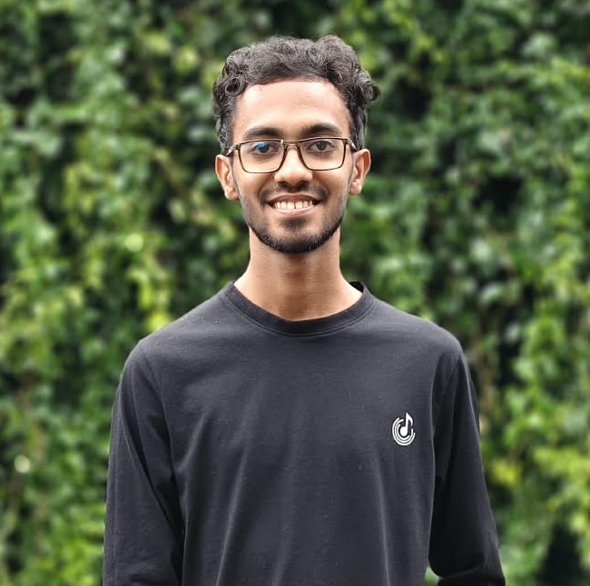

9.2 TG/2024/2096 - N.V.S. Himansana
Role: Lecturer Module Developer (Backend and GUI)
GitHub Branch: TG2096_Himansana
GitHub Total commits: 73 (22 authored + 1 merge)

Files Edited/Created:
- LecturerDashboardController and section controllers: LecturerCoursesController, LecturerMaterialsController, LecturerMarksController, LecturerEligibilityController, LecturerAttendanceController, LecturerMedicalController, LecturerNoticesController, LecturerTimetableController, LecturerProfileController, StudentDetailsController
- Services: LecturerCourseService, LecturerMaterialService, LecturerMarksService, LecturerEligibilityService, LecturerAttendanceService, LecturerMedicalService, LecturerNoticeService, LecturerTimetableService, LecturerProfileService, StudentDetailsService
- DAO interfaces and implementations for each service (LecturerMarksDAO, LecturerMaterialDAO, LecturerAttendanceDAO, ...)
- Models in model/lecture: MarkEntry, EligibilityRow, AttendanceSummaryRow, LecturerMaterial, MedicalEntry, LecturerNotice, StudentDetails, ...
- FXML screens in fxml/lecture/sections

Responsibilities and Contributions:
Himansana designed and implemented the complete Lecturer role, from the FXML screens to the database queries. Every service checks that the logged-in user is a Lecturer and that the selected course belongs to him or her before any data is read or changed.

Key Functionalities Developed:
- Marks management: Add, update and delete marks for any evaluation type with CA/FINAL category and 0–100 validation.
- Eligibility: Batch and individual eligibility using CA average ≥ 40% and attendance ≥ 80% (approved medicals counted).
- Attendance and medical views: Batch summary and individual view of attendance and medical records of the lecturer’s courses.
- Course materials: Upload, modify and remove materials for assigned courses.
- Profile, notices, timetable, student details: Profile update (except username and password), role-targeted notices, lecturer timetable and student detail screens.



TG/2024/2080 - I.A.S.S. Appuhami
Role: Undergraduate (Student) Module Developer
GitHub Branch: TG2080_Sudeshika
GitHub Total commits: 101 (38 authored + 1 merge)

Files Edited/Created:
- StudentDashboardController, HomePage (dashboard shell and home content)
- StudentCoursesController, StudentAttendanceController, StudentMedicalController, StudentGradesController, StudentTimetableController, StudentNoticesController, StudentProfileController
- StudentService (GPA and summaries), StudentDAO / StudentDAOImpl
- Undergraduate, StudentRecords models, StudentUi helper
- FXML screens (student_dashboard, HomeContent, sections/*.fxml) and student.css

Responsibilities and Contributions:
Sudeshika developed everything an undergraduate sees after login. The module reads the student’s own records only and lets the student change nothing except contact details and the profile picture.

Key Functionalities Developed:
- Dashboard and home page: Navigation shell with summary cards for attendance, GPA and notices.
- Courses, timetable, notices: Enrolled courses with materials, weekly timetable and role-targeted notices.
- Attendance and medicals: Theory, practical and combined attendance per course, and the approval status of submitted medicals.
- Grades and GPA: Grades, grade points, SGPA per semester and CGPA using StudentService.gpa().
- Profile: Update of contact details and profile picture only (FR-07).



TG/2024/2127 - D.S.R.N. Dahanayaka
Role: Technical Officer Module Developer, Attendance and Medical Specialist
GitHub Branch: TG2127_Sandaru
GitHub Total commits: 66 (54 authored + 2 merge/other)

Files Edited/Created:
- TechnicalOfficerDashboardController, ToUi, section controllers: ToAttendanceController, ToMedicalController, ToNoticesController, ToTimetableController, ToProfileController
- Services: AttendanceService, AttendanceCalculator, MedicalService, NoticeService, TimetableService, ProfileService, TODashboardService, ServiceSupport
- DAOs: AttendanceDAO, MedicalDAO, StudentQueryDAO, CourseQueryDAO, NoticeQueryDAO, TimetableQueryDAO, ProfileDAO (+ implementations)
- Models in model/to: Attendance, AttendanceSummary, AttendanceSheetRow, MedicalRecord, ApprovalStatus, AttendanceStatus, SessionType, Course, Notice, TimetableEntry
- Validator, FileStorageUtil, ServiceException, ValidationException; fxml/to and to.css

Responsibilities and Contributions:
Sandaru built the Technical Officer module, which records the attendance and medical data that the eligibility rules of the whole system depend on. He also wrote the shared attendance rules, input validator and exception classes.

Key Functionalities Developed:
- Attendance entry: 15-session sheets for theory and practical, 2 hours per session, with medical linking per absence.
- Attendance rules: AttendanceCalculator – percentage, 80% rule and the five scenarios (including medicals).
- Medical management: Submit/record medicals, upload documents, and approve or reject them with PENDING/APPROVED/REJECTED status.
- Validation and errors: Validator (e-mail, phone, NIC, required, length) and friendly ServiceException messages.
- Notices, timetable and profile: Read-only notices and department timetable, profile update except username and password.

10. GitHub Project Link
Repository URL: https://github.com/Hasaranga-kariyawasam/OOPP-2026-GP-05
Main branches: main (stable), dev (integration). Member branches: TG2095_Hasaranga, TG2096_Himansana, TG2127_Sandaru, TG2080_Sudeshika.
Repository Structure

OOPP-2026-GP-05/
├── pom.xml Maven build
├── README.md
├── db/
│ ├── schema.sql 16-table MySQL schema
│ ├── seed_data.sql demo data
│ ├── create_app_user.sql least-privilege DB user
│ └── db.properties connection settings
├── docs/ SRS, EER and class diagrams
├── uploads/ profile pictures, medicals
└── src/main/
├── java/com/faculty/
│ ├── MainApp.java
│ ├── config/ DBConnection
│ ├── model/ User, Staff, role packages
│ ├── dao/ DAO interfaces + JDBC impls
│ ├── service/ business rules
│ ├── controller/ admin, lecture, student, to
│ ├── exception/ custom exceptions
│ └── util/ PasswordUtil, Validator, ...
└── resources/
├── fxml/ screens of every role
├── css/ style sheets
└── img/

11. References
1. University of Ruhuna, Faculty of Technology – ICT2132 Object Oriented Programming Practicum, Mini Project specification (2026).
2. Group 05 – Software Requirements Specification (SRS) for the Faculty Management System, 13 September 2026.
3. University Grants Commission (Sri Lanka) – UGC Commission Circular No. 12-2024 (grading scheme referred to in the project brief).
4. OpenJFX Project – JavaFX documentation. https://openjfx.io
5. Oracle – The Java Tutorials: JDBC Database Access. https://docs.oracle.com/javase/tutorial/jdbc/
6. Oracle – MySQL 8.0 Reference Manual and MySQL Connector/J documentation. https://dev.mysql.com/doc/
7. Provos, N. and Mazières, D. – A Future-Adaptable Password Scheme (bcrypt); jBCrypt library. https://www.mindrot.org/projects/jBCrypt/
8. Apache Maven Project – Maven documentation. https://maven.apache.org
9. Bloch, J. – Effective Java, 3rd Edition, Addison-Wesley, 2018.

12. Appendices

12.1 Hardware Requirements
Minimum configuration
- Processor: Intel Core i3 or AMD equivalent
- RAM: 4 GB
- Storage: 500 MB free disk space (application, database and uploads)
- Display: 1366 x 768 resolution
- Input: standard keyboard and mouse
Recommended configuration
- Processor: Intel Core i5 or AMD equivalent
- RAM: 8 GB or more
- Storage: 2 GB free space (SSD preferred)
- Display: 1920 x 1080 resolution

12.2 Software Requirements
- Operating system: Windows 10/11 or a recent Linux distribution
- Java: JDK 17 or newer
- JavaFX: 21.0.2 (downloaded automatically by Maven)
- Database: MySQL Server 8.0.16 or newer (CHECK constraints are enforced from this version); local install, XAMPP or Docker
- Build tool: Apache Maven 3.8+
- IDE (optional): IntelliJ IDEA
- Libraries (Maven): javafx-controls, javafx-fxml, mysql-connector-j 8.4.0, jbcrypt 0.4

12.3 Setup and Run Instructions
# 1. Create the database and tables (as MySQL root)
mysql -u root -p < db/schema.sql

# 2. Load the demo data
mysql -u root -p < db/seed_data.sql

# 3. (Optional, recommended) create the least-privilege application user
# edit the password inside the script first
mysql -u root -p < db/create_app_user.sql

# 4. Put the connection details in db/db.properties
# db.url=jdbc:mysql://localhost:3306/faculty_db
# db.user=<mysql user> db.password=<password>

# 5. Build and start the application
mvn clean javafx:run

