A PARTNER-NEUTRAL COMMUNITY DEVELOPMENT INITIATIVE

NAMANJALALA
WATER INITIATIVE
Responsible water development on Joseph Wafula's land in Namanjalala, Trans Nzoia County, Kenya — and the foundation for a self-sustaining community development model.
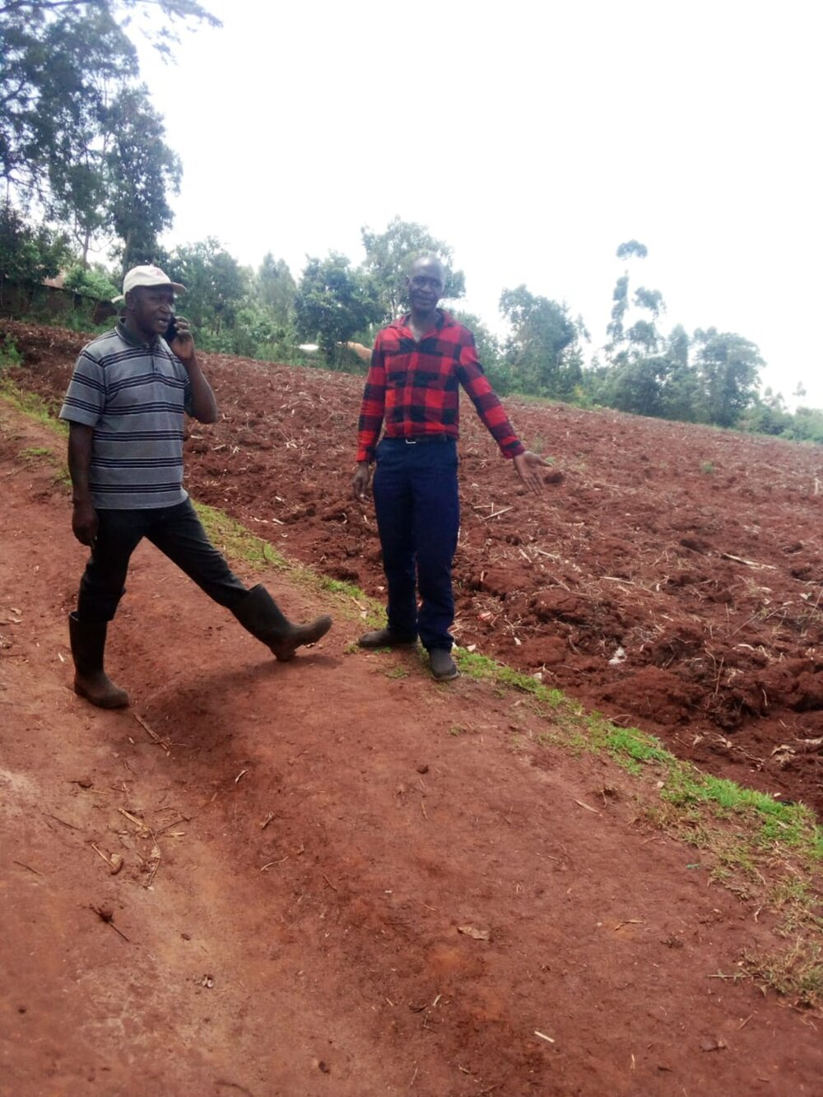
Water First. Then We Build What Water Makes Possible.

PHASE 1 PROJECT BOOK · PREPARED FOR PROSPECTIVE PARTNERS AND FUNDERS
September 2026

CONTENTS
Joseph Wafula: The Man Behind the Project
The Need
The Bigger Vision
What We're Building — Phase 1
This is a living project book. It will be updated as Phase 1 findings, partner conversations, and vendor quotations are finalized.

JOSEPH WAFULA: THE MAN BEHIND THE PROJECT
To understand this project, you first have to understand Joseph Wafula.
Not simply his résumé. Not simply the fact that he became a pharmacist, worked for respected institutions, raised children, or retired after a long career.
You have to understand the distance between where Joseph began and the man he became.
Because it is in that distance that the purpose of this project begins to make sense.
 | 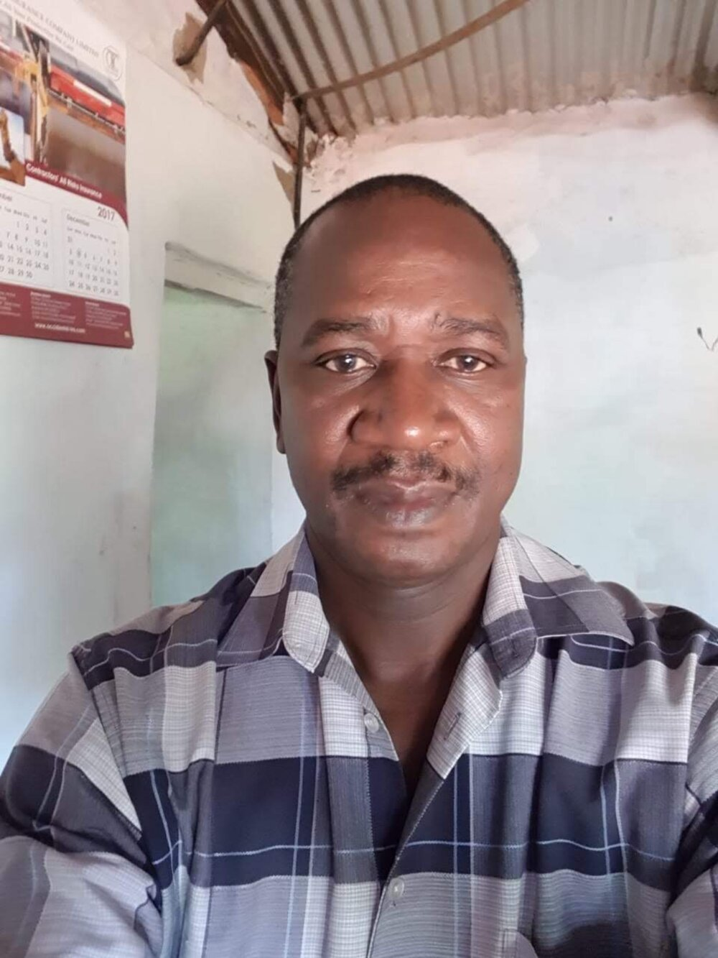
Joseph Wafula today — a life shaped by pharmacy, family, and a lifelong habit of carrying other people forward.

Before Everything Else, There Was Namanjalala
Joseph's story begins in Namanjalala, Western Kenya, in circumstances that offered a child very little certainty.
He was one of nineteen children.
There were many mouths to feed and very little to go around.
At an age when most children should have been protected from the worries of adults, Joseph already understood hunger. At around five years old, he was grazing cattle. He knew what it meant to live in a small hut and to look at food not as something guaranteed to appear at the next mealtime, but as something precious that might have to last.
There were times when Joseph would get hold of food and bury it in the ground to hide it for later.
A five-year-old child should not have to think that way.
But when you do not know what tomorrow will bring, even a little food becomes something worth protecting.
There were times when he ate snails simply to put something into his stomach.
These were not stories Joseph encountered later in life while working in healthcare or employee wellness. This was his childhood.
Before qualifications. Before scholarships. Before a career. Before children of his own.
There was a little boy in Namanjalala learning, far too early, how to survive.
And yet somehow, amid all of that, Joseph learned.
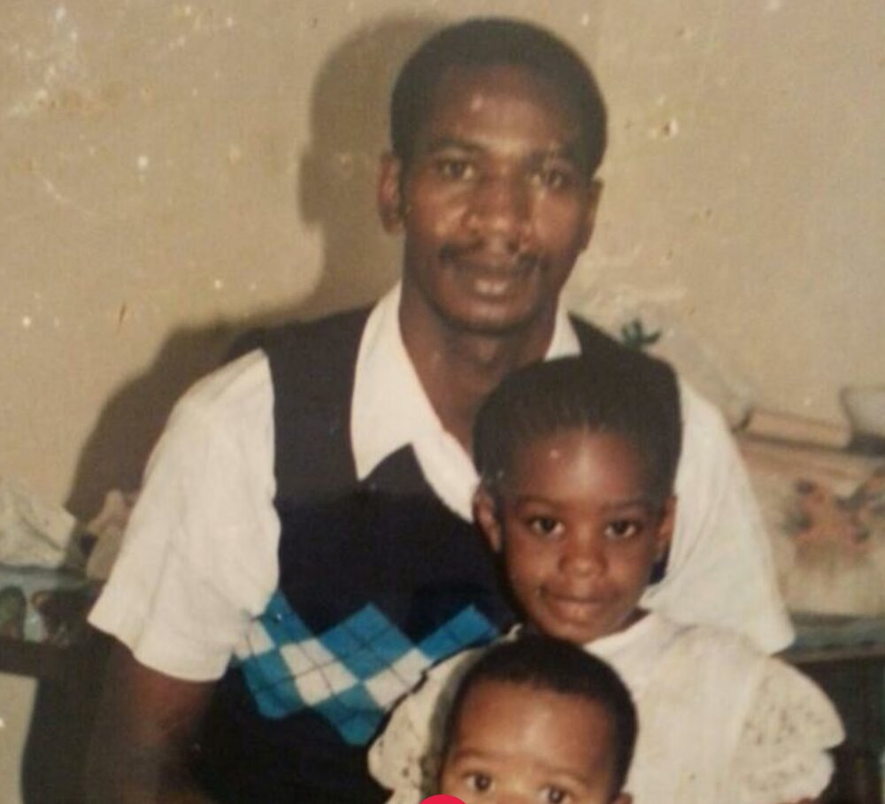
An old family photograph — the father who, before he died, entrusted Joseph with the responsibility of caring for the other children.

Education Became His Way Forward
Joseph showed academic ability. His path through school was not effortless or perfectly linear. At a critical stage in his education, when his performance would determine whether he could progress toward high school, the first result was not enough to take him where he needed to go.
Joseph repeated the class.
That detail says something important about him.
He could have accepted the first result as evidence that this was simply as far as a boy from his circumstances was going to go.
He didn't. He went back. He tried again.
And when Joseph sat for the qualification again, he did not merely scrape through. According to the family, he became one of the top qualifiers in his area.
Suddenly, doors began opening that poverty alone could never have opened.
Joseph earned scholarships. His education eventually took him to Mang'u, and later to Maseno for his A-level studies.
Think about the distance already traveled. The little boy grazing cattle in Namanjalala was now walking into educational institutions that could place an entirely different future within his reach.
And he kept going. Joseph eventually trained and qualified as a licensed pharmacist.
The child who once ate whatever he could find to quiet his hunger had entered healthcare.
But his education would eventually change more lives than his own.

His Success Came With Other People Attached to It
There is another part of Joseph's story that helps explain the man he became.
His father died. And before he died, he entrusted Joseph with an enormous responsibility: take care of the other children.
For Joseph, those words did not disappear when his father was buried. He carried them.
His education was therefore never simply a pathway toward personal success. As Joseph began progressing through life, there were people behind him whose futures mattered too.
His siblings needed opportunities. They needed education. They needed support. They had lost their father, but the responsibility their father had carried did not simply disappear. Some of it had been placed on Joseph.
And Joseph accepted it.
As his circumstances improved, he helped educate his siblings. He helped family members through school. Later, that generosity and responsibility extended into another generation — nephews and nieces were helped too.
Over time, Joseph became one of those people families quietly build themselves around — the person somebody calls when school fees are due, when a young person needs an opportunity, when something has gone wrong, or when someone simply needs help getting to the next stage of life.
The extraordinary part is that Joseph knew intimately what it felt like to need exactly that kind of person.
Perhaps that is one reason he became one.

The Pharmacist
Joseph's professional journey eventually took him into pharmacy. He worked as a pharmacist at Aga Khan. He later worked as a pharmacist at Barclays. Eventually, his work at Barclays evolved beyond dispensing medicine and into something broader: employee wellness.
This is an important distinction in Joseph's professional story. Healthcare was not simply his occupation. His career increasingly became concerned with people's lives beyond the immediate treatment of illness.
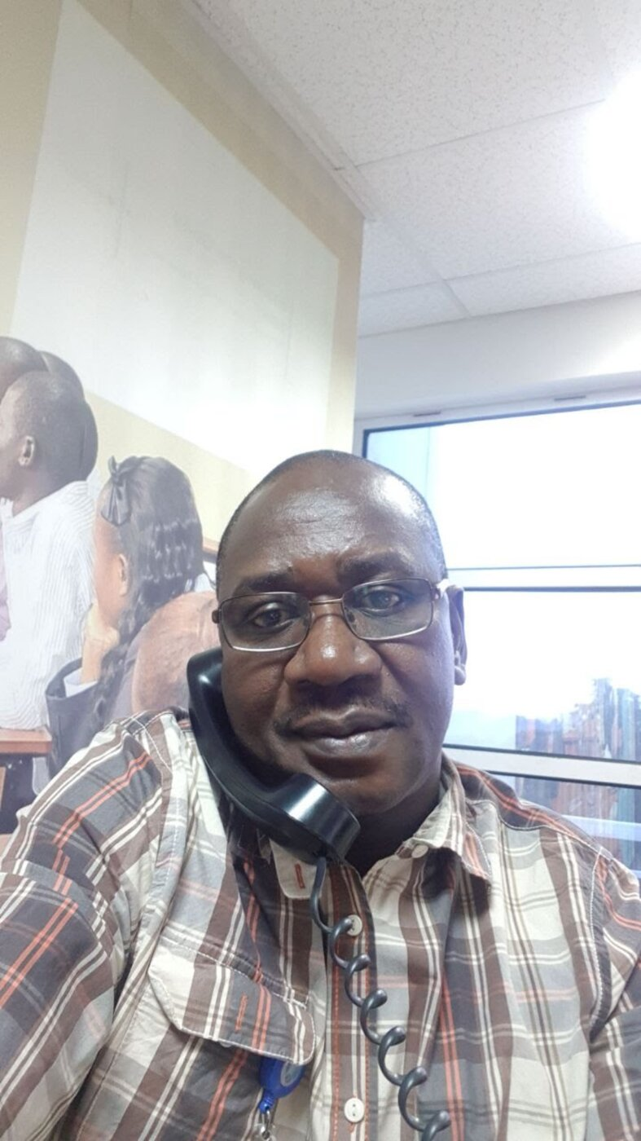 | 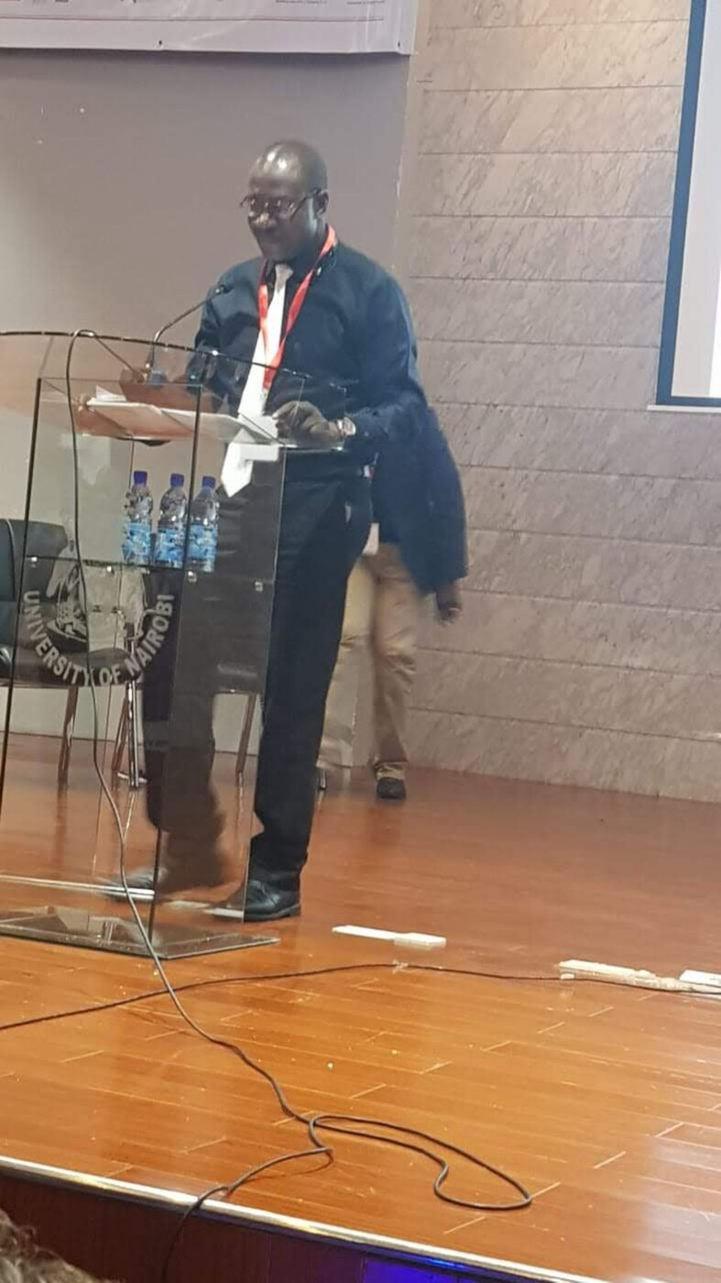
Left: Joseph at work in employee wellness. Right: presenting on HIV prevention and workplace health at the University of Nairobi.
One particularly important part of that work involved HIV prevention and employee health. Through education, awareness, and consistent outreach, Joseph helped contribute to a meaningful decline in HIV-related risk among the people he served. The family holds video documentation of Joseph's presentation on this work at a World AIDS Day event — a public record of a man who took healthcare beyond the pharmacy counter and into people's everyday lives.
Even before attaching a number to it, the larger pattern in Joseph's life is already visible.
He had gone from needing help to survive... to becoming educated... to entering healthcare... to taking responsibility for the wellbeing of other people.

Then He Became a Father
Joseph also built a family of his own.
He raised his children while carrying responsibilities that did not stop at the walls of his own home. He educated his children. He continued helping siblings. He helped nieces and nephews. He supported members of the extended family. And he did this while navigating his own complicated human life.
Joseph went through divorce. Later, after his older children were grown and established, he remarried. Today, Joseph has younger children as well.
He is not a man whose story has finished. He is a father in the middle of another chapter of his life.
There are children who still need him. There are surviving siblings who still look to him. There is still a household. There are still responsibilities. There are still dreams.
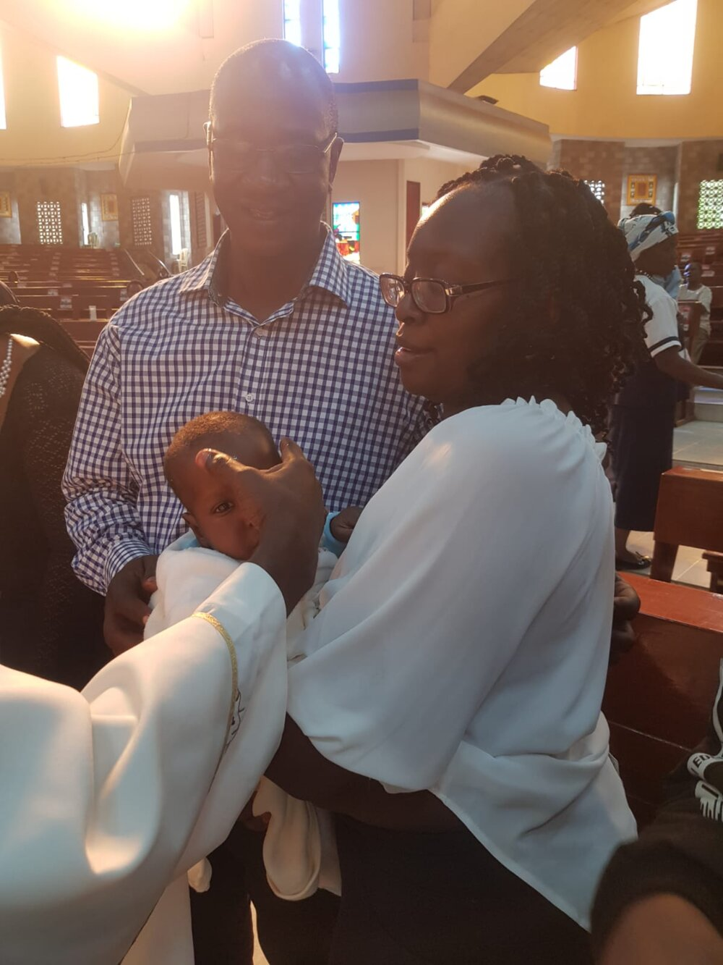 | 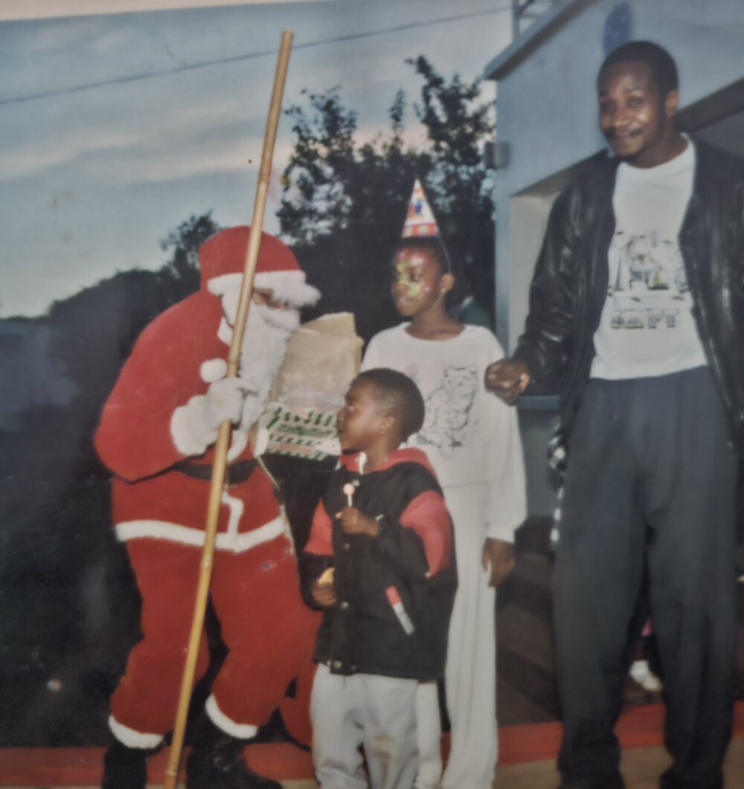
Family, across the years — a christening with his wife and young child, and an old photograph from an earlier Christmas with his older children.

Retirement Did Not End the Responsibility
Joseph retired in 2018 at the age of 60.
But retirement from employment is not necessarily retirement from being the person everyone depends upon.
The salary stopped. The responsibilities did not.
And eventually, the arithmetic of a lifetime of giving changes.
Joseph spent decades putting resources into people. Education. Children. Siblings. Nephews. Nieces. Family emergencies. The ordinary and extraordinary responsibilities that accumulate when everyone knows that, somehow, Joseph will try to help.
Today, he is a pensioner. And despite the professional career he built and the number of people he has helped move forward, his own home remains incomplete.
That image deserves to sit quietly for a moment.
Because it would be very easy to look at an unfinished house and see only an unfinished house.
But when you know Joseph's story, you see something else. You see a man who had finite resources and an enormous number of people to care about. You see the cost of repeatedly choosing to help.
And now there is a difficult reversal taking place.
Joseph needs us. The siblings he helped. The children he raised. The nephews and nieces he supported. The family whose burdens he carried.
The responsibility his father placed into his hands all those years ago has been honored again and again. Now the person who carried so many people needs other people to carry something with him.
Not because Joseph has stopped being capable. Not because his usefulness is behind him. And certainly not because this project is intended as some kind of memorial.
Quite the opposite.

Joseph Is Still Here
This distinction is essential.
Joseph Wafula is alive. He is still a father. He is still raising children. He is still connected to his siblings. He is still thinking about his community. He is still capable of helping. He is still building.
And this project is being developed precisely because there is more he wants to do.
We are not attempting to construct a monument to Joseph's past. We are trying to place resources into the hands of a man whose past has already shown us what he tends to do with resources: he uses them to help people.
That is an entirely different proposition.
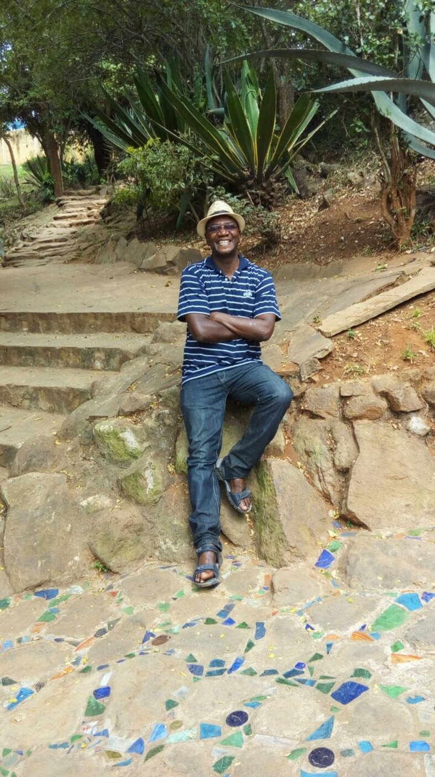
Joseph today — still building, still raising children, still connected to the community that shaped him.

And Now, We Return to Namanjalala
After everything — the hunger, cattle, school, scholarships, Mang'u, Maseno, pharmacy, Aga Khan, Barclays, employee wellness, marriage, children, siblings, nieces, nephews, retirement — the story circles back to the place where it began.
Namanjalala.
And this is where the borehole enters the story. Not as the story itself. As the beginning of the next chapter.
Joseph knows what scarcity feels like because he has lived it. He knows what education can accomplish because education altered the trajectory of his own life. He knows what access can do because scholarships placed opportunities in front of a child whose family circumstances could not have purchased them. And he knows what happens when the person who receives an opportunity decides not to keep its benefits entirely for himself.
That is the man behind this project.
And so the question before us is larger than whether we can raise enough money to drill a borehole.
The question is: What could Joseph do for Namanjalala if, this time, he had the resources behind him?

Water could support his family. But it could also support farming. Farming could produce food and potentially income. A central resource could grow around it. Children could come after school and receive something Joseph himself understands intimately: another layer of opportunity.
Not simply another classroom. A place where formal education could be supplemented with the things life often expects young people to somehow discover for themselves — financial literacy, entrepreneurship, technology, agriculture, communication, problem-solving, career understanding, leadership, and the practical knowledge required to become more self-reliant.
And somewhere among those children could be another little Joseph. A child whose present circumstances tell you almost nothing about what he or she could eventually become.
That is something Joseph would understand without anyone having to explain it to him.
Because once, he was that child.
There is an image from his childhood that we keep returning to. A little boy digging into the earth of Namanjalala and hiding food because he needed to know there might be something there when hunger returned.
We do not need to manufacture a metaphor around that. The truth is powerful enough.
More than six decades later, Joseph's family is preparing to dig into the earth of Namanjalala again. Only now, we are looking for water.
And if we can bring that water to the surface, the hope is not merely that it will serve Joseph.
The hope is that it gives Joseph something he has spent much of his life trying to give other people: a way forward.
This time, however, he should not have to do it alone.

THE NEED
Water First. Then We Build What Water Makes Possible.

Before We Can Build Anything, We Need Water
There are many things Joseph still wants to build.
He wants to finish his home. He wants to grow food from the land around him. He wants to create something productive enough to support his younger family as he grows older. And increasingly, he wants the land that sustains his family to become useful to people beyond his family — to children, to neighbors, and to the community that shaped the person he became.
But almost every one of those dreams eventually arrives at the same question: Where will the water come from?
That question sounds simple until you understand what water means when you are trying to build a life from land.
Water is what turns soil into food. It is what allows a family to plant without placing everything at the mercy of the next rainfall. It is what allows animals to be cared for. It is what makes sanitation possible. It is what allows a household to function with dignity.
And if this project grows into what we believe it can become, water is what will make almost everything else possible — the farming, the food, the children, the after-school program, the community resource, and the possibility of creating income from the land instead of continually depending on someone else for help.
Before any of those things can grow, there has to be water.
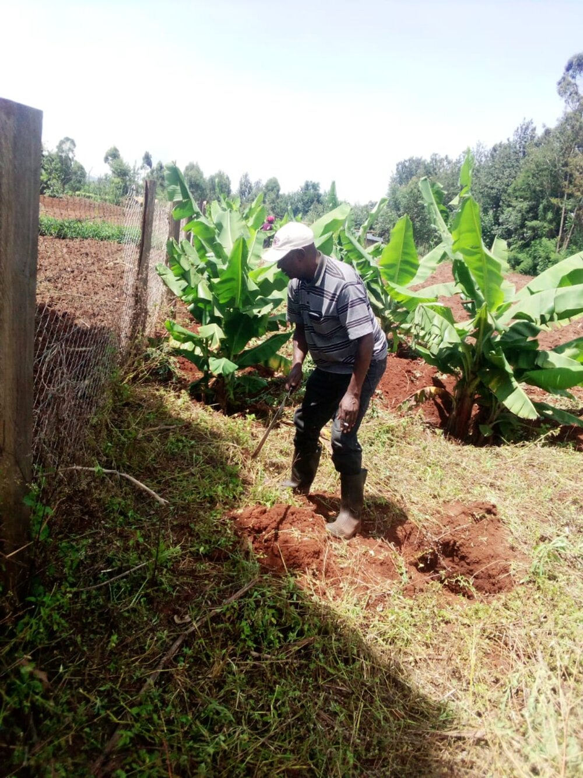 | 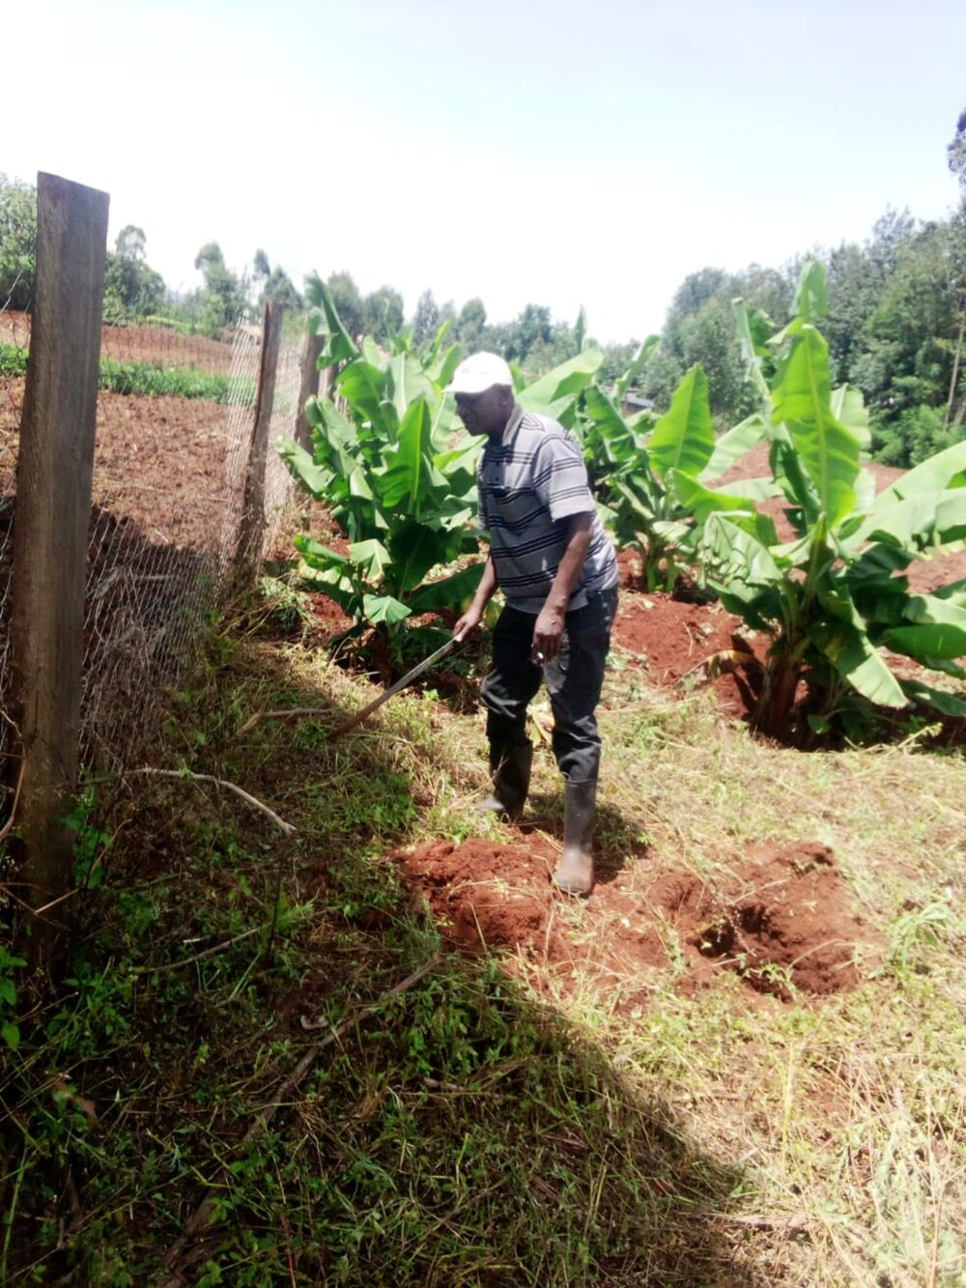
Joseph on his land in Namanjalala, among the banana plants, marking the ground before drilling can begin.

This Is Not a Problem We Are Inventing
We have to be careful with Joseph's story.
We do not want to take the needs of one family and suggest that every person in Trans Nzoia lacks access to water. That would not be true.
But neither would it be true to suggest that reliable, safe water access has been solved.
As recently as February 2025, the Trans Nzoia County Government commissioned a KES 3.7 million solar-powered water project in Tima, Kaplamai Ward, specifically to address what county officials described as persistent water shortages. The project was designed to provide a steady supply of water to hundreds of households, as well as schools, businesses and other community institutions.
In March 2025, another KES 8 million water project was launched to serve communities in Machewa and Sikhendu wards. Supported through government and climate-resilience funding, it was designed to bring clean water to more than 3,000 residents, including schools, dispensaries and markets.
These are not stories from another country or another part of Kenya. They are happening in Trans Nzoia County. And they tell us something important: water infrastructure is still being built because communities still need it.
But then we come closer to home. To Namanjalala itself.

In Namanjalala, Water Can Become a Question of Safety
In March 2026, residents of the Namanjalala area of Kwanza Constituency faced another side of water insecurity.
Flooding displaced families and disrupted schooling for more than 100 students.
As floodwaters overwhelmed the area, pit latrines reportedly collapsed and contaminated local wells. Residents were left confronting the frightening possibility that water available around them was no longer water they could safely drink. Residents raised concerns about sewage entering wells. Community health workers warned about the danger of waterborne disease. Families were displaced. Children missed school. And fears of a cholera outbreak followed.
This does not prove that every household in Namanjalala experiences chronic water scarcity, and we will not use it to make that claim.
What it does establish is something equally important: water security is not only about whether water exists. It is about whether the water people can reach is safe, reliable and resilient when conditions change.

A well that becomes contaminated during flooding is not secure water. A water source that cannot be relied upon throughout changing conditions is not complete infrastructure. And a community should not have to wait for illness to discover that the water available to it is unsafe.
Elsewhere in Trans Nzoia, county officials have also identified unsafe drinking water as a contributor to illness and absenteeism among young learners, particularly at the early-childhood level — another reminder that the consequences of water insecurity do not end at the water source. They follow children into classrooms. They follow families into their homes. They affect health, productivity and opportunity.
That makes the question before us larger than simply: Can we find water?
The real question is: Can we develop a safe, sustainable source of water that people can depend upon?

And There Is Something Else We Must Be Honest About
We do not yet know exactly what lies beneath Joseph's land. And we are not going to pretend that we do.
Preliminary information suggests that successful boreholes in the wider Kitale area may encounter groundwater at approximately 80 to 150 metres, although drilling to greater depths has occasionally been required depending on local conditions.
But preliminary information is not enough to build a responsible water project.
We do not yet know the precise depth of a viable aquifer beneath Joseph's property. We do not know its sustainable yield. We do not know the exact quality of that groundwater. We do not know what treatment may be required. And until those questions are answered, we cannot responsibly promise how many households, acres of farmland, children or community activities one borehole could ultimately support.
That honesty is part of this project.
Before a drilling rig arrives, the land needs to be professionally studied. Before we promise water to a community, we need to know how much water the ground can sustainably provide. Before we call that water safe, it needs to be tested. Before we build agriculture, children's programming or community infrastructure around it, we need to understand exactly what the resource can support.
We would rather begin with unanswered questions than raise money on promises we cannot prove.
The first responsibility of this project is therefore not drilling. It is knowing.

A professional hydrogeological survey. Proper siting. Responsible drilling. Water-quality testing. Yield testing. Treatment where necessary. And only then, decisions about how far that water can responsibly reach.

For Joseph, Water Means Independence
For Joseph, however, the need is also intensely personal.
He has spent much of his life solving problems for other people. His siblings needed education. His children needed raising. Nephews and nieces needed opportunities. Family members needed help. And when his father died after placing the responsibility of the younger children into Joseph's hands, Joseph carried that responsibility forward for decades.
Now, at 68, the arithmetic of his life has changed.
He is retired. The salary stopped. The responsibilities did not.
Joseph is still raising younger children. His own home remains unfinished. There is land with potential around him, but potential alone cannot feed a family, irrigate a crop, or create income.
And after a lifetime of helping other people move forward, we do not want Joseph's next chapter to become another cycle of dependency.
That is what makes the borehole different. We are not simply trying to give Joseph water. We are trying to give him infrastructure. Something permanent. Something productive. Something that can continue working long after a donation has been spent. Something that can help his family grow food. Something that can make more productive farming possible. Something that may eventually generate income. Something that gives a father still raising children greater security about what will remain for them as he grows older. And, if the water supply proves capable of supporting it, something that can extend beyond his household and serve others around him.
That is a very different kind of help.
Because when we look back at Joseph's life, the things that changed its direction were rarely temporary gestures. They were tools.
A scholarship was a tool. Education was a tool. A profession was a tool. Each gave Joseph the ability to do something for himself that he could not have done otherwise.
And then Joseph did something important with those opportunities: he shared what they made possible. He educated other people. He supported other people. He raised other people. He helped other people move forward.
Now, water can become another tool.

We Are Not Drilling a Hole. We Are Unlocking the Land.
There is already land. There is already a family willing to work. There are already ideas for farming. There is already a vision for children. There is already a man whose life has demonstrated what can happen when an opportunity reaches his hands.
What is missing is one of the most fundamental resources required to connect those pieces: Water.
And perhaps that is why the first physical stage of this project sounds so simple.
Study the land. Find the water. Drill responsibly. Test it. Treat it if necessary. Bring it to the surface.
But then the real work begins.
Because this project is not ultimately about what comes out of a borehole. It is about what can grow because the borehole exists.
Food. Income. Security. A productive piece of land. A father who can continue providing. A family that can begin building something sustainable. Children who can eventually have somewhere to go after school. A place where those children can learn not only what is required to pass an examination, but some of the things Joseph had to spend a lifetime learning for himself — how to understand money, create opportunity, use technology, solve problems, grow something, build something, and become more capable of standing on their own.
And, if the water beneath this land proves capable of supporting it, a resource whose usefulness can reach beyond the boundaries of Joseph's home.
We do not know yet exactly how large that impact can become. We intend to find out before we promise it.
There is something difficult to ignore about beginning this particular project by returning to the earth. As a little boy in Namanjalala, Joseph once dug into the ground to hide food because he did not know whether there would be enough tomorrow. More than six decades later, his family is preparing to look beneath the ground again.
This time, we are searching for something that does not have to be hidden. Something that can be brought to the surface. Something that can grow food instead of being buried beside it. Something that can give an aging father greater security. Something that can help children who are only beginning their own stories. Something that, if we build this carefully and responsibly, can keep giving long after the people who funded it have gone home.
Water is not the whole dream. Water is what gives the dream somewhere to begin.

THE BIGGER VISION

From Water to a Living Community
The borehole is where this project begins. It is not where we intend for it to end.
Everything below this point is exactly that — a vision. It depends entirely on what the feasibility work confirms, what partners we're able to bring in, and what actually proves viable once we test it against real conditions on Joseph's land. None of it is a promise. All of it is a direction.
If the hydrogeological work confirms that Joseph's land can support a reliable and sustainable water source, our ambition is to build outward from that, carefully, one proven layer at a time.
We see the possibility of a place where water supports land, land produces food, food creates enterprise, enterprise creates work, and the entire environment becomes a place where children and families can learn how to build something of their own.
Not a collection of unrelated charity programs. A living system.
We are looking for partners who can teach us, challenge us, introduce proven approaches, bring technical knowledge, and help us grow something meaningful with the community of Namanjalala.

Water Becomes the Foundation
If viable groundwater is confirmed, the first objective is straightforward: develop a safe, reliable water system for Joseph's household and productive use of the land.
Over time — and only if the numbers support it — we envision the water infrastructure becoming more than a private household resource. Depending on verified borehole yield, treatment requirements, regulation and community need, we want to investigate a separate community water point, designed so neighbors do not have to come to Joseph personally and ask for water. It should be infrastructure, not a favor.
That could eventually mean a dedicated public access point with transparent rules for use. We are interested in exploring metering and models used successfully by other water-access programs where appropriate, including whether modest usage fees beyond a basic allocation could contribute toward maintenance.
The principle is important: if we build water infrastructure, we also need to build a way to keep it working.
Solar power could become part of that system — initially supporting the borehole pump, and potentially expanding over time to provide lighting for evening activities, agricultural operations, and basic technology.

From Water to Food
Once water is established, we want to learn what the land can actually do.
The first responsibility is Joseph's household. Reliable food production could give his younger family greater security and reduce dependence on purchased food and external assistance.
From there, we want to experiment — not by telling neighboring farmers what they should grow, but by testing ideas on the project land first.
Demonstration plots could allow us to learn which crops perform well, how much water they require, what methods are economically realistic, and which ideas simply do not work. That distinction matters. A family with limited resources should not have to gamble scarce money on an agricultural idea because somebody told them it sounded promising.
We can test. We can fail. We can measure. We can improve. And when something genuinely works, we can share what we learned.
Over time, the land could include irrigated crops, greenhouse or shade-net cultivation, vegetables, higher-value crops, a tree nursery, and carefully selected livestock. Eventually, surplus production could become income.
Water begins producing food. Food begins producing economic opportunity. These are still if-clauses, not commitments — but they are the shape of what we're aiming to test.
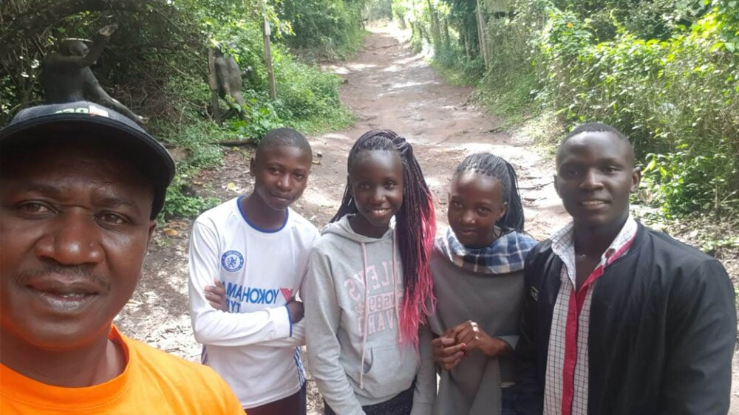
Left: surveying newly-turned farmland on Joseph's property. Right: Joseph with young people from the community — the future participants this project is built for.

Aquaculture: Producing Fish Locally
One idea we particularly want to investigate is aquaculture and local tilapia production.
Fish is deeply embedded in Kenyan food culture, but much of the country's best-known tilapia production is associated with Lake Victoria and Nyanza. Namanjalala is not Nyanza.
Rather than simply accepting distance as part of the supply chain, we want to investigate a straightforward question: could quality tilapia be produced locally?
If the answer is yes — technically, environmentally and economically — fish farming could become another productive layer of the project: protein for families, a product for local sale, and another real enterprise through which young people can learn.
But we will not build fish ponds because aquaculture sounds exciting. We need partners who already know how to do this — aquaculture specialists, farmers, universities, agricultural organizations, Kenyan fish producers, technical programs, researchers — people who understand fingerlings, feed, water quality, stocking density, fish health, harvesting, markets, and the real costs that separate a working operation from an expensive experiment.
We want to learn first. Then build.

Hydroponics: Growing More With Less Land and Less Water
Alongside traditional and irrigated farming, we also want to investigate hydroponics — growing crops without soil, with nutrient-rich water delivered directly to plant roots.
For a family working a modest plot of land, hydroponics could offer a way to produce more food, more consistently, using less land and, in many systems, significantly less water than conventional farming. It is also less dependent on existing soil quality, which matters on land that has been farmed for generations.
We do not yet know whether hydroponics is appropriate for this specific site, climate, and water supply. That is precisely why it belongs in the same category as aquaculture and aquaponics: something to test in a small demonstration setup before committing significant resources, guided by partners who already understand the systems, the crops that perform well in them, and the real costs of running one.
If it proves viable, hydroponics could also become one more system children in the after-school program learn to build, monitor, and manage — another practical, measurable process they can follow from seed to harvest.

Aquaponics: Where Water, Fish and Crops Meet
Aquaponics could take that idea further — a system where fish, water, and plants work together, and a young person can stand in one place and watch an entire food system function: nutrients moving, water being reused, food being harvested, records being kept, costs being calculated, products being sold.
That is no longer simply agriculture. That is a classroom without four walls — if it proves feasible.
We want to investigate whether aquaponics is appropriate for the site, and whether partnerships can help us establish small demonstration systems before attempting anything larger. Biology and water management alongside bookkeeping. Agriculture alongside entrepreneurship. Food production alongside technology. Environmental stewardship alongside business.
The lesson we want to teach is simple: this is how a system works — now, how would you build one?

Looking Forward Without Forgetting the Land Behind Us
There is another educational opportunity here that matters to us. We want young people to learn about historic and traditional relationships with land and food production in this region.
How did earlier generations cultivate this land? How did they read rainfall and seasons? Which crops were indigenous or historically important? How were soils maintained, seeds preserved, animals integrated into food systems? What knowledge worked, what declined, and what can modern agricultural science add to it now?
We do not want to romanticize the past, and we don't want to teach children that everything old was backward and everything new is automatically better. We want them to investigate both — traditional knowledge, modern science, appropriate technology — and understand the land beneath their own feet.
There is something meaningful about doing that on Joseph's land specifically. The little boy who once grazed cattle out of necessity could someday watch children learn agriculture there not because circumstance forces it on them, but because they understand land itself can be knowledge, food, enterprise and independence.

The After-School Project
This is one of the most important parts of the larger vision — and the one closest to something we intend to actually build, not merely test.
We do not want to create another conventional school. Children already have classrooms. We want a place that complements their education with things life will eventually expect them to know, but that formal schooling doesn't always have room to teach deeply.
The program can start remarkably small: a room, a covered outdoor area, benches beneath a tree, a few books, a few children. It does not need an impressive building to become useful.
Over time, the curriculum could grow alongside the project — financial literacy, confidence, communication, basic bookkeeping, banking, budgeting, entrepreneurship, agriculture, technology, digital literacy, career awareness, leadership, and practical problem-solving.
We don't want those lessons to stay theoretical. If children learn budgeting, eventually give them a small real budget to manage. If they learn bookkeeping, let them see the farm's records. If they learn agriculture, let them grow something. If they learn entrepreneurship, let them help turn something produced on the site into a tiny enterprise. If they learn aquaculture — should it exist by then — let them understand what it costs to raise a fish before deciding what it should sell for.
Learn it. Practice it. Build something with it. Eventually, teach it.

Our long-term hope is that some children who enter the program eventually become its young mentors. The student becomes the teacher. Knowledge stays within the community. Leadership begins reproducing itself — which is how a program becomes more durable than the people who first built it.

A Place of Ideas
There should also be books. A small library does not sound revolutionary, but a shelf of books in the right place can change what a child believes exists beyond what they already know.
Eventually, basic connectivity, computers, or tablets could introduce children to digital literacy — not as a prop for a donor photograph, but as something they can actually use: researching something, building a spreadsheet, learning basic coding, discovering a profession they'd never encountered, communicating with someone beyond their community.
The world becomes larger when you can see more of it.

From Beneficiaries to Participants
There is a principle underneath all of this: we do not want to build a project where Joseph gives and everyone else receives. Joseph has already spent enough of his life carrying things alone. We don't want international donors stepping into that role either.
The long-term objective is participation. Neighbors becoming farmers. Young people becoming mentors. Community members becoming employees. Someone managing the water point. Someone keeping the books. Someone maintaining agricultural systems. Someone overseeing crops.
As production grows, seasonal agricultural work could create wages. As children's programming grows, local young adults could move from volunteers into paid roles. If a cooperative model eventually makes sense, neighboring farmers could participate economically and contribute toward shared infrastructure rather than only receiving its benefits.
The community should not merely surround the project. It should increasingly become part of running it.

Building Small Enterprises Into the System — If They Earn Their Place
We want to explore modest revenue streams wherever they make practical sense: farm produce, seedlings from a nursery, tilapia, possibly value-added agricultural products, possibly metered water access, possibly basic processing or packaging.
Not every idea will survive feasibility testing. That's fine. We don't need twenty businesses. We need a few things that actually work.
The objective isn't profit for its own sake. It's resilience. A pump will eventually need maintenance. Equipment will eventually break. Seeds have to be purchased. Fish require feed. Programs require materials. Employees deserve wages. Infrastructure deteriorates. A project that can gradually pay for some of that itself becomes stronger every year.
So every enterprise idea has to answer the same question:
Does this help the project carry more of its own weight over time?

If it doesn't, we should be willing to reconsider it — even if it sounded good on paper.

A Future Bottled-Water Enterprise — If the Water Supports It
One of the most significant potential pieces of the self-sustaining model is a future, regulated bottled-water enterprise — but only if the water quality, sustainable yield, licensing requirements, and commercial feasibility genuinely support it.
This is not a founding assumption of the project. It is a possibility we want to keep open and evaluate honestly once real data exists. What does water-quality testing actually show? Is the sustainable yield large enough to support bottling in addition to household, agricultural, and community use? What does Kenyan regulation require of a water-bottling operation, and what would compliance actually cost? Does the economics of small-scale bottling make sense in this market, at this location, against established competitors?
If the answers line up, a licensed bottled-water business could become one of the strongest tools this project has for paying its own way — generating income that helps sustain the borehole, the farming, the after-school program, and local employment, long after any initial donation has been spent.
If the answers do not line up, we will say so plainly, and the project will not chase it. Like every enterprise idea here, it has to earn its place by strengthening the system rather than complicating it.

Health Can Return to Joseph's Story Too
Joseph spent his professional life in healthcare — first as a pharmacist, later in employee wellness and HIV education and prevention. That knowledge doesn't have to disappear because he retired.
If the site eventually becomes a genuine gathering place, it could periodically host appropriate community health education and outreach, delivered with qualified partners. Not a program we promise on day one — an opportunity, if and when the site can support it, for Joseph's professional knowledge to become part of what he passes forward too.

And Joseph Gets to Be There
Perhaps the most important thing about this vision is also the simplest: Joseph is here to see it.
He can walk the land. He can watch the first water come out of the ground. He can see the first crop. He can talk to the children. He can tell them himself what Namanjalala looked like when he was five — what hunger felt like, what it meant to repeat a school year, what scholarships and Mang'u and Maseno gave him, what it meant to become a pharmacist, to carry his father's final responsibility, to help siblings, raise children, work, make mistakes, and start again.
And then those children can look around them — at water, at crops, at whatever this becomes — at something growing on the same land where Joseph once struggled simply to have enough.
That is not a memorial. That is transmission. One generation standing in front of another and saying: here is what life taught me — take it further.

We Are Looking for Partners, Not Just Donors
That is why this vision requires more than money. We are looking for people and organizations willing to introduce us to what we do not yet know: aquaculture partners, aquaponics experts, agricultural institutions, farmers, universities and researchers, youth-development organizations, technology partners, curriculum specialists, water engineers, solar specialists, local leaders, and people who understand both traditional and modern agriculture.
Some partners may contribute funding. Others may contribute equipment, knowledge, introductions, training, markets — or simply years of experience that prevent us from making an expensive mistake.
We do not need to know everything ourselves to build something meaningful. We need to know when to invite the right people to the table.

From One Site to a Model
If this works, we should document it honestly — including the failures.
How much water did the borehole actually produce? What did it cost to operate? What crops worked, and what didn't? Did aquaculture make economic sense? How much food, income, and employment did it actually generate? How many children participated, what did they actually learn, and how many eventually became mentors? How much of the project's operating cost was eventually covered by its own productive activity?
If this eventually becomes something a future partner wants to reproduce elsewhere, Namanjalala should offer more than a compelling story. It should offer evidence.
We build one site carefully. We learn. We correct. We prove what actually works. Only then do we ask whether this model deserves to travel somewhere else.
Namanjalala doesn't need to become the place where we claim to have solved everything. It can become something more useful: the place where we learned how to build it properly.
Build it. Document it. Prove it.

The Bigger Vision, In One Line
The dream is not a borehole surrounded by projects. It is an ecosystem in which each piece strengthens another.
Water makes food possible. Food can create income. Income can create jobs. The farm becomes a classroom. The classroom develops capability. Capability creates enterprise. Enterprise helps maintain the infrastructure that made it possible.
Gradually, something that began because Joseph needed help becomes something capable of helping alongside Joseph.
For decades, Joseph himself was the system. When someone needed education, Joseph helped. When family needed support, Joseph helped. When his father placed responsibility into his hands, Joseph carried it.
But one person can only carry so much.
Perhaps the greatest thing we can build for Joseph now is not something that asks him to keep carrying everyone. Perhaps it's something that carries with him — a borehole that keeps producing water, land that keeps producing food, enterprises that generate income, young people who become employees, students who become mentors, knowledge that stays after the person who taught it has gone home, and a community that increasingly participates in what it uses.
Joseph spent his life helping people one person at a time. Now we have an opportunity to build something that can help alongside him.

Every element above depends on what Phase 1 confirms and which partners we're able to bring in. This is the direction we're building toward — not a list of commitments already made.

WHAT WE'RE BUILDING

Phase 1: Know Before We Drill
The first phase of this project is deliberately simple.
Before we build anything, we need to understand the water beneath Joseph's land.
We are not beginning with promises about how many families one borehole will serve, how much food it will produce, or how large the project can become.
Know first. Build second.

The first step is a professional hydrogeological survey and borehole siting assessment. Preliminary regional information suggests that successful boreholes in the wider Kitale area may reach groundwater somewhere around 80–150 metres, with drilling occasionally required to greater depths depending on local conditions.
Those figures are not yet facts about Joseph's property. Phase 1 exists to establish what is actually there. The work will determine the most appropriate drilling location, expected depth, geological conditions, and the technical information a contractor needs before drilling can responsibly begin.
Phase 1 is built around a defined sequence of work:
— A professional hydrogeological survey and site assessment, to identify the most viable drilling location on Joseph's land
— Test drilling and depth confirmation, to determine how far down water can actually be reached
— 24-hour test pumping and water-quality analysis, to establish sustainable yield and whether treatment is required
— A pump and control system appropriately specified for the confirmed depth and yield
— A full, itemized construction budget, based on verified site conditions rather than regional estimates
We are no longer working from a single unverified estimate. We are actively collecting multiple competitive quotations from qualified borehole contractors, and requiring proof of completed projects — completion records, water-testing reports, test-pumping records, project photographs, and references — before any quotation is treated as reliable. That process, not a single number, is what will produce the itemized, contractor-backed budget this project stands behind.
We would rather tell donors and partners exactly what we know and don't know than present a number we can't defend.

What Phase 1 Gives Us
Phase 1 gives the project something more valuable than speculation: a real plan.
We will know where to drill. We will know how deep. We will have a verified, contractor-backed cost estimate instead of a regional approximation. Once water is reached, test pumping will tell us how much the borehole can sustainably produce, and water-quality testing will tell us whether — and how much — treatment is required.
Only then can we responsibly decide how the water should be used: first for Joseph's household and land, and eventually, if capacity allows, for farming, community access, and the larger vision we've described.
The first investment is not simply in drilling. It is in making sure that everything we build afterward stands on something real.

Partnering With Us
This project is being developed independently, while we actively build relationships with the nonprofit, technical, implementation, and funding organizations best positioned to help it succeed.
We are open to conversations with:
— Strategic Partners — organizations that can help shape the direction and long-term structure of the project
— Implementation Partners — organizations with on-the-ground experience delivering water, agriculture, or youth-development programs
— Technical Partners — hydrogeologists, drilling contractors, solar engineers, aquaculture and aquaponics specialists, agronomists
— Funding Partners — foundations, corporate sponsors, and individual donors who share this approach to building infrastructure that helps sustain itself
We are also actively requesting quotations from multiple borehole companies, and asking them to provide proof of completed projects — completion records, water-testing reports, test-pumping records, project photographs, and references — so that any final selection is grounded in verified performance rather than the lowest bid alone.
This document is a living record. Phase 1 will determine the facts on which every later phase depends. Nothing beyond Phase 1 is a commitment — it is the direction Joseph and his family are building toward, together with the partners who join them.

