

Bahria University, Islamabad

Department of Software Engineering

Computer Communication & Networking Lab (Fall-2025)
Instructor: Engr. Muhammad Faisal Zia

Student:
Enrollment:

Lab Journal: 12
Date:

Task No: | Task Wise Marks |  | Documentation Marks |  |  | Total Marks  (20)
Task No: | Assigned | Obtained | Assigned | Obtained |  | Total Marks  (20)
1
2
3
4
5
Comments:

Signature

LAB # 12

Configuring OSPF routing protocol between two routers

Objective
To enable communication between two hosts that are connected not to a single router but with the different routers in such a way that the reflection of the network change is sudden and not instantaneous.
Introduction
Open Shortest Path First (OSPF) is a routing protocol developed for Internet Protocol (IP) networks by the Interior Gateway Protocol (IGP) working group of the Internet Engineering Task Force (IETF). The working group was formed in 1988 to design an IGP based on the Shortest Path First (SPF) algorithm for use on the Internet. Similar to the Interior Gateway Routing Protocol (IGRP), OSPF was created because in the mid-1980s, the Routing Information Protocol (RIP) was increasingly incapable of serving large, heterogeneous internetworks.
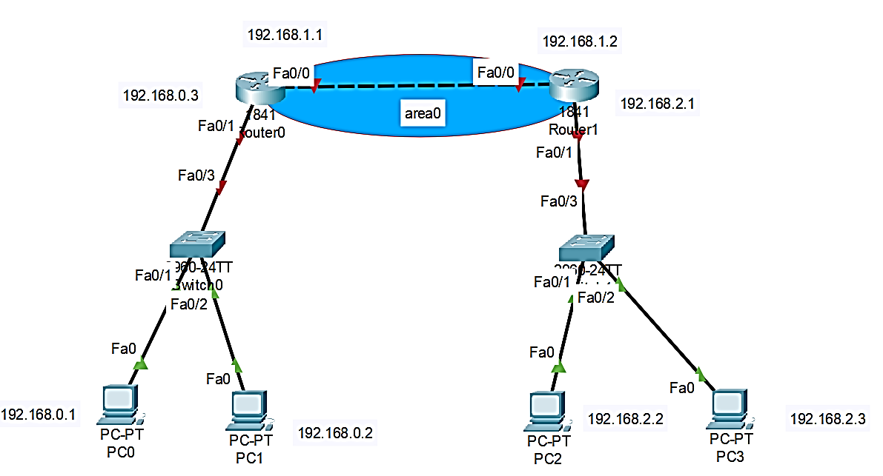

OSPF has two primary characteristics.
- The first is that the protocol is open, which means that its specification is in the public domain. The OSPF specification is published as Request for Comments (RFC) 1247.
- The second principal characteristic is that OSPF is based on the SPF algorithm, which sometimes is referred to as the Dijkstra algorithm, named for the person credited with its creation.
OSPF is a link-state routing protocol. Link-state routing is designed to overcome the drawbacks of distance-vector routing. When a router is initialized, it determines the link cost on each of its network interfaces. The router then advertises this set of link costs to all other routers in the internet topology, not just neighboring routers. From then on, the router monitors its link costs. Whenever there is a significant change router again advertises its set of link costs to all other routers in the configuration. Information on attached interfaces, metrics used, and other variables is included in OSPF LSAs. As OSPF routers accumulate link-state information, they use the SPF algorithm to calculate the shortest path to each node.

As a link-state routing protocol, OSPF contrasts with RIP and IGRP, which are distance- vector routing protocols. Routers running the distance-vector algorithm send all or a portion of their routing tables in routing-update messages to their neighbors.

Areas in OSPF (Open Shortest Path First) provide numerous advantages, primarily centered on improving scalability, stability, and efficiency in large and complex networks. Smaller Link-State Databases (LSDBs): Each router within an area only needs to maintain a detailed topological map (LSDB) of its own area. When a change in the network topology occurs (e.g., a link failure), the Shortest Path First (SPF) algorithm needs to run only on the routers within the affected area.

Procedure:
Step1: Assign IP address on all ports of R0 andR1
Assign IP addresses to all ports of Router shown in figure above.
Step2: Configure OSPF protocol on all routers
Configure OSPF protocol (Router-0)
Router0#configure terminal
Router0(config)#router ospf 1
!(WAN network ip)
Router0(config-router)#network 192.168.1.0 0.0.0.255 area 0
!(LAN network ip)
Router0(config-router)#network 192.168.0.0 0.0.0.255 area 0
Router0(config-router)#end

Configure OSPF protocol (Router-1)
Router1# configure terminal
Router1(config)#router ospf 1
!(WAN network ip)
Router1(config-router)#network 192.168.1.0 0.0.0.255 area 0
!(LAN network ip)
Router1(config-router)#network 192.168.2.0 0.0.0.255 area 0
Router1(config-router)#end
Step3: Assign IP address to all computers
Assign IP address to computers with same network that they assign to their respective port
Step4: confirm connection
Use ping command to confirm connection of each PC.
Step5: check routing protocol
ExampleName(config)# show ip route
Tasks:
- Draw the following network diagram
Configure the routers as explained above and verify the connection using ping command and perform the configurations on packet tracer as well.
- Perform all the steps on the network diagram below as indicated in Task 1

Task 1

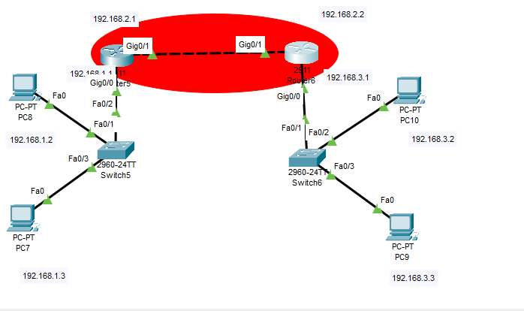

Assigning ips to pc form 192.168.1.2 to….192.168.3.3

R1

Step 1
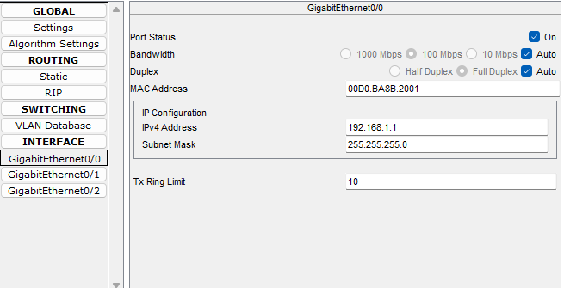

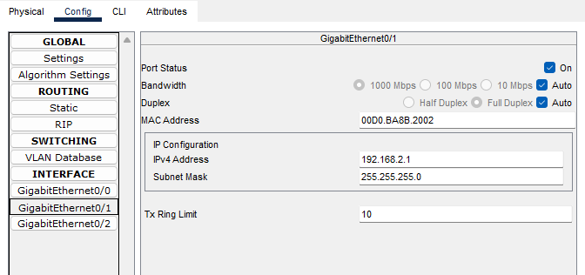

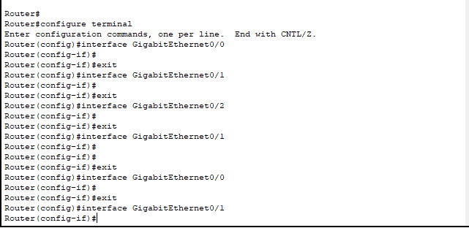
Step 2

R2

Step 1
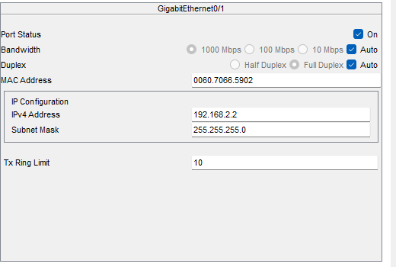

Step 2
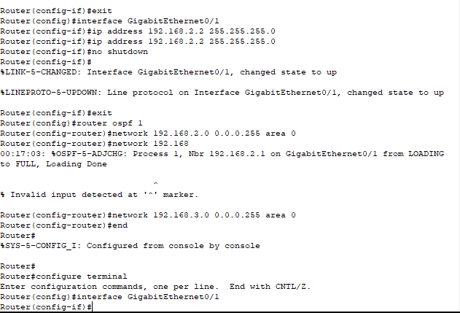

Testing

