

Department of Computer and Software Engineering
Lab Project

Submitted by:

ZAIN RASHID BSCE-23041
M Najeeb Javed BSCE-23036
Haseeb Ashfaq BSCE-23048
Abdul Jabbar BSCE-23038

Submitted To:

SIR ASIM MUNIR
Title: Access Control System Room Security and Automation System Design

Introduction:
Access control systems are essential components in modern security infrastructure, designed to restrict unauthorized entry and automate specific tasks. This project focuses on designing a Room Security (password-based) and Automation System using principles of Digital Logic Design (DLD). The system is developed and tested using Multisim simulation tools, ensuring reliability and precision. By integrating various logical gates and components, the circuit is capable of performing secure access operations and basic automation functions.
The Room Security system allows users to enter a preset password. If the entered password matches the set password, the correct light turns on, granting access. For incorrect password entries, an incorrect light turns on, and an incorrect attempt is counted, providing feedback on the password authentication process.

Requirements / Specifications:
The project requirements are as follows:
Input Voltage: 2.5/5 V DC logic levels.
Logic Components: AND, OR, NOT, XNOR gates
Outputs: Indicators for correct and incorrect password entry.
Functional Validation: Verify the circuit’s performance using simulation tools.

Components Selection:
Below is the list of components used in the design, along with their functions:

Logical Gates:
XNOR Gate: Used for equality checking between password digits and entered digits.
JK Flip Flops: To implement counter
Clock
AND Gate: Combines results to validate the complete password.
NOT Gate: Inverts signals as needed for additional logic.

Additional Components:
DC Power Sources: Provide the logic levels for the circuit inputs.
Indicator LEDs: Display the output logic states visually (correct and incorrect indicators).
Connections and Wires: Used for interfacing and connecting various circuit elements.

Circuit Design and Working:

Password Authentication Logic:
Password Setting and Entry:
The preset password is compared with the entered password using XNOR gates.
Each digit is checked individually for equality.
Correct Password Indicator:
Outputs of the XNOR gates are fed into an AND gate.
If all digits match, the AND gate output turns on the correct light.
Incorrect Password Indicator:
A NOT gate inverts the AND gate output to signal incorrect attempts.
Each incorrect entry increments a counter, and the incorrect light turns on.

Circuit Design:
The circuit diagram is designed in Multisim, showing connections for password comparison, correct/incorrect indicators, and feedback mechanisms. Logical gates are arranged systematically for clarity.

Simulation Results:

Setup:
The circuit was simulated in Multisim.
All possible combinations of HIGH (1) and LOW (0) inputs were tested.

Observations and Outputs:
For correct password entries, the correct light turned on, granting access.
For incorrect password entries, the incorrect light turned on, and incorrect attempts were recorded.

Logical AND, XNOR, and NOT operations were verified for all input combinations.
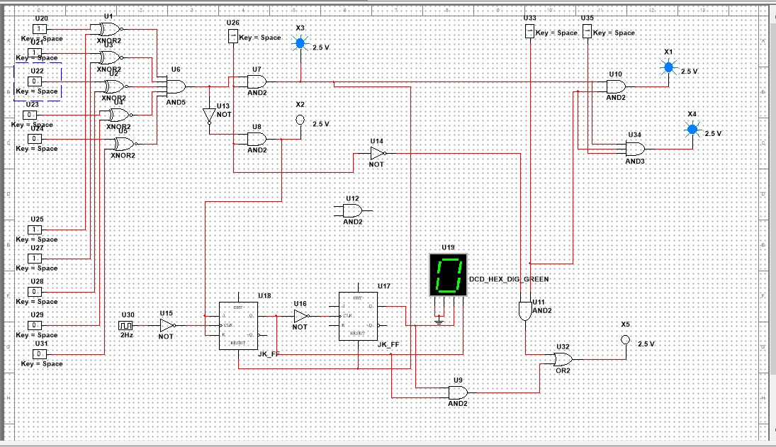
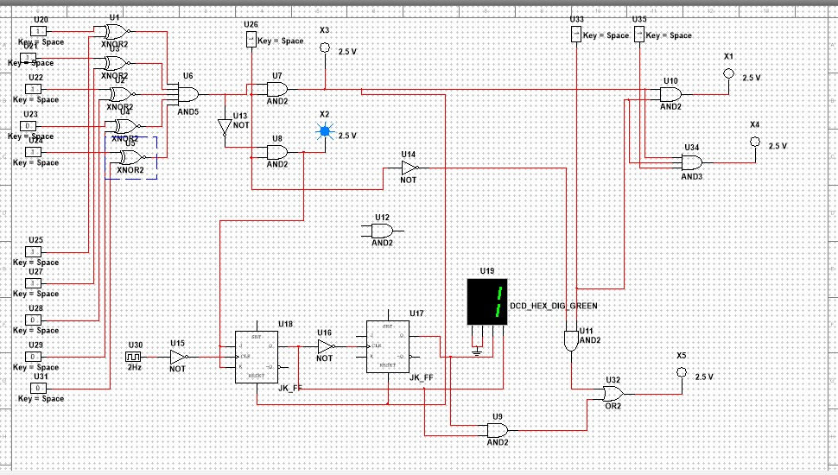
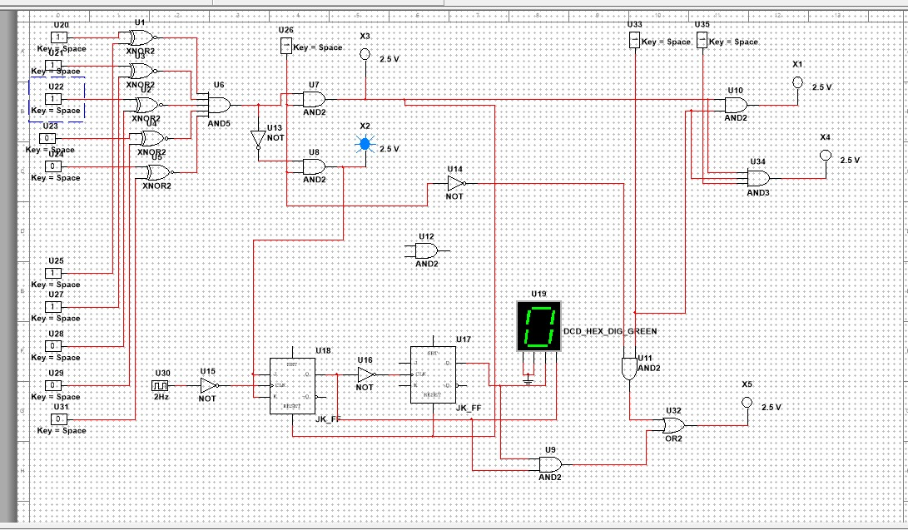

Key Observations:
The password authentication logic worked as intended.
Visual feedback provided by the LEDs confirmed the functionality of the circuit.

Conclusion:
In this project, we successfully designed and simulated a Room Security and Automation System using Multisim. The simulation validated the password-based access control functionality. This project demonstrates the practical application of digital logic principles in designing secure and automated systems. By integrating feedback mechanisms, the system provides real-time insights into correct and incorrect password entries, enhancing its usability and reliability.

