Information Technology University of the Punjab
CE304T Software Engineering – Spring 2026

Assignment 3 – Detailed Design
Prison Management System
Structural Model (UML Class Diagram) & Dynamic Models

Group Member | Roll Number
Haseeb Ashfaq | BSCE23048
Hassan Subhani | BSCE23034
Taimoor Shahzaman | BSCE23046

Degree Program: BS Computer Engineering
Submission Date: May 20, 2026

Part A – Structural and Dynamic Models (CLO1, CLO2)

1. Structural Model – UML Class Diagram
The UML Class Diagram below represents the complete structural model of the Prison Management System (PMS). It identifies all major classes, their attributes, operations, and inter-class relationships (inheritance, association, composition, and aggregation). The diagram covers all major functional domains identified in Assignment 1: user authentication, prisoner record management, cell occupancy management, medical records management, visitor management, reporting, and audit logging.

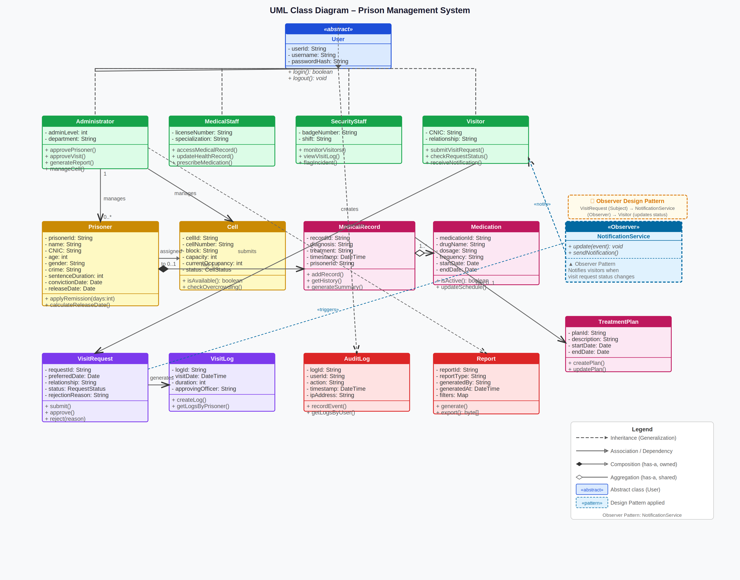
Figure 1: UML Class Diagram – Prison Management System (All Major Classes and Relationships)

1.1 Key Classes and Their Roles
Class | Layer | Responsibility
User (abstract) | Application Layer | Base class for all system users; holds common authentication attributes (userId, username, passwordHash). Subclassed by Administrator, MedicalStaff, SecurityStaff, and Visitor.
Administrator | Application Layer | Full-access user; manages prisoner records, cell assignments, visitor approvals, and report generation.
MedicalStaff | Application Layer | Restricted to medical domain; accesses and updates MedicalRecord and manages Medication and TreatmentPlan objects.
SecurityStaff | Application Layer | Monitors visitor activity; can view VisitLog and flag security incidents.
Visitor | Application Layer | Restricted portal user; submits VisitRequest objects and receives notifications via NotificationService.
Prisoner | Domain / DB | Central domain entity; holds personal (name, CNIC, age, gender), legal (crime, sentenceDuration, convictionDate), and computed (releaseDate) attributes. Linked to Cell, MedicalRecord, and VisitLog.
Cell | Domain / DB | Represents a physical cell; tracks capacity and currentOccupancy, and raises overcrowding alerts when 90% threshold is exceeded.
MedicalRecord | Domain / DB | Records individual health events (diagnosis, treatment, timestamp) for a Prisoner; composed of Medication and TreatmentPlan objects.
VisitRequest | Domain / DB | Manages the full lifecycle of a visitation request (DRAFT → PENDING → UNDER REVIEW → APPROVED/REJECTED). Triggers NotificationService on status change.
VisitLog | Domain / DB | Immutable record of an approved visit; stores visitDate, duration, and approvingOfficer.
AuditLog | Integration Layer | Tamper-evident log of every system action; records userId, action type, timestamp, and IP address (NFR-4.4).
NotificationService | Integration Layer | Observer pattern implementation; subscribed to VisitRequest status changes and dispatches portal notifications to Visitor objects.
Report | Application Layer | Generated on demand by Administrator or MedicalStaff; supports prisoner, occupancy, visitor frequency, and medical summary report types.

1.2 Design Pattern: Observer Pattern
The Observer (Publish-Subscribe) design pattern is applied in the Visitor Notification subsystem of the Prison Management System.

Aspect | Detail
Pattern Name | Observer (Behavioral Pattern – GoF)
Subject (Observable) | VisitRequestService – notifies registered observers whenever a VisitRequest changes state (APPROVED or REJECTED)
Observer Interface | NotificationService – implements the update(event) method; decoupled from the subject via an interface
Concrete Observer | NotificationService.sendNotification() – dispatches a portal notification to the affected Visitor
Where Applied | In the Integration Layer, between VisitRequestService (Application Layer) and Visitor portal notifications
Justification | The Observer pattern decouples the approval/rejection business logic from the notification delivery mechanism. Future notification channels (SMS, email) can be added as new ConcreteObserver implementations without modifying VisitRequestService. This directly supports NFR-1.1 (Modular Architecture) and NFR-2.1 (Separation of Concerns).

2. Dynamic Model
The dynamic models capture the runtime behavior of the system. They include two sequence diagrams for major use cases, one state diagram for an important entity, and one activity diagram for a major workflow.

2a. Sequence Diagram 1 – Visitor Request Submission & Admin Approval
This sequence diagram models the use cases FR-5.1 (Submit Visit Request), FR-5.2 (Admin Approval Workflow), FR-5.3 (Visitor Notification), and FR-5.4 (Visitation Log). It demonstrates the interaction between Visitor, VisitorPortal (UI), AuthService, VisitRequestService, NotificationService (Observer Pattern), and the Administrator across the Presentation, Application, and Integration layers.

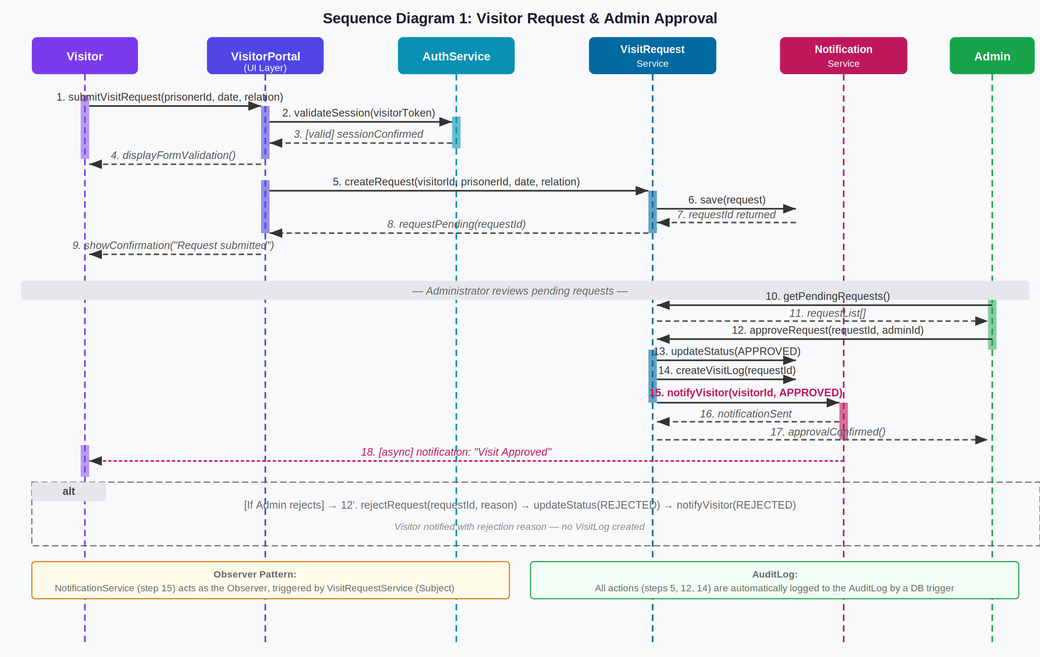
Figure 2: Sequence Diagram – Visitor Visit Request Submission and Admin Approval Workflow

Key interactions demonstrated:
- Session validation (AuthService) before any data submission — implements FR-1.4
- VisitRequest is persisted to the database with PENDING status — implements FR-5.1
- Admin retrieves and reviews pending requests — implements FR-5.2
- On approval, NotificationService (Observer) is invoked — implements Observer Pattern + FR-5.3
- VisitLog is automatically created upon approval — implements FR-5.4
- All transitions are captured in the AuditLog — implements NFR-4.4
- The alt fragment shows the rejection path where no VisitLog is created but the visitor is notified with the reason

2b. Sequence Diagram 2 – Prisoner Registration & Automatic Release Date Calculation
This sequence diagram models the use cases FR-2.1 (Add Prisoner), FR-2.4 (Release Date Calculation via DB trigger), FR-3.4 (Overcrowding Alert), and FR-1.5 (Audit Logging). It shows the interaction between the Administrator, Admin Dashboard (UI), PrisonerService, CellService, MySQL Database (with trigger), and the AuditLog.

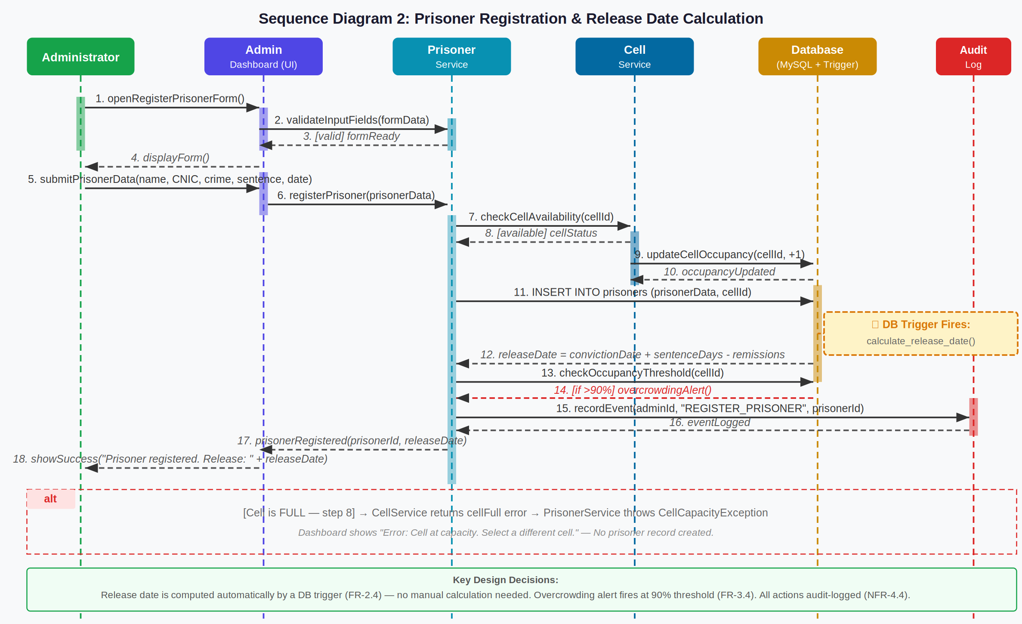
Figure 3: Sequence Diagram – Prisoner Registration with Automatic Release Date Calculation (DB Trigger)

Key interactions demonstrated:
- RBAC check at the Application Layer before rendering the form — implements NFR-4.2
- Cell availability is checked via CellService before inserting any prisoner record — implements FR-3.1
- INSERT into the prisoners table triggers the calculate_release_date() DB trigger — implements FR-2.4
- Overcrowding threshold check fires automatically — implements FR-3.4
- AuditLog entry is written for every register operation — implements NFR-4.4
- The alt fragment handles the "Cell Full" exception — no prisoner is created, error is surfaced to UI

2c. State Diagram – VisitRequest Entity
The State Diagram below models the complete lifecycle of the VisitRequest entity, which is the most behaviorally complex entity in the system with clearly defined state transitions governed by guards and events.

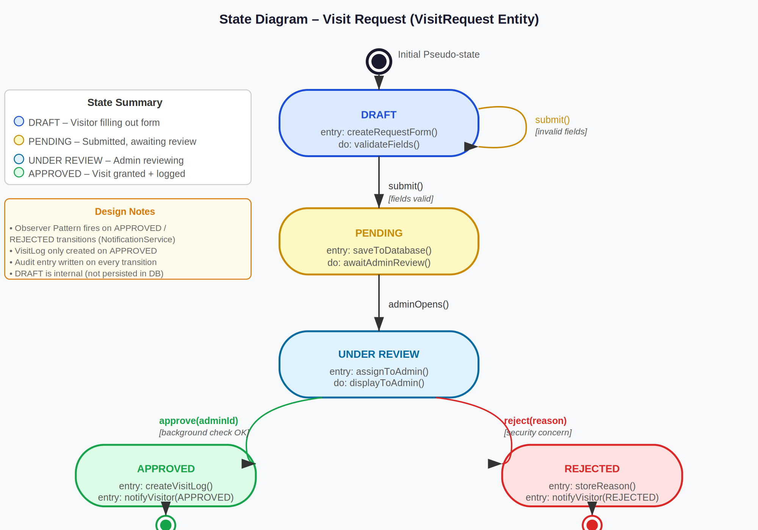
Figure 4: State Diagram – VisitRequest Lifecycle (DRAFT → PENDING → UNDER REVIEW → APPROVED / REJECTED)

States and transitions:
State | Description | Entry Actions
DRAFT | Visitor is actively filling in the request form. Not yet persisted to the database. | createRequestForm(), validateFields()
PENDING | Form submitted and saved to database. Awaiting admin action. | saveToDatabase()
UNDER REVIEW | Administrator has opened the request and is actively reviewing it. | assignToAdmin(), displayToAdmin()
APPROVED | Admin approves request. VisitLog created, visitor notified. | createVisitLog(), notifyVisitor(APPROVED)
REJECTED | Admin rejects request with a reason. No VisitLog created. | storeReason(), notifyVisitor(REJECTED)

Note:
The Observer Pattern fires on both the APPROVED and REJECTED transitions — NotificationService.sendNotification() is invoked as part of the entry action in both terminal states.

2d. Activity Diagram – Prisoner Registration Workflow
The Activity Diagram below represents the complete end-to-end workflow for prisoner registration, organized into three swimlanes: Administrator, System/Application Layer, and Database Layer. It captures all decision points, exception paths, and automated database actions.

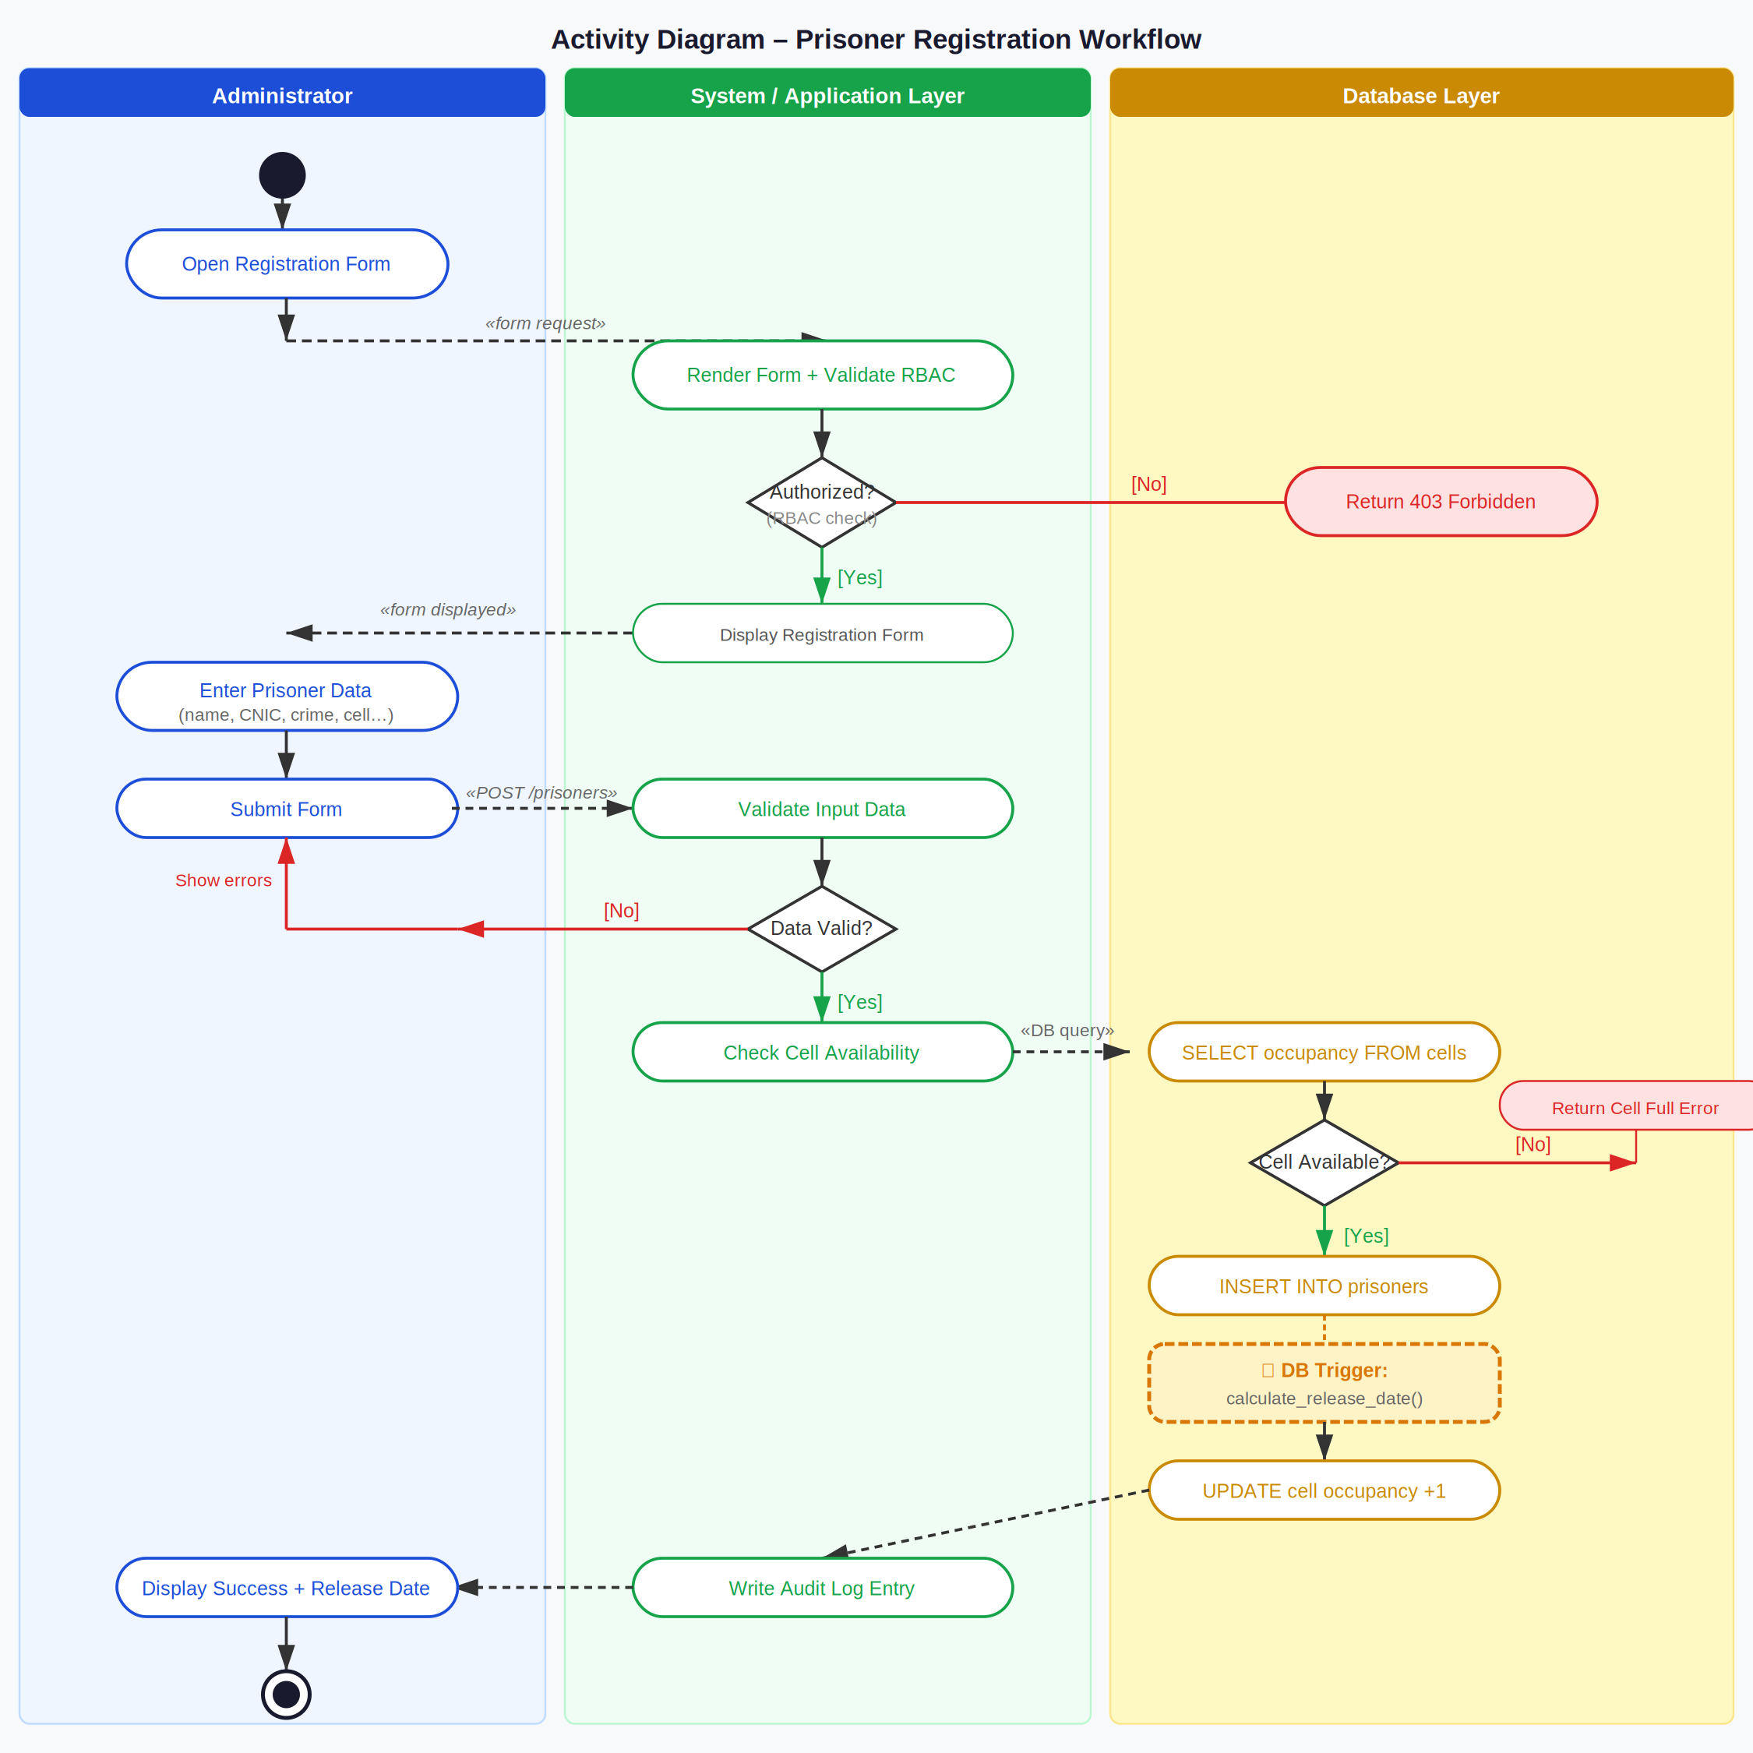
Figure 5: Activity Diagram – Prisoner Registration Workflow (Three-Swimlane View)

Swimlane responsibilities:
- Administrator Swimlane: Opens form, enters prisoner data, and receives outcome (success/error)
- System/Application Layer Swimlane: Handles RBAC validation, input validation, CellService coordination, and audit logging
- Database Layer Swimlane: Executes INSERT, fires calculate_release_date() trigger, and updates cell occupancy counter

Decision points covered:
- [Authorized?] — RBAC check; unauthorized users receive 403 Forbidden response
- [Data Valid?] — Input validation; invalid data loops back to the form with inline error messages
- [Cell Available?] — Occupancy check; full cell returns a CellCapacityException, no record is created

Part B – GitHub Repository (CLO4)

3. GitHub Repository Upload
All design models produced in this assignment have been uploaded to the project GitHub repository under the /Assignment3/ directory, following the repository structure established in Assignments 1 and 2.

Artifact | Repository Path
UML Class Diagram (SVG + PNG) | /Assignment3/diagrams/class_diagram.svg
Sequence Diagram 1 – Visitor Approval | /Assignment3/diagrams/sequence_diagram_1_visitor_approval.svg
Sequence Diagram 2 – Prisoner Registration | /Assignment3/diagrams/sequence_diagram_2_prisoner_registration.svg
State Diagram – VisitRequest | /Assignment3/diagrams/state_diagram_visit_request.svg
Activity Diagram – Registration Workflow | /Assignment3/diagrams/activity_diagram_prisoner_registration.svg
Assignment 3 Report (this document) | /Assignment3/Assignment3_PMS_DetailedDesign.docx

Repository URL: https://github.com/[BSCE23048]/PrisonManagementSystem
Note: Replace [BSCE23048] with your actual GitHub username/organization before submission. Ensure the repository is set to public or the instructor has been granted collaborator access.

Submission Checklist
Done | Requirement | CLO
✓ | UML Class Diagram with all major classes, attributes, relationships, and interfaces | CLO1, CLO2
✓ | At least one design pattern identified, applied, and justified (Observer Pattern) | CLO1, CLO2
✓ | Sequence Diagram 1: Visitor Request & Admin Approval (FR-5.1 to FR-5.4) | CLO1, CLO2
✓ | Sequence Diagram 2: Prisoner Registration & Release Date Calculation (FR-2.1, FR-2.4) | CLO1, CLO2
✓ | State Diagram: VisitRequest entity (5 states + transitions) | CLO1, CLO2
✓ | Activity Diagram: Prisoner Registration Workflow (3 swimlanes) | CLO1, CLO2
☐ | All models uploaded to GitHub repository under /Assignment3/ | CLO4

