**Digital Logic and Design**

**Members:**

Muhammad Ibrahim BSAI-23046

Haseeb Farooq BSAI-23003

**Date:** December 1, 2023

**Digital Communication System**

**Introduction:**

The digital communication system is used to transmit a 4 bit input through a transmitter and a receiver. A shifter is used as a transmitter and a receiver which includes the problem of synchronizing the transmitter and receiver and to make sure if it receives and transmits 4 bits of data.

Here are some key applications of digital communication systems:

* Telecommunication
* Internet Communication
* Broadcasting
* Satellite Communication etc..

**Methodology:**

**Counter:**

A counter is used to handle the synchronization and 4 bit stoppage problem. It works with the clock pulse and a 4 bit stoppage system that stops the counter by giving the load 0. The transmitter and the receiver are both connected with the counter and stop when the counter is stopped so everything is synchronized.

**Transmitter:**

Transmitter holds the properties like converting the parallel 4 bit input into serial transmission and shifts it to the receiver. It uses a shifter for transmission. When the clock pulse starts it shifts the first input to its first output and this carries on for 4 bits. By using this shifter as a transmitter the parallel to serial problem is handled and now we get a 4 bit serial data in the first shifter.

**Receiver:**

Receiver as from the name itself, the purpose of this is to receive the 4 bit serial data sent by the transmitter. Its job is to convert the serial bits back to the original parallel bits, so that the 4 bits we receive at the end can be further used in digital displays. The same clock is used for the transmitter as well so that these two can be synchronized. The input for the receiving shifter is the 3rd output of the transmitter because every bit is passed through it so we get every bit in the receiver.

**Implementation:**

**System Requirements:**

* Clock
* Xnor Gate
* Counter
* Shifter
* Not Gate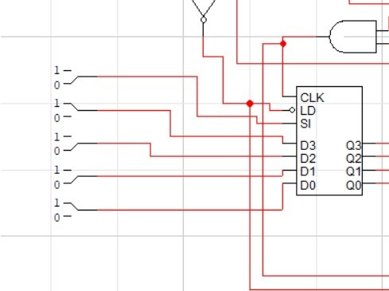
* And Gate

The user will give the 4 bit input from the input module which is connected to the transmitter. The user gives a 4 bit parallel input which is converted into serial transmission.

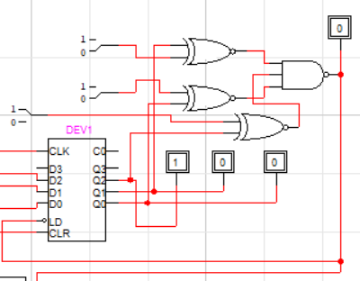

When the user starts the communication system the counter is turned on which is responsible for the synchronization and stoppage of the system. It ensures the 4 bit stoppage by using a XNOR circuit that gives 0 at a unique combination.

An AND gate is then implemented for clock and the output by the shifter. It will change the output until the shifter remains 1. As soon as the shifter turns 0 it will terminate and stop the whole system. This output will be used as the clock for the transmitter.

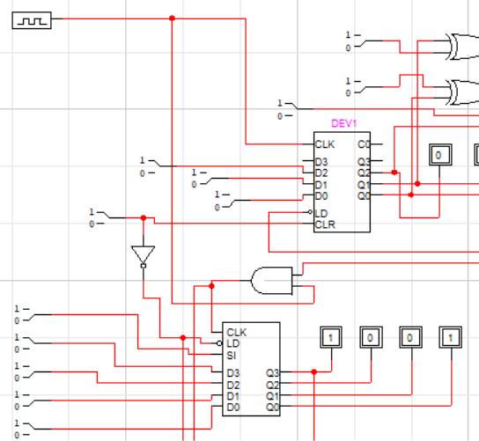

The transmitter is synchronized with the counter and the clock because of the AND gate this shifter shifts the 4 inputs one by one when it gets clock pulses. When the counter stops the clock after 4 bits it stops and the 4 bits are transmitted and have been converted into series.

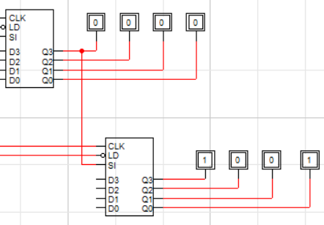

The load and clock of the receiver is connected to the same clock and counter as of the transmitter to ensure synchronization. The shifting pin is connected to the last output of the transmitter ,because the whole serial 4 bit number passes through this output at least once. When it passes through the transmitter it is shifted to the receiver which again shifts the values one by one giving us a 4 bit parallel output for further use .

**Discussion and Conclusion:**

Many difficulties were encountered throughout the project. Some of them being:

* It was hard for us to stop the clock when the output reaches 1, we then implemented the NAND gates, connected with the outputs of the shifters. Which automatically turn into 1 when all outputs are 0.
* We faced difficulty in synchronizing the clock signals between the transmitter and the receiver.
* The key finding involves the successful transmission and reception of binary data.

It concludes that the digital communication system addresses the synchronization of transmitter and receiver while ensuring the precise transmission of 4-bit data. The integration of a counter works as a clock pulse, which is the key component in synchronization and it avoids the 4-bit stoppage issues. The transmitter, utilizing a shifter, converts parallel 4-bit input into serial transmission. On the receiving end, the receiver converts the received serial data back into the original parallel bits, facilitating its use in digital displays. The use of clock pulses is common for both transmitter and receiver and gives seamless synchronization. Overall, the system meets the requirements for various applications such as telecommunication, internet communication, broadcasting, and satellite communication.