FAST National University of Computer and Emerging Sciences Karachi

**Name:**

Bilal Ahmed (K21-4864) (Group Leader)

Muhammad Qasim Alias Haseeb (K21-4889)

Muhammad Younas (K21-3284)

**Subject**: Programming Fundamentals Lab

**Teacher(s)**: Miss Aqsa Zahid

**Project Topic:**  DBMS for Educational Institutions

# Project Objective

The project goal is to make a realistic model for data and record management system for educational institutions. This includes both the use of fundamental database related functions and some extra options to manage the co-curricular activities in the institution.

# Important Functionalities

The Program mainly contains following main functionalities;

1. Data management.
2. Add Record
3. Modify Record
4. Delete Record

This function mainly contains the basic functions of a database. This provides essential functions to add, modify and delete records in the student database.

1. Information Display.
2. Search Record
3. Display Section Information
4. Display Department Information
5. Display Batch Information
6. Display All Records
7. Display count of students

This function is used to print the specified data from the database for the specified record. It contains option to search and print a complete record, display data section wise, display the department information, display the records with respect to their batches, display all the records entered, and to show the total count of records/students.

1. Fees Management.
2. Edit Fees
3. Display Student Fees

This is an essential database function for educational institutions; to manage their data regarding student’s fees.

1. Event Management.
2. Event Details
3. Event Application
4. Event Reservations
5. Cancel Reservation

This function works as an add-on function, to manage the events with the help of student database. This function contains options like displaying event details, option for booking an event, organizing an event, and canceling the reservation for the event.

1. Scholarship Program.
2. Display Program details
3. Display eligible students for specific programs
4. Top 10 Students.

The above mentioned function helps students get information about the available scholarships, to show the eligibility criteria, and information about the top students for the scholarship.

1. Creating new account.

This function helps the moderator create new accounts for the possible operators as a part of login system.

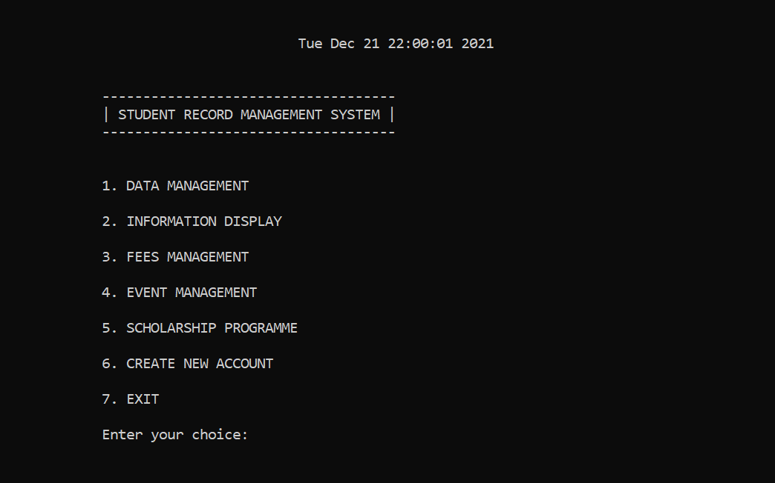

# Programming Concepts/Libraries Utilized

Following are the concepts utilized;

1. Functions and Nested Functions
2. Switch and Nested Switch
3. Loops
4. Break and Continue Statements
5. Filing
6. Structures

# Future Works

This project is designed to while keeping the realistic scenario in the concern, after making a GUI interface this will be applicable for use in Educational institutions with some changes.

# Screenshots

Data Management

Information Display

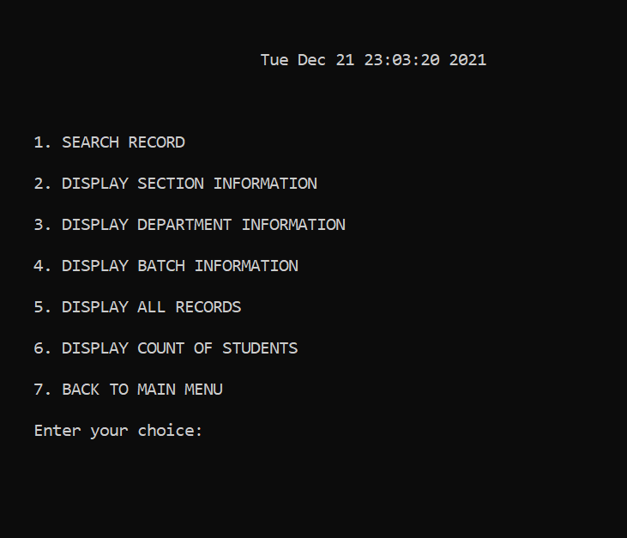

Fees Management

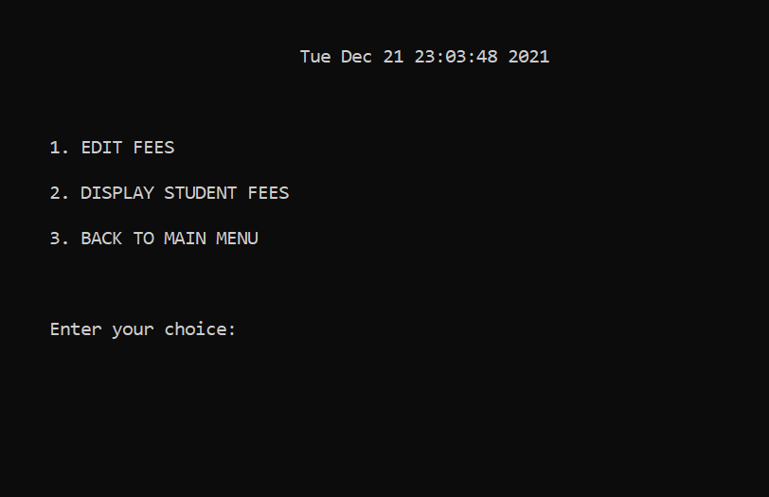

Event Management

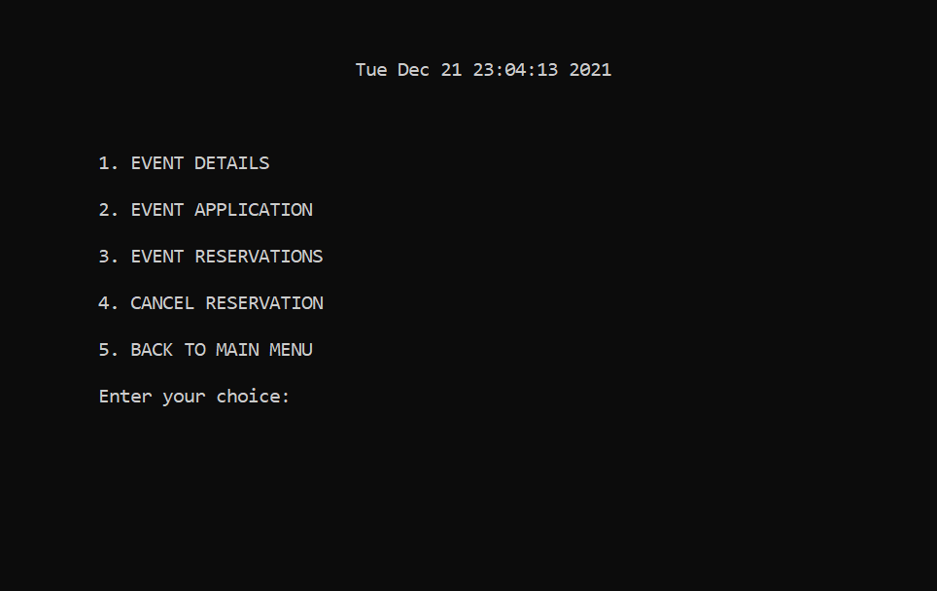

Scholarship Details

