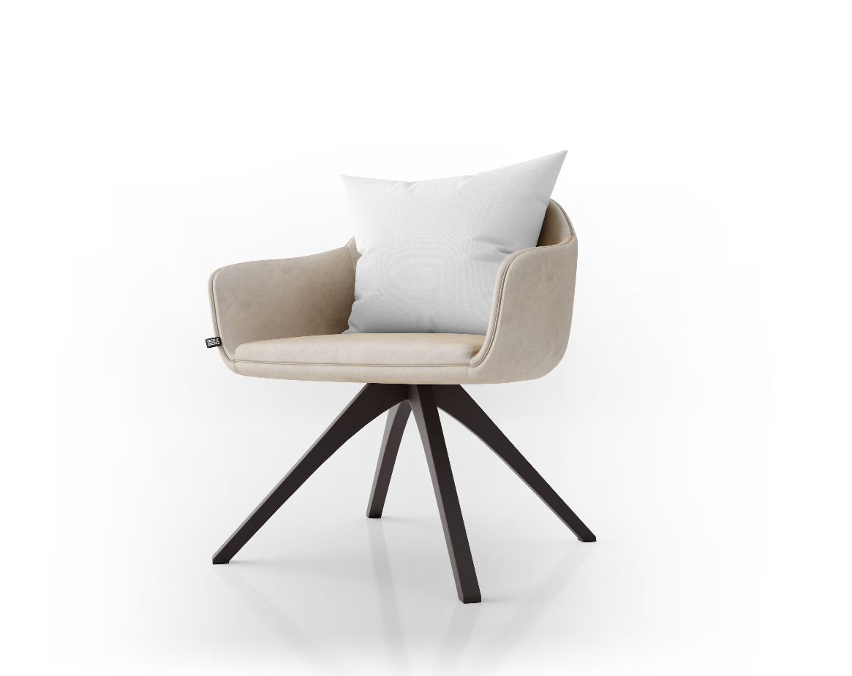

$$38 DOLLAR

Whit , brown , light brown

Color :

Price :

The Simple Chair is a modern chair with scandi flair. It's strong structure makes it the ideal chair to support you comfortably while you get on with your daily work from home or from the office. To assemble, individual slats are fitted by hand into the two outer frames to form a solid structure.

ABOUT :

### Fancy side chair X9