**Problem 1: (Arrays)**

Store the following string in array of character “V12$0i#r17k”. Now, develop a C++ program that will read the array character by character and print numbers of digits after counting from array. After that, you need to read characters from array and print the string as it is and in reverse order too.

**Hint:** Use array of characters to print a string in reverse order.

**Output Sample:**

|  |
| --- |
| Reading String…  Number of Digits= 5  Message= Virk  Reverse= kriV |

**Source Code:**

|  |
| --- |
| #include <iostream>  #include <string>  using namespace std;  int main()  {    char array[]="V12$0i#r17k";  int i = 0;  int no_of_digits = 0;    while (array[i] != '\0')  {  if (array[i] >= '0' && array[i] <= '9')  {  no_of_digits++;  }  i++;  }  cout << "Number of Digits= "<< no_of_digits <<endl;  cout << "Message =" ;  for (int j = 0; j < sizeof(array)-1; j++)  {  if (array[j] >= 'a' && array[j] <= 'z' || array[j] >= 'A' && array[j] <= 'Z')  {  cout << array[j];  }  }  cout<< "\nReverse= ";  for (int i = sizeof(array)-1 ; i >= 0 ; i--)  {  if (array[i] >= 'a' && array[i] <= 'z' || array[i] >= 'A' && array[i] <= 'Z')  {  cout << array[i];  }  }  return 0;  } |

**OUTPUT**

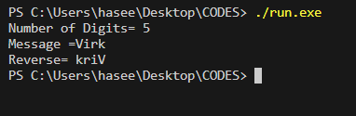

**Problem 2: (Arrays)**

**Develop** a C++ program that will ask the user to enter a string that includes names of the users (store at least ten names in array), Your program should store the entire names in the array of characters. After the print only names that start from vowel characters. (Vowel characters are: a, e, i, o, u).

**Output Sample:**

|  |
| --- |
| Enter the Name: Rehman  Enter the Name: Usman  Enter the Name: Ahmad  …..  Printing vowel Names:  Usman  Ahmad |

**Source code**

|  |
| --- |
| #include <iostream>  #include <string>  using namespace std;  int main()  {  int size = 10;    string names_in_string[size];  char names_in_ch[size][30];  for (int i = 0; i < size; i++)  {  cout << "Enter The Name " << i + 1 << " : ";  getline(cin, names_in_string[i]);  }  for (int i = 0; i < size; i++)  {  int j = 0;  while (names_in_string[i][j] != '\0' && j < 29)  {  names_in_ch[i][j] = names_in_string[i][j];  j++;  }  names_in_ch[i][j] = '\0';  }  cout << "Printing vowel Names:"<<endl;  for (int i = 0; i < size; i++)  {  if (names_in_ch[i][0] == 'a' || names_in_ch[i][0] == 'e' || names_in_ch[i][0] == 'i' || names_in_ch[i][0] == 'o' || names_in_ch[i][0] == 'u' || names_in_ch[i][0] == 'A' || names_in_ch[i][0] == 'E' || names_in_ch[i][0] == 'I' || names_in_ch[i][0] == 'O' || names_in_ch[i][0] == 'U')  {  cout << names_in_ch[i] << endl;  }  }  return 0;  } |

**Output**

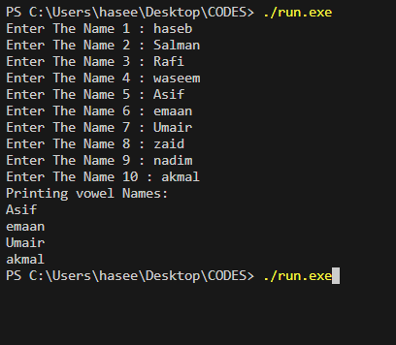

**Problem 3: (Arrays)**

Demonstrate programming skills by developing a C++ program that will take a string of characters from the user and will check whether it is a Palindrome or not.

**Note:** A string is said to be palindrome if it remains the same on reading from both ends. It means that when you reverse a given string, it should be the same as the original string.

**Output Sample:**

|  |
| --- |
| Enter the string: abcdefedcba  Output: The given string is palindrome  Enter the string: radar  Output: The given string is palindrome  Enter the string: malik  Output: The given string is not a palindrome |

**Source code**

|  |
| --- |
| #include <iostream>  using namespace std;  int main()  {    int h = 0;  do{    cout << "enter the size of letters in the words: ";  int size;  cin >> size;  char pldrn_arr[size];  cout << "Enter the word: ";      for (int i = 0; i < size; i++)  {  cin >> pldrn_arr[i];  }  bool check = true;    for (int i = 0; i < size/2; i++)  {  if (pldrn_arr[i] != pldrn_arr[size - 1 - i])  {  check = false;  break;  }  }  if (check)  {  cout << "string is palindrome" << endl;  }  else  {  cout << "string is not palindrome" << endl;  }    h++;  }while(h != 3);    return 0;  } |

**Output**

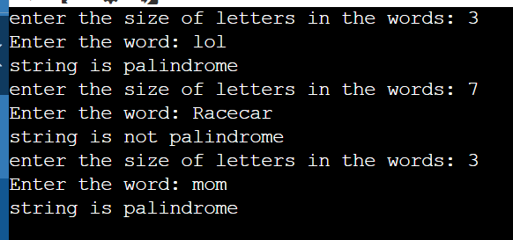

**Problem 4: (Array + Loop + Conditional)**

**Develop** a C++ program that will ask the user to enter a characters and store them in an array of characters. Examine each character if it is a vowel or a consonant with the help of a C++ code. You need to take 10 characters (one by one) from user as input using loop and store these characters into a array, one by one. As output, you need to print whether a given character is a vowel or consonant.

**Hint:** Vowel means given character is ‘a’ or ‘e’ or ‘i’ or ‘o’ or ‘u’ and consonant means given character is other than a vowel.

**Output Sample:**

|  |
| --- |
| Enter a character: a  Vowel  Enter a character: g  Consonant  Enter a character: u  Vowel  Enter a character: i  Vowel  Enter a character: s  Consonant |

**Source code**

|  |
| --- |
| #include <iostream>  using namespace std;  // Output Sample:  // Enter a character: a  // Vowel  // Enter a character: g  // Consonant  // Enter a character: u  // Vowel  // Enter a character: i  // Vowel  // Enter a character: s  // Consonant  int main()  {  char ch[10];  for (int i = 0; i < 10; i++)  {  cout << "Enter a character: "<< ch[i];  cin >> ch[i];  if (ch[i] >= 'a' && ch[i] <= 'z' || ch[i] >= 'A' && ch[i] <= 'Z')  {  if (ch[i] == 'a' || ch[i] == 'e' || ch[i] == 'i' || ch[i] == 'o' || ch[i] == 'u' ||  ch[i] == 'A' || ch[i] == 'E' || ch[i] == 'I' || ch[i] == 'O' || ch[i] == 'U')  {  cout << "Vowel"<<endl;  }  else  {  cout << "Consonant"<<endl;  }    }else {  cout << "Number"<<endl;  }    }    return 0;  } |

**Output**

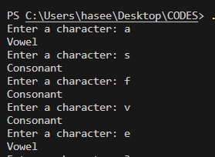

**Problem 5. (Array + Loop) Marks: 5**

Demonstrate programming skills by developing a C++ program that will take 3 numbers (one by one) from user as input using loop and store these numbers into an array, one by one. As output, you need to print its quad with the given number.

Hint: Quad means Power 4 (Quad of 2 is 24)

**Output Sample:**

|  |
| --- |
| Enter a Number: 5  The Quad of 5 is 625  Enter a Number: 11  The Quad of 11 is 14641  Enter a Number: 7  The Quad of 7 is 2401 |

**Source code**

|  |
| --- |
| #include <iostream>  #include <cmath>  #include <iomanip>  using namespace std;  int main() {  int numbers[3];  cout <<"Enter the numbers:\n";  for (int i = 0; i < 3; i++)  {  cin >> numbers[i];  }    long double arrnum = 0;  for (int i = 0; i < 3; ++i) {  arrnum = arrnum * 10 + numbers[i];  }  cout << "The quad is " << arrnum * arrnum * arrnum * arrnum <<endl;  cout << setprecision(100) << "The quad is " << pow(arrnum,4);  return 0;  } |

**Output**

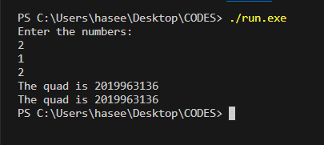

**Problem 6. (Array) Marks: 5**

Demonstrate programming skills by developing a C++ program that will take two strings from the users and store them in an array. Compare both strings and generate output whether they are same or not.

**Output Sample:**

|  |
| --- |
| Enter a string one: 1 2 3 4 5 6  Enter the second string: 1 2 3 4 5 6  Output: Both strings are same  Enter a string one: M o n a L  Enter the second string: M o n a L  Output: Both strings are same  Enter a string one: 1 2 3 4 5 8  Enter the second string: 1 2 3 4 5 6  Output: Both strings are not same |

**Source code**

|  |
| --- |
| #include <iostream>  #include <string>  using namespace std;  int main()  {        string user_input1;      string user_input2;      cout << "Enter the first string: ";      getline(cin,user_input1);      cout << "Enter the second string: ";      getline(cin,user_input2);      string arr1[1];      string arr2[1];      for (int i = 0; i < 1; i++)      {          arr1[0] = user_input1;          arr2[0] = user_input2;      }      for (int i = 0; i < 1; i++)      {          if (arr1[0] == arr2[0])          {              cout << "Both strings are same"<<endl;          }else          {              cout << "Both strings are not same"<<endl;          }        }        return 0;  } |

**Output:**

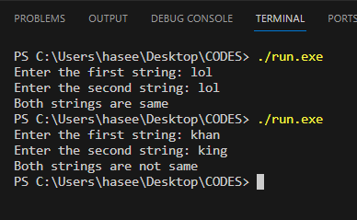

**Problem 7. (Array) Marks: 5**

Demonstrate programming skills by developing a C++ program that will take one string from the users and store them in an array of characters. Convert the entered string into UPPER and Lower case. (Note: You can use builtin function)

**Source Code:**

|  |
| --- |
| #include <iostream>  #include <string>  using namespace std;  int main()  {  int size = 100;  string name = "haseeb";    cout << "Enter a string: ";  getline(cin, name);    int length_of_string = 0;    while (name[length_of_string] != '\0')  {  length_of_string++;  }  char arr[length_of_string];  for (int i = 0; i < length_of_string; i++)  {  arr[i] = name[i];  }  for (int i = 0; i < length_of_string; i++)  {  if (arr[i] >= 'a' && arr[i] <= 'z')  {  arr[i] = toupper(arr[i]);  }  else if (arr[i] >= 'A' && arr[i] <= 'Z')  {  arr[i] = tolower(arr[i]);  }  }  for (int i = 0; i < length_of_string; i++)  {  cout << arr[i];  }  cout << " && ";  for (int i = 0; i < length_of_string; i++)  {  cout << name[i];  }  return 0;  } |

**Output**

