**Superior University Reiwend Road**

Name: Haseeb Arshad

Roll no: SU92–BSSEM-F22-177

Section:5D

Subject: CN Lab  
Task 3

Submitted to: Sir Rasikh Ali

**Task 1; Design the network of "Lab-7" or “Lab-8” (2-3 rows of computers) Use: Switch, Router, & End-Devices like Laptop/PC Assign them IP Address (Static/Manually) of any Network (or you can use network 192.168.1.0)**

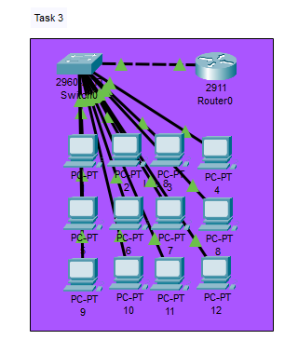

**Router Configuration Command:**

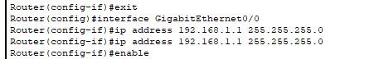

**Switch Configuration Command:**

