
Institute of Business Management

OPP
Spring - 2026

PHARMACY MANAGEMENT SYSTEM PROJECT PROPOSAL

Group Members:-
STD_ID | NAME
Syed Muhammad Ahmed | 20251-39657
Zainab Zeeshan | 20251-39918
Ali Hassan | 20251-38974
Laiba Malik | 20251-38973
Haseeb Ahmed | 20251-39916

TABLE OF CONTENTS
Chapter 1: Introduction .............................................................. 1
Chapter 2: Problem Statement ........................................................ 2
Chapter 3: Goals ...................................................................... 3
Chapter 4: Solution ................................................................... 4
Chapter 5: Contribution of Each Member .............................................. 8
Chapter 6: Conclusion ................................................................. 9

Chapter I:-Introduction
The Pharmacy Management System (PMS) is a console-based Java application that digitizes the core operations of a small pharmacy. The system manages medicine inventory with expiry tracking, sales with automatic bill generation, refunds, role-based user login, proactive stock and expiry alerts, and complete file persistence. Every piece of data is saved to structured text files that survive between program runs. Small pharmacies in Pakistan still rely on manual, paper-based records — stock levels go untracked, expiry dates get missed, and there is no separation between owner and staff access. This project was built to solve those problems in one clean, self-contained Java application structured around all four core OOP principles.

CHAPTER II:- Problem Statement
The following operational problems at small pharmacies in Pakistan were identified and addressed:
- Inventory Oversights:- Medicines expired or ran out undetected. Resolved via automated expiry and low-stock alerts on every startup.
- Health Risks:- Manual records risked selling expired stock. The AlertSystem flags all expired medicines before the menu loads.
- Inflexible Service:- Staff had no way to suggest alternatives for out-of-stock items. findAlternatives() now returns substitutes by formula category.
- Lack of Accountability:- No audit trail for price changes or deletions. The Admin/Staff hierarchy and activity log record every privileged action with a timestamp

CHAPTER III :- Goals
The following goals were defined before development began. All goals listed below were fully achieved in the final implemented system:
- Centralized Inventory: Store and manage complete medicine records — name, company, price, expiry date, quantity, minimum stock threshold, formula category, and prescription flag — in a persistent file that survives between sessions.
- Seamless Sales: Process sales that automatically reduce stock, generate formatted receipts with bill IDs, support percentage discounts applied after the sale, and handle full refunds that restore inventory.
- Role-Based Security: Enforce two access levels: Admin with full system control and Staff with restricted access. Lock out any user after three consecutive failed login attempts.
- Proactive Alerts: Automatically flag expired medicines, medicines expiring within 7 days, and medicines below minimum stock threshold on every program startup — before the menu appears.
- Data Reliability: Persist every inventory change, every transaction, every admin action, and every alert to dedicated files. Never overwrite sales or activity logs. Generate a dated inventory backup on every shutdown.
- Alternative Suggestions: When a medicine is out of stock, automatically scan the inventory for alternatives sharing the same formula category and present them to the customer with name, quantity, and price.
- Reporting: Provide Admin-only reports including daily, weekly, and monthly sales summaries, best-selling medicine tracker, and a profit and loss statement covering revenue, discounts, and refunds.

CHAPTER IV:- Soloution
The system is built on a twelve-class architecture. Each class has a single, well-defined responsibility:

Class | Responsibility | Key Methods
Medicine.java | Core inventory engine. Stores all medicine data in a static array of 100 objects. | addMedicine(), deleteMedicine(), searchByName(), findAlternatives(), viewAll()
FileManager.java | Sole file I/O class. Manages all five data files and the backup system. | loadInventory(), saveInventory(), logSale(), logAlert(), generateBackup()
DataLoader.java | Loads 19 preloaded medicines on first run only. | loadDefaultMedicines()
Medicine.java | Date parsing and expiry calculations for the AlertSystem. | daysUntilExpiry(), isExpired(), isExpiringSoon()
DateHelper.java | All date-related utility operations in dd/MM/yyyy format. | daysUntilExpiry(), isExpired(), formatForDisplay()
AlertSystem.java | Runs on every startup. Checks expiry and low stock across all medicines. | checkAllOnStartup(), checkExpiry(), checkLowStock(), saveAlertHistory()
Bill.java | Represents one complete sale transaction. Auto-calculates totals. | calculateTotal(), printBill(), toCsvString(), fromCsvString()
Sales.java | Manages all selling, discounting, refunding, and reporting. | sellMedicine(), applyDiscount(), processRefund(), getDailySummary(), calculateProfitLoss()
SalesReport.java | Supporting class for report formatting output. | showProfitLoss()
User.java | Abstract base class. Enforces login with three-attempt lockout. | login(), isLocked(), showCapabilities() (abstract)
Admin.java | Extends User. Full system access including price control and reporting. | changePrice(), viewActivityLog(), showCapabilities()
Staff.java | Extends User. Restricted to sales, search, and inventory viewing. | showCapabilities()
Menu.java | System controller. Handles all input/output and routes all actions. | main(), startup(), shutdown(), showAdminMenu(), handleInput()

Screenshots:
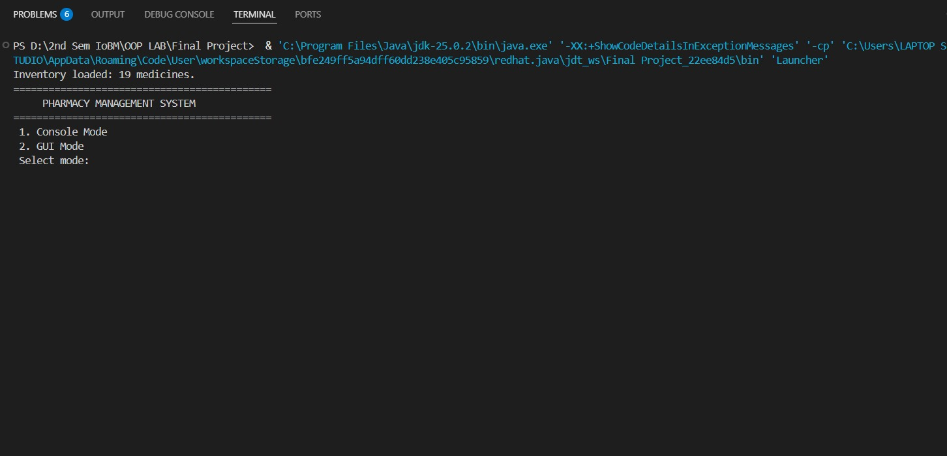

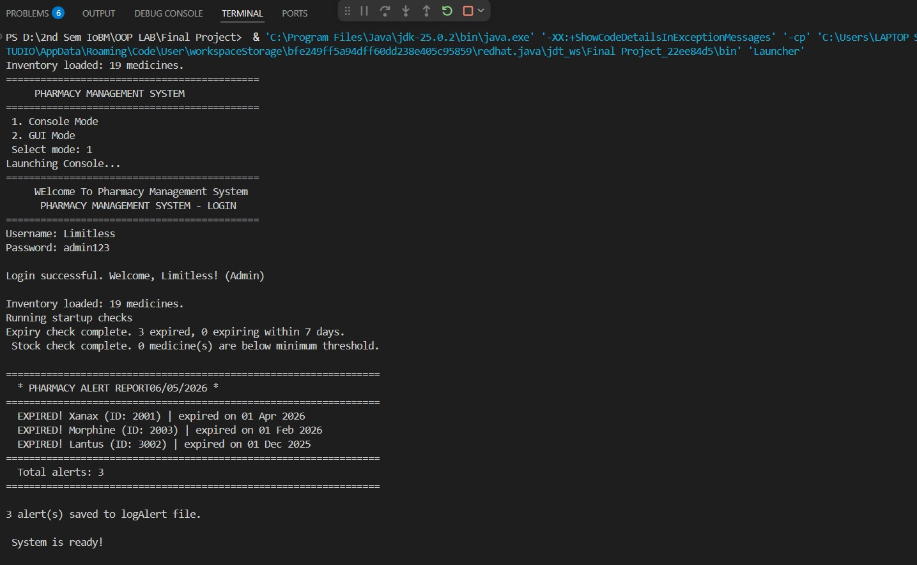


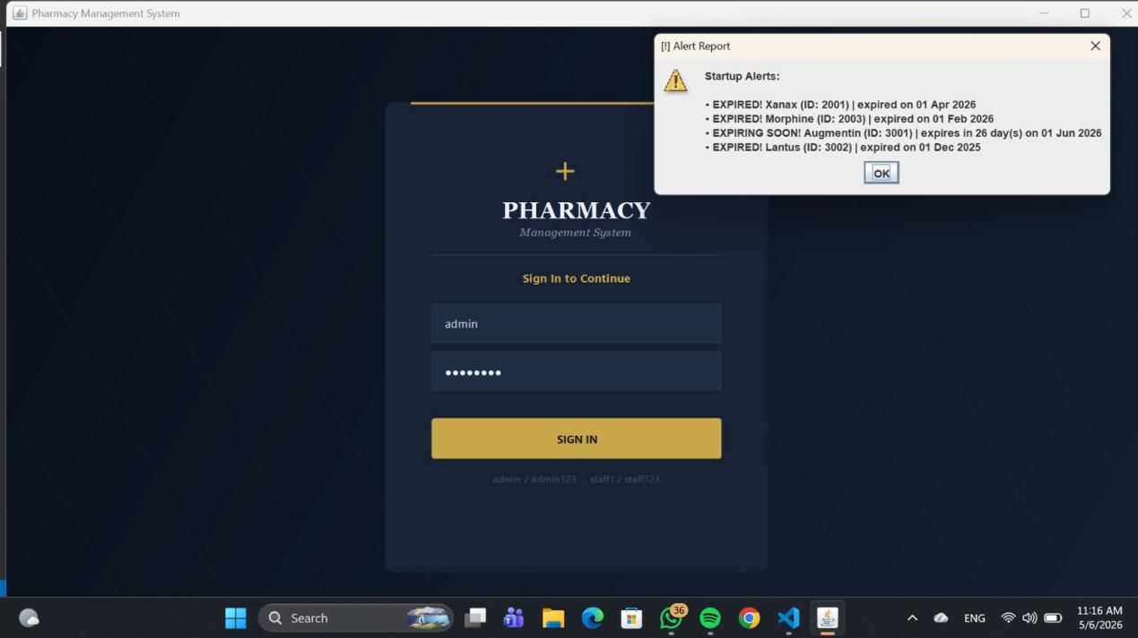

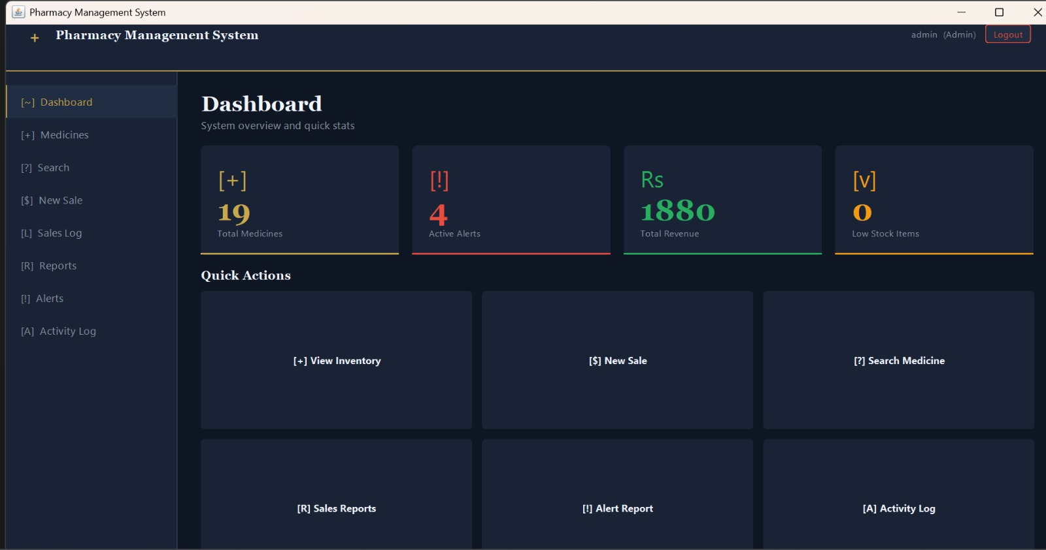

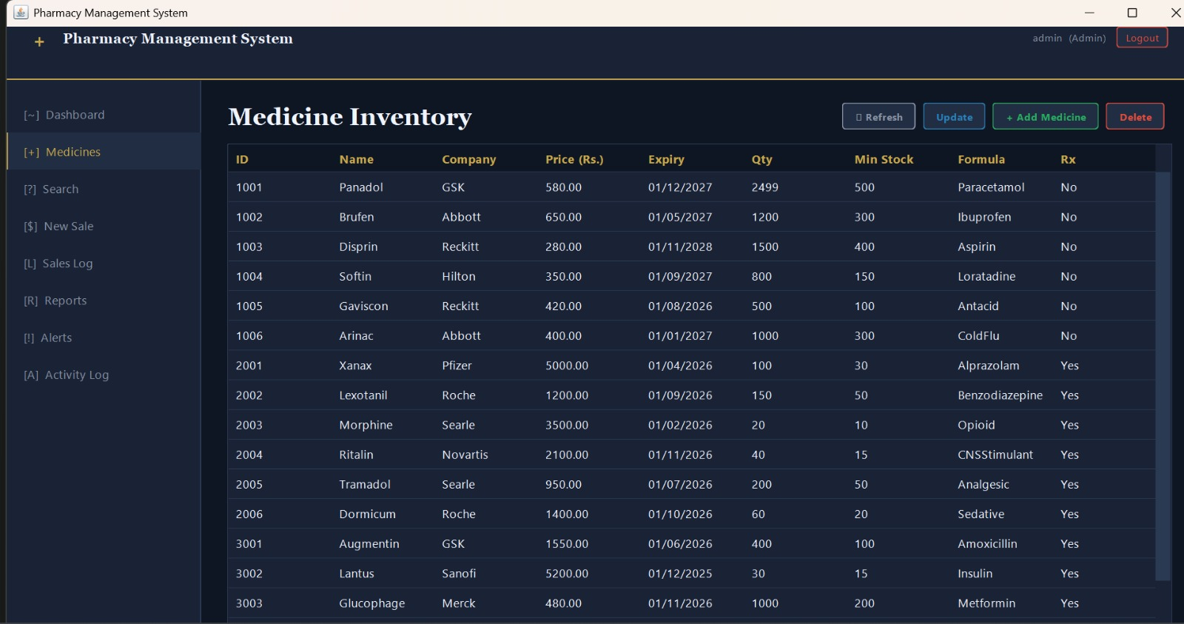
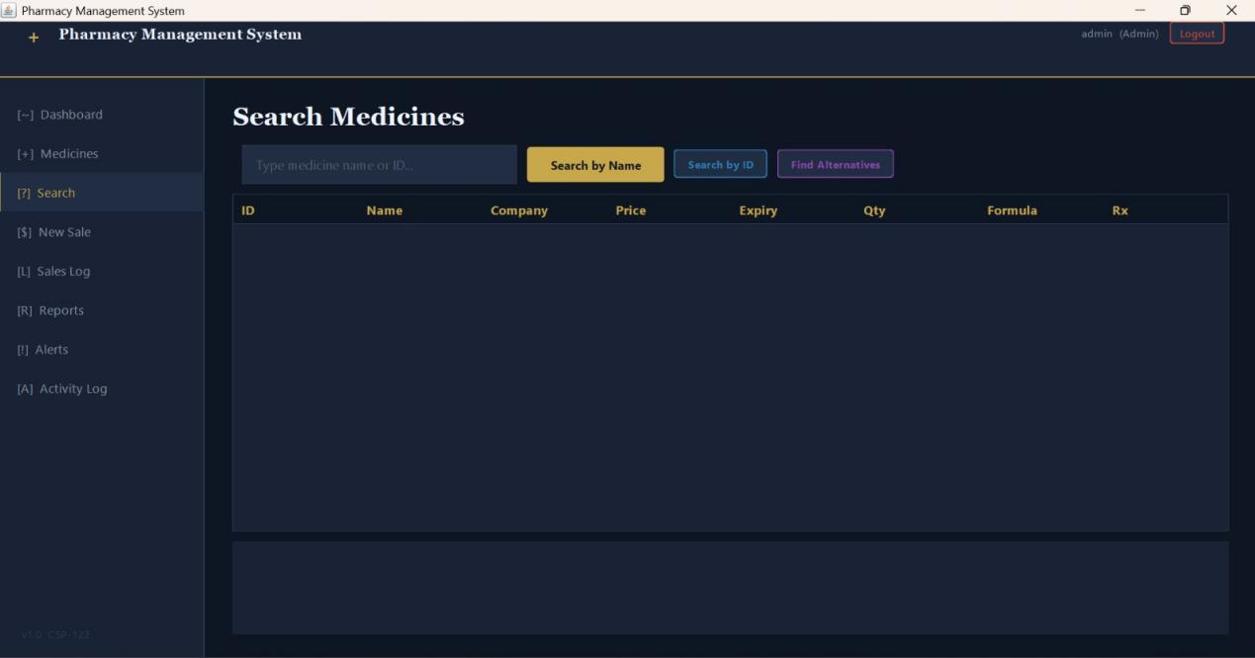

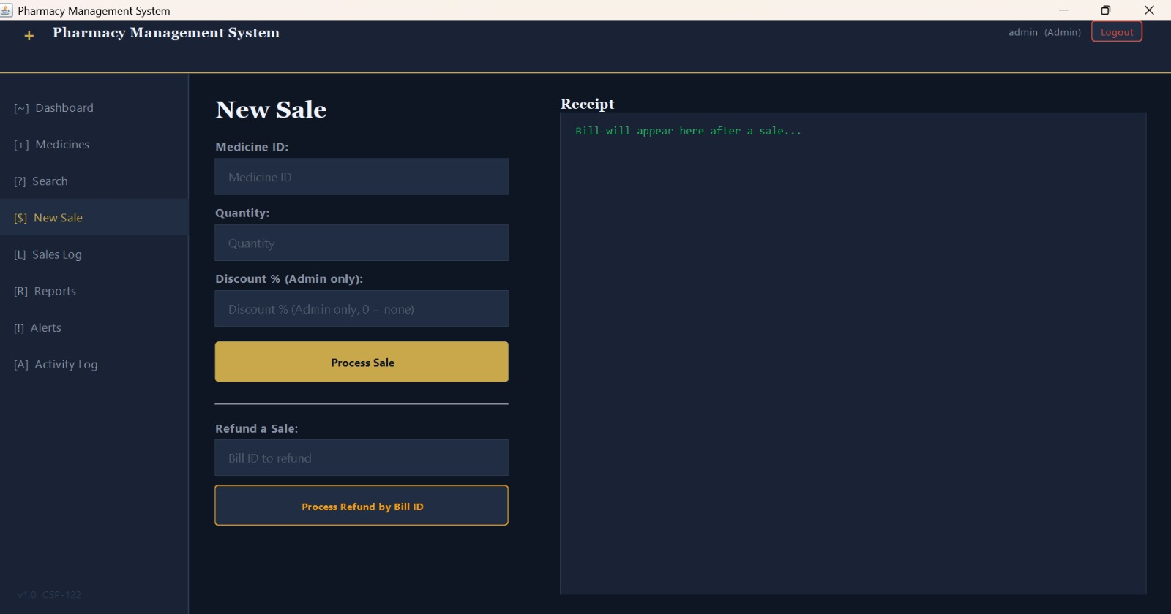

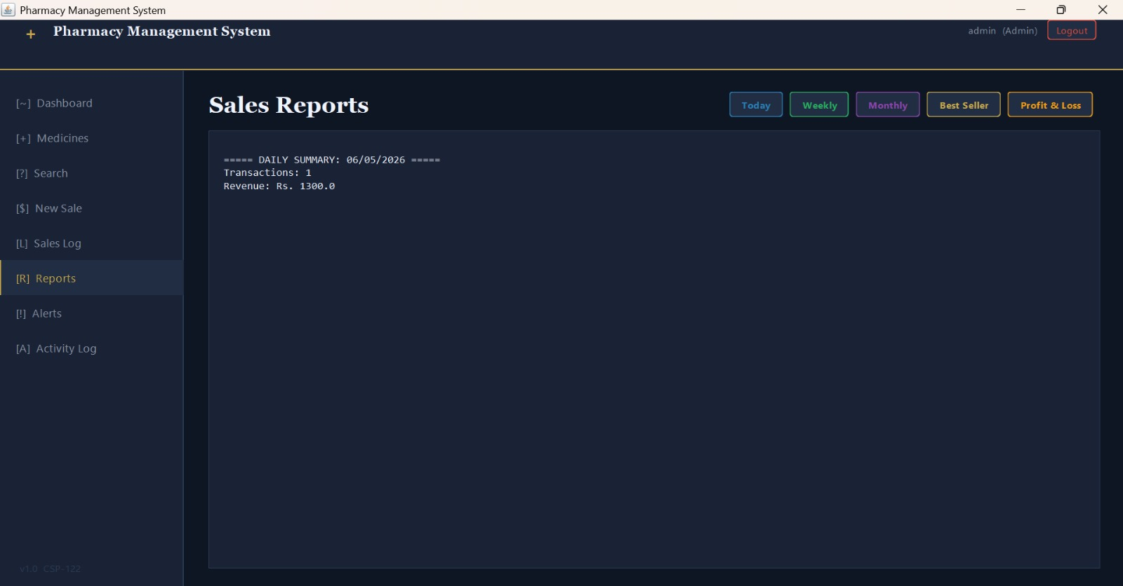

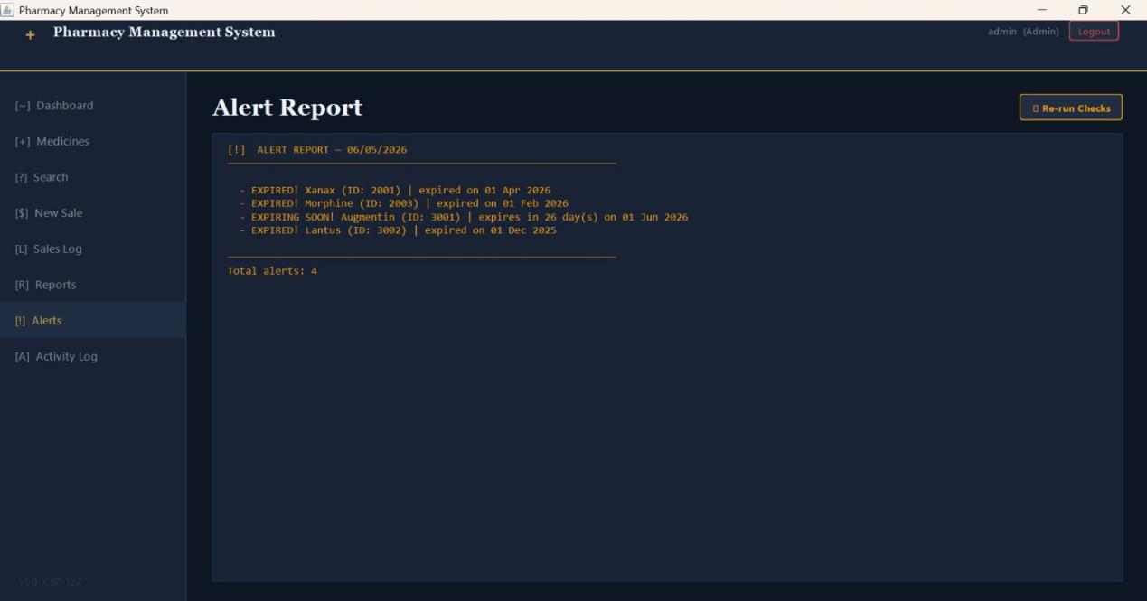

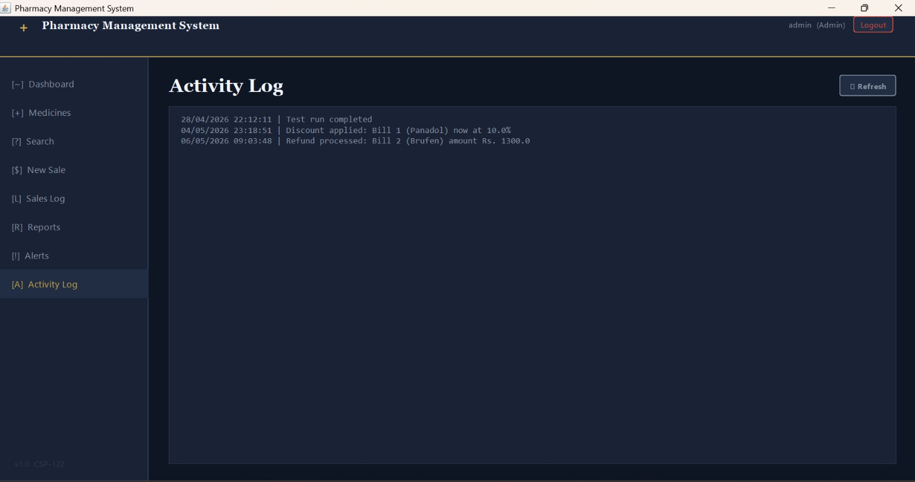

OOP Concepts Applied:-

Concept | Where Applied | How It Is Used
Encapsulation | All 12 classes | Every field is private; access controlled through getters and setters
Inheritance | User → Admin, Staff | Admin and Staff extend User, inheriting login logic and credentials
Abstraction | User.java | User is abstract — cannot be instantiated; showCapabilities() is abstract
Polymorphism | Menu.java | currentUser declared as User type; holds Admin or Staff at runtime
Composition | Sales HAS-A Bill | Sales creates, stores, and manages Bill objects per transaction
File I/O | FileManager.java | BufferedReader and BufferedWriter manage all five persistent data files
Exception Handling | FileManager, Menu | All file operations wrapped in try-catch for IOException
Array of Objects | Medicine.java | Static array of 100 Medicine objects stores the full inventory
ArrayList | Sales.java | Dynamic ArrayList of Bill objects stores the in-memory sales log

CHAPTER V:-Contributions

Member | Role | Files & Responsibilities
Syed Muhammad Ahmed | Team Leader | Medicine.java, FileManager.java,Pharmacy GUI ,Core inventory engine, all file operations, preloaded data
Haseeb Ahmed | Sales | Bill.java, Sales.java— Billing, transactions, discounts, refunds, all reports
Ali Hassan | Access Control | User.java, Admin.java, Staff.java ,DateHelper.java, Abstract user hierarchy, login, role-based access
Laiba Malik | Integration | AlertSystem.java, Menu.java ,Alerts, date utilities, main menu, system controller
Zainab Zeeshan | Data Analyst | Launcher.Java ,,DataLoader.java,Proposal,Report, Presentation,UML — All written documentation and presentation material

CHAPTER VI:- Conclusion

The Pharmacy Management System was successfully built and tested as a fully functional console-based Java application. All goals defined before development began were achieved in the final submission. The system handles inventory management, role-based user access with login lockout, automated startup alerts, sales processing with billing and refunds, admin-level reporting, and complete persistent file storage with automatic dated backups.
The project demonstrates all four core OOP concepts in working, functional code.Beyond the four required concepts, the system also applies composition (Sales containing Bill objects), static members (Medicine's shared inventory array), ArrayList for dynamic sales log management, exception handling throughout file operations, and a single-responsibility file I/O class that keeps all persistence logic in one place.
The system could realistically be deployed in a small pharmacy today to replace manual record-keeping and improve both operational accuracy and customer service.

END

