Three Weeks Report

UET Kala Shah Kaku

|  |
| --- |
| **-:**Disclaimer**:-**  This report is based on my personal experiences, observations, and research conducted during my time at UET KSk. It reflects my own opinions and may not fully represent the views of the university or its staff. While I have tried my best to provide accurate information, some details may vary, and I recommend verifying them through official sources if needed. This report is intended for educational purposes and not for any commercial use.  Now, let's talk about **copyrights**. Copyrights are a set of rights that protect the creator's work. Whenever someone creates something like a book, song, painting, or even this report, it is automatically protected by copyright. This means that others cannot copy, share, or use the creator's work without permission. For example, if you write a story or draw a picture, it is your creation, and nobody else can claim it as their own. If someone uses your work without asking you, they might be breaking the law.  Copyrights encourage people to create new things by giving them control over how their work is used. For example, an author who writes a book can decide who can sell it or turn it into a movie. Without copyright protection, people might be afraid to create new things because anyone could steal their ideas. In Pakistan, copyright laws help protect creators’ rights, just like in other countries. However, not everything is protected by copyright. Ideas, facts, and simple phrases are usually not covered unless they are turned into a creative work  In summary, copyrights protect the original works of creators and ensure that they have the right to control how their work is used. This helps promote creativity and innovation while making sure that creators are rewarded for their hard work. In this report, I have tried to respect all copyrights and give proper credit where necessary. Please do not copy or distribute this report without permission. It’s important to follow copyright laws, just like following school rules, to make sure everyone is treated fairly and can benefit from their work. |
| **-:**Credits**:-**  I’m **Haseeb iqbal** an author of this report . Every alphabets typed by me is based on my observations. This is my first litle assignment. My Roll No. is **2024-CS-700** |

Table of Contents

1 Overview 4

2 Infrastructure 5

2.1 Campus Layout 5

2.1.1 Main Academic Buildings 5

2.1.2 Administrative Offices 5

2.1.3 Green Spaces 6

2.2 Classroom Facilities 6

2.2.1 Classroom Capacity 6

2.2.2 Multimedia and AV Support 6

2.3 Laboratories 6

2.3.1 Computer Lab 6

2.3.2 Physics Lab 6

2.4 Library 6

3 Hostel and Accommodation 7

3.1 Rooms Environment 7

3.2 Management Behaviour 7

3.3 Mess and food 7

4 Transportation 8

4.1 University transport facility 8

4.1.1 Quality of buses 8

4.1.2 Driver Driving Skills 8

4.2 Public transport accessibility 8

## Table of Figures

**1: Main Entrance** 4

**2: Departments** 5

**3: Hostels** 7

**4: Transport** 8

**Table of Tables**

**1: Overall Opinion** 9

# Overview

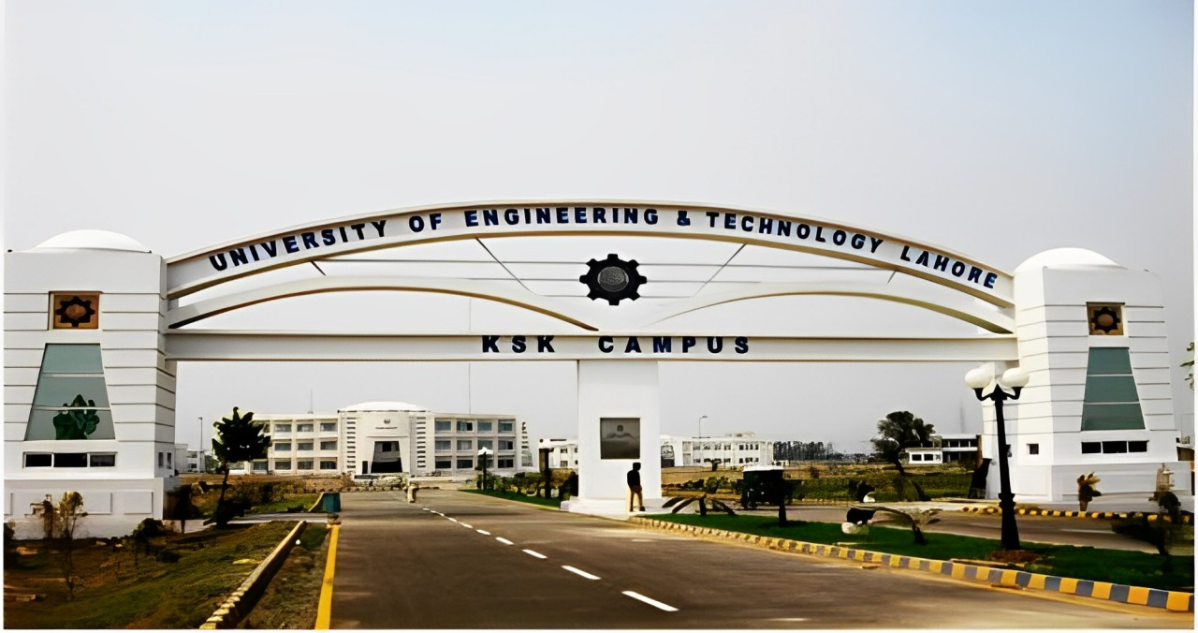University of Enginearing and technology (UET) KSK campus is actually an extension of UET Lahore.

1: Main Entrance

It’s a great university and has 751-760 rank in **QS World University Ranking**.(1: Main Entrance)

This University offers wide range of discipline to undergraduates and postgraduates students.Every student have taken an entrance test named **ECAT** to secure its addmission in this great university.

Actually, Kala Shah Kaku (KSK ) campus is a relatively new campus established in **2006**.So that’s why it is not very extraordinary campus.

There are a lot of green spaces in this campus . which provide a refreshing and peaceful environment for students. The open spaces not only enhance the beauty of the campus but also offer students a relaxing atmosphere where they can study, unwind, and engage in extracurricular activities. This natural environment fosters a sense of calmness and encourages a healthy balance between academic work and outdoor activities.

Despite being a relatively new campus, UET KSK is rapidly advancing, with continuous improvements in its infrastructure, facilities, and academic programs. It offers students the opportunity to be part of a growing campus community, where they can gain a solid education in engineering while also contributing to the development of the campus itself

In addition to academics, UET KSK also places a strong emphasis on co-curricular and extracurricular activities. The campus hosts various societies and clubs that cater to a wide range of student interests, including sports, robotics, debate, and cultural activities. These societies provide students with opportunities to develop leadership, teamwork, and communication skills, which are essential for success in the engineering profession. UET KSK encourages students to actively participate in these activities, recognizing that a well-rounded education goes beyond classroom learning.

It’s green fields are the best for sports. There is also a football ,cricket and badmintion parts.The playing fields are different for every sport.

# Infrastructure

2: Departments

Its infratrature is quite good . Every departmental building is well maintained. This campus consist of almost every thing that students needed.It have a library that consist wide collection of books .Students can go there any time of the day.This campus also has an Admin block that solves every problem related to students dues , clearance , Hostel related issues and much more.This Campus also contains the proper functional labs.The computer lab that is present inside **CS** (2: Departments)Despartment and a Aplied Physics Lab present in **BHS** Department

## Campus Layout

This campus consist of almost every thing that students needed.It have a library that consist wide collection of books .Students can go there any time of the day.This campus also has an Admin block that solves every problem related to students dues , clearance , Hostel related issues and much more.This Campus also contains the proper functional labs.

### Main Academic Buildings

Uet New Campus consist of well maintained Departments.They are well cleaned.It has BSCS department, Electrical Enginearing Deaprtment, Basic Humanities department, Mechanical department, Computer Enginearing and Civil enginearing department.

### Administrative Offices

This campus also has an Admin block that solves every problem related to students dues , clearance , Hostel related issues and much more .

### Green Spaces

There are a lot of green spaces in this campus . which provide a refreshing and peaceful environment for students. The open spaces not only enhance the beauty of the campus but also offer students a relaxing atmosphere where they can study, unwind, and engage in extracurricular activities.

## Classroom Facilities

Classrooms are not that good its not an air conditioned classes but a litle bit airy. There is one wide white board in every class and a projector. Teacher use projector to showcase powerpoint slide and other study material to students.Wooden chairs are used by students.there is maximum 50 chairs.

### Classroom Capacity

There is total capacity of 50 students in each class. Wooden chairs are used by students.there is maximum 50 wooden chairs.There is a mostly the chairs of girls are aligned at right side of room and chairs of boyas are at left side.

### Multimedia and AV Support

There is one wide white board in every class and a projector. Teacher use projector to showcase powerpoint slide and other study material to students.Teachers also create google classrooms for student to give them assignments.

## Laboratories

Laboratories plays a vital role in understanding topics related to particular subject.It increase the productivity of a student and clears the concept s of students. The computer lab that is present inside **CS** Despartment and a Aplied Physics Lab present in **BHS** Department.

### Computer Lab

Computer Lab is also present in Uet KSK. It conatins large number of good specs computers.It is present in **CS Department.**

### Physics Lab

Physics Lab is also present in UET KSK. It conatins instruments of goot quality.It is present in **BSH Department.**

## Library

Library is also present in UET KSK. It conatins large number of good specs computers.It is present near **ADMIN BLOCK.**

# Hostel and Accommodation

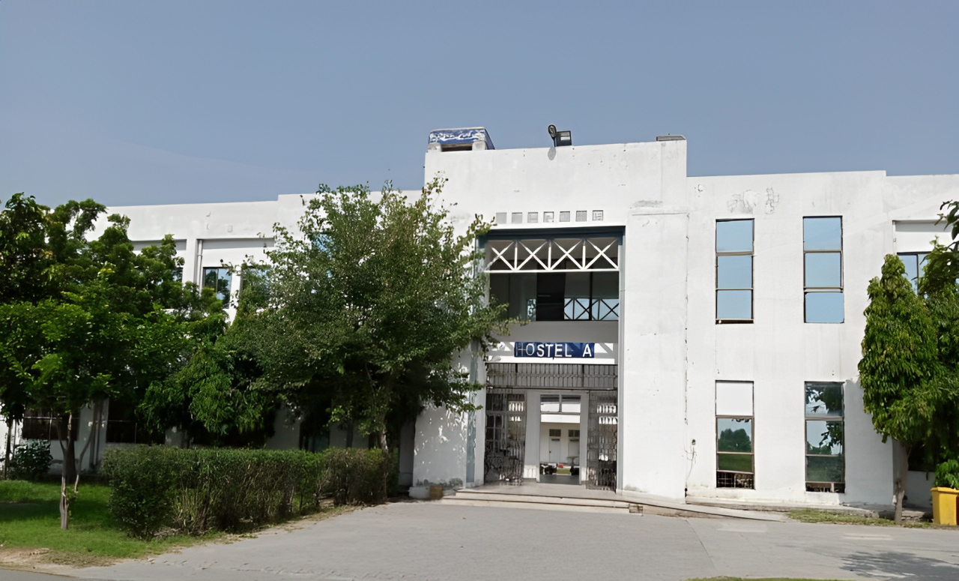

3: Hostels

## Rooms Environment

Hostel Rooms are normal. As I’m day scholar I didn’t explore much about hostel but according to some students reviews its environment was quite good . The quality of food given in hostel was also normal.

## Management Behaviour

Hostel management is also coporative . It helps the hotelize students in every matter and resolve his issue.

## Mess and food

The food in the hostel at UET KSK can be a mix of tasty and not-so-great days. Sometimes, we get delicious biryani or spicy karahi, which makes everyone happy! But other times, the veggies might be overcooked, and we wish for a little more flavor. Overall, it’s a fun experience.

## Number of Hostels

There are two hostels. “Hostel A” (3: Hostels) and “Hostel B” located at different locations within the university.

# C:\Users\Beast\Pictures\buses.jpegTransportation

Transport at UET KSK is really important for students to get around. The buses usually help us reach classes on time, but there’s a big problem! Sometimes, the number of passengers is more than the buses can handle (4: Transport). This makes it super crowded, and some of us even have to stand! It can get really uncomfortable, especially on hot days. We all wish there were more buses so everyone could have a seat. If that happens, it would make our daily rides much better. Let’s hope for some changes soon!

4: Transport

## University transport facility

University provide transport facility at low –cost.It facilitate students that live at distance from university.

### Quality of buses

Quality of buses is mediocre . It is not that great but resonable.Ther eare only few number of buses.

### Driver Driving Skills

Driver drives the bus at normal speed ensuring the safety of the students .

## Public transport accessibility

Public transports are not easily accessible as the university is out of lahore and for any public transport the student has to manage to enter in lahore to use any public transport. This is the only Con of this university. The student has to face difficulty to use public transport.

The process often involves additional time and effort, as students must first find a way to enter Lahore before they can connect to the city’s transportation network. This can lead to longer travel times, increased commuting costs, and potential difficulties in coordinating schedules, especially for those with tight class timings or part-time jobs. As a result, many students may experience stress and frustration, particularly during peak hours when public transport is overcrowded.

: Overall Opinion

|  |  |
| --- | --- |
| **Things** | **Ratings** |
| 1. **Infrastructure** 2. **Classroom Facilities** 3. **Laboratories** 4. **Library** 5. **Hostel and Accommodation** 6. **Transportation** | **8 out of 10**  **7 out of 10**  **9 out of 10**  **8 out of 10**  **7 out of 10**  **6 out of 10** |