|  |
| --- |
| **-:Disclaimer:-**  This report is based on my personal experiences, observations, and research conducted during my time at UET KSk. It reflects my own opinions and may not fully represent the views of the university or its staff. While I have tried my best to provide accurate information, some details may vary, and I recommend verifying them through official sources if needed. This report is intended for educational purposes and not for any commercial use.  Now, let's talk about **copyrights**. Copyrights are a set of rights that protect the creator's work. Whenever someone creates something like a book, song, painting, or even this report, it is automatically protected by copyright. This means that others cannot copy, share, or use the creator's work without permission. For example, if you write a story or draw a picture, it is your creation, and nobody else can claim it as their own. If someone uses your work without asking you, they might be breaking the law.  Copyrights encourage people to create new things by giving them control over how their work is used. For example, an author who writes a book can decide who can sell it or turn it into a movie. Without copyright protection, people might be afraid to create new things because anyone could steal their ideas. In Pakistan, copyright laws help protect creators’ rights, just like in other countries. However, not everything is protected by copyright. Ideas, facts, and simple phrases are usually not covered unless they are turned into a creative work  In summary, copyrights protect the original works of creators and ensure that they have the right to control how their work is used. This helps promote creativity and innovation while making sure that creators are rewarded for their hard work. In this report, I have tried to respect all copyrights and give proper credit where necessary. Please do not copy or distribute this report without permission. It’s important to follow copyright laws, just like following school rules, to make sure everyone is treated fairly and can benefit from their work. |
| **-:Credits:-**  I’m **Haseeb iqbal** an author of this report . Every alphabets typed by me is based on my observations. This is my first litle assignment. |

Table of Contents

1 Overview 4

2 Infrastructure 5

2.1 Campus Layout 5

2.1.1 Main Academic Buildings 5

2.1.2 Administrative Offices 5

2.1.3 Green Spaces 6

2.2 Classroom Facilities 6

2.2.1 Classroom Capacity 6

2.2.2 Multimedia and AV Support 6

2.3 Laboratories 6

2.3.1 Computer Lab 6

2.3.2 Physics Lab 6

2.4 Library Resources 6

3 Hostel and Accommodation 7

3.1 Rooms Environment 7

3.2 Management Behaviour 7

3.3 Mess and food 7

4 Transportation 8

4.1 University transport facility 8

4.1.1 Quality of buses 8

4.1.2 Driver Driving Skills 8

4.2 Public transport accessibility 8

**Table of Figures**

Main Entrance 4

Departments 5

Hostels 7

Transport 8

# Overview

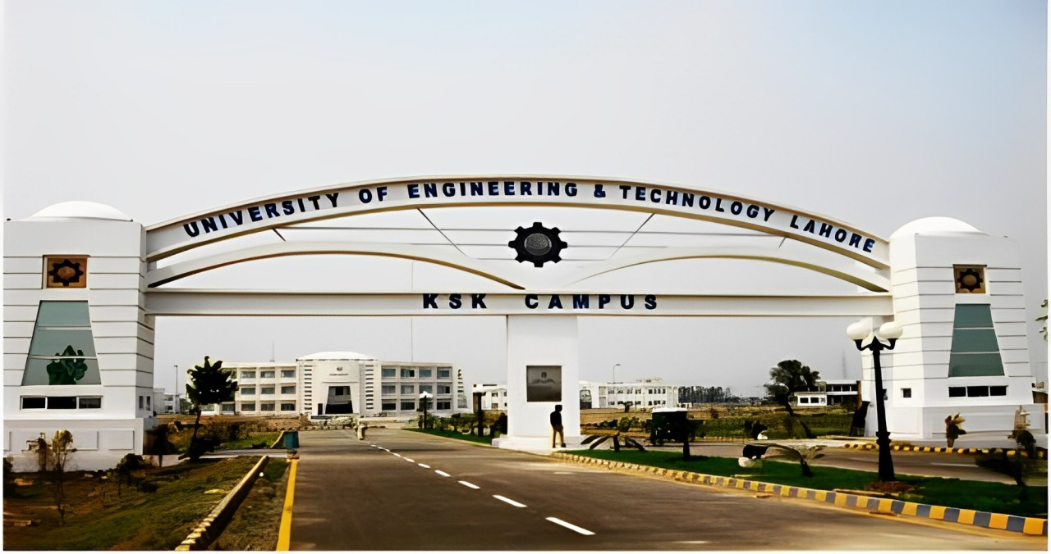University of Enginearing and technology (UET) KSK campus is actually an extension of UET Lahore.

1: Main Entrance

It’s a great university and has 751-760 rank in **QS World University Ranking**.

This University offers wide range of discipline to undergraduates and postgraduates students.Every student have taken an entrance test named **ECAT** to secure its addmission in this great university.

Actually, Kala Shah Kaku (KSK ) campus is a relatively new campus established in **2006**.So that’s why it is not very extraordinary campus.

There are a lot of green spaces in this campus . which provide a refreshing and peaceful environment for students. The open spaces not only enhance the beauty of the campus but also offer students a relaxing atmosphere where they can study, unwind, and engage in extracurricular activities. This natural environment fosters a sense of calmness and encourages a healthy balance between academic work and outdoor activities.

Despite being a relatively new campus, UET KSK is rapidly advancing, with continuous improvements in its infrastructure, facilities, and academic programs. It offers students the opportunity to be part of a growing campus community, where they can gain a solid education in engineering while also contributing to the development of the campus itself

In addition to academics, UET KSK also places a strong emphasis on co-curricular and extracurricular activities. The campus hosts various societies and clubs that cater to a wide range of student interests, including sports, robotics, debate, and cultural activities. These societies provide students with opportunities to develop leadership, teamwork, and communication skills, which are essential for success in the engineering profession. UET KSK encourages students to actively participate in these activities, recognizing that a well-rounded education goes beyond classroom learning.

It’s green fields are the best for sports. There is also a football ,cricket and badmintion parts.The playing fields are different for every sport.

# Infrastructure

2: Departments

Its infratrature is quite good . Every departmental building is well maintained. This campus consist of almost every thing that students needed.It have a library that consist wide collection of books .Students can go there any time of the day.This campus also has an Admin block that solves every problem related to students dues , clearance , Hostel related issues and much more.This Campus also contains the proper functional labs.The computer lab that is present inside **CS** Despartment and a Aplied Physics Lab present in **BHS** Department

## Campus Layout

The campus is designed thoughtfully with academic blocks, administrative offices, and green spaces arranged in a way that makes it easy to move around. There are signs everywhere to guide new students, and the paths between buildings are well-maintained, making it a pleasant walk across the campus.

### Main Academic Buildings

Uet New Campus consist of well maintained Departments.They are well cleaned.It has BSCS department, Electrical Enginearing Deaprtment, Basic Humanities department, Mechanical department, Computer Enginearing and Civil enginearing department.

### Administrative Offices

This campus also has an Admin block that solves every problem related to students dues , clearance , Hostel related issues and much more .

### Green Spaces

There are a lot of green spaces in this campus . which provide a refreshing and peaceful environment for students. The open spaces not only enhance the beauty of the campus but also offer students a relaxing atmosphere where they can study, unwind, and engage in extracurricular activities.

## Classroom Facilities

Classrooms are not that good its not an air conditioned classes but a litle bit airy. There is one wide white board in every class and a projector. Teacher use projector to showcase powerpoint slide and other study material to students.Wooden chairs are used by students.there is maximum 50 chairs.

### Classroom Capacity

There is total capacity of 50 students in each class. Wooden chairs are used by students.there is maximum 50 wooden chairs.The university provides students with labs for practical learning. The computer lab is equipped with the latest computers and software necessary for computer science courses, while the physics lab is fully stocked with all the tools needed for hands-on experiments, ensuring students can perform practicals effectively.

### Multimedia and AV Support

The university provides students with labs for practical learning. The computer lab is equipped with the latest computers and software necessary for computer science courses, while the physics lab is fully stocked with all the tools needed for hands-on experiments, ensuring students can perform practicals effectively.

## Laboratories

The university provides students with labs for practical learning. The computer lab is equipped with the latest computers and software necessary for computer science courses, while the physics lab is fully stocked with all the tools needed for hands-on experiments, ensuring students can perform practicals effectively.

### Computer Lab

For those who do not use the university buses, public transport options are easily accessible. There are rickshaws, buses, and vans available right outside the university gate, making it convenient for students to travel to and from the campus.

### Physics Lab

For those who do not use the university buses, public transport options are easily accessible. There are rickshaws, buses, and vans available right outside the university gate, making it convenient for students to travel to and from the campus.

## Library Resources

For those who do not use the university buses, public transport options are easily accessible. There are rickshaws, buses, and vans available right outside the university gate, making it convenient for students to travel to and from the campus.

# Hostel and Accommodation

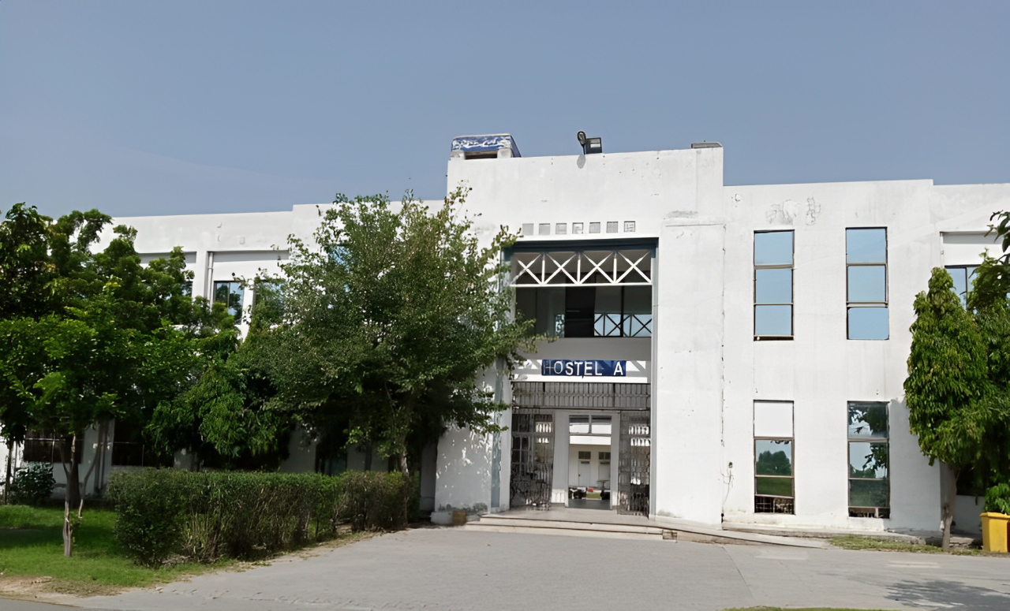

: Hostels

## Rooms Environment

For those who do not use the university buses, public transport options are easily accessible. There are rickshaws, buses, and vans available right outside the university gate, making it convenient for students to travel to and from the campus.------------------------------------

## Management Behaviour

The university provides students with labs for practical learning. The computer lab is equipped with the latest computers and software necessary for computer science courses, while the physics lab is fully stocked with all the tools needed for hands-on experiments, ensuring students can perform practicals effectively.--------------------------------------------------------------------------------

For those who do not use the university buses, public transport options are easily accessible. There are rickshaws, buses, and vans available right outside the university gate, making it convenient for students to travel to and from the campus.

## Mess and food

For those who do not use the university buses, public transport options are easily accessible. There are rickshaws, buses, and vans available right outside the university gate, making it convenient for students to travel to and from the campus.--------------------

# C:\Users\Beast\Pictures\buses.jpegTransportation

The university provides students with labs for practical learning. The computer lab is equipped with the latest computers and software necessary for computer science courses, while the physics lab is fully stocked with all the tools needed for hands-on experiments, ensuring students can perform practicals effectively.--------------------------------------------------------------------------------

For those who do not use the university buses, public transport options are easily accessible. There are rickshaws, buses, and vans available right outside the university gate, making it convenient for students to travel to and from the campus.-----------------------------------------------------------------------------------

4: Transport

## University transport facility

For those who do not use the university buses, public transport options are easily accessible. There are rickshaws, buses, and vans available right outside the university gate, making it convenient for students to travel to and from the campus.

### Quality of buses

For those who do not use the university buses, public transport options are easily accessible. There are rickshaws, buses, and vans available right outside the university gate, making it convenient for students to travel to and from the campus.

### Driver Driving Skills

For those who do not use the university buses, public transport options are easily accessible. There are rickshaws, buses, and vans available right outside the university gate, making it convenient for students to travel to and from the campus.

## Public transport accessibility

For those who do not use the university buses, public transport options are easily accessible. There are rickshaws, buses, and vans available right outside the university gate, making it convenient for students to travel to and from the campus.

For those who do not use the university buses, public transport options are easily accessible. There are rickshaws, buses, and vans available right outside the university gate, making it convenient for students to travel to and from the campus.

For those who do not use the university buses, public transport options are easily accessible. There are rickshaws, buses, and vans available right outside the university gate, making it convenient for students to travel to and from the campus.