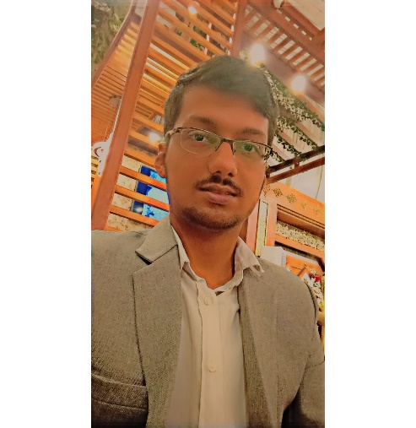

Power Engineering Student

Haseeb Nadeem



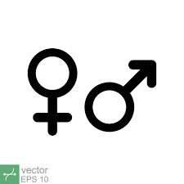

**OBJECTIVE**

Male

July 7, 2001

+92 327 2332949

[Haseebumer549@gmail.com](mailto:Haseebumer549@gmail.com)

Sindh, Pakistan

As a BE Electrical (Power) student, I am eager to apply my strong foundation in mathematical concepts and problem-solving skills to real-world challenges. As my summer break approaching, I am seeking an internship opportunity to gain hands-on experience in engineering field. This experience will not only enhance my technical expertise but also provide valuable industry exposure, helping me to contribute effectively to future projects and advancements in the field of electrical engineering.









**EDUCATION**

**SKILLS**

**Computer**

* Matlab
* Engineering Drawing (AutoCAD)
* Python, C++
* Word, Excel, Power point

**Language**

* English

**HIGHER EDUCATION**

**BE Electrical (Power)**

* Usman institute of engineering & technology
* CGPA 3.1
* Karachi-Pakistan
* 2024 In process

**INTERMEDIATE**

* NCR CET (College of Emerging Technology)
* Karachi-Pakistan
* 2019-2021 Grade: B

**ACADAMIC PROJECTS**

* Arduino Based Projects
* Air Quality Monitoring System
* Home Appliance Controlling
* Home Invertor DC to AC.
* Created lucky seven game (using Python)

*INTEREST*

* *Love to play chess, cricket*

**ROBOMINIA** Award: Honorable mention

**Hebrew university of Jerusalem Award:** completed build a modern computer from first principles from Nand to Tetris

**ACTIVITIES**